

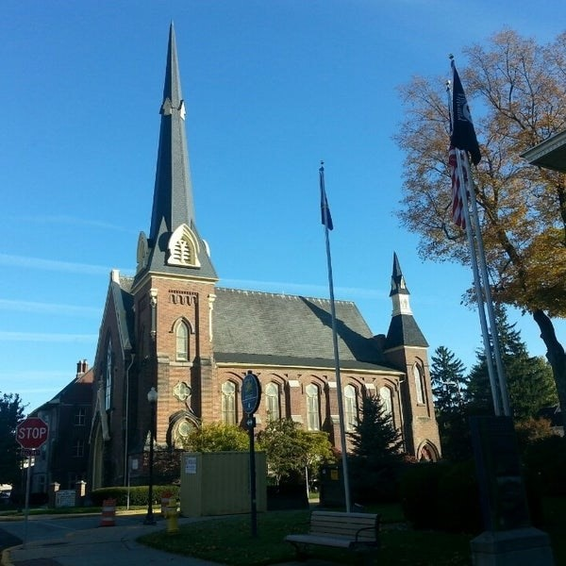
April 15, 2026

A Global Methodist Church
214 S. 5th Street
Goshen, IN 46528
Phone: 574-533-9518
Web Site: goshenfirstgmc.org

Office Hours: Monday-Friday,
8:00 a.m.-12:00 noon
Worship: 9:00 a.m.
Sunday School: 10:30 a.m.
Pastor Jeff & Lisa
Associate Pastor Rich Hull
OUR VISION: “Growing in Faith, Gathering in Community, and Giving in Love”.

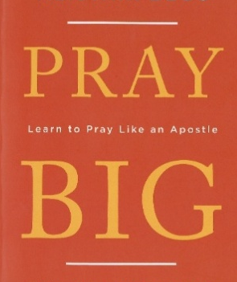

PRAY BIG!
Beginning on April 20, our Monday morning Bible study will begin a four-week study of the Apostle Paul’s prayers. All are welcome! Come and join us at 9:30 a.m., at the church!

There will be a Celebration of Life Service for Lester Hooley, husband of Eva
Hooley, on Thursday, April 30, at Yoder-Culp Funeral Home. Visitation will be at
10:00 a.m. and the service will be at 11:00 a.m.

VOLUNTEERS – Thank you for your service! Sunday morning, April 19
Greeters: Chuck & Carol Rink VIP: Loraine Troyer
Elevator Hosts: Dan & Kathy Seltenright
Ushers: Gary Miller, Patty Krebs, Jeff Showalter, Ron Troyer, Hudson Martin
Scripture Reader: Dar Dechant
Elementary Junior Church: Pat Huber, Karen Andrews, Dar Dechant
Junior High Church: Beth Pettit
Coffee Hour: Steve & Beth Pettit
Bus Driver: Al Eppert

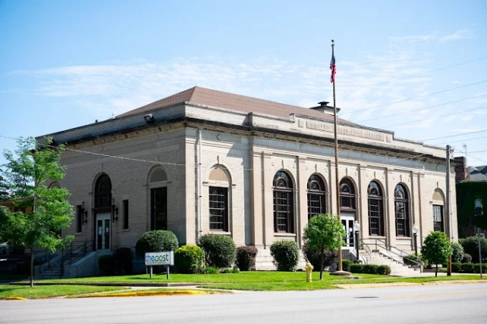
Our Mission of the Month for April -
“The Post.”
The Post is a Christ-centered non-profit youth center located in the historic old post office at 301 E. Lincoln Avenue in Goshen. The Post is open to 6th – 12th graders, Monday through Friday, from after school until 9pm. They provide a safe, positive space for teens to gather. The Post has programs with a curriculum designed to point teens toward finding their identity in Christ, as well as equip them with skills that they can use in everyday life. Programs include: I Am Second/Bible Study, Smart Goals, Life Skills, and Friday open gym and outings. Our church has supported The Post for the past five years through our April mission giving and by providing a meal on the 2nd Thursday of each month. For further information regarding The Post, check out www.the-post.org or contact Linda Russell, JDLR801@gmail.com or 574-238-2084. Thanks for supporting The Post!

He Just Had A Big Heart
My family clan has a special day which is, was, and always will be the holiday of holidays for us. On this day the Faithful gather from across this great land to celebrate the festival that yields a time of food, friends, family and frantic cheering. For the first 30 years of my life, I spent every first Saturday in May with my extended family just outside of Louisville, Kentucky. We would all gather to watch the greatest race – The Run for the Roses. I remember the Saturday I fell in love with the Kentucky Derby. On May 5th , 1973 I witnessed, on a small black and white TV screen in the basement of my Uncle Jack’s home, history as Secretariat won the Derby. Not only did he win but he did two incredible things. First, Secretariat set a new track record which still stands on the world’s most famous track – Church Hill Downs. Second, Secretariat was the first horse in history to run each quarter-of-a-mile faster than the previous one. One sports writer wrote, “Secretariat kept increasing his power like a locomotive and finished the race like a fighter jet. On that Saturday in May everyone took notice of him. Secretariat then went on to claim The Preakness Stakes (setting another track record), and then granddaddy of them all, The Belmont States. There Secretariat set the WORLD record which still stands to this day for 1½ mile race, winning by an amazing 31+ horse lengths. He became the first Triple Crown winner in over 25 years to be crowned. Secretariat lived to be 19 years old before he died by an incurable hoof infection. Traditionally famous horses are buried with only their head, leads and heart, but Secretariat was honored with the ultimate horse burial honor of being buried whole. But before his burial his owners had a veterinarian do an autopsy to discover if there was anything unique about this thundering thoroughbred. What was discovered is simply amazing. You see the normal thoroughbred’s heart size of a racehorse weigh about 8½ pounds. Secretariat’s heart, though he was in perfect physical condition, weighed an incredible 21 pounds. That’s over two and half times bigger than the average thoroughbred’s heart! As we have celebrated Jesus’ rising from the dead, victory at the Cross and over our sins, let us remember that we worship a God whose heart is the most Loving and Merciful that the world has ever experienced. For God Loves You! He has shattered every record to win your heart. He holds the world record in number of Saves that He has delivered billions to the throne room of heaven. And He desires to run the race, the eternal race, with you and help you finish strong in
Connecting Others to Jesus Christ. Remember God is Good and that He loves you because He has the biggest heart for you. God Is Good! ATT!
-Pastor Jeff

