Parkside Lutheran Church
Rediscovering the Radical Love of Jesus
Gathering All
Serving All
Caring For All



May 10th, 2026
Sixth Sunday of Easter
Holy Communion 10:00am
Rev. Jeremiah Smith

Parkside Lutheran Values

Proclaiming Grace - Jesus shared and lived out a message of grace, love, and new life. We believe these promises come from God freely, as a gift for all. We are loved and the Spirit inspires us to share this good news in accessible, relevant, and new ways. Luke 4:17-19, John 1:16-17, John 3:16-17, Ephesians 2:8-9

Practicing Hospitality – Jesus welcomed the little children, broke bread with outcasts, and proclaimed the Good News to all. Whether you are strong in faith, wrestling with doubt, or somewhere in between, we affirm that you are welcome here. Jesus is for everyone. Leviticus 19:34, Matthew 9:10, Matthew 19:14, Hebrews 13:2

Loving Boldly - Jesus challenged traditions to demonstrate God’s justice and love of neighbor. His compassionate and sacrificial love inspires us to take risks. Striving to follow his command to love neighbor, our ministries serve, transform, and advocate for folks near and far. Micah 6:8, Mark 11:15-17, Luke 10:25-28, John 15:12-13

Cultivating Community - Jesus built communities that transformed lives. We are the body of Christ and we are called to continue this ministry of transformation. Guided by the Holy Spirit, we build connections within and outside of these walls, and with all of God’s creation. Ecclesiastes 4:9-12, Matthew 28:16-20, 1 Corinthians 12:12-14, Galatians 3:26-29

Welcome Visitors!
Please use QR code to let us know you were here today or to sign up for our weekly enewsletter. Find us on Facebook & Instagram
WIFI: Balcony password: FreeGrace

For your safety in the event of an emergency: In addition to the three exits in the back of the sanctuary, there are exits on either side of the altar (on left side: floor level near piano and up steps past altar. On right side: up steps to the altar, past band area)

Contact us: (716) 836-1361
2 Wallace Ave. Buffalo, NY 14214
parksidelutheran.org | parksidelutheran@gmail.com

GATHER
The Holy Spirit calls us together as the people of God.

Introduction to the Day: Jesus does not abandon his followers. Through the Holy Spirit, Jesus comes to abide with his disciples of every generation. As Pentecost draws near, we are reminded that the risen Christ dwells in us as the Spirit of truth. We receive this Spirit in baptism and pray that in our gathering around the Lord’s table the Spirit will transform us to be the body of the risen Christ in the world.

Prelude Michael Hooker, Music Director

Call to Worship Please stand as you are able
WA: We gather together in the presence of God,
C: the Lord of heaven and earth:
WA: the Creator of our world and everything in it;
C: the One who gave us life and breath,
WA: the One who is never far away from any of us,
C: the One in whom we live and move and have our being.
All: Let’s worship God together!

+Gathering Hymn: Come Thou, Almighty King ELW #408
Welcome and Announcements

Thanksgiving for Baptism
P: Alleluia! Christ is risen.
C: Christ is risen indeed. Alleluia!
P: Salvation belongs to our God who is seated on the throne and to the Lamb!
C: Amen.
P: Let us give thanks for the gifts of baptism.
Water may be poured into the font as the presiding minister continues.
P: Merciful God, you are the one who was, who is, and who is to come. You lead us beside still waters. We thank you for the waters of creation: morning dew, gentle rain, roaring waves. We thank you for the waters that nourish us.
Blessed are you.
C: You guide us to springs of the water of life.
P: Jesus Christ, you are the faithful witness who accompanies us on our journeys.
We give you thanks for your life-giving death and resurrection. We praise you for joining us in joy and sorrow. Blessed are you.
C: You guide us to springs of the water of life.
P: Holy Spirit, you anoint our head with oil and our cup overflows. Break down barriers that divide us. Fill us with the breath of peace. Blessed are you.
C: You guide us to springs of the water of life.
P: Holy One, we thank you for the gifts and grace of baptism, and for making us a new creation. We join with saints and angels, giving you honor and praise,
now and forever.
C: Amen.

Greeting

WA: The grace of our Lord, Jesus Christ, the love of God, and the communion of the Holy Spirit be with you all. C: And also with you.

Canticle of Praise ELW p. 149
(printed next page)

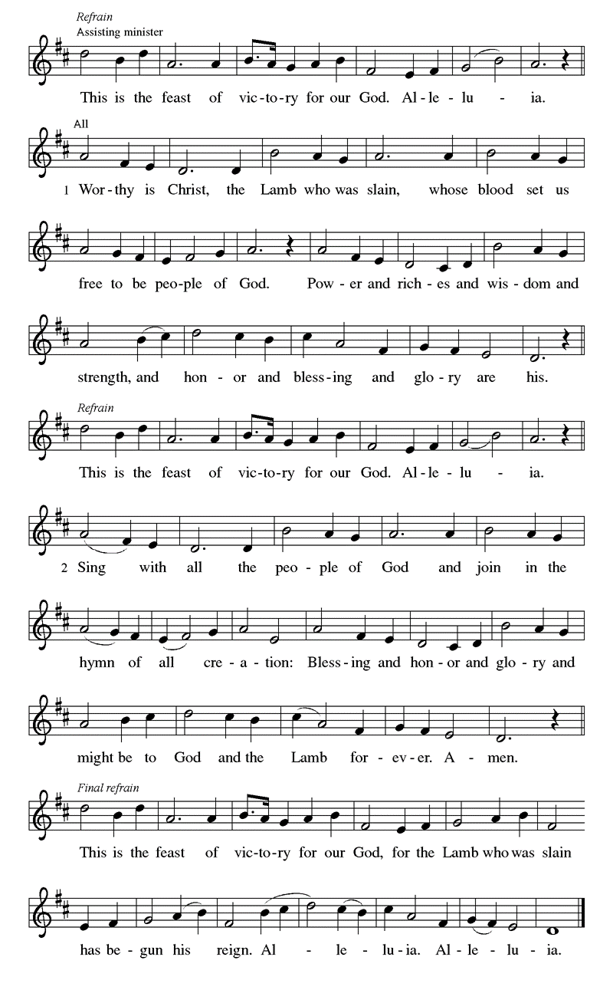
Prayer of the Day
WA: Let us pray together.
C: Almighty and ever-living God, you hold together all things in heaven and on earth. In your great mercy receive the prayers of all your children, and give to all the world the Spirit of your truth and peace, through Jesus Christ, our Savior and Lord, who lives and reigns with you and the Holy Spirit, one God, now and forever. Amen

Children’s Sermon: Jesus said, “Let the little children come to me!”
We welcome children in worship.

WORD
God speaks to us in scripture readings, preaching and song.

First Reading: Acts 17:22-31 In Athens, Paul faces the challenge of proclaiming the gospel to Greeks who know nothing of either Jewish or Christian tradition. He proclaims that the “unknown god” whom they worship is the true Lord of heaven and earth who will judge the world with justice through Jesus, whom God has raised from the dead. ²² Paul stood in front of the Areopagus and said, “Athenians, I see how extremely spiritual you are in every way. ²³ For as I went through the city and looked carefully at the objects of your worship, I found among them an altar with the inscription, ‘To an unknown god.’ What therefore you worship as unknown, this I proclaim to you. ²⁴ The God who made the world and everything in it, he who is Lord of heaven and earth, does not live in shrines made by human hands, ²⁵ nor is he served by human hands, as though he needed anything, since he himself gives to all mortals life and breath and all things. ²⁶ From one ancestor he made all peoples to inhabit the whole earth, and he allotted the times of their existence and the boundaries of the places where they would live, ²⁷ so that they would search for God and perhaps fumble about for him and find him—though indeed he is not far from each one of us. ²⁸ For ‘In him we live and move and have our being’; as even some of your own poets have said,
‘For we, too, are his offspring.’
²⁹ “Since we are God’s offspring, we ought not to think that the deity is like gold or silver or stone, an image formed by the art and imagination of mortals. ³⁰ While God has overlooked the times of human ignorance, now he commands all people everywhere to repent, ³¹ because he has fixed a day on which he will have the world judged in righteousness by a man whom he has appointed, and of this he has given assurance to all by raising him from the dead.” L: Word of God, word of life. C: Thanks be to God.

Second Reading: 1 Peter 3:13-22
The author of 1 Peter encourages Christians to remain faithful even in the face of defamation and persecution. In baptism we are made clean to act in accordance with what is right.
L: ¹³ Now who will harm you if you are eager to do what is good? ¹⁴ But even if you do suffer for doing what is right, you are blessed. Do not fear what they fear, and do not be intimidated, ¹⁵ but in your hearts sanctify Christ as Lord. Always be ready to make your defense to anyone who demands from you an accounting for the hope that is in you, ¹⁶ yet do it with gentleness and respect. Maintain a good conscience so that, when you are maligned, those who abuse you for your good conduct in Christ may be put to shame. ¹⁷ For it is better to suffer for doing good, if suffering should be God’s will, than to suffer for doing evil. ¹⁸ For Christ also suffered for sins once for all, the righteous for the unrighteous, in order to bring you to God. He was put to death in the flesh but made alive in the spirit, ¹⁹ in which also he went and made a proclamation to the spirits in prison, ²⁰ who in former times did not obey, when God waited patiently in the days of Noah, during the building of the ark, in which a few, that is, eight lives, were saved through water. ²¹ And baptism, which this prefigured, now saves you—not as a removal of dirt from the body but as an appeal to God for a good conscience, through the resurrection of Jesus Christ, ²² who has gone into heaven and is at the right hand of God, with angels, authorities, and powers made subject to him.
L: Word of God, word of life. C: Thanks be to God

Please stand as you are able

Gospel Acclamation ELW #174
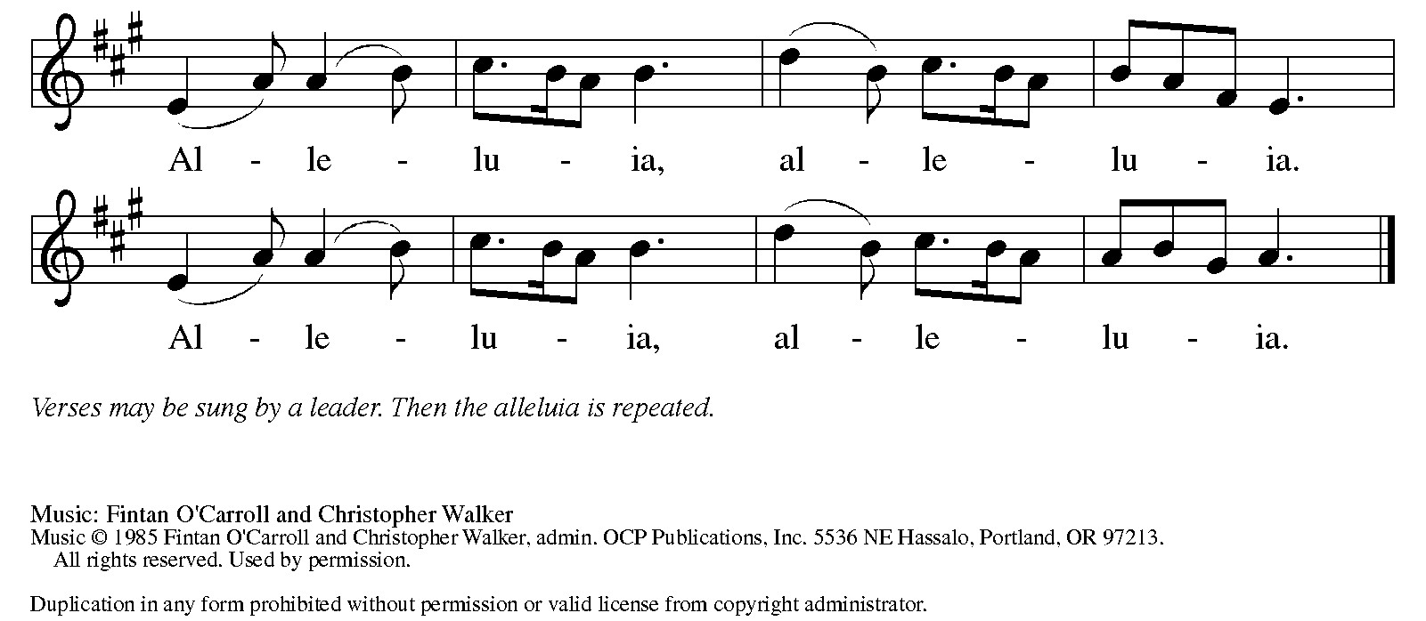

Gospel Reading: John 14:15-21
In final words to his disciples on the night of his arrest, Jesus encourages obedience to his commandments and speaks of the Spirit, who will be with them forever.

P: The Holy Gospel according to John. C: Glory to you, O Lord.
P: [Jesus said to the disciples:] ¹⁵ “If you love me, you will keep my commandments. ¹⁶ And I will ask the Father, and he will give you another Advocate, to be with you forever. ¹⁷ This is the Spirit of truth, whom the world cannot receive because it neither sees him nor knows him. You know him because he abides with you, and he will be in you.
¹⁸ “I will not leave you orphaned; I am coming to you. ¹⁹ In a little while the world will no longer see me, but you will see me; because I live, you also will live. ²⁰ On that day you will know that I am in my Father, and you in me, and I in you. ²¹ They who have my commandments and keep them are those who love me, and those who love me will be loved by my Father, and I will love them and reveal myself to them.”
P: The Gospel of the Lord. C: Praise to you, O Christ.

Psalm: Psalm 66:8-20 Bless our God, you peoples; let the sound of praise be heard. (Ps 66:8)
L: ⁸ Bless our God, you peoples; let the sound of praise be heard.
C: ⁹ Our God has kept us among the living
and has not allowed our feet to slip.
L: ¹⁰ For you, O God, have tested us;
you have tried us just as silver is tried.
C: ¹¹ You brought us into the net;
you laid heavy burdens upon our backs.
L: ¹² You let people ride over our heads; we went through fire and water,
but you brought us out into a place of refreshment.
C: ¹³ I will enter your house with burnt offerings
and will pay you my vows—
L: ¹⁴ those that I promised with my lips
and spoke with my mouth when I was in trouble.
C: ¹⁵ I will offer you burnt offerings of fatlings with the smoke of rams;
I will give you oxen and goats.
L: ¹⁶ Come and listen, all you who believe,
and I will tell you what God has done for me.
C: ¹⁷ I called out to God with my mouth,
and praised the Lord with my tongue.
L: ¹⁸ If I had cherished evil in my heart,
the Lord would not have heard me;
C: ¹⁹ but in truth God has heard me
and has attended to the sound of my prayer.
L: ²⁰ Blessed be God, who has not rejected my prayer,
nor withheld unfailing love from me.

Sermon Rev. Jeremiah Smith

Please stand as you are able

+Hymn of the Day: Blessed Assurance ELW #638
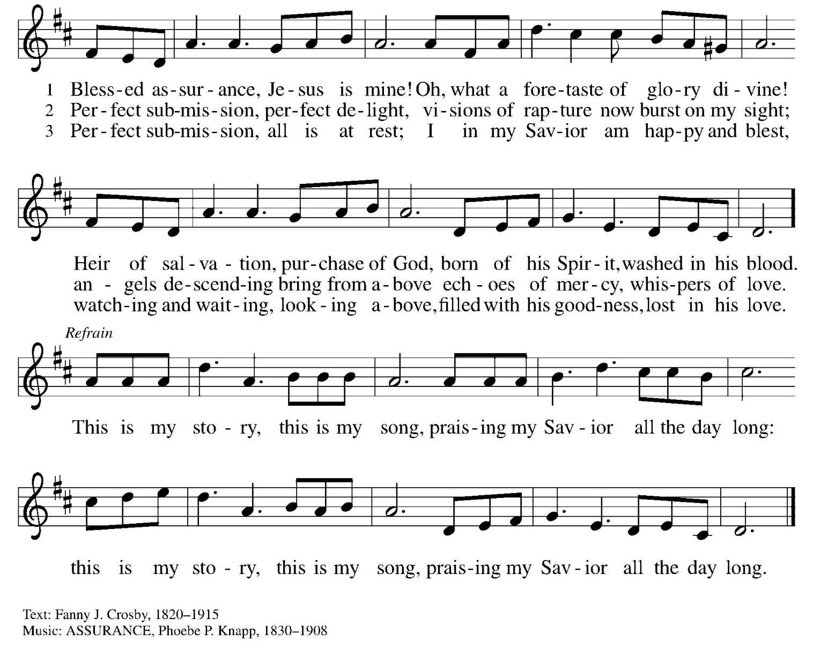

Nicene Creed WA: Let us confess the faith using the words of the Nicene Creed.
C: We believe in one God, the Father, the Almighty, maker of heaven and earth, of all that is, seen and unseen.
We believe in one Lord, Jesus Christ, the only Son of God, eternally begotten of the Father, God from God, Light from Light,
true God from true God, begotten, not made, of one Being with the Father; through him all things were made. For us and for our salvation he came down from heaven, was incarnate of the Holy Spirit and the virgin Mary and became truly human. For our sake he was crucified under Pontius Pilate; he suffered death and was buried. On the third day he rose again in accordance with the scriptures; he ascended into heaven and is seated at the right hand of the Father. He will come again in glory to judge the living and the dead, and his kingdom will have no end.
We believe in the Holy Spirit, the Lord, the giver of life, who proceeds from the Father and the Son, who with the Father and the Son is worshiped and glorified, who has spoken through the prophets. We believe in one holy catholic and apostolic church. We acknowledge one baptism for the forgiveness of sins. We look for the resurrection of the dead, and the life of the world to come. Amen.

Prayers of the People WA: Trusting in the power of Christ’s resurrection to heal and redeem our broken world, let us pray for the needs of all creation. (a brief silence)
WA: God of new life, you call us through the waters of baptism to be in relationship with you and one another. Guide the church and its leaders to proclaim Christ’s righteousness throughout the world. Merciful God, C: receive our prayer.
WA: You set civil servants in the places where we live. Instill truth and equity among judges and lawyers, gentleness and courage among first responders, and peace among leaders of towns and nations. Merciful God, C: receive our prayer.
WA: You provide comfort in times of trouble. Heal those who ae sick, shelter any who are unhoused, feed those undernourished, and accompany and console all who are lonely bereaved, anxious, or ill. We pray especially for those we name aloud or in the silence of our hearts…. Merciful God, C: receive our prayer.

WA: You are love and you desire that we love one another. As a mother hen cares for her chicks, bless all who provide motherly care in our lives, and inspire us to care for one another. Merciful God, C: receive our prayer.

WA: God of new life, your steadfast love endures forever. Inspire us by the example of the faithful departed, who clung to your promises of life, forgiveness of sins, and salvation. Merciful God, C: receive our prayer.

WA: God of resurrection power, use us and these prayers to proclaim the good news of new life to all the world, through Jesus Christ, our risen Savior. C: Amen.

Peace
P: The peace of Christ be with you always. C: And also with you.
Meal - God feeds us with the presence of Jesus Christ

Offering
We are grateful to those who help sustain our mission. To donate online, please use QR code:


+ Offering Prayer
WA: Let us pray together:
C: Merciful God, accept the fruits of our labor, gathered to give you glory. You have set a table before us, a glimpse of that great day when we will hunger and thirst no more. Nourish us with the body and blood of Jesus, that goodness and mercy may follow us, and bless the world you love. In the name of Jesus. Amen.

+ Offertory Song
Praise God, from whom all blessings flow;
praise God, all creatures here below;
praise God above, ye heav’nly host;
praise Father, Son, and Holy Ghost. Amen.

Great Thanksgiving
P: The Lord be with you. C: And also with you.
P: Lift up your hearts. C: We lift them to the Lord.
P: Let us give thanks to the Lord our God.
C: It is right to give our thanks and praise.

Preface
P: It is indeed right, our duty and our joy, that we should at all times and in all places give thanks and praise to you, almighty and merciful God for the glorious resurrection of our Savior Jesus Christ, the true Paschal Lamb who gave himself to take way our sin, who in dying has destroyed death, and in rising has brought us to eternal life. And so, with Mary Magdalene and Peter and all the witnesses of the resurrection, with earth and sea and all their creatures, and with angels and archangels, cherubim and seraphim, we praise your name and join their unending hymn:

Holy Holy Holy ELw setting 4 (p. 153)
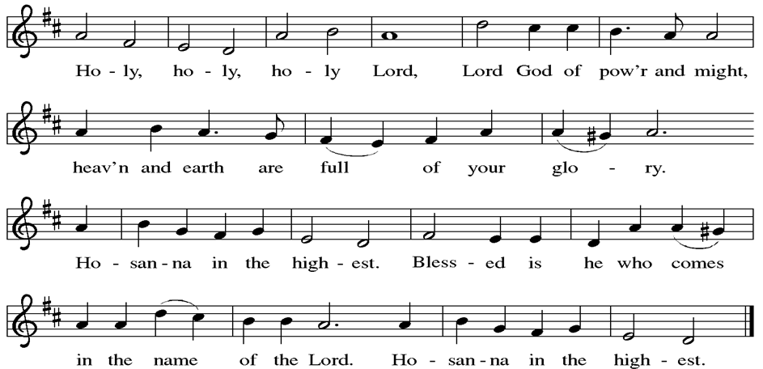

Thanksgiving at the Table

P: Blessed are you, O God of the universe. Your mercy is everlasting and your faithfulness endures from age to age.
Praise to you for creating the heavens and the earth. Praise to you for saving the earth from the waters of the flood. Praise to you for bringing the Israelites safely through the sea. Praise to you for leading your people through the wilderness to the land of milk and honey. Praise to you for the words and deeds of Jesus, your anointed one. Praise to you for the death and resurrection of Christ. Praise to you for your Spirit poured out on all nations.
In the night in which he was betrayed, our Lord Jesus took bread, and gave thanks; broke it, and gave it to his disciples, saying: Take and eat; this is my body, given for you. Do this for the remembrance of me. Again, after supper, he took the cup, gave thanks, and gave it for all to drink, saying: This cup is the new covenant in my blood, shed for you and for all people for the forgiveness of sin.
Do this for the remembrance of me.
With this bread and cup we remember our Lord’s passover from death to life
as we proclaim the mystery of faith:
C: Christ has died. Christ is risen. Christ will come again.
P: O God of resurrection and new life: Pour out your Holy Spirit on us
and on these gifts of bread and wine. Bless this feast. Grace our table with your presence.
C: Come, Holy Spirit.
P: Reveal yourself to us in the breaking of the bread. Raise us up as the body of Christ for the world. Breathe new life into us. Send us forth, burning with justice, peace, and love.
C: Come, Holy Spirit.
P: With your holy ones of all times and places, with the earth and all its creatures, with sun and moon and stars, we praise you, O God, blessed and holy Trinity, now and forever. C: Amen.

Lord’s Prayer
P: Lord, remember us in your kingdom and teach us to pray.
C: Our Father, who art in heaven, hallowed be thy name, thy kingdom come, thy will be done, on earth as it is in heaven. Give us this day our daily bread; and forgive us our trespasses, as we forgive those who trespass against us; and lead us not into temptation, but deliver us from evil. For thine is the kingdom, and the power, and the glory, forever and ever. Amen.

Invitation to the Table
At Parkside Lutheran Church we have an open table. We believe the invitation to receive comes from Jesus himself and all are welcome at Christ’s table. More than just Bread and Wine these are tangible signs of God’s love for you! If you do not wish to receive communion but would like a blessing, come forward and cross your arms over your chest. The Pastor will give you a blessing before you return to your seat via the side aisle. You’ll receive a communion wafer* in your hands. You may dip it in the cup of wine or juice. When giving the bread and cup, the communion ministers say: “The body of Christ, given for you. The blood of Christ, shed for you.”
and each person may respond : Amen
*Please let Pastor know if you need a gluten-free wafer
P: Come to the table of new life. Receive the risen Lord.

The Communion Distribution

Communion Song ELW setting 4 (p. 154)
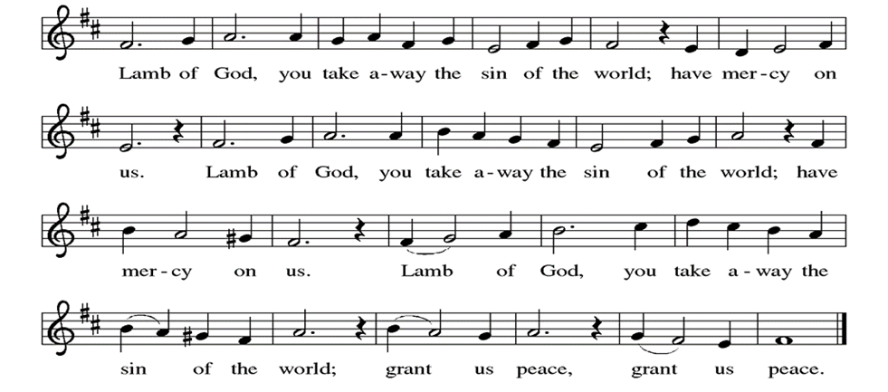

Communion Song: I am the Bread of Life ELW # 485
(printed next page)
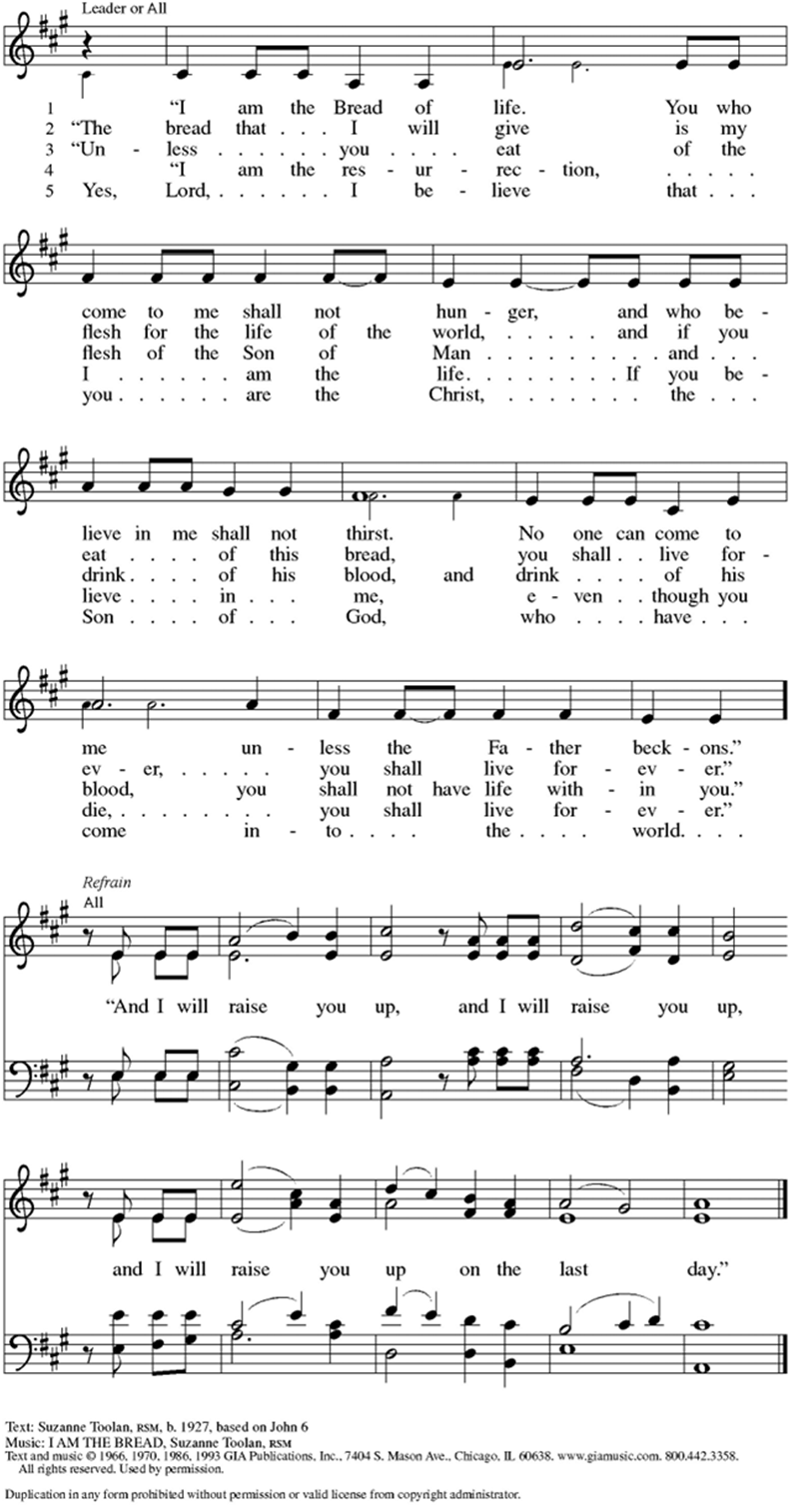
Communion Song: Sanctuary
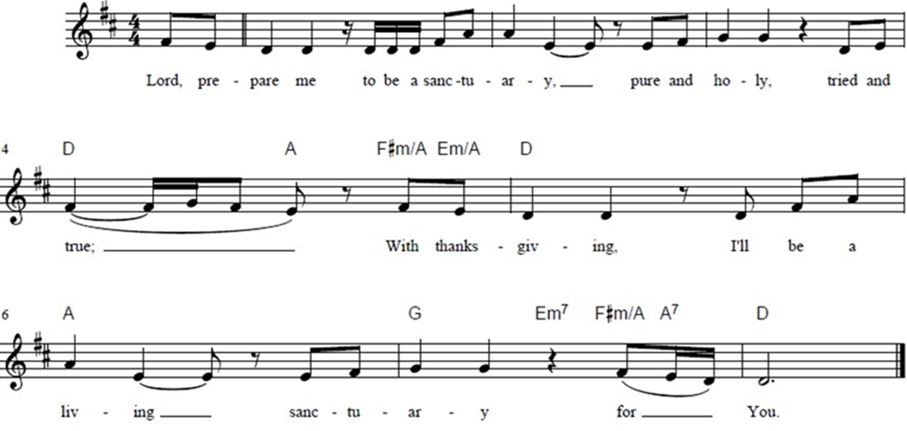

Post Communion Blessing
P: The Body and Blood of our Lord and Savior, Jesus Christ, strengthen you and keep you in God's grace. C: Amen.

Prayer After Communion
WA: Let us pray together.
C: Holy One, through this meal you have made your home among us and are making all things new. Send us now to speak peace to anxious hearts, to love our enemies, and to bring your healing to the nations. In the name of Jesus. Amen.

Sending - God blesses us and sends us in mission to the world.

Blessing
P: God Almighty, who is the beginning and the end, Jesus Christ, the firstborn of the dead, and the Spirit, our advocate and peace, + bless you now and forever. C: Amen

Sending Hymn: Alleluia! Sing to Jesus! ELW #392 (printed next page)

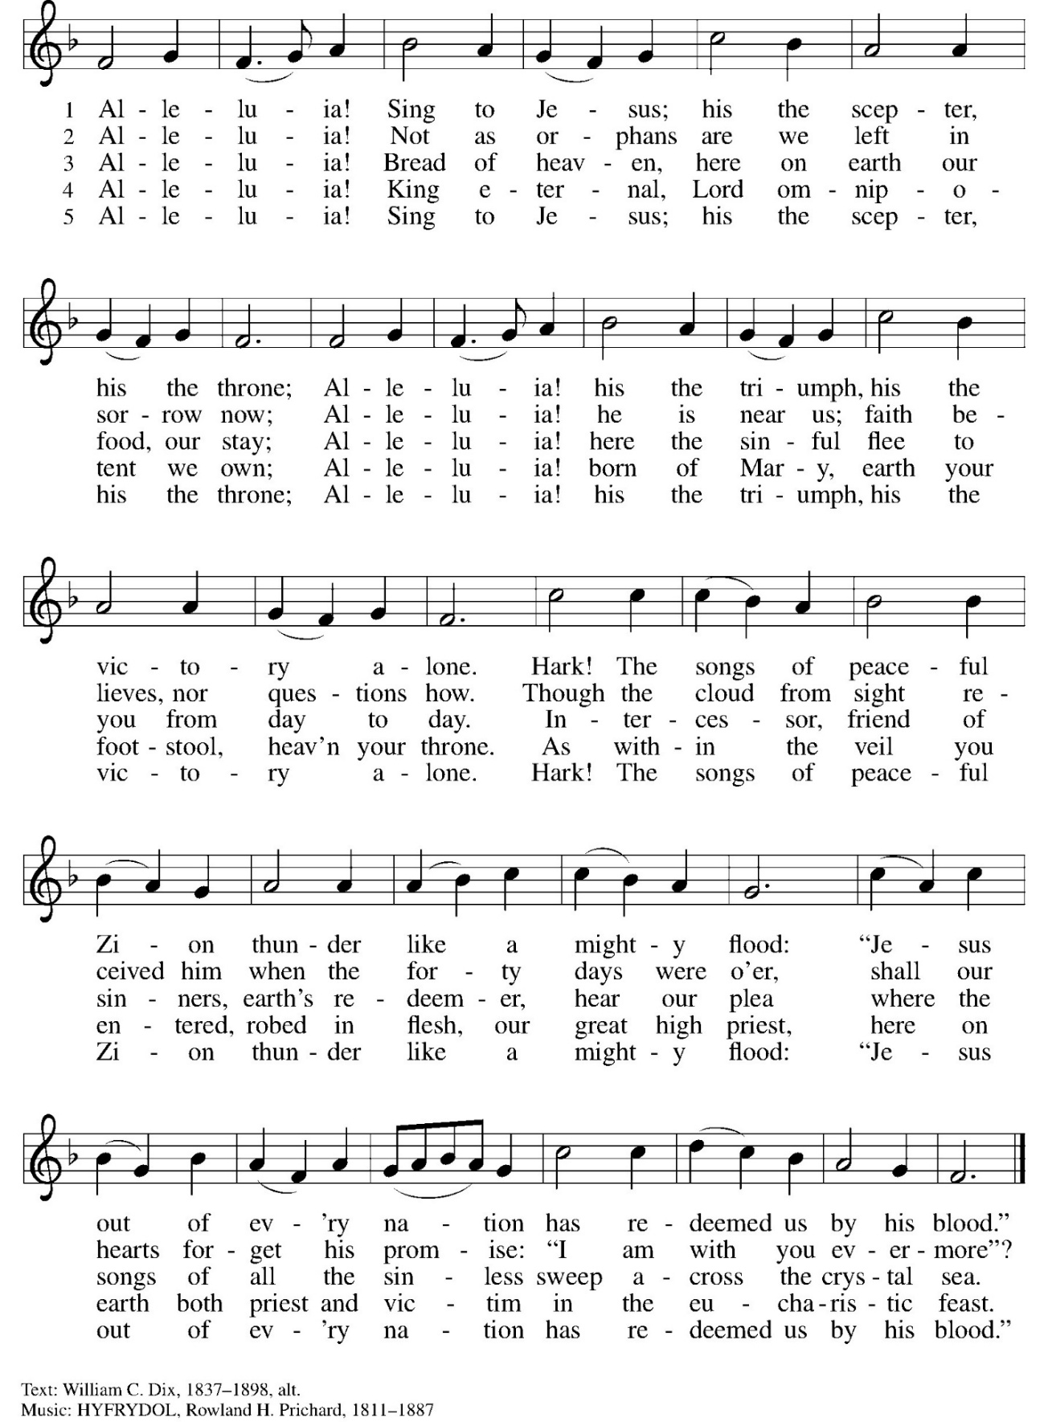
Dismissal and Postlude
P: Parkside Lutheran Church is rediscovering the radical love of Jesus.
C: Gathering All, Serving All, Caring for All
P: Go in peace. Praise the Lord. Alleluia!
C: Thanks be to God. Alleluia! Alleluia!

ELW Music licensed from Sundays & Seasons, Augsburg Fortress CCLI MUSIC License # 11440069 , CCLI Streaming License#21835523 Do not duplicate any music or Liturgy herein without license and permission
scripture readings adapted and written by susan lukey
PARKSIDE STAFF:
• The Rev. Jeremiah Smith: prjeremiahpsmith@gmail.com
• Kris Pope & Suzanne Gracie, Admin. Assistants (Church Office): parksidelutheran@gmail.com
• Mike Hooker, Music Director: mrhooker@me.com
CHURCH OFFICE HOURS: M/T/R 10:00am-3:00pm (716)836-1361

Acolytes: |  | Worship Assistants:
5/10 – David & Grace |  | 5/10 – John
5/17 – Katie & Chris |  | 5/17 – Onda
Readers: |  | Ushers:
5/10 - Kathie |  | 5/10 – Joanne, Kathy, Gary
5/17 – Sarah |  | 5/17 – Shannon, Rickey, Joanne

Coming up:
- ***TODAY! Parkside Apparel Orders are DUE!***
- May 17th – New Usher Training, after Worship
- May 17th – Volunteer Orientation & Package Assembly for Migrant Families, after Worship
- May 20th – Brewing Theology – 7pm at Chandler Street Brewing
- May 29th – Middle School Game Night in Stowell Lounge
- May 31st – Confirmation Sunday

Visit our website for more information about these and other Events at Parkside – www.parksidelutheran.org/events

BURRITO PROJECT DONATIONS ARE NEEDED!
Our funding for the Buffalo Burrito Project is running low and we need your help. Donations can be left in the collection plate (please label for Burrito Project) or via Tithely QR Code (select Burrito Project Fund) ~~>
Feed 10 people - $9.00
Feed 20 people - $18.00
Feed 50 people - $45.00
Feed 100 people - $90.00
Fund the Burrito Project for one month - $180
Fund the Burrito Project for one quarter - $540

