
A CELEBRATION OF WORSHIP
COMMUNION SUNDAY
May 3rd, 2026

GOD’S PEOPLE GATHER TOGETHER IN FELLOWSHIP
ANNOUNCEMENTS

RINGING OF THE HOUR
PRELUDE Thou Art Worthy TFWS 2041
The Light of Christ Enters

INVITATION
CONFESSION
Merciful God, we confess that we have not loved you with our whole heart. We have failed to be an obedient church.

We have not done your will, we have broken your law, we have rebelled
against your love, we have not loved our neighbors, and we have not heard the cry of the needy.

Forgive us, we pray. Free us for joyful obedience, through Jesus Christ our Lord. Amen.

PARDON
People to Leader:
In the name of Jesus Christ, you are forgiven
Leader to People:
Glory to God. Amen
+OPENING HYMN The Church’s One Foundation UMH 545
HOLY COMMUNION
Sharing of the Bread and the Cup
Let Us Break Bread

Special Music Rock of Ages WC Choir

Wesley Chapel
United Methodist Church

LIFE OF THE CONGREGATION
LORD’S PRAYER
Our Father, who art in heaven, hallowed be thy name. Thy kingdom come, thy will be done on earth as it is in heaven. Give us this day our daily bread. And forgive us our trespasses as we forgive those who trespass against us. And lead us not into temptation, but deliver us from evil. For thine is the kingdom, the power, and the glory forever. AMEN.

THE GIVING OF TITHES, OFFERINGS, AND OURSELVES
Offertory Anthem HE Filomena Shepperson

+Doxology
Praise God, from whom all blessings flow; praise him, all creatures here below; praise him above ye heavenly host; Praise Father, Son and Holy Ghost. AMEN.

PROCLAMATION AND RESPONSE

1Peter 2:7-10 The Living Stone and a Chosen People Pg 857-858

SERMON Now... The Building Blocks are in! Pastor Glenn Riggs
Response to the word
Lord, as we go from this place, walk with us. Give us renewed confidence in your will and transform our lives that we may serve you better. AMEN.

SENDING FORTH
WELCOME!

+CLOSING HYMN My Hope is Built on Nothing Less UMH 368

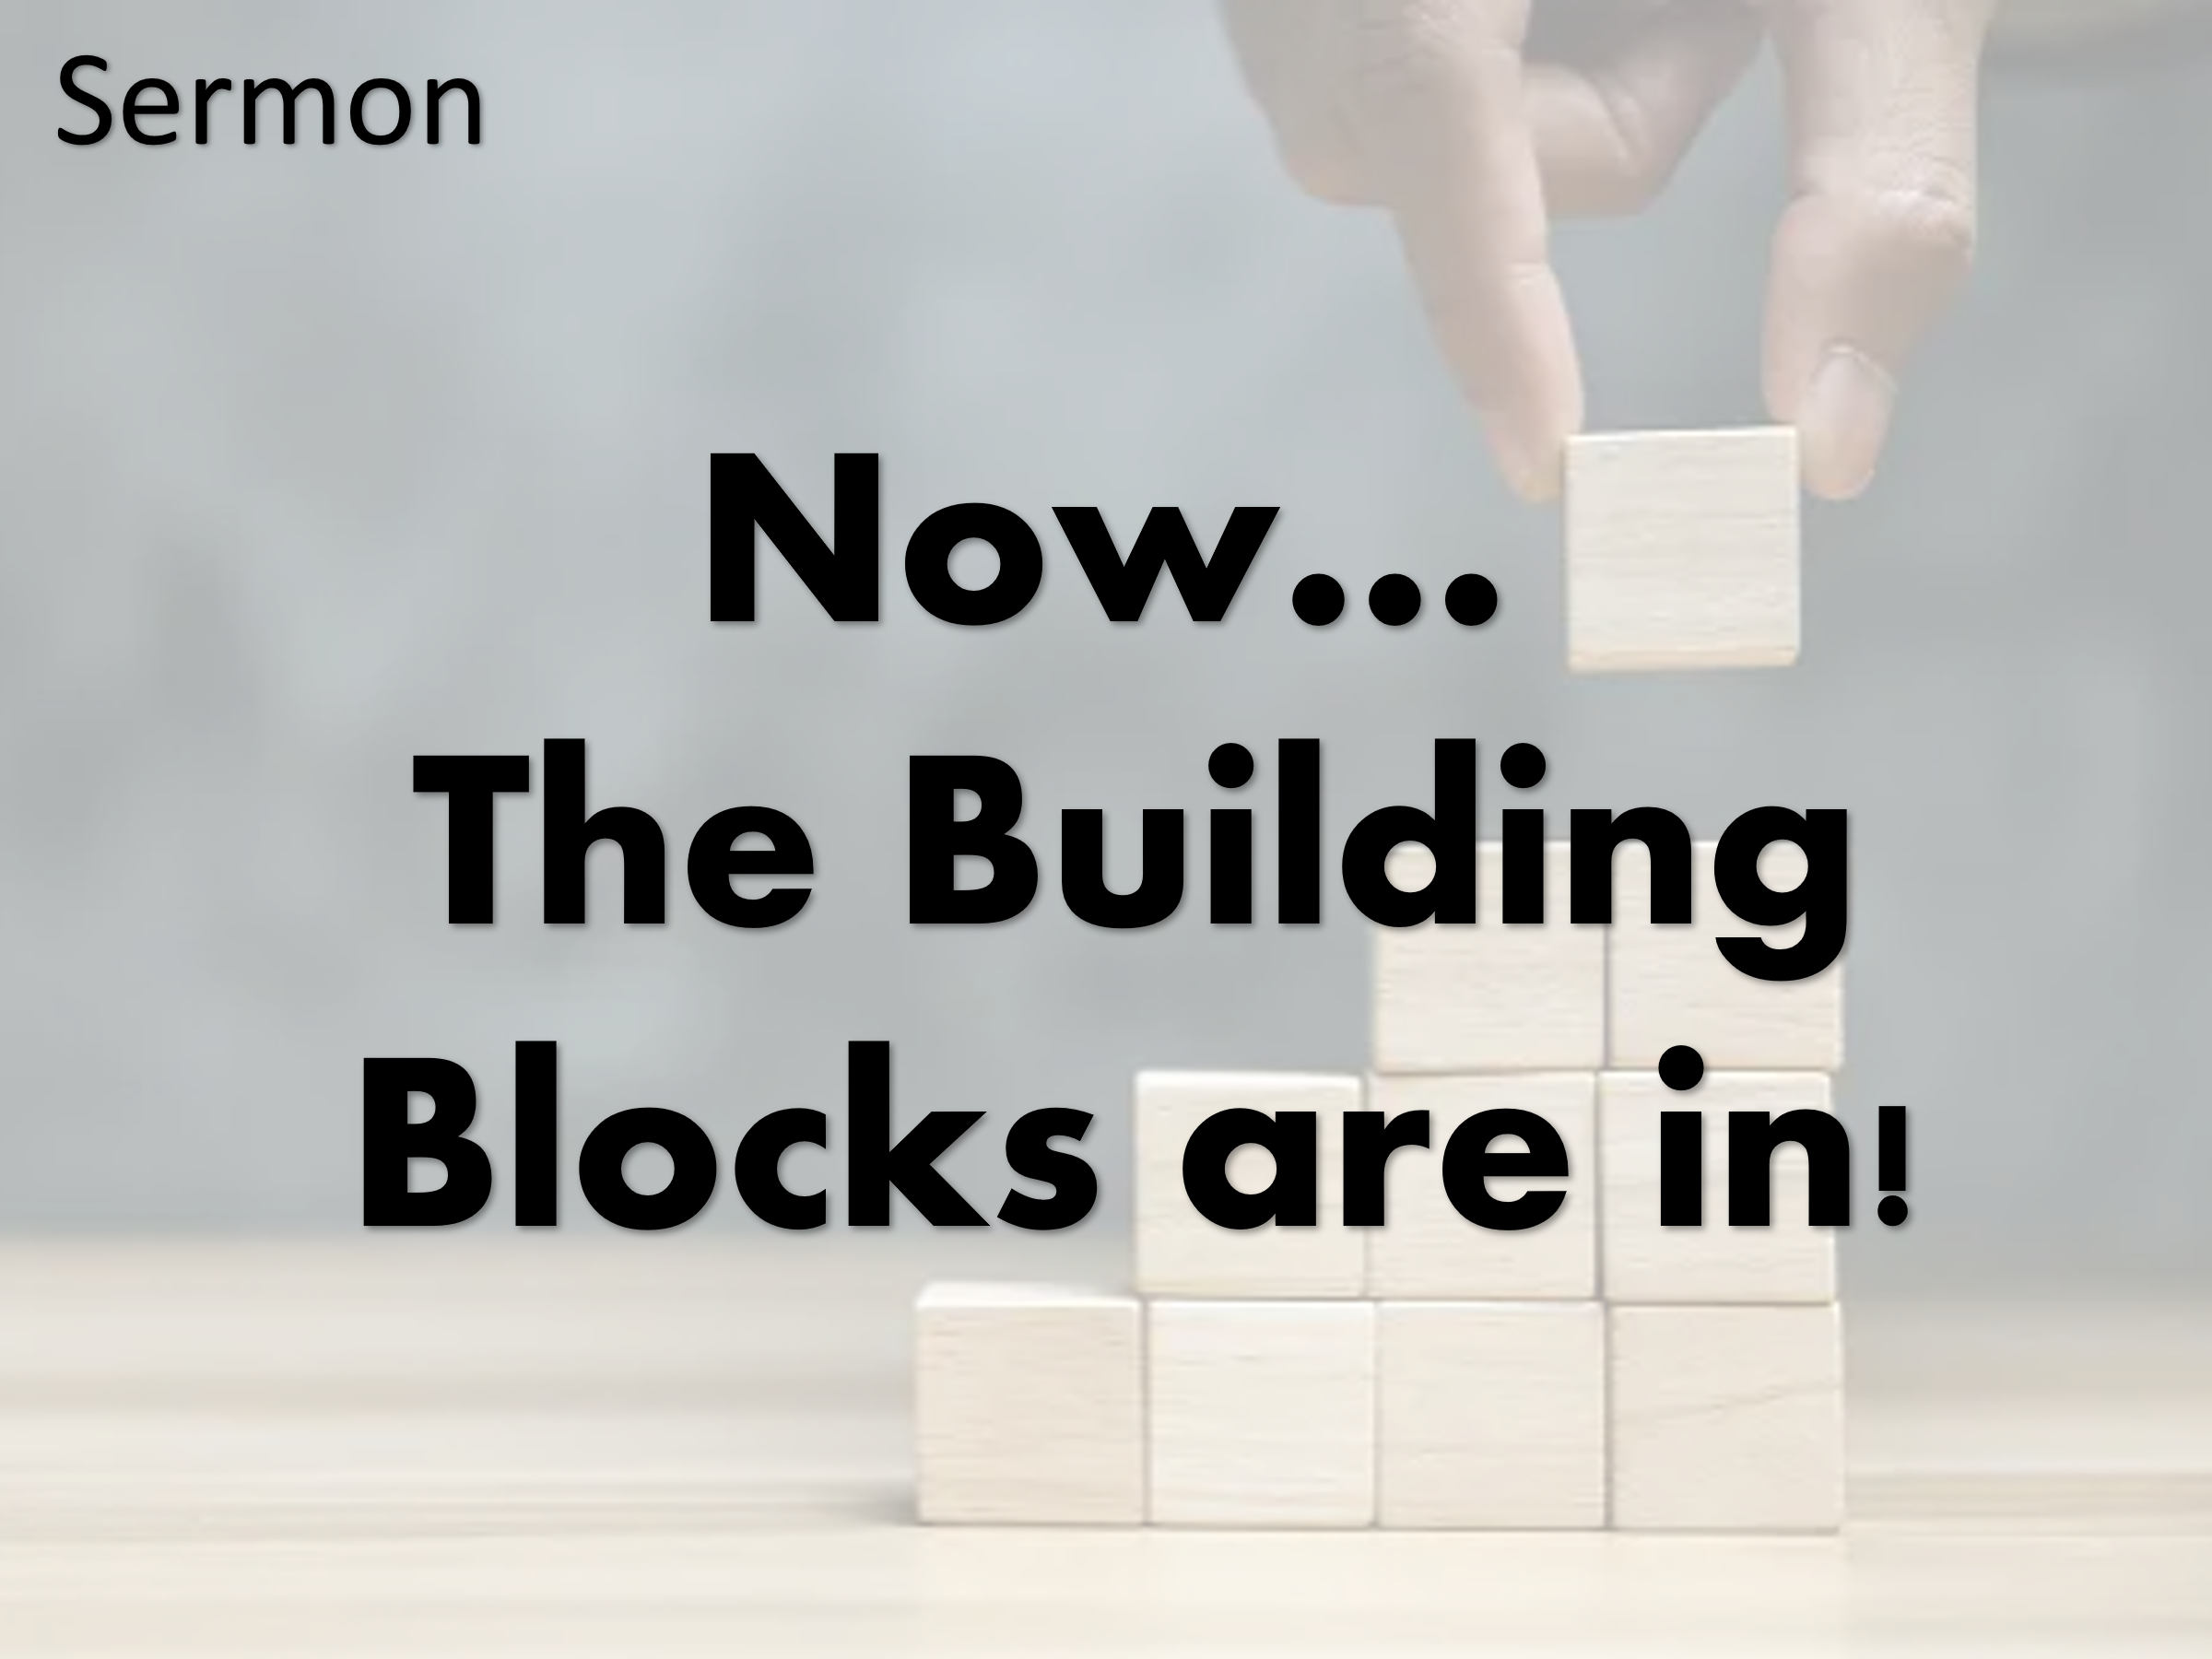
The Light of Christ returns to the world in you

POSTLUDE
+Please stand as you are able

Wesley Chapel United Methodist Church
9227 River Road
South Chesterfield, VA 23803
804-590-1837
Pastor Glenn Riggs
Sunday School - 8:45 a.m.
Wesley Chapel
Worship – 10:00 a.m.
Email: Wesleychapelumc.va@gmail.com
Website: wesleychapelumcva.org
Facebook: Wesley Chapel UMC – Matoaca, VA
United Methodist Church

Donate from your smartphone. Scan this image using your phone’s camera or QR app.

May 3rd, 2026

