Holy Trinity Lutheran Church
150 River Road Red Bank, NJ 07701
Church Office: (732) 741-9241 Fax: (732) 741-9577
email: holytrinitychurch4@verizon.net
Website: htlcredbank.org
Pastor: Rev. John Mack, Jr.
Cell: (336)-392-5839
Minister of Music: Peter Isherwood
Parish Administrator: Deanna Vergari
Council President: Cynthia Kazmac



May 3, 2026

Fifth Sunday of Easter

Introduction
As we continue to celebrate the fifty days of Easter, today’s gospel includes Jesus’ promise that he goes to prepare a place for his followers in his Father’s house. Our baptism commissions us to share Jesus’ mission in the world. As 1 Peter reminds us, we are a holy people, called to proclaim the one who called us out of darkness into light. In words and deeds we bear witness to the risen Christ—our way, our truth, our life.

Welcome & Announcements (Please remember to silence your cell phone!)

Prelude (We prayerfully prepare our hearts and minds to worship!)

+ GATHERING +

Thanksgiving for Baptism
All may make the sign of the cross, the sign that is marked at baptism, as the presiding minister begins.
P:Alleluia! Christ is risen.
C:Christ is risen indeed. Alleluia!
P:Salvation belongs to our God who is seated on the throne
and to the Lamb!
C:Amen.
P:Let us give thanks for the gifts of baptism.
Water may be poured into the font as the presiding minister continues.
P:Merciful God,
you are the one who was, who is, and who is to come.
You lead us beside still waters.
We thank you for the waters of creation:
morning dew, gentle rain, roaring waves.
We thank you for the waters that nourish us (local waters may be named).
Blessed are you.
C:You guide us to springs of the water of life.
P:Jesus Christ, you are the faithful witness
who accompanies us on our journeys.
We give you thanks for your life-giving death and resurrection.
We praise you for joining us in joy and sorrow.
Blessed are you.
C:You guide us to springs of the water of life.
P:Holy Spirit, you anoint our head with oil and our cup overflows.
Break down barriers that divide us.
Fill us with the breath of peace.
Blessed are you.
C:You guide us to springs of the water of life.
P:Holy One, we thank you for the gifts and grace of baptism,
and for making us a new creation.
We join with saints and angels, giving you honor and praise,
now and forever.
C:Amen.

*Gathering Hymn ELW 424 Ye Watchers and Ye Holy Ones
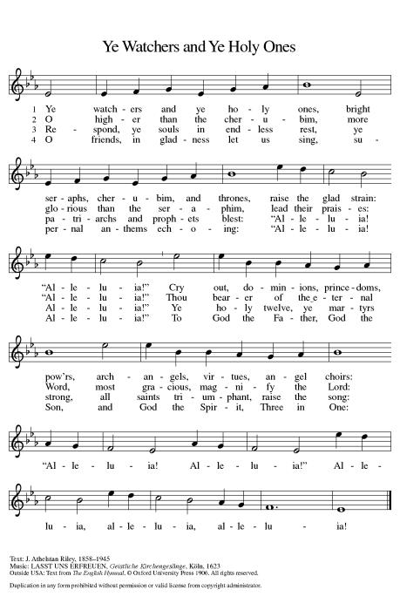

*Pastoral Greeting

P: The Grace of our Lord Jesus Christ, the love of God, and the communion of the Holy Spirit be with you all.

C: And also with you!

Hymn of Praise

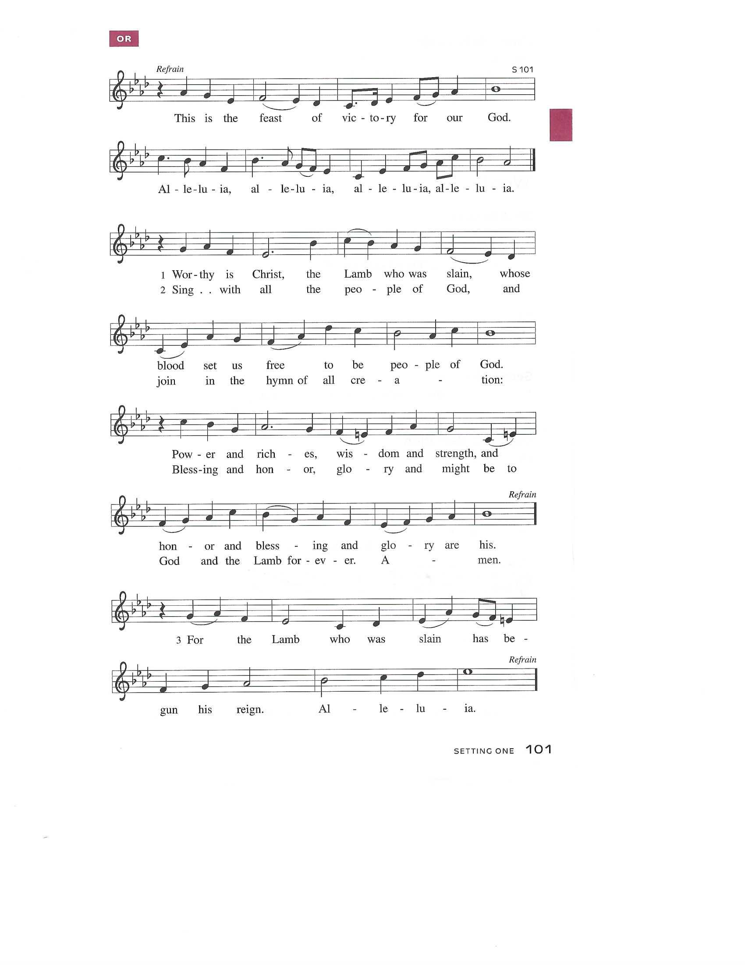

Prayer of the Day
P: Almighty God, your Son Jesus Christ is the way, the truth, and the life. Give us grace to love one another, to follow in the way of his commandments, and to share his risen life with all the world, for he lives and reigns with you and the Holy Spirit, one God, now and forever.
C: Amen!

+WORD+

First Reading: Acts 7:55-60
Stephen was one of the seven men chosen by the apostles to serve tables so that the apostles could be free to serve the word (Acts 6:1-6). Stephen does more than distribute food, however. For his preaching of God’s word, he becomes the first martyr of the faith.

⁵⁵ Filled with the Holy Spirit, [Stephen] gazed into heaven and saw the glory of God and Jesus standing at the right hand of God. ⁵⁶ “Look,” he said, “I see the heavens opened and the Son of Man standing at the right hand of God!” ⁵⁷ But they covered their ears, and with a loud shout all rushed together against him. ⁵⁸ Then they dragged him out of the city and began to stone him, and the witnesses laid their coats at the feet of a young man named Saul. ⁵⁹ While they were stoning Stephen, he prayed, “Lord Jesus, receive my spirit.” ⁶⁰ Then he knelt down and cried out in a loud voice, “Lord, do not hold this sin against them.” When he had said this, he died.

Psalm: Psalm 31:1-5, 15-16
Into your hands, O Lord, I commend my spirit. (Ps. 31:5)

¹ In you, O Lord, have I taken refuge; let me never be | put to shame;
deliver me | in your righteousness.
² Incline your | ear to me;
make haste to de- | liver me.
³ Be my strong rock, a castle to keep me safe, for you are my crag | and my stronghold;
for the sake of your name, lead | me and guide me.
⁴ Take me out of the net that they have secretly | set for me,
for you are my tow- | er of strength.
⁵ Into your hands I com- | mend my spirit,
for you have redeemed me, O Lord, | God of truth.
¹⁵ My times are | in your hand;
rescue me from the hand of my enemies, and from those who | persecute me.
¹⁶ Let your face shine up- | on your servant;
save me in your | steadfast love.”

Second Reading: 1 Peter 2:2-10
Christ is the cornerstone of God’s saving work and the foundation of our lives. We are God’s chosen, holy people who continuously celebrate and declare the mercy of God we experience through Jesus Christ.

² Like newborn infants, long for the pure, spiritual milk, so that by it you may grow into salvation ³ if indeed you have tasted that the Lord is good.
⁴ Come to him, a living stone, though rejected by mortals yet chosen and precious in God’s sight, and ⁵ like living stones let yourselves be built into a spiritual house, to be a holy priesthood, to offer spiritual sacrifices acceptable to God through Jesus Christ. ⁶ For it stands in scripture:
“See, I am laying in Zion a stone,
a cornerstone chosen and precious,
and whoever believes in him will not be put to shame.”
⁷ This honor, then, is for you who believe, but for those who do not believe,
“The stone that the builders rejected
has become the very head of the corner,”
⁸ and
“A stone that makes them stumble
and a rock that makes them fall.”
They stumble because they disobey the word, as they were destined to do.
⁹ But you are a chosen people, a royal priesthood, a holy nation, God’s own people, in order that you may proclaim the excellence of him who called you out of darkness into his marvelous light.
¹⁰ Once you were not a people,
but now you are God’s people;
once you had not received mercy,
but now you have received mercy.

*Gospel Acclamation
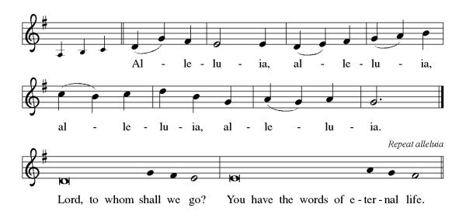

P: The Holy Gospel According to St. John 14th Chapter
C: Glory to You O Lord!

Gospel: John 14:1-14
On the night that he is to be arrested, Jesus shares final words with his disciples. As the one through whom God is known, he promises to go before them and act on their behalf.

[Jesus said to the disciples:] ¹ “Do not let your hearts be troubled. Believe in God; believe also in me. ² In my Father’s house there are many dwelling places. If it were not so, would I have told you that I go to prepare a place for you? ³ And if I go and prepare a place for you, I will come again and will take you to myself, so that where I am, there you may be also. ⁴ And you know the way to the place where I am going.” ⁵ Thomas said to him, “Lord, we do not know where you are going. How can we know the way?” ⁶ Jesus said to him, “I am the way and the truth and the life. No one comes to the Father except through me. ⁷ If you know me, you will know my Father also. From now on you do know him and have seen him.”
⁸ Philip said to him, “Lord, show us the Father, and we will be satisfied.” ⁹ Jesus said to him, “Have I been with you all this time, Philip, and you still do not know me? Whoever has seen me has seen the Father. How can you say, ‘Show us the Father’? ¹⁰ Do you not believe that I am in the Father and the Father is in me? The words that I say to you I do not speak on my own, but the Father who dwells in me does his works. ¹¹ Believe me that I am in the Father and the Father is in me, but if you do not, then believe because of the works themselves. ¹² Very truly, I tell you, the one who believes in me will also do the works that I do and, in fact, will do greater works than these, because I am going to the Father. ¹³ I will do whatever you ask in my name, so that the Father may be glorified in the Son. ¹⁴ If in my name you ask me for anything, I will do it.”

P: The Gospel of the Lord
C: Praise to you, O Christ!
Sermon
*Hymn of the Day HOF 56 Love Divine, All Loves Excelling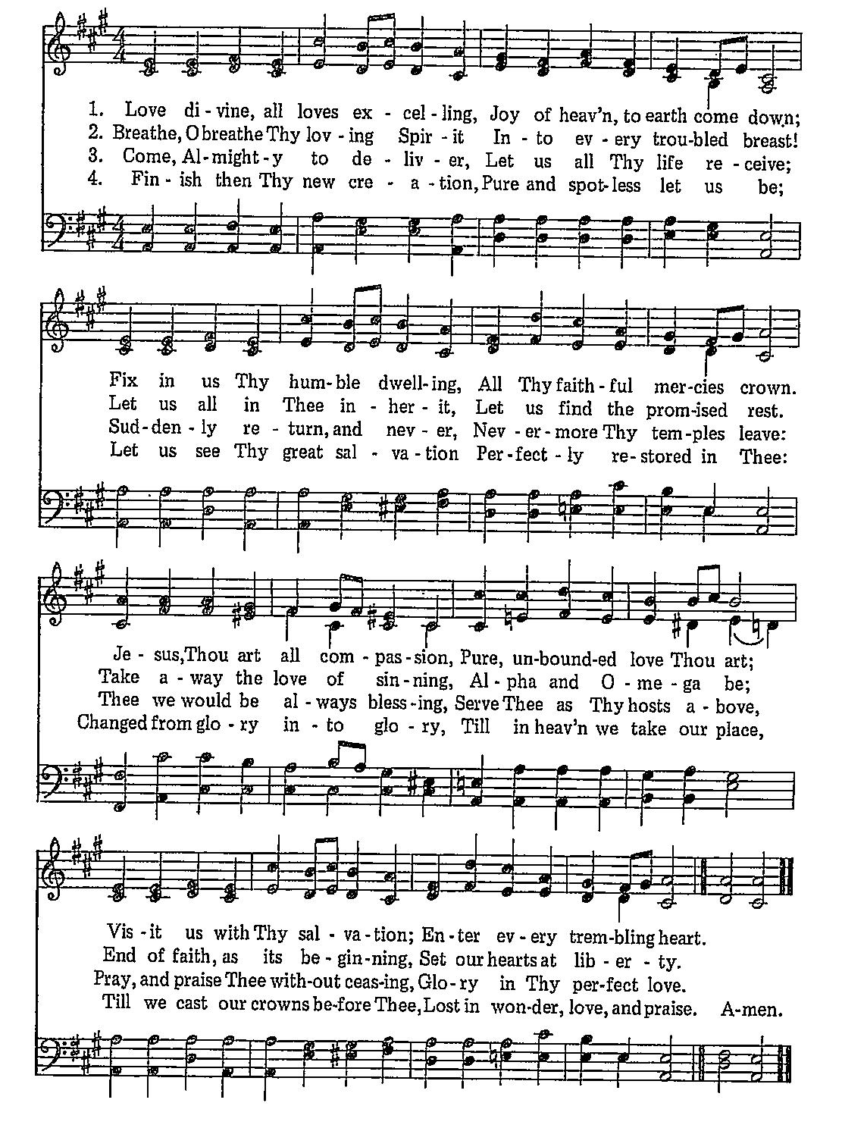

*Nicene Creed
We believe in one God,
the Father, the Almighty,
maker of heaven and earth,
of all that is, seen and unseen.
We believe in one Lord, Jesus Christ,
the only Son of God,
eternally begotten of the Father,
God from God, Light from Light,
true God from true God,
begotten, not made,
of one Being with the Father;
through him all things were made.
For us and for our salvation
he came down from heaven,
was incarnate of the Holy Spirit and the Virgin Mary
and became truly human.
For our sake he was crucified under Pontius Pilate;
he suffered death and was buried.
On the third day he rose again
in accordance with the Scriptures;
he ascended into heaven
and is seated at the right hand of the Father.
He will come again in glory to judge the living and the dead,
and his kingdom will have no end.
We believe in the Holy Spirit, the Lord, the giver of life,
who proceeds from the Father and the Son,
who with the Father and the Son is worshiped and glorified,
who has spoken through the prophets.
We believe in one holy catholic and apostolic church.
We acknowledge one baptism for the forgiveness of sins.
We look for the resurrection of the dead,
and the life of the world to come. Amen.

*Prayers of Intercession
Trusting in the power of Christ’s resurrection to heal and redeem our broken world, let us pray for the needs of all creation.
A brief silence.
God of glory, you have built your church on Christ the cornerstone. Inspire lay leaders, deacons, pastors, and bishops to proclaim forgiveness and your steadfast love to all whom they encounter. Merciful God,
C:receive our prayer.
God of majesty, you bring forth plants and animals, skies and seas, mountains and valleys. Protect all you have made from the ravages of pollution and climate disaster. Merciful God,
C:receive our prayer.
God of mercy, you intend governments and social service agencies to be instruments of peace and justice. Guide political leaders and organizations to be agents of compassion, and raise up advocates for those who seek refuge and assistance. Merciful God,
C:receive our prayer.
God of well-being, you soothe those in distress, console all who grieve, provide for any in need, and comfort those who are sick (especially). Instill caregivers with a sense of purpose to be your healing hands in this world. Merciful God,
C:receive our prayer.
God of community, you call us together as your people for mutual support and to witness to your love in the world. Make your presence known among those unable to attend worship today. Merciful God,
C:receive our prayer.
Here other intercessions may be offered.
God of eternal life, you have prepared dwelling places for your people, so that we are never separated from you. We give you thanks for the faithful departed who witnessed to your mighty acts in word and deed. Merciful God,
C:receive our prayer.
God of resurrection power, use us and these prayers to proclaim the good news of new life to all the world, through Jesus Christ, our risen Savior.
C: Amen.

Greeting of Peace
P: The peace of Christ be with you always!
C: And also with you!

Offering (Thank you for your support for our ministry!)

*Doxology ELW 384 v.4 That Easter Day with Joy Was Bright (Please stand and join in singing as we share our gifts!)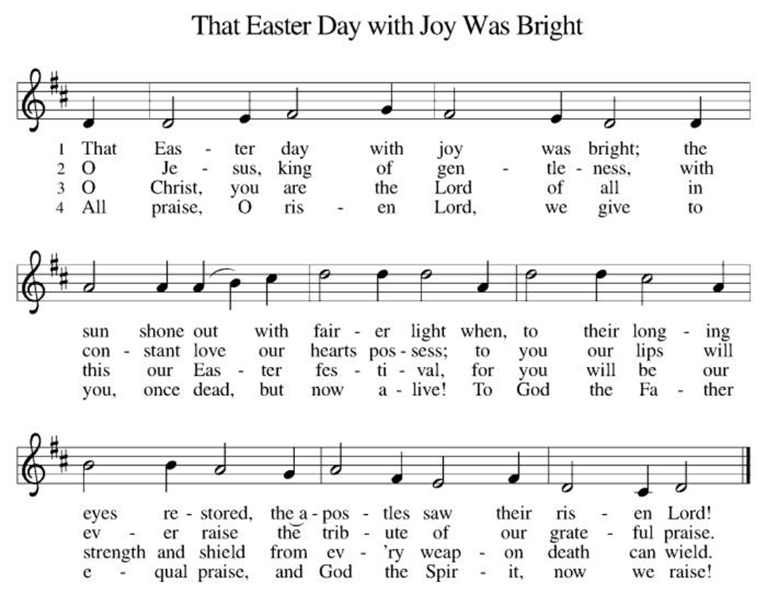

*Offering Prayer
A: Merciful God,
C: accept the fruits of our labor, gathered to give you glory.
You have set a table before us, a glimpse of that great day
when we will hunger and thirst no more.
Nourish us with the body and blood of Jesus,
that goodness and mercy may follow us
and bless the world you love.
In the name of Jesus,
Amen!

+MEAL+
*Great Thanksgiving
P: The Lord be with you.
C: And also with you.

P: Lift up your hearts.
C: We lift them to the Lord.

P: Let us give thanks to the Lord our God.
C: It is right to give our thanks and praise.

P: It is indeed right, our duty and our joy,
that we should at all times and in all places
give thanks and praise to you, almighty and merciful God,
for the glorious resurrection of our Savior Jesus Christ,
the true Paschal Lamb who gave himself to take away our sin;
who in dying has destroyed death,
and in rising has brought us to eternal life.
And so, with Mary Magdalene and Peter and all the witnesses of the resurrection, with earth and sea and all their creatures,
and with angels and archangels, cherubim and seraphim,
we praise your name and join their unending hymn:

*Sanctus
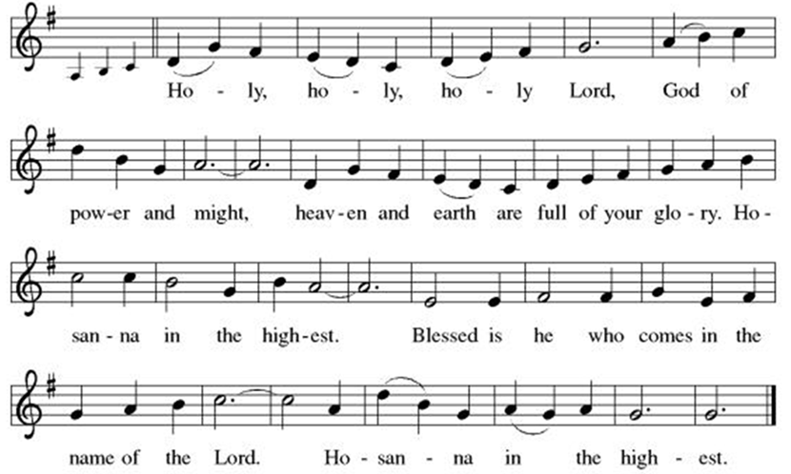

*Eucharistic Prayer
P: Holy, mighty, and merciful Lord,
heaven and earth are full of your glory.

In great love you sent to us Jesus, your Son,
who reached out to heal the sick and suffering,
who preached good news to the poor,
and who, on the cross, opened his arms to all.

In the night in which he was betrayed,
our Lord Jesus took bread, and gave thanks;
broke it, and gave it to his disciples, saying:
Take and eat; this is my body, given for you.
Do this for the remembrance of me.

Again, after supper, he took the cup, gave thanks,
and gave it for all to drink, saying:
This cup is the new covenant in my blood,
shed for you and for all people for the forgiveness of sin.
Do this for the remembrance of me.

Remembering, therefore, his death, resurrection, and ascension,
we await his coming in glory.

Pour out upon us the Spirit of your love, O Lord,
and unite the wills of all who share this heavenly food,
the body and blood of Jesus Christ, our Lord;
to whom, with you and the Holy Spirit,
be all honor and glory, now and forever.

C: Amen!

*THE LORD’S PRAYER
Our Father, who art in heaven,
hallowed be thy name,
thy kingdom come,
thy will be done,
on earth as it is in heaven.
Give us this day our daily bread;
and forgive us our trespasses,
as we forgive those
who trespass against us;
and lead us not into temptation,
but deliver us from evil.
For thine is the kingdom,
and the power, and the glory,
forever and ever. Amen.
*Lamb of God
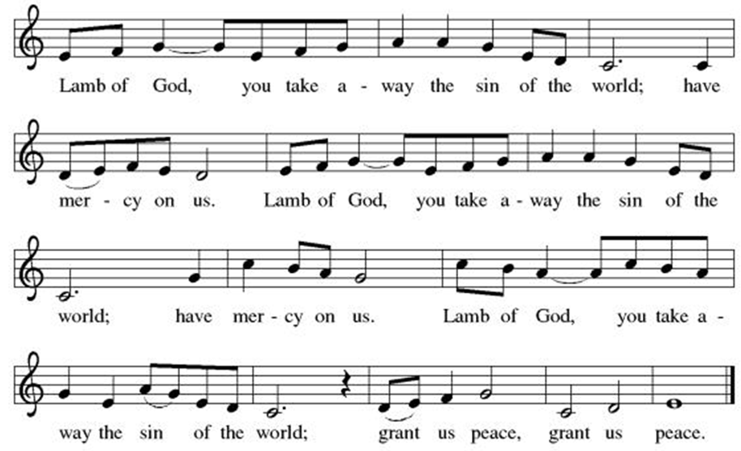

Spiritual Communion Prayer
P: Let us pray for the communion of all present here, those viewing our service virtually, those in our hearts and in our world.
C: Lord Jesus, I believe you are truly present in the Sacrament of Holy Communion. When I cannot receive Communion, I pray that you come into my heart. I know that nothing in Heaven or on earth can separate me from your love. Amen.

Invitation to Communion
P: Come to the table of new life.
Receive the risen Lord.

C: Thanks be to God!
(All are invited to the communion rail following the guidance of the ushers. Communion will be shared through the host and individual cups. If you would like communion but are unable to join us at the rail, please alert the usher!)
Communion Hymns (Please join in singing!)
ELW 482 I Come with Joy
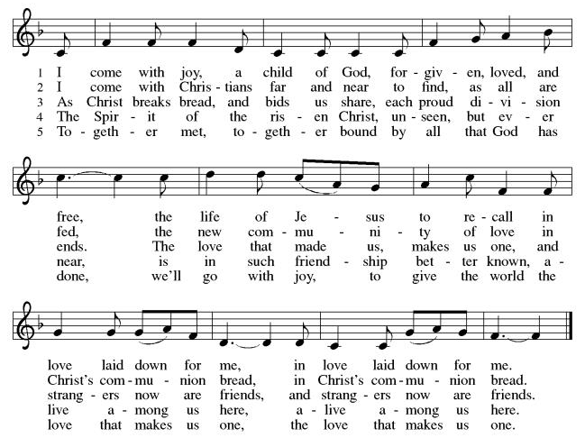

ELW 379 Now the Green Blade Rises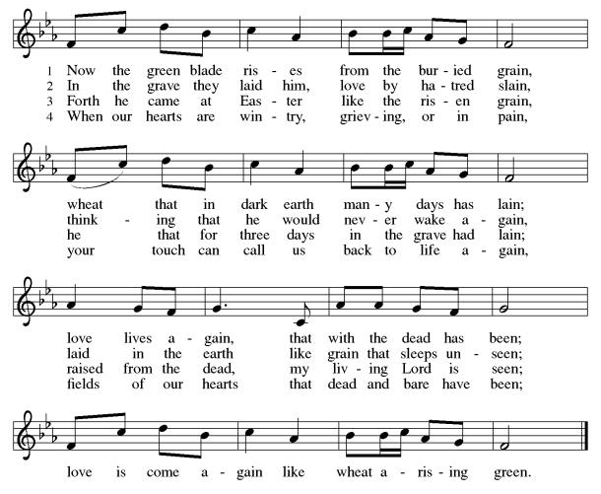

P: The body and blood of our Lord Jesus Christ strengthen you and keep you in his grace. C: Amen!

*Prayer after Communion
A: Holy One,
through this meal you have made your home among us
and are making all things new.
Send us now to speak peace to anxious hearts,
to love our enemies,
and to bring your healing to the nations.
In the name of Jesus,
C: Amen.

+Sending+

*Blessing
P: God Almighty, who is the beginning and the end,
Jesus Christ, the firstborn of the dead,
and the Spirit, our advocate and peace,
☩ bless you now and forever.
C: Amen!

*Sending Hymn ELW 380 Halleluja! Jesus Lives!
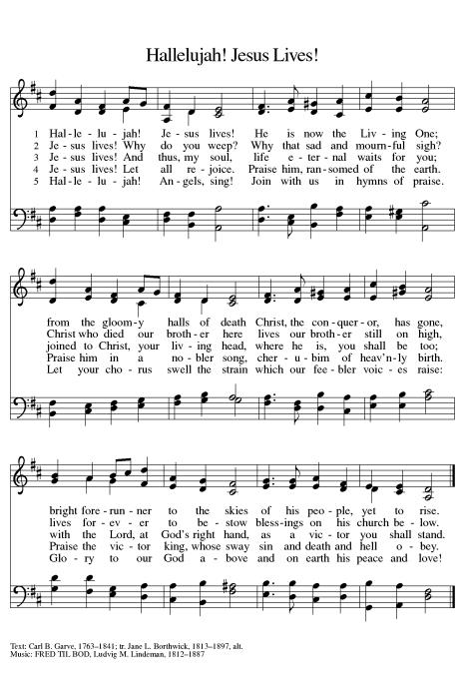
*Dismissal
A: Go in peace. Praise the Lord. Alleluia!
C: Thanks be to God. Alleluia!
Postlude

Copyright © 2020 Augsburg Fortress. All rights reserved. Reprinted by permission under Augsburg Fortress Liturgies Annual License #SB106907. New Revised Standard Version Bible, Copyright © 1989, Division of Christian Education of the National Council of the Churches of Christ in the United States of America. Used by permission. All rights reserved. Revised Common Lectionary, Copyright © 1992 Consultation on Common Texts, admin Augsburg Fortress. Used by permission.
Treasurer’s Report


March giving totaled $24,026, putting us ahead of pace toward our 2026 Challenge goal of $244,000, with 39% raised in just 25% of the year. Continued participation through regular or additional Challenge gifts will help ensure we fully fund HTLC’s ministry and mission in the months ahead.

Worship Volunteer Schedule
Date | Asst. Min | Usher | Sacristan | Lector | Counter
May 3 | Keith Bennett | Kathy Caputo | Sherry Lee | Bill Spreen | Socha/Cheek
May 10 | Keith Bennett | Dan Grillon | Helga Britton | Cynthia Kazmac | Carleo/Spreen
May 17 | Chris Foard | Jill Socha | Nancy Poole | Molly Foard | Foss/Foard
May 24 | Charlie Rugg | Andy Wehr/Dan Grillon | Pat Pienkos | Rosemary Lane | Bradford/Coleman
May 31 | Linda Coleman | Keith Bennett | Joanne Giordano | Emily Kaster | Socha/Bohner

Coffee Hour- Freezer clean out
Altar Flowers Linda Coleman in honor of mothers everywhere.

ANNOUNCEMENTS Thank you! To all who consistently support our church and ministries through your time, talent, and treasure. Please help us grow by inviting your friends and family to worship and events. You are what makes Holy Trinity a wonderful church family!

Stay in touch! Please visit our church website, www.htlcredbank.org for updates and information. You can also find us on Facebook and view services online. The office is open from 9am to 2pm, Monday to Thursday.
Car Wash-May 17th The car wash will start at 10 AM with churchgoers cars washed first, then will open up to the general public from noon till 2:00 PM. We will need volunteers to wash the cars, dry cars, manage supplies and supervise. Please sign up in the Red Book. Contact Lauren Bennett with questions period proceeds will support Cross Roads Day Camp.

100 Anniversary Committee- Meeting Sunday, May 17.Please bring your ideas to that meeting and if you are unable to attend, share your thoughts by e-mail or in conversation. We will form better channels of communication as we move forward.

Interested in becoming an usher?Training May 24- Would you like to be a substitute if needed? Or maybe you need to brush up on your skills? Dan Grillon will be leading an Usher Training/Refresher class Sunday, May 24, after worship service. Sign up below, all are welcome!

Name Tag Sundays: On the first Sunday of each month, names tags and markers will be at each entrance of the sanctuary. Please fill out a tag and wear one for worship and for coffee hour to welcome visitors and help newcomers put names to faces.

Sunday School in the New Year, we will continue to study stories and lessons from the Old Testament beginning with Jacob. Kids will love the crafts, songs and games that accompany each lesson.
The following dates there will be Sunday School:
April- 12 and 26, May- 3, 17 and 31, June- 7 and 14
As was done in the fall, there will be opportunities to volunteer as SS lead teacher. A signup will be emailed out shortly and will also be posted in the red binder. Consider signing up! All lesson materials will be supplied and laid out and a leader guide will be emailed to volunteers approximately 1 week in advance. Blessings for a wonderful 2026!~Lauren

Choir The Holy Trinity Choir welcomes our singers back for a preparation rehearsal on Sunday, September 7th at 9am in the church hall. All are welcome to join us in song as often as you are able. Choir meets each Sunday at 9am to practice and prepare our music. Join us and help us grow by spreading the word about the HTLC Choir!

Quilting- The Quilters need gently used any bed sheets of any size! Please leave any donations in the quilters closet in Fellowship Hall. Thank you!

Quilters Need Help
If anyone is traveling through Mechanicsville, PA (near Peddler’s Village), and can add a few extra minutes to your trip, the warehouse for shipping quilts, school kits, etc is located directly off one of the exits.
We accumulate many quilts throughout the year and we would appreciate sending some quilts with you to deliver. Any questions, please call Sherry Lee or Elaine Theophall.

Weekly Quilting on Wednesdays at 9:30. Bring your lunch and enjoy some fellowship at noon. All are welcome.

Social Ministry
*Year-round collections will continue for food items for Lunch Break. There is a sign-up sheet in the red book for those who can help drop these items to Lunch Break.
*We will also collect adult men's socks to periodically drop at the Red Bank Warminq Center.
*For those interested in the Heartwarminq Center — the new women's shelter is adjacent to the First Baptist Church of Red Bank at 90 Maple Ave. You can follow up on this mission through their website - https://www.thefeastnj.org- On this site, they also include wish list items that can be purchased through amazon. We will be exploring purchasing some of these through a Thrivent card. If you want to purchase on your own, you can leave items at church, and the Social Ministry will deliver them.

JBJ Soul Kitchen Day of Hope Walk– Tuesday, May 12, 2026
Holy Trinity Church has participated in this event for several years. We’re excited to participate again this year in the annual Day of Hope Walk on Tuesday, May 12th! There will be a sign up in the red book.
Event Details:Location: Begins at Riverside Gardens Park, Red Bank & concludes at JBJ Soul Kitchen Check-in: 10:00AM Walk Begins: 11:00AM Refreshments: Available at JBJ Soul Kitchen after the walk.

Pastoral Care and Prayer... We are here to care for and pray! Please contact the office to add or adjust prayer requests. If you or someone you know needs pastoral care, please contact the office and Pastor Mack!

THANK YOU for supporting and sustaining our church and ministries! All are welcome here! Please invite your family and friends to worship with us! Find us online at www.htlcredbank.org


Every gift matched up to 2-to-1
$25K + Synod Match → Mortgage Paid Off
Progress: Kick-off has begun!
Scan to Give

Use Designated Envelopes
Use Any Envelope and note: “Mortgage Freedom”

