THE ORDER OF WORSHIP
April 26, 2026/Fourth Sunday of Easter
Greeter: Dale Dixon and Rachel Hawk
Please fill out your Prayer & Praise Cards. Announcements are on the screens. Please come to the front pews to meet with a member of our Prayer Team before or after the service.
Gathering
Prayer of Consecration: Pastor John
One: Wake up, sleeper, rise from the dead,
All: and Christ will shine on you. Jesus, I belong to you. I lift up my heart to you. I set my mind on you. I fix my eyes on you. I offer my body to you as a living sacrifice. Jesus, we belong to you. Praying in the name of the Father, and the Son, and the Holy Spirit, amen.

Opening Chorus: “Come, Now Is the Time to Worship” No. 669 (2 X)
Prelude: Choral Prelude on “Charleston” John Troutman
Arr. By Susan B. Gesehke

Bringing In the Light of Christ: Nancy Henry
Welcome & Announcements: Joanne Corley

*Call to Worship: Ann Ragland
One: Children of God, it's time to take off your shoes,
All: Step out of your comfort zone, and wade with trust into the stream of God's mercy.
One: Stand still for a moment, barefoot, on holy ground. Let the healing waters wash your feet.
All: Take a deep breath as Love soaks into your soul. Be silent and listen for God's word to us today. Amen.

*Greeting our Brothers and Sisters

Proclamation and Response
*Opening Hymn: “Praise to the Lord” No. 3
(Collection of Prayer & Praise Cards)

Joys and Concerns: Pastor John
Prayer Chorus: “He Is Lord” No. 268 On Screen (Sing Twice)
Silent Prayer & Pastoral Prayer /Lord’s Prayer: Pastor John

Anthem: “Heal Me” Solo by Birt Cory/Kevin Stokes & Connie Harrington
Collection of Tithes and Offerings
*The Doxology: “My Tribute” On the Screen
*The Apostle’s Creed No. 691

Scripture Reading: Micah 6:1-8
One: The word of God for the people of God.
All: Thanks be to God and I believe it.

Sermon: “It’s Not About You” J. T. Clark

Sending Forth
*Closing Hymn: “Have Thine Own Way, Lord” No. 343
Postlude: “When I Looked Over Jordan” John M. Rasley

Please be seated. You are invited to close your eyes and use the few moments of music at the end of our service to practice Listening Prayer. This is a time to expect God to speak to you before you leave the sanctuary. In John 10:17, Jesus tells us; “My sheep hear my voice, and I know them, and they follow me.” Let’s try listening as we are silent and still. Members of the prayer team will remain on the front pews after the service. Feel free to come forward.
Benediction: Pastor John

ANNOUNCEMENTS

TO OUR VISITORS: We welcome you to Laurel Hill and hope that you feel at home. We invite you to join Laurel Hill if you do not have a church home. Please call our church office at 804-795-2772. You will find our Laurel Hill family both warm and eager to welcome you into our fellowship. Please fill out a visitor’s card and place it in the offering plate. The password for our public WiFi is LivingHope - feel free to connect with us.

THE ALTAR FLOWERS are presented to the Glory of Almighty God, and given in loving memory of Dave Dagenhart, by his wife, Gail, in remembrance of his birthday today, April 26th.

WE WELCOME J.T. CLARK to our worship service this morning. He will be bringing us our message this morning and also Sunday evening through Wednesday evening.
Please plan to be here every evening.

REVIVAL MEETINGS/APRIL 26th through 29th at 7 PM/J. T. Clark will be preaching.

OPPORTUNITY TO BLESS AND BE BLESSED by ministering through Prayer Stations at the Dorey Park Farmers Market through the summer. Training at LHGMC begins Wednesday, May 6 from 1:30 through 3 pm and continues weekly through June 3. Please talk with Pastor John, Judy Kennedy (804-625-0192) or Keith Kennedy (207-447-7221) for more details, or check this website: https://prayerstations.org/ywam/ This is an exciting chance to expand your prayer life.

FISH YARD SALE…Please do not bring any more donations until after the upcoming sale. We thank you for all you have already donated. We have so much. Also, the list of upcoming workdays to prepare for the sale are on the flyer from last Sunday or on the table in the hallway. We need help with many areas to prepare. If you can help in any way, or have questions, please call Pam Wilson at (804) 795-7726.

PLEASE ADD Janet Doesschate to your new church directory. There are spaces in the back to add new members. Her address is P. O. Box 5953, Williamsburg, Va. 23188.
Her phone number is 804-239-6019 and e-mail at jld.cma10@gmail.com.

SICK AND SHUT-INS – Kim Davis, Jean Miller, Mary Hicks, Evelyn & Bob Steele, Kathleen McKinsey, Phyllis and Sara Nelson, Regina Humphrey, John Brockman, David Torrence, Dot Gay, Sharon Loving & Family and ML Yuhas.

KEEP IN OUR PRAYERS
- Our Weekday School – Margo Keeles (Director), our teachers, students and families.
- Our community of Varina and all the residents, our churches in our neighborhoods, schools, students, teachers, administrators and all employees.
- Our state of Virginia, our residents and leaders.
- The United States of America, our citizens and leaders, the countries of the world, their people and leaders. May God bless us all and His will be done.
- Those affected by war in Israel and Ukraine

WEEKLY CALENDAR
Monday 10:30 AM New Life House Church (804-303-4828)
NO Bible Study/Hebrews, in person and Zoom.
7:00 PM Revival Meeting/J. T. Clark

Tuesday 7:00 PM Revival Meeting/J. T. Clark

Wednesday NO AM Prayer in Sanctuary with Holy Communion

NO AM Bible Study on “Finding the Holy Spirit”
7:00 PM Revival Meeting/J. T. Clark

Thursday 7:00 PM PTL House Church at the Wilson’s (804)795-1275

Friday 10:00 AM Thankful Hearts House Church (804) 737-7450

Sunday 10:00 AM Sunday School
11:00 AM Sunday Worship Service – (also available online)

Question: What is biblical stewardship?
https://www.gotquestions.org/biblical-stewardship.html

Answer: More often than not, when we think of good stewardship, we think of how we manage our finances and our faithfulness in paying God’s tithes and offerings. But as we’re beginning to see, it’s much more than that. In fact, it’s more than just the management of our time, our possessions, our environment, or our health. Stewardship is our obedient witness to God’s sovereignty. It’s what motivates the follower of Christ to move into action, doing deeds that manifest his belief in Him. Paul’s stewardship involved proclaiming that which was entrusted to him—the gospel truth.

How can you give at Laurel Hill GMC?

1 – Cash and checks may be placed in the offering plate. Please contact the church office for offering envelopes.
2 - You may also give online. The QR code below will take you to our website’s giving page: https://laurelhill.tithelysetup.com/give

3 – Planned giving – including the LHGMC in your will is a wonderful way to ensure the ministries we are called to provide for Varina will continue into the future.

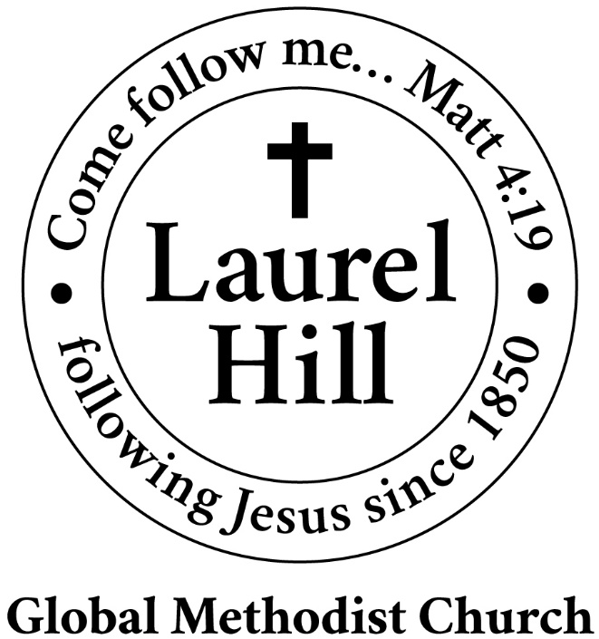
Our Mission: The Global Methodist Church exists to make disciples
of Jesus Christ and spread scriptural holiness across the globe.

1919 New Market Road, Henrico, VA 23231
On the web @ laurelhillchurch.org
Email to laurelhillchurch.varina@gmail.com
Phone: Office/804.795.2772 Pastor/804.437.0937

STAFF
Pastor: Rev. John Bright Organist/Choir Director: Pam Wilson
Secretary: Barbara Wendel School Director: Margo Keeles
Communications Assistant: Ben Wilson

that we you in thought, word, and deed.

