THE ORDER OF WORSHIP
May 3, 2026/Fifth Sunday of Easter
Greeter: Dale Dixon and Rachel Hawk
Please fill out your Prayer & Praise Cards. Announcements are on the screens. Please come to the front pews to meet with a member of our Prayer Team before or after the service.
Gathering
Prayer of Consecration: Pastor John
One: Wake up, sleeper, rise from the dead,
All: and Christ will shine on you. Jesus, I belong to you. I lift up my heart to you. I set my mind on you. I fix my eyes on you. I offer my body to you as a living sacrifice. Jesus, we belong to you. Praying in the name of the Father, and the Son, and the Holy Spirit, amen.

Opening Chorus: “Come, Now Is the Time to Worship” No. 669 (2 X)
Prelude: “Amazing Grace” Edward Broughton

Bringing In the Light of Christ: Ann Via
Welcome and Announcement: John Turner

*Call to Worship: John Turner
One: Welcome to the community of faith, the family of God!

All: We come, seeking connection with the Creator and one another.

One: We proclaim the Word of Life, made known in Jesus Christ.

All: We come to abide in Christ, whose light shines in our darkness.
Let us worship the Lord and experience complete joy! Amen.

*Greeting our Brothers and Sisters

Proclamation and Response
*Opening Hymn: “O Come, All Ye Faithful” No. 174
(Collection of Prayer & Praise Cards)

Joys and Concerns: Pastor John
Prayer Chorus: “He Is Lord” No. 268 On Screen (Sing Twice)
Silent Prayer & Pastoral Prayer /Lord’s Prayer: Pastor John

Anthem: Ladies “How Beautiful” Twila Paris/Lloyd Larson
Collection of Tithes and Offerings: Kirby Miller & Buddy Whitlow
*The Doxology: “My Tribute” On the Screen

Scripture Reading: 1 John 1:1-4
One: The word of God for the people of God.
All: Thanks be to God and I believe it.

Sermon: Series: Letter of John/“Jesus, the Only Way”
Holy Communion and Anointing: Page 731 /On Screen

Sending Forth
*Closing Hymn: “Have Thine Own Way, Lord” No. 343
Postlude: “Postlude in G” Gerald Peterson

Please be seated. You are invited to close your eyes and use the few moments of music at the end of our service to practice Listening Prayer. This is a time to expect God to speak to you before you leave the sanctuary. In John 10:17, Jesus tells us; “My sheep hear my voice, and I know them, and they follow me.” Let’s try listening as we are silent and still. Members of the prayer team will remain on the front pews after the service. Feel free to come forward.
Benediction: Pastor John

ANNOUNCEMENTS

TO OUR VISITORS: We welcome you to Laurel Hill and hope that you feel at home. We invite you to join Laurel Hill if you do not have a church home. Please call our church office at 804-795-2772. You will find our Laurel Hill family both warm and eager to welcome you into our fellowship. Please fill out a visitor’s card and place it in the offering plate. The password for our public WiFi is LivingHope - feel free to connect with us.

THE ALTAR FLOWERS are presented to the Glory of Almighty God and given by Barbara Wendel in honor of all the members of the Varina Woman’s Club. Thank you for blessing my family with wonderful scholarships and for the “Fun Friday” events that you have provided our Weekday School children over the past year. You have brought so much joy to so many.
PLEASE WELCOME MEMBERS OF THE VARINA WOMAN’S CLUB who are joining us in worship this morning. The club is a community volunteer organization chartered in 1970 that supports local and global charities. Find out more at www.varinawomansclub24.com. Meetings are held monthly September-May at Laurel Hill GMC. Come join us!

OPPORTUNITY TO BLESS AND BE BLESSED by ministering through Prayer Stations at the Dorey Park Farmers Market through the summer. Training at LHGMC begins Wednesday, May 6 from 1:30 through 3 pm and continues weekly through June 3. Please talk with Pastor John, Judy Kennedy (804-625-0192) or Keith Kennedy (207-447-7221) for more details, or check this website: https://prayerstations.org/ywam/ This is an exciting chance to expand your prayer life.

FISH YARD SALE…Please do not bring any more donations until after the upcoming sale. Also, the list of upcoming work days is on the back of the Yard Sale Flyer on the table. We need all the help we can get to prepare and clean up from the sale. Questions, call Pam Wilson at (804) 795-7723.

SAVE THE DATE…Virginia Annual Conference, 2026 will be held on May 28-30, 2026.
The speaker will be Peter Bellini. It will be held at the Wilderness Community Church in Spotsylvania, Virginia. Flyers are on the table with all the details. Take one!

SICK AND SHUT-INS – Kim Davis, Jean Miller, Mary Hicks, Evelyn & Bob Steele, Kathleen McKinsey, Phyllis and Sara Nelson, Regina Humphrey, John Brockman, David Torrence, Dot Gay, Sharon Loving & Family and ML Yuhas.

KEEP IN OUR PRAYERS
- Our Weekday School – Margo Keeles (Director), our teachers, students and families.
- Our community of Varina and all the residents, our churches in our neighborhoods, schools, students, teachers, administrators and all employees.
- Our state of Virginia, our residents and leaders.
- The United States of America, our citizens and leaders, the countries of the world, their people and leaders. May God bless us all and His will be done.
- Those affected by war in Israel and Ukraine

WEEKLY CALENDAR
Monday 10:30 AM New Life House Church (804-303-4828)
Bible Study/Hebrews, in person and Zoom.

Wednesday 9:00 AM Prayer in Sanctuary with Holy Communion

10:30 AM Bible Study on “Finding the Holy Spirit”
1:30 PM Prayer Station Training
6:45 PM Handbell Choir Rehearsal
7:00 PM Adult Chancel Choir

Thursday 1:00 PM Laurel Quilters

7:00 PM PTL House Church at the Wilson’s (804)795-1275

Friday 10:00 AM Thankful Hearts House Church (804) 737-7450

Sunday 8:00 AM Men’s Breakfast Group
10:00 AM Sunday School
11:00 AM Sunday Worship Service – (also available online)

Question: What is biblical stewardship?
https://www.gotquestions.org/biblical-stewardship.html

Answer: The biblical doctrine of stewardship defines a man’s relationship to God. It identifies God as owner and man as manager. God makes man His co-worker in administering all aspects of our life. The apostle Paul explains it best by saying, “For we are God’s fellow workers; you are God’s field, God’s building” (1 Corinthians 3:9). Starting with this concept, we are then able to accurately view and correctly value not only our possessions, but, more importantly, human life itself. In essence, stewardship defines our purpose in this world as assigned to us by God Himself. It is our divinely given opportunity to join with God in His worldwide and eternal redemptive movement (Matthew 28:19-20). Stewardship is not God taking something from us; it is His method of bestowing His richest gifts upon His people.

How can you give at Laurel Hill GMC?
1 – Cash and checks may be placed in the offering plate. Please contact the church office for offering envelopes.
2 - You may also give online. The QR code below will take you to our website’s giving page: https://laurelhill.tithelysetup.com/give

3 – Planned giving – including the LHGMC in your will is a wonderful way to ensure the ministries we are called to provide for Varina will continue into the future.

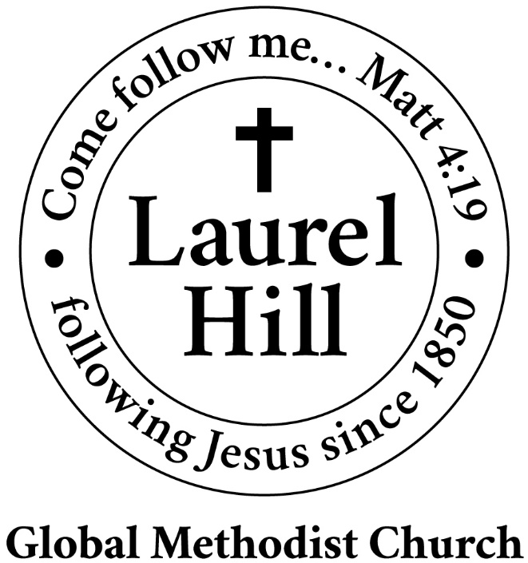
Our Mission: The Global Methodist Church exists to make disciples
of Jesus Christ and spread scriptural holiness across the globe.

1919 New Market Road, Henrico, VA 23231
On the web @ laurelhillchurch.org
Email to laurelhillchurch.varina@gmail.com
Phone: Office/804.795.2772 Pastor/804.437.0937

STAFF
Pastor: Rev. John Bright Organist/Choir Director: Pam Wilson
Secretary: Barbara Wendel School Director: Margo Keeles
Communications Assistant: Ben Wilson

that we you in thought, word, and deed.

