All Saints Anglican Church
6904 Lougheed Highway, Agassiz, B.C. V0M 1A0
Bulletin April 27th, 2026 – May 3rd, 2026

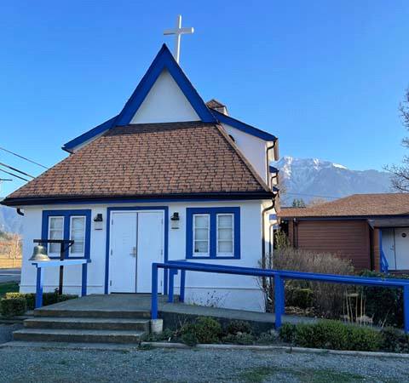

‘The ground we walk does not belong to us; for thousands of years it has been - and remains - the territory of the Stó:lō. We are grateful for their sharing.

Phone: 604-796-3553
Website: www.allsaints-agassiz.ca
https://www.facebook.com/groups/AllSaintsFamily
OUR DOOR IS OPEN AND ALL ARE WELCOME
May 3rd, 2026, Fifth Sunday of Easter
Priest in Charge: The Reverend Philip Barker
Hosts: Graham Featherstone/Jennifer Pinlac
Intercessor: Valerie/David Hamilton
Lay Administrator: Dorothy Cresswell
Announcer: Virginia Jennings
Organ/Piano: Francesca Froehlich
Readers: Greg Veltman/Andrea Hansen
Vicar’s cell phone: Revd. Philip Barker. 778-867-2461

Vicar’s Warden: Ginny Jennings. 604-796-2206
People’s Warden: Lynn Laughlin. 604-799-5131
Parish email: revpb1950@gmail.com
Please contact either warden if you have an issue that needs to be brought to the attention of the Vicar - or contact the Vicar direct (see above for details).

All Saint’s Calendar/Announcements:

- Book Club – On April 8th Book Club will resume Zoom meetings on Wednesdays at 5.00 pm. The first week will be a discussion of the 3 books that were read by members during Lent.

The next book will be "The Last Week: What the Gospels really teach about Jesus' final days in Jerusalem", by Marcus J. Borg and John Dominic Crosson. This will be an appropriate follow on from Holy Week.
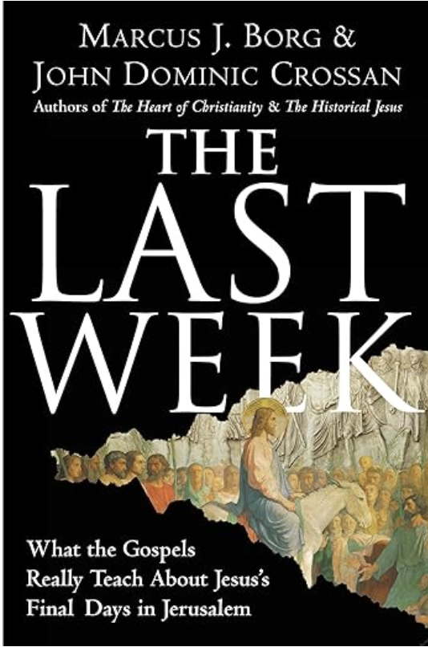
The book is $21.00 in paperback on Amazon and also
available on Kindle.

If you would like to join the group or have a copy of the
book, please contact Sheila at sjbarker0379@gmail.com

- Bible Study with Karol is every Saturday morning 0830-0900 on Zoom.

- Prayer Requests can be given on a piece of paper to either of the Wardens or the Vicar or entered in the Prayer Request Book on the lectern. Alternatively, you can contact Anthea Lewis at antheamlewis@shaw.ca for Pray First Prayer Circle, which is a confidential online prayer circle.

- Music Requests may be given to the Wardens or the Vicar.

- AA meets in the hall every Tuesday and Friday at noon.

- Every Thursday in the hall 1100-1200 we have a social time with coffee, games if you like or just talk.

- At 1000-1100 on Thursdays there is an Interactive Bible Study on the day’s Lectionary readings. All are welcome – discover the treasures in this amazing book!

- 5th Sunday of each month will be a potluck lunch after the service – Next Potluck is Sunday May 31st.

Ministerial Meandering
Why so sad?

We all have moments when we feel down and sad - and we feel trapped in that place. Like many people who have had years of suffering from depression, I know that activity and displacement therapy is a good antidote - particularly physical training - that hurts. However, Churchill’s ‘black dog’ will catch up with you eventually.

Paul, the apostle, complained of a ‘thorn in his side’, which he had asked the Lord to take away from him three times - but it appeared that the Lord had other plans. We never find out what it is, and perhaps he also suffered from inner sadness. Paul was sanguine enough to realize that his ‘thorn’ was probably for a purpose, and rationalized with himself that God’s power was more evident in his (Paul’s) weakness, than in any power he had of his own.
If Paul is to be believed, he would rejoice in the most crushing of circumstances; ‘We are hard pressed on every side, but not crushed; perplexed, but not in despair; persecuted, but not abandoned; struck down, but not destroyed.’ And this is probably the most restrained of his claims. If we read a little further into his second letter to the Corinthians, he asserts that of all the apostles, he has suffered more. If you want to be impressed with his fortitude, read 2 Corinthians 11:23-27.
I don’t usually quote long passages from the bible in my MM’s, so I won’t, but only make the point that most of us have never experienced the sort of punishment that members of the Early Church faced, and are never likely to. And that’s a huge relief. But that is not my main message today.

Existential - or external adversity, that which might threaten our bodies in the way that Paul was subjected to physical trauma and deprivation - is not what usually makes us sad. It is a soul-sickness and weariness that saps our inner selves and makes us helpless to face even the simplest of tasks sometimes. I recall watching Andrew Solomon give a TED talk on the subject of depression from his personal experience, and he said that one day it hit him so hard, he thought he’d had a stroke. He was so debilitated, he couldn’t get out of bed to even make a phone call to ask for help. In his talk he quoted Emily Dickinson’s personal experience in her poem, ‘I felt a funeral, in my brain.’ But of all the observations he made, one sticks in my mind powerfully; he said that one of the things that gets lost in conversations about depression is that ‘you know it’s ridiculous - even while you’re experiencing it,’ to which I would add, ‘and there’s not a damn thing you can do about it.’ I am very aware of the inner and outward paralysis that takes over your very being, and would wish it on no-one.

My emphasis is to say that we have to find ways to combat our demons. Running from them only makes them chase us faster. In the same way, after I stopped drinking, I had to find a way to fill the hours that I had previously numbed; activity again. But that was not enough. My mind screamed for engagement, for purpose, for challenge, for change. This is why activities such as Men’s Shed movements are so healthy. Statistics repeatedly show us that those with the most morbidity and mortality are men - often living alone - in their 60’s and upwards, who are retired and have found nothing to do. They are the biggest suicide risks.

Engagement with others is essential to our well-being; it doesn’t have to be chatter and gossip - the latter is usually harmful - but it is just getting alongside another human being and spending time together. Many a walk has been made blissfully in silent company. Men’s Clubs in London have always attracted loners, and I remember well the retirement present my old Housemaster was given when he left my senior school - membership of the Atheneum Club in London. He was ecstatic. He would go there to sit and smoke his pipe and read the papers, and take a meal occasionally. Conversation was not his long suit - but that club was his connection to humanity.

John Donne famously wrote, ‘No man is an island,’ and so I urge us all, as we get older, to make certain we keep some connection to our fellow human beings. Some of them can be quite nice.

Philip+

A Little Chuckle…



Birthdays this Month May

Karol Henrotte – 2 Allen Low – 7
Lijo George – 8 Sidney Toy – 10

Diocesan Cycle of Prayer: We Pray for the Clergy and Congregation:

The Deanery of Tri-Cities / North Burnaby – The Revd Philip Cochrane, Regional Dean; The Legal Officers of the Diocese - George Cadman, K.C., AAM, ODNW, Chancellor; Kevin Smith, ODNW, Vice-Chancellor; Donald Paul, ODNW, Registrar; Jennifer Dezell, ODNW, Legal Assessor ; All Saints, Burnaby - The Revd Justin
Cheng, The Revd Leah Skuro

Anglican Church of Canada Cycle of Prayer – We Pray for:

The Rt. Rev. Rod BrantFrancis, Bishop, and the clergy and people of the Diocese of Moosonee

Collect

Almighty God, your Son Jesus Christ is the way, the truth, and the life. Give us grace to love one another and walk in the way of his commandments, who lives and reigns with you and the Holy Spirit, one God, now and for ever.

Proverbs 4:10-18 Greg Veltman

¹⁰ Listen, my son, accept what I say,
and the years of your life will be many.
¹¹ I instruct you in the way of wisdom
and lead you along straight paths.
¹² When you walk, your steps will not be hampered;
when you run, you will not stumble.
¹³ Hold on to instruction, do not let it go;
guard it well, for it is your life.
¹⁴ Do not set foot on the path of the wicked
or walk in the way of evildoers.
¹⁵ Avoid it, do not travel on it;
turn from it and go on your way.
¹⁶ For they cannot rest until they do evil;
they are robbed of sleep till they make someone stumble.
¹⁷ They eat the bread of wickedness
and drink the wine of violence.

¹⁸ The path of the righteous is like the morning sun,
shining ever brighter till the full light of day.

Psalm 31:1-5, 15-16

¹ In you, Lord, I have taken refuge;
let me never be put to shame;
deliver me in your righteousness.
² Turn your ear to me,
come quickly to my rescue;
be my rock of refuge,
a strong fortress to save me.
³ Since you are my rock and my fortress,
for the sake of your name lead and guide me.
⁴ Keep me free from the trap that is set for me,
for you are my refuge.
⁵ Into your hands I commit my spirit;
deliver me, Lord, my faithful God.

¹⁵ My times are in your hands;
deliver me from the hands of my enemies,
from those who pursue me.
¹⁶ Let your face shine on your servant;
save me in your unfailing love.

1 Peter 2:2-10 Andrea Hansen

² Like newborn babies, crave pure spiritual milk, so that by it you may grow up in your salvation, ³ now that you have tasted that the Lord is good.

⁴ As you come to him, the living Stone—rejected by humans but chosen by God and precious to him— ⁵ you also, like living stones, are being built into a spiritual house to be a holy priesthood, offering spiritual sacrifices acceptable to God through Jesus Christ. ⁶ For in Scripture it says:

“See, I lay a stone in Zion,
a chosen and precious cornerstone,
and the one who trusts in him
will never be put to shame.”

⁷ Now to you who believe, this stone is precious. But to those who do not believe,

“The stone the builders rejected
has become the cornerstone,”

⁸ and,

“A stone that causes people to stumble
and a rock that makes them fall.”

They stumble because they disobey the message—which is also what they were destined for.

⁹ But you are a chosen people, a royal priesthood, a holy nation, God’s special possession, that you may declare the praises of him who called you out of darkness into his wonderful light. ¹⁰ Once you were not a people, but now you are the people of God; once you had not received mercy, but now you have received mercy.

John 14:1-14 Vicar Philip Barker
¹“Do not let your hearts be troubled. You believe in God; believe also in me. ² My Father’s house has many rooms; if that were not so, would I have told you that I am going there to prepare a place for you? ³ And if I go and prepare a place for you, I will come back and take you to be with me that you also may be where I am. ⁴ You know the way to the place where I am going.”

⁵ Thomas said to him, “Lord, we don’t know where you are going, so how can we know the way?”

⁶ Jesus answered, “I am the way and the truth and the life. No one comes to the Father except through me. ⁷ If you really know me, you will know my Father as well. From now on, you do know him and have seen him.”

⁸ Philip said, “Lord, show us the Father and that will be enough for us.”

⁹ Jesus answered: “Don’t you know me, Philip, even after I have been among you such a long time? Anyone who has seen me has seen the Father. How can you say, ‘Show us the Father’? ¹⁰ Don’t you believe that I am in the Father, and that the Father is in me? The words I say to you I do not speak on my own authority. Rather, it is the Father, living in me, who is doing his work. ¹¹ Believe me when I say that I am in the Father and the Father is in me; or at least believe on the evidence of the works themselves. ¹² Very truly I tell you, whoever believes in me will do the works I have been doing, and they will do even greater things than these, because I am going to the Father. ¹³ And I will do whatever you ask in my name, so that the Father may be glorified in the Son. ¹⁴ You may ask me for anything in my name, and I will do it.

Odds and Ends


Last Chance!!!

“Facts Behind Faith” is a collection of Philip’s sermons put together in a booklet.

If you would like a copy of this Philip Barker Collection, the cost is $10.00 and any additional donations are greatly appreciated.

