This Week at PPBC
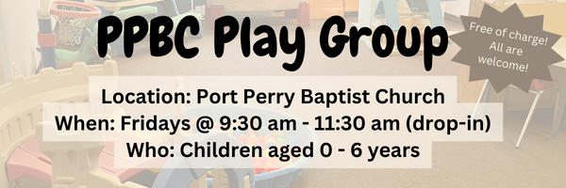




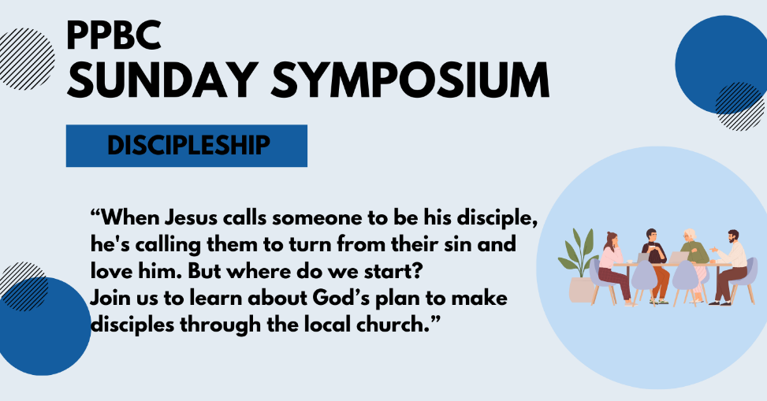
May 24, 2026


May 9th, 2026
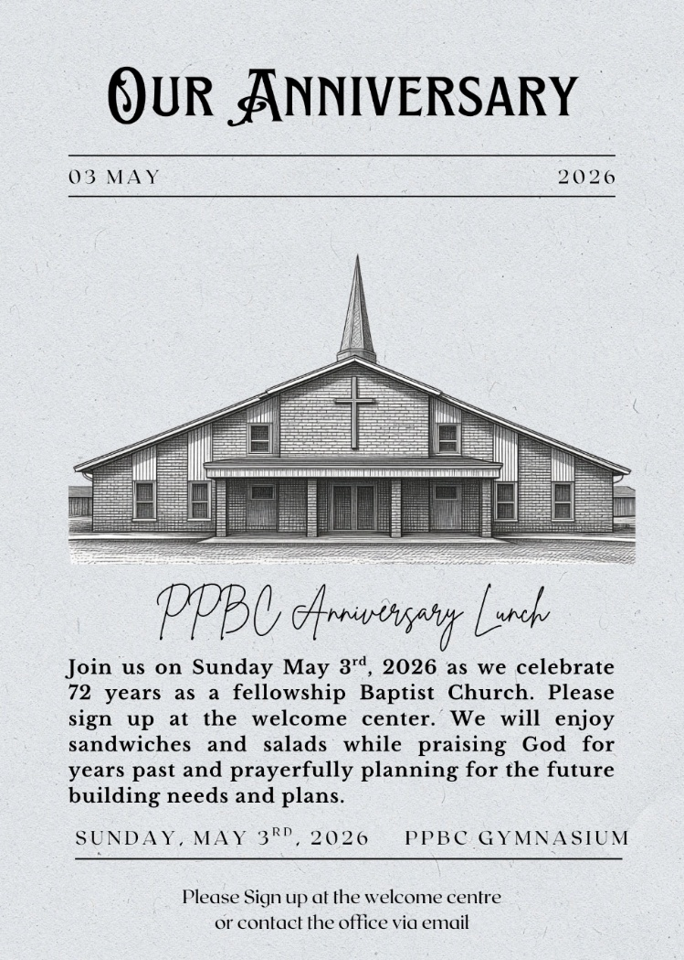

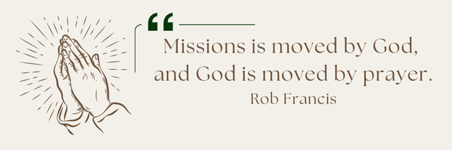
A Prayer Request from the Lambs: Recruiting the next generation of missionaries is always on their hearts. They had no students in training for this year’s training session, which is really discouraging for their team, but it’s the harsh reality as recruitment across Canada is getting harder and harder. “Pray the Lord of the harvest to raise up laborers.” Martin has been meeting with a couple who are interested in coming into our Bible school training and also serving at our HQ - so that’s been encouraging.

Sunday Ministry Schedules
Below are ministry schedules for Nursery, Jr. Church, Greeters, Ushers, and Sound & Video:
Nursery
May 3: Jan Gerrow, Hannah Colwell
May 10: Brenda Clemens, Audrianna Angrove
Infant Nursery
May 3: Laura Saunders, Elise Anderson
May 10: Stephanie Anderson, Karis Henkelman
Jr. Church; ages 3 to grade 1
May 3: Ellianne McLaren, Mikayla Ferguson
May 10: Christine McLaren, Grace Brown
Jr. Church; Grades 2 to 6
May 3: Tracy Ballanger, Kim St-Onge
May 10: Kate Anderson, Graeme Anderson
Greeters
May 3: Fern & Kim St-Onge
May 10: Graeme & Barb Foster
Ushers
May 3: Matt Saunders, Gregg Anderson
May 10: Paul Sammut, Joe Colwell
Sound & Video
May 3: Sound: Eric Duchesne | Video: Josh Myers
May 10: Sound: | Video:

Sunday Service
Song – All Hail the Power of Jesus Name
Welcome
Song – Jesus Paid it All
Baptism - Ben
Song – Christ is Mine Forevermore
Scripture
Song – There is One Gospel
Prayer
Message – Pastor Jim Clemens
Song – Before the Throne of God Above
Communion
Song – Jesus Thank You

Praise & Prayer Highlights
PRAY for Joan Mabley who has been moved to Glen Hill Strathaven in Bowmanville. Please PRAY for Joan’s comfort and peace.
PRAY for John & Joan Mank and their ongoing health concerns.
PRAY for Martin & Tina McCurley and their ongoing health concerns. PRAY for them as they prepare to move the end of April.
PRAY for Jordan & Stephanie Anderson. PRAY for Jordan as he undergoes training in Quebec.
PRAY for Laurie Buismans sister Debbie and their family. Debbie is in Lakeridge health Hospital under observation. PRAY for the family and the doctors who are caring for them.
PRAY for Darren & Brooke VanUden. They are expecting a baby in May 2026. PRAY for Brooke and the little ones health as they approach the due date and delivery.
PRAY for Betty Collins cousin Pat and her ongoing concerns. PRAY for her healing for her neck and that the doctors and nurses would have wisdom in caring for her.

Giving
Just as a reminder, there are several ways you can give:
In Person using the offering box located on the back wall of the sanctuary. Donation envelopes are available at the Welcome Centre. Please contact the church office if you would like a box of donation envelopes (office@portperrybaptist.ca)
Through your online banking, you may send electronic transfers to ppbcdonations@gmail.com.
You can also give through Canada Helps. Donation receipts will be provided by Canada Helps, and transaction fees apply.
***********************************************************************
Weekly Newsletter
The PPBC Newsletter is emailed to the church family every Friday. If you would like to be added to the weekly email list, please contact the office by phone: 905-985-8681 or by email: office@portperrybaptist.ca.
*****************************************************************
Church Information:
Location:
2210 Hwy 7A
Port Perry, ON
L9L 1B4
Office Hours:
Monday: 8:30am – 4:00pm
Tuesday: 8:30am – 4:00pm
Wednesday: Closed
Thursday: 8:30am – 4:00pm
Friday: 8:30 am - 3:00 pm
Contact:
Phone: 905.985.8681
Email: office@portperrybaptist.ca
Website: www.portperrybaptist.ca
Staff:
Sr. Pastor – Rev. Jim Clemens
Administrative Assistant – Madeline Werner
Family Ministries Director – Josh Anderson
Pastoral Intern – Scott McKenzie

PPBC Newsletter
Sunday, May 3, 2026


Sunday Starting Point
Sunday, May 3, 2026 - 9:30 am
“Beginning the day with the Word and prayer”
Adults:
Adults will meet in the sanctuary for a time of study and prayer.
Youth:
Jr High (Grades 7-8) will meet in room 18 with Kate Anderson to study Thessalonians.
Children:
Children ages 3 - grade 6 will meet in room 26.
(Please note nursery is unavailable during Starting Point)
Sunday Morning Worship
Sunday, May 3, 2026 - 10:30 am
We are meeting in the sanctuary and will continue to live-stream for those who are unable to attend.
Message: Grace from Start to Finish
Scripture: Exodus 31:1-11. Hebrews 9:1-14
Pastor Jim Clemens

