Holy Trinity Evangelical Lutheran Church

The Fifth Sunday of Easter

May 3, 2026, at 10:30am

Lay Speaker, Bill Pim

*Prelude

* Welcome and Announcements Worship Assistant

* Opening Hymn "I’m So Glad Jesus Lifted Me" ELW 860
Public Domain
1.i’m so glad Jesus lifted me. I’m so glad Jesus lifted me.
I’m so glad Jesus lifted me, singing glory, hal-le-lu-jah! Jesus lifted me.

2.Satan had me bound, Jesus lifted me. Satan had me bound, Jesus lifted me. Satan had me bound, Jesus lifted me, singing
glory, hal-le-lu-jah! Jesus lifted me.

3.When I was in trouble, Jesus lifted me. When I was in trouble, Jesus lifted me. When I was in trouble, Jesus lifted me, singing
Glory, hal-le-lu-jah! Jesus lifted me.

* Confession and Forgiveness Lay Speaker, Bill
Trusting in the mercy of God, let us confess our sin.
Gracious God, we confess that we have not always lived as Easter people. We cling to fear when you offer peace. We hold onto doubt without seeking you. We close doors that you long to open. Forgive us for the ways we resist your resurrection life. Breathe your Spirit into us again, that we may live as your forgiven and renewed people. Through Jesus Christ, our risen Lord. Amen.

Hear the good news: Christ is risen, and nothing—not even sin or death—can separate us from the love of God. In the mercy of almighty God, your sins are forgiven. You are made new in Christ. Thanks be to God.

* Canticle of Praise “This is the Feast” ELW pg. 149
Refrain: This is the feast of victory for our god. al-le-lu-ia.
1.worthy is christ, the lamb who was slain, whose blood set us free to be people of god. power and riches and wisdom and
strength, and honor and blessing and glory are his.

refrain: this is the feast of victory for our God. Al-le-lu-ia.
2.Sing with all the people of god and join in the hymn of all creation: Blessing and honor and glory and might be to god and the lamb forever. amen.

final refrain: this is the feast of victory for our god, for the lamb who was slain has begun his reign. al-le-lu-ia. al-le-lu-ia.

*Greeting Bill Pim
The Grace of our Lord, Jesus Christ, the love of god and the communion of the Holy Spirit be with you all. and also with you

*Prayer of the Day Worship Assistant
Almighty God, your Son Jesus Christ is the way, the truth, and the life. Give us grace to love one another, to follow in the way of his commandments, and to share his risen life with all the world, for he lives and reigns with you and the Holy Spirit, one God, now and forever. Amen.

*Passing of the Peace Worship Assistant
May the Peace of Christ be with you Always. And also with you.

Please share the peace of christ with one another with a wave.

*Children’s Moment Pulpit prequel Bill Pim
*First Lesson: Ezekiel 34:7-15 Reader
⁵⁵ Filled with the Holy Spirit, [Stephen] gazed into heaven and saw the glory of God and Jesus standing at the right hand of God. ⁵⁶ “Look,” he said, “I see the heavens opened and the Son of Man standing at the right hand of God!” ⁵⁷ But they covered their ears, and with a loud shout all rushed together against him. ⁵⁸ Then they dragged him out of the city and began to stone him, and the witnesses laid their coats at the feet of a young man named Saul. ⁵⁹ While they were stoning Stephen, he prayed, “Lord Jesus, receive my spirit.” ⁶⁰ Then he knelt down and cried out in a loud voice, “Lord, do not hold this sin against them.” When he had said this, he died.

The Word of the Lord. Thanks be to God.

*Second Lesson: 1 Peter 2:2-10 Reader
² Like newborn infants, long for the pure, spiritual milk, so that by it you may grow into salvation ³ if indeed you have tasted that the Lord is good.
⁴ Come to him, a living stone, though rejected by mortals yet chosen and precious in God’s sight, and ⁵ like living stones let yourselves be built into a spiritual house, to be a holy priesthood, to offer spiritual sacrifices acceptable to God through Jesus Christ. ⁶ For it stands in scripture:
“See, I am laying in Zion a stone,
a cornerstone chosen and precious,
and whoever believes in him will not be put to shame.”
⁷ This honor, then, is for you who believe, but for those who do not believe,
“The stone that the builders rejected
has become the very head of the corner,”⁸ and
“A stone that makes them stumble
and a rock that makes them fall.”
They stumble because they disobey the word, as they were destined to do.
⁹ But you are a chosen people, a royal priesthood, a holy nation, God’s own people, in order that you may proclaim the excellence of him who called you out of darkness into his marvelous light.
¹⁰ Once you were not a people,
but now you are God’s people;
once you had not received mercy,
but now you have received mercy.

The Word of the Lord. Thanks be to God.

* Gospel Acclamation Blessed is the One ACS 929
One License A-700000
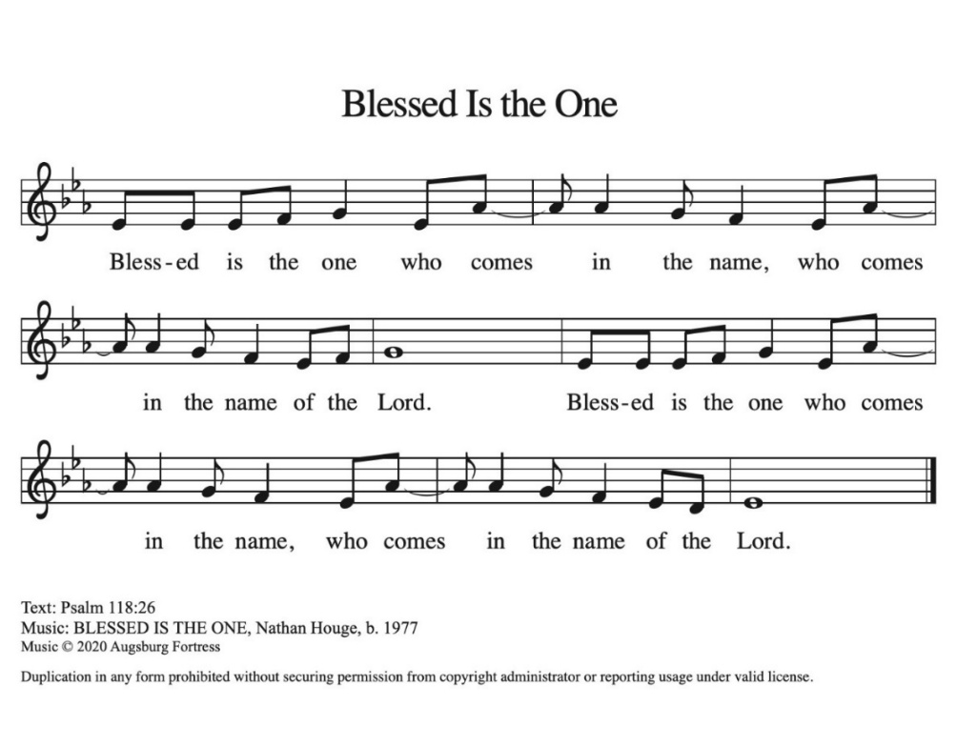

* Gospel: John 14:1-14 Bill Pim
The Holy Gospel according to John, the 14th chapter. Glory to you, O Lord.

[Jesus said to the disciples:] ¹ “Do not let your hearts be troubled. Believe in God; believe also in me. ² In my Father’s house there are many dwelling places. If it were not so, would I have told you that I go to prepare a place for you? ³ And if I go and prepare a place for you, I will come again and will take you to myself, so that where I am, there you may be also. ⁴ And you know the way to the place where I am going.” ⁵ Thomas said to him, “Lord, we do not know where you are going. How can we know the way?” ⁶ Jesus said to him, “I am the way and the truth and the life. No one comes to the Father except through me. ⁷ If you know me, you will know my Father also. From now on you do know him and have seen him.”
⁸ Philip said to him, “Lord, show us the Father, and we will be satisfied.” ⁹ Jesus said to him, “Have I been with you all this time, Philip, and you still do not know me? Whoever has seen me has seen the Father. How can you say, ‘Show us the Father’? ¹⁰ Do you not believe that I am in the Father and the Father is in me? The words that I say to you I do not speak on my own, but the Father who dwells in me does his works. ¹¹ Believe me that I am in the Father and the Father is in me, but if you do not, then believe because of the works themselves. ¹² Very truly, I tell you, the one who believes in me will also do the works that I do and, in fact, will do greater works than these, because I am going to the Father. ¹³ I will do whatever you ask in my name, so that the Father may be glorified in the Son. ¹⁴ If in my name you ask me for anything, I will do it.”

The Gospel of the Lord. Praise to you, O Christ.

Sermon “In My Father’s House” Lay Speaker, Bill Pim
* Hymn of the Day "O Jesus, I Have Promised" ELW 810
Public Domain
1.O Jesus, I have promised to serve you to the end,
remain forever near me, my master and my friend.
I shall not fear the battle if you are by my side,
nor wander from the pathway if you will be my guide.

2.Oh, let me feel you near me; the world is ever near,
I see the sights that dazzle, the tempting sounds I hear,
my foes are ever near me, around me and within; but, Jesus,
then draw nearer to shield my soul from sin.

3.Oh, let me hear you speaking in accents clear and still
Above the storms of passion, the murmurs of self will.
Now speak to reassure me, to hasten or control;
Now speak and make me listen, O Guardian of my soul.

4.O Jesus, you have promised to all who follow you
that where you are in glory your servant shall be too.
And Jesus, I have promised to serve you to the end;
Oh, give me grace to follow, my master and my friend.

* Apostle’s Creed Worship Assistant
Let us proclaim our faith in the words of the apostle’s creed.
I believe in God, the Father almighty,
creator of heaven and earth.
I believe in Jesus Christ, God's only Son, our Lord,
who was conceived by the power of the Holy Spirit,
born of the Virgin Mary,
suffered under Pontius Pilate,
was crucified, died, and was buried;
he descended to the dead.
On the third day he rose again;
he ascended into heaven,
he is seated at the right hand of the Father,
and he will come to judge the living and the dead.
I believe in the Holy Spirit,
the holy catholic Church,
the communion of saints,
the forgiveness of sins,
the resurrection of the body,
and the life everlasting. Amen.

* Prayers of Intercession Bill Pim
Be Seated
Prayer requests or shouts of joy
God of resurrection and new life, we come before you in prayer for the church, the world, and all who are in need.

God of glory, you have built your church on Christ the cornerstone. Inspire lay leaders, deacons, pastors, and bishops to proclaim forgiveness and your steadfast love to all whom they encounter. Merciful God, receive our prayer.

God of majesty, you bring forth plants and animals, skies and seas, mountains and valleys. Protect all you have made from the ravages of pollution and climate disaster. Merciful God, receive our prayer.

God of mercy, you intend governments and social service agencies to be instruments of peace and justice. Guide political leaders and organizations to be agents of compassion, and raise up advocates for those who seek refuge and assistance. Merciful God, receive our prayer.

God of well-being, you soothe those in distress, console all who grieve, provide for any in need, and comfort those who are sick (especially). Instill caregivers with a sense of purpose to be your healing hands in this world. Merciful God, receive our prayer.

God of community, you call us together as your people for mutual support and to witness to your love in the world. Make your presence known among those unable to attend worship today. Merciful God, receive our prayer.

God of eternal life, you have prepared dwelling places for your people, so that we are never separated from you. We give you thanks for the faithful departed who witnessed to your mighty acts in word and deed. Merciful God, receive our prayer.
We commend these and all our prayers to you, O God, trusting that you are always with us; in the name of Jesus Christ, our risen Savior. Amen.

*Offering – Worship assistant
The Monthly Mission for May is for “The church family care fund.” Let us Give to God what He has first given us.

*Offering Music by Jared

* Offering Hymn “Be Not Afraid” ELW #388 (sing 2x)
One License A-700000
Be not afraid, sing out for joy! Christ is risen, Al-le-lu-ia.
Be not afraid, sing out for joy! Christ is risen, Al-le-lu-ia.

* Offering Prayer Worship Assistant and Congregation
Generous and Abundant God, all that we have comes from your hand—bread from the earth, water that sustains, love that binds us together. Bless these gifts we bring today. May they nourish the hungry, strengthen the weary, and build communities of justice and care, as signs of your new creation. In Christ’s name we pray, Amen.

* Lord’s Prayer Bill Pim ELW pg. 154
Our Father, who art in heaven, hallowed be thy name, thy kingdom come, thy will be done, on earth as it is in heaven. Give us this day our daily bread; and forgive us our trespasses, as we forgive those who trespass against us; and lead us not into temptation, but deliver us from evil. For thine is the kingdom, and the power, and the glory, forever and ever. Amen.

* Blessing Bill Pim
The risen Christ stands among you and says, “Peace be with you.” May that peace guard your hearts and minds, now and forever. Amen.

Hymnology Story Bill Pim

* Closing Hymn "My Faith Looks Up To Thee" ELW 759
Public Domain
1.My faith looks up to thee, thou Lamb of Calvary, Savior divine!
Now hear me while I pray, take all my guilt away, oh, let me from this day be wholly thine!
2.May thy rich grace impart strength to my fainting heart, my zeal inspire; as thou as died for me, oh, may my love to thee pure, warm, and changeless be, a living fire!

3.While life’s dark maze I tread and griefs around me spread, be thou my guide; bid darkness turn to today, wipe sorrow’s tears away, nor let me ever stray from thee aside.

4.When ends life’s transient dream, when death’s cold, sullen stream shall o’er me roll; blest Savior, then, in love fear and distrust remove; oh, bear me safe above, a ransomed soul!

* Dismissal Worship Assistant
Go in peace. Share the good news: Christ is risen!
Christ is risen indeed. Alleluia!

*Postlude

The Offering Prayer and Prayer After Communion are by Rev. Kristina N. Crog, 2025

