Saturday, April 25 & Sunday, April 26, 2026 ~ Fourth Sunday of Easter

Prayer of the Day
Let us pray. O God our shepherd, you know your sheep by name and lead us to safety through the valleys of death. Guide us by your voice, that we may walk in certainty and security to the joyous feast prepared in your house, through Jesus Christ, our Savior and Lord, who lives and reigns with you and the Holy Spirit, one God, now and forever. Amen.

First Reading: Acts 2:42-47

They devoted themselves to the apostles’ teaching and fellowship, to the breaking of bread and the prayers. Awe came upon everyone because many wonders and signs were being done through the apostles. All who believed were together and had all things in common; they would sell their possessions and goods and distribute the proceeds to all, as any had need. Day by day, as they spent much time together in the temple, they broke bread at home and ate their food with glad and generous hearts, praising God and having the goodwill of all the people. And day by day the Lord added to their number those who were being saved.

Word of God, word of life.

Thanks be to God.

Psalm 23 (read responsively)
¹The Lord is my shepherd; I shall not be in want.
²The Lord makes me lie down in green pastures and leads me beside still waters.
³You restore my soul, O Lord, and guide me along right pathways for your name’s sake.
⁴Though I walk through the valley of the shadow of death, I shall fear no evil; for you are with me; your rod and your staff, they comfort me.
⁵You prepare a table before me in the presence of my enemies; you anoint my head with oil, and my cup is running over.
⁶Surely goodness and mercy shall follow me all the days of my life, and I will dwell in the house of the Lord forever.

Second Reading: 1 Peter 2:19-25

For it is a commendable thing if, being aware of God, a person endures pain while suffering unjustly. If you endure when you are beaten for doing wrong, what credit is that? But if you endure when you do good and suffer for it, this is a commendable thing before God. For to this you have been called, because Christ also suffered for you, leaving you an example, so that you should follow in his steps. “He committed no sin, and no deceit was found in his mouth.”

When he was abused, he did not return abuse; when he suffered, he did not threaten, but he entrusted himself to the one who judges justly. He himself bore our sins in his body on the cross, so that, having died to sins, we might live for righteousness; by his wounds you have been healed. For you were going astray like sheep, but now you have returned to the shepherd and guardian of your souls. Word of God, word of life.

Thanks be to God.

Gospel: John 10:1-10

“Very truly, I tell you, anyone who does not enter the sheepfold by the gate but climbs in by another way is a thief and a bandit. The one who enters by the gate is the shepherd of the sheep. The gatekeeper opens the gate for him, and the sheep hear his voice. He calls his own sheep by name and leads them out. When he has brought out all his own, he goes ahead of them, and the sheep follow him because they know his voice. They will not follow a stranger, but they will run from him because they do not know the voice of strangers.” Jesus used this figure of speech with them, but they did not understand what he was saying to them.

So again Jesus said to them, “Very truly, I tell you, I am the gate for the sheep. All who came before me are thieves and bandits, but the sheep did not listen to them. I am the gate. Whoever enters by me will be saved and will come in and go out and find pasture. The thief comes only to steal and kill and destroy. I came that they may have life and have it abundantly.

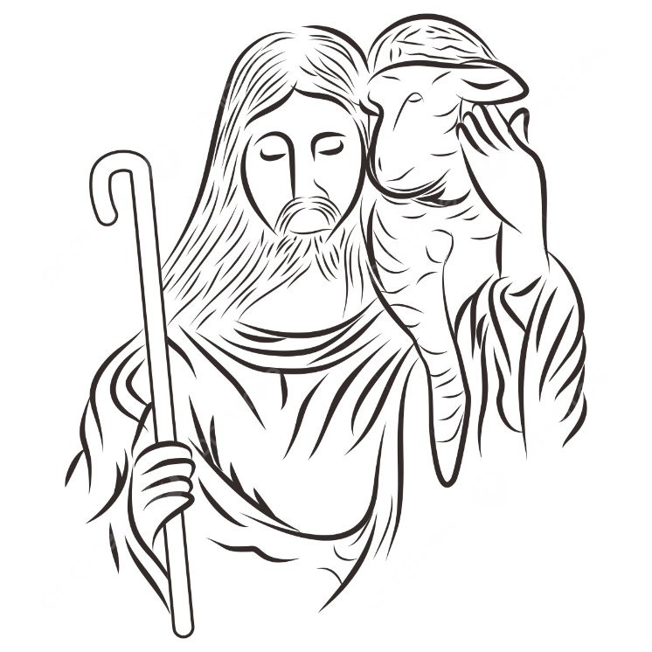

Saturday, 4/25 & Sunday, 4/26/2026 Prayers of Intercession
Trusting in the power of Christ’s resurrection to heal and redeem our broken world, let us pray for the needs of all creation.
A brief silence.
Shepherding God, draw all people to yourself and lead them in paths of righteousness. Embolden your church to enter the valleys of the world and guide us beside the still waters of your grace. We pray for military and prison chaplains serving near and far. Merciful God,
receive our prayer.
Creator God, by the resurrection of your Son, show us your steadfast love and instruct our hearts in your ways. Help us to revere and protect the wonders of your creation. Merciful God,
receive our prayer.
Righteous Judge, strengthen and uphold those who work for justice and advocate for human rights. Bring an end to oppression and save us from the temptation of violence or vengeance. Merciful God,
receive our prayer.
Great Physician, walk with those who are grieving, and anoint those who are ill or injured (especially [names].…and all other people or concerns we now name aloud on our lips or in the silence of our hearts.) Restore them to health of body, mind, and spirit. Merciful God,
receive our prayer.
Good Shepherd, continually seek us out as lambs of your flock, and form us into a community where all are honored and cared for. Spread a feast before us and fill our cups to overflowing. Merciful God,
receive our prayer.
Living God, we praise you for the saints who have died in faith and now dwell in your love. At our end, bring us, with them, to our heavenly home. Merciful God,
receive our prayer.
God of resurrection power, use us and these prayers to proclaim the good news of new life to all the world, through Jesus Christ, our risen Savior.
Amen.

