  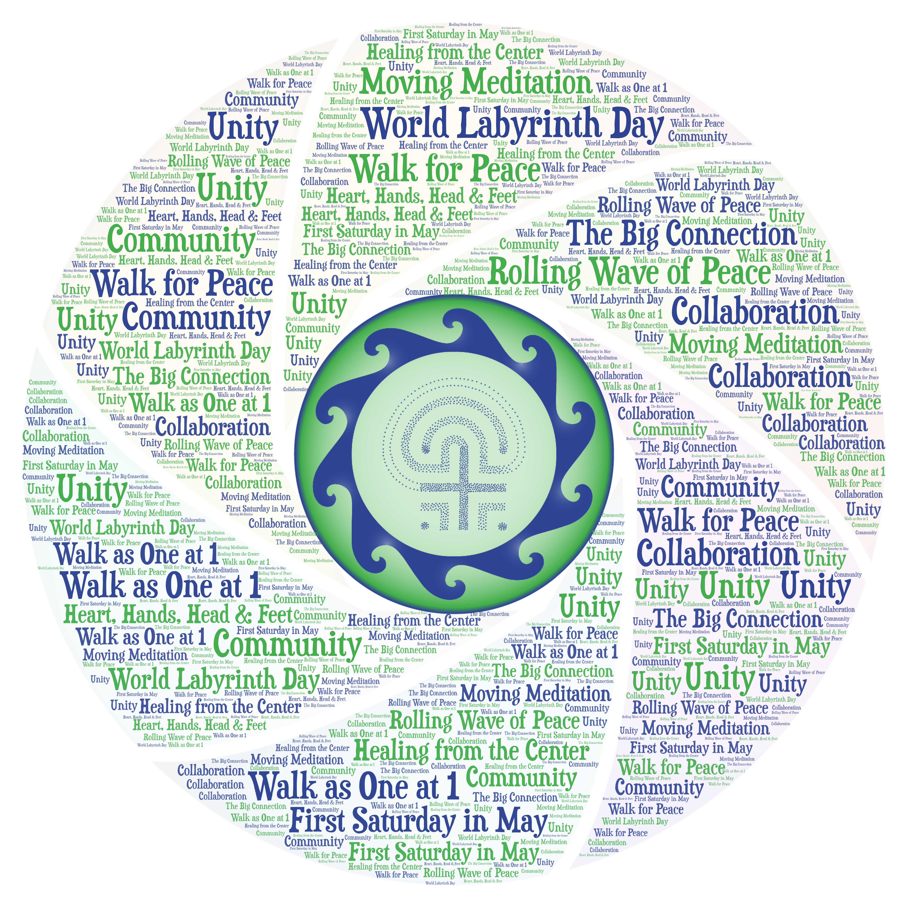
    - may 2, 2026
  World labyrinth Day
  Walk as One for Peace
  Fort Myers participants will be joining with thousands of people from around the world, walking the labyrinth at 1pm local time, creaing a unified rolling wave of peaceful energy passing from one time zone to the next across the earth!
  
  Location:
  Unitarian universalist congregation
  13411 Shire lane fort myers, FL 33912
  Time
  12:30pm – 2pm
  all are welcome to attend this free event
  For more info: https://creatingsoulspace.org/spiritual-retreat or WorldLabyrinthDay.org
  https://creatingsoulspace.org/spiritual-retreat
  World Labyrinth Day
  is an annual international event sponsored by The Labyrinth Society.
  Every year on the first Saturday in May thousands of people around the world participate in this moving meditation for world peace and celebration of the labyrinth experience.

