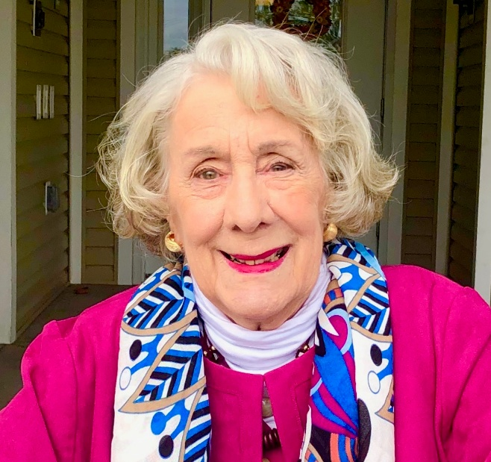
Imogene (Genie) Lineburg Poland
Imogene (Genie) Lineburg Poland, born July 7, 1929, passed away on April 26, 2026. She was born in Washington, D.C., to Hesler and Mae Lineburg. She was preceded in death by her parents; her husband of 57 years, J. Wesley Poland; her sister, Margie Moyers; her brother-in-law, Robert (Bob) Moyers; and her nephew, Frankie Malcolm.
Genie is survived by her daughters, Mona Poland Rawles of Harrisonburg and Sandy Barker (husband James Barker) of Elizabethton, TN; her grandson, James Wesley Barker and wife Leslie Schorr; and one great-grandson, Richard Wesley Barker of Columbus, GA. She is also survived by Eddie Sze, whom she considered her adopted son, and his wife, MaryBeth Sze, of Jamesville, NY, whom she considered her dear friend.
She also leaves behind nieces Jan Moyers Foltz, Jill Moyers Bush, Beverley Sirbaugh Ridings, Joan Malcolm, Ann Malcolm, and nephew Alan Sirbaugh.
Genie was the valedictorian of her graduating class at New Market High School in New Market, VA. She graduated from the Medical College of Virginia in Richmond in 1950 as a Registered Physical Therapist. A recipient of a grant from the Polio Foundation, she cared for polio patients during the pandemic in New York, California, New Orleans, and at the Woodrow Wilson Rehabilitation Center in Virginia. Notably, she was one of two therapists who established the physical therapy department at Rockingham Memorial Hospital.
She was an active, long-standing member of the Gideons International Auxiliary and a member of Manor Memorial United Methodist Church in New Market, Virginia.
A Celebration of Life will be held at Manor Memorial United Church, 9320 N. Congress St., New Market, VA, at 3:00 p.m. on May 9th. Family and friends are invited to a reception in the fellowship church hall following the service.
The family extends a heartfelt thanks to Pastor Stephen Creech, Gary Comer, Derek Young, and the staff and residents of Brunk House at Virginia Mennonite Retirement Center for their friendship, amazing care, humor, and love.
Genie loved the color blue; the family invites attendees to wear blue to the celebration.
In lieu of flowers, Genie requested memorials be given to the Gideons to fund their Bible ministry: http://gideons.org/donate

