Holy Trinity Lutheran Church
150 River Road Red Bank, NJ 07701
Church Office: (732) 741-9241 Fax: (732) 741-9577
email: holytrinitychurch4@verizon.net
Website: htlcredbank.org
Pastor: Rev. John Mack, Jr.
Cell: (336)-392-5839
Minister of Music: Peter Isherwood
Parish Administrator: Deanna Vergari
Council President: Cynthia Kazmac



April 26, 2026

Fourth Sunday of Easter

Introduction
Today is sometimes called “Good Shepherd Sunday.” Jesus is called the “gate” of the sheep in today’s gospel. The risen Christ opens the way to abundant life. He anoints our heads with oil and guides us beside the still waters of our baptism. Each Sunday he spreads a feast before us amid the world’s violence and war. We go forth to be signs of the resurrection and extend God’s tender care to all creation.

Welcome & Announcements (Please remember to silence your cell phone!)

Prelude (We prayerfully prepare our hearts and minds to worship!)

+ GATHERING +

Thanksgiving for Baptism
All may make the sign of the cross, the sign that is marked at baptism, as the presiding minister begins.
P:Alleluia! Christ is risen.
C:Christ is risen indeed. Alleluia!
P:Salvation belongs to our God who is seated on the throne
and to the Lamb!
C:Amen.
P:Let us give thanks for the gifts of baptism.
Water may be poured into the font as the presiding minister continues.
P:Merciful God,
you are the one who was, who is, and who is to come.
You lead us beside still waters.
We thank you for the waters of creation:
morning dew, gentle rain, roaring waves.
We thank you for the waters that nourish us (local waters may be named).
Blessed are you.
C:You guide us to springs of the water of life.
P:Jesus Christ, you are the faithful witness
who accompanies us on our journeys.
We give you thanks for your life-giving death and resurrection.
We praise you for joining us in joy and sorrow.
Blessed are you.
C:You guide us to springs of the water of life.
P:Holy Spirit, you anoint our head with oil and our cup overflows.
Break down barriers that divide us.
Fill us with the breath of peace.
Blessed are you.
C:You guide us to springs of the water of life.
P:Holy One, we thank you for the gifts and grace of baptism,
and for making us a new creation.
We join with saints and angels, giving you honor and praise,
now and forever.
C:Amen.

*Gathering Hymn ELW 778 The Lord Is My Shepherd
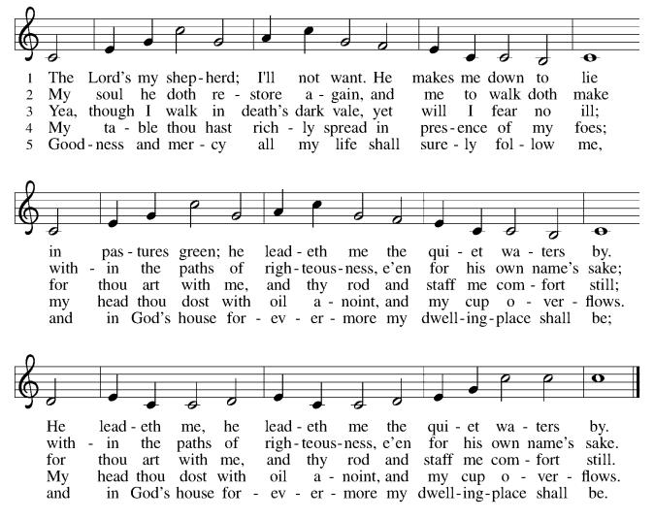

*Pastoral Greeting

P: The Grace of our Lord Jesus Christ, the love of God, and the communion of the Holy Spirit be with you all.

C: And also with you!

Hymn of Praise

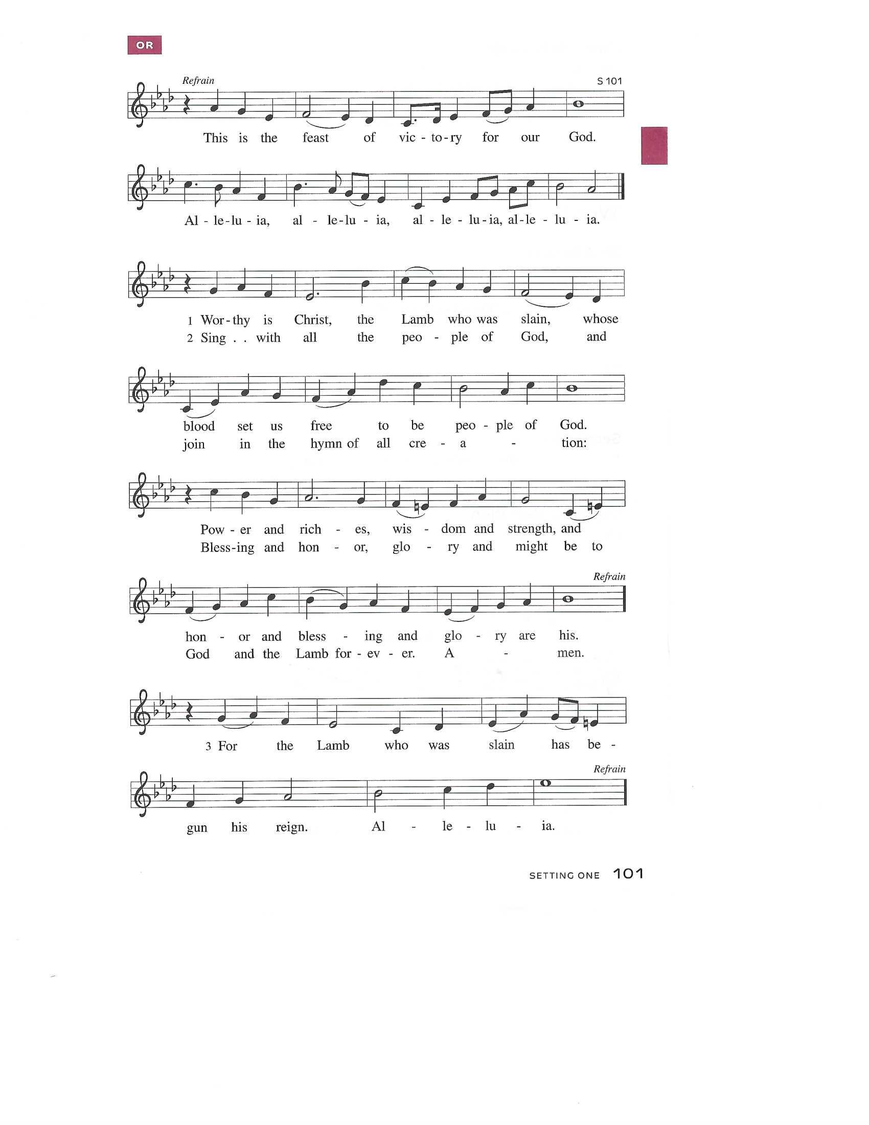

Prayer of the Day
P: O God our shepherd, you know your sheep by name and lead us to safety through the valleys of death. Guide us by your voice, that we may walk in certainty and security to the joyous feast prepared in your house, through Jesus Christ, our Savior and Lord, who lives and reigns with you and the Holy Spirit, one God, now and forever.
C: Amen!

Children’s Message

+WORD+

First Reading: Acts 2:42-47
Today’s reading is a description of life in the community following Peter’s sermon on the day of Pentecost, when the Spirit was poured out on God’s people. The new community is sustained in worship and fellowship, shares what they have, and ensures that everyone has enough.

⁴² [The baptized] devoted themselves to the apostles’ teaching and fellowship, to the breaking of bread and the prayers.
⁴³ Awe came upon everyone because many wonders and signs were being done through the apostles. ⁴⁴ All who believed were together and had all things in common; ⁴⁵ they would sell their possessions and goods and distribute the proceeds to all, as any had need. ⁴⁶ Day by day, as they spent much time together in the temple, they broke bread at home and ate their food with glad and generous hearts, ⁴⁷ praising God and having the goodwill of all the people. And day by day the Lord added to their number those who were being saved.

Psalm: Psalm 23
The Lord is my shepherd; I shall not be in want. (Ps. 23:1)

¹ The Lord | is my shepherd;
I shall not | be in want.
² The Lord makes me lie down | in green pastures
and leads me be- | side still waters.
³ You restore my | soul, O Lord,
and guide me along right pathways | for your name’s sake.
⁴ Though I walk through the valley of the shadow of death, I shall | fear no evil;
for you are with me; your rod and your staff, they | comfort me.
⁵ You prepare a table before me in the presence | of my enemies;
you anoint my head with oil, and my cup is | running over.
⁶ Surely goodness and mercy shall follow me all the days | of my life,
and I will dwell in the house of the | Lord forever.

Second Reading: 1 Peter 2:19-25
Doing the right things does not guarantee that one will not experience difficulties, hardships, rejection, or even suffering. Here Christ is presented as the model for our path of endurance and loyalty to God, particularly amid adversity.

¹⁹ It is a commendable thing if, being aware of God, a person endures pain while suffering unjustly. ²⁰ If you endure when you are beaten for doing wrong, what credit is that? But if you endure when you do good and suffer for it, this is a commendable thing before God. ²¹ For to this you have been called, because Christ also suffered for you, leaving you an example, so that you should follow in his steps.
²² “He committed no sin,
and no deceit was found in his mouth.”
²³ When he was abused, he did not return abuse; when he suffered, he did not threaten, but he entrusted himself to the one who judges justly. ²⁴ He himself bore our sins in his body on the cross, so that, having died to sins, we might live for righteousness; by his wounds you have been healed. ²⁵ For you were going astray like sheep, but now you have returned to the shepherd and guardian of your souls.

*Gospel Acclamation
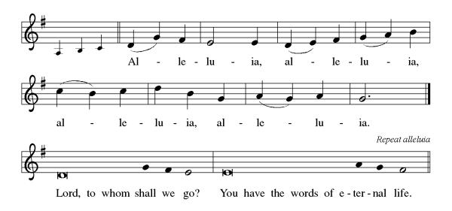

P: The Holy Gospel According to St. John 10th Chapter
C: Glory to You O Lord!

Gospel: John 10:1-10
Jesus uses an image familiar to the people of his day to make a point about spiritual leadership. Those who listen to Jesus are led to abundant life.

[Jesus said:] ¹ “Very truly, I tell you, anyone who does not enter the sheepfold by the gate but climbs in by another way is a thief and a bandit. ² The one who enters by the gate is the shepherd of the sheep. ³ The gatekeeper opens the gate for him, and the sheep hear his voice. He calls his own sheep by name and leads them out. ⁴ When he has brought out all his own, he goes ahead of them, and the sheep follow him because they know his voice. ⁵ They will not follow a stranger, but they will run from him because they do not know the voice of strangers.” ⁶ Jesus used this figure of speech with them, but they did not understand what he was saying to them.
⁷ So again Jesus said to them, “Very truly, I tell you, I am the gate for the sheep. ⁸ All who came before me are thieves and bandits, but the sheep did not listen to them. ⁹ I am the gate. Whoever enters by me will be saved and will come in and go out and find pasture. ¹⁰ The thief comes only to steal and kill and destroy. I came that they may have life and have it abundantly.”

P: The Gospel of the Lord
C: Praise to you, O Christ!
Sermon
*Hymn of the Day ELW 764 Have No Fear, Little Flock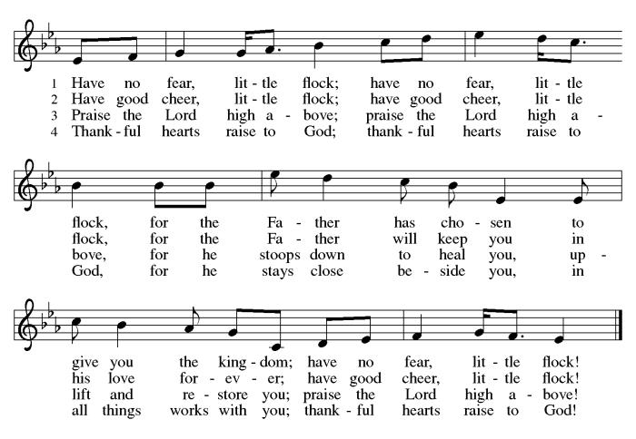
*Nicene Creed
We believe in one God,
the Father, the Almighty,
maker of heaven and earth,
of all that is, seen and unseen.
We believe in one Lord, Jesus Christ,
the only Son of God,
eternally begotten of the Father,
God from God, Light from Light,
true God from true God,
begotten, not made,
of one Being with the Father;
through him all things were made.
For us and for our salvation
he came down from heaven,
was incarnate of the Holy Spirit and the Virgin Mary
and became truly human.
For our sake he was crucified under Pontius Pilate;
he suffered death and was buried.
On the third day he rose again
in accordance with the Scriptures;
he ascended into heaven
and is seated at the right hand of the Father.
He will come again in glory to judge the living and the dead,
and his kingdom will have no end.
We believe in the Holy Spirit, the Lord, the giver of life,
who proceeds from the Father and the Son,
who with the Father and the Son is worshiped and glorified,
who has spoken through the prophets.
We believe in one holy catholic and apostolic church.
We acknowledge one baptism for the forgiveness of sins.
We look for the resurrection of the dead,
and the life of the world to come. Amen.

*Prayers of Intercession
Trusting in the power of Christ’s resurrection to heal and redeem our broken world, let us pray for the needs of all creation.
A brief silence.
Shepherding God, draw all people to yourself and lead them in paths of righteousness. Embolden your church to enter the valleys of the world and guide us beside the still waters of your grace. We pray for military and prison chaplains serving near and far. Merciful God,
receive our prayer.
Creator God, by the resurrection of your Son, show us your steadfast love and instruct our hearts in your ways. Help us to revere and protect the wonders of your creation. Merciful God,
C:receive our prayer.
Righteous Judge, strengthen and uphold those who work for justice and advocate for human rights. Bring an end to oppression and save us from the temptation of violence or vengeance. Merciful God,
C:receive our prayer.
Great Physician, walk with those who are grieving, and anoint those who are ill or injured (especially). Restore them to health of body, mind, and spirit. Merciful God,
C:receive our prayer.
Good Shepherd, continually seek us out as lambs of your flock, and form us into a community where all are honored and cared for. Spread a feast before us and fill our cups to overflowing. Merciful God,
C:receive our prayer.
Here other intercessions may be offered.
Living God, we praise you for the saints who have died in faith and now dwell in your love. At our end, bring us, with them, to our heavenly home. Merciful God,
C:receive our prayer.
God of resurrection power, use us and these prayers to proclaim the good news of new life to all the world, through Jesus Christ, our risen Savior.
C: Amen.

Greeting of Peace
P: The peace of Christ be with you always!
C: And also with you!

Offering (Thank you for your support for our ministry!)

*Doxology ELW 384 v.4 That Easter Day with Joy Was Bright (Please stand and join in singing as we share our gifts!)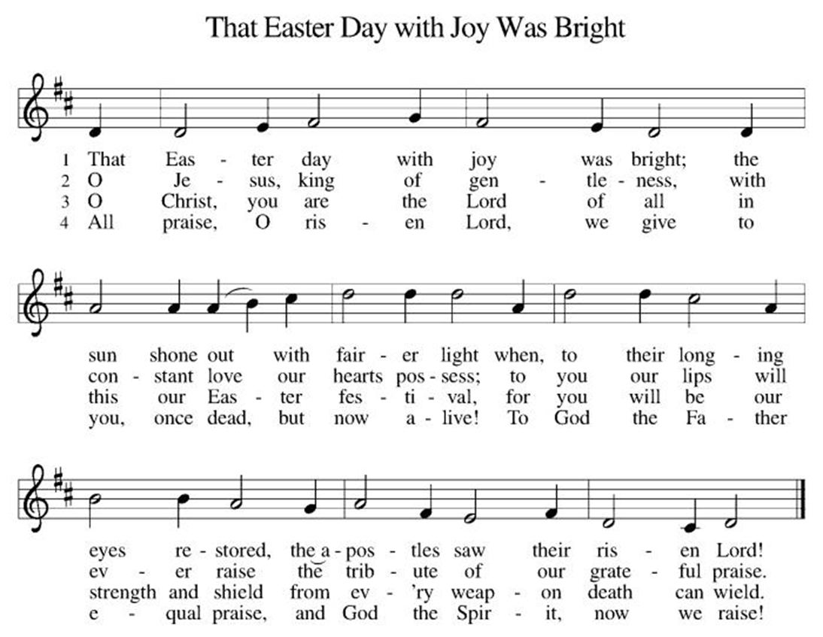

*Offering Prayer
A: Merciful God,
C: accept the fruits of our labor, gathered to give you glory.
You have set a table before us, a glimpse of that great day
when we will hunger and thirst no more.
Nourish us with the body and blood of Jesus,
that goodness and mercy may follow us
and bless the world you love.
In the name of Jesus,
Amen!

+MEAL+
*Great Thanksgiving
P: The Lord be with you.
C: And also with you.

P: Lift up your hearts.
C: We lift them to the Lord.

P: Let us give thanks to the Lord our God.
C: It is right to give our thanks and praise.

P: It is indeed right, our duty and our joy,
that we should at all times and in all places
give thanks and praise to you, almighty and merciful God,
for the glorious resurrection of our Savior Jesus Christ,
the true Paschal Lamb who gave himself to take away our sin;
who in dying has destroyed death,
and in rising has brought us to eternal life.
And so, with Mary Magdalene and Peter and all the witnesses of the resurrection, with earth and sea and all their creatures,
and with angels and archangels, cherubim and seraphim,
we praise your name and join their unending hymn:

*Sanctus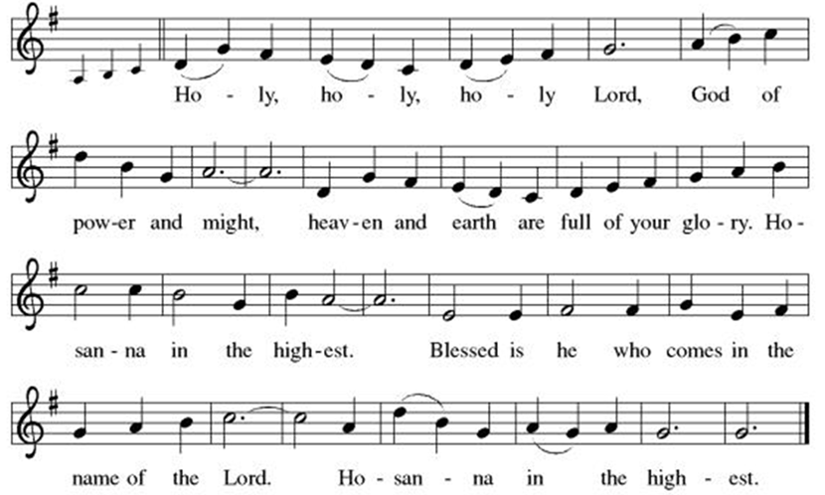

*Eucharistic Prayer
P: Holy, mighty, and merciful Lord,
heaven and earth are full of your glory.

In great love you sent to us Jesus, your Son,
who reached out to heal the sick and suffering,
who preached good news to the poor,
and who, on the cross, opened his arms to all.

In the night in which he was betrayed,
our Lord Jesus took bread, and gave thanks;
broke it, and gave it to his disciples, saying:
Take and eat; this is my body, given for you.
Do this for the remembrance of me.

Again, after supper, he took the cup, gave thanks,
and gave it for all to drink, saying:
This cup is the new covenant in my blood,
shed for you and for all people for the forgiveness of sin.
Do this for the remembrance of me.

Remembering, therefore, his death, resurrection, and ascension,
we await his coming in glory.

Pour out upon us the Spirit of your love, O Lord,
and unite the wills of all who share this heavenly food,
the body and blood of Jesus Christ, our Lord;
to whom, with you and the Holy Spirit,
be all honor and glory, now and forever.

C: Amen!

*THE LORD’S PRAYER
Our Father, who art in heaven,
hallowed be thy name,
thy kingdom come,
thy will be done,
on earth as it is in heaven.
Give us this day our daily bread;
and forgive us our trespasses,
as we forgive those
who trespass against us;
and lead us not into temptation,
but deliver us from evil.
For thine is the kingdom,
and the power, and the glory,
forever and ever. Amen.
*Lamb of God
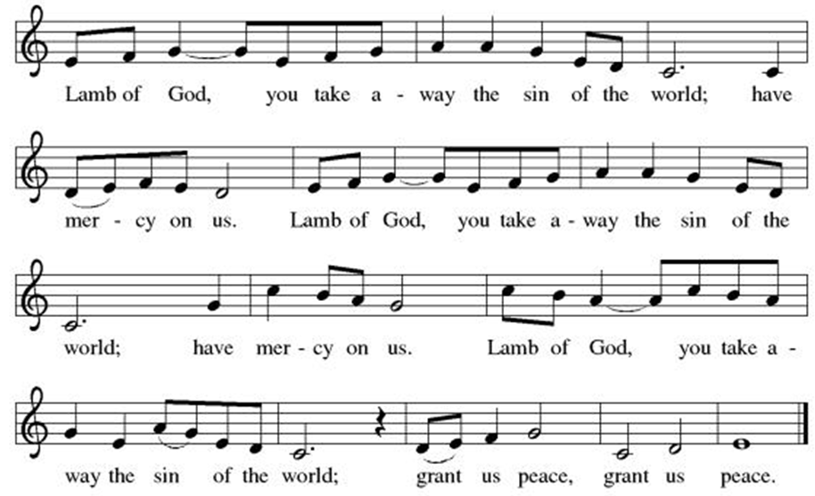

Spiritual Communion Prayer
P: Let us pray for the communion of all present here, those viewing our service virtually, those in our hearts and in our world.
C: Lord Jesus, I believe you are truly present in the Sacrament of Holy Communion. When I cannot receive Communion, I pray that you come into my heart. I know that nothing in Heaven or on earth can separate me from your love. Amen.

Invitation to Communion
P: Come to the table of new life.
Receive the risen Lord.

C: Thanks be to God!
(All are invited to the communion rail following the guidance of the ushers. Communion will be shared through the host and individual cups. If you would like communion but are unable to join us at the rail, please alert the usher!)
Communion Hymns (Please join in singing!)
ELW 780 Shepherd Me, O God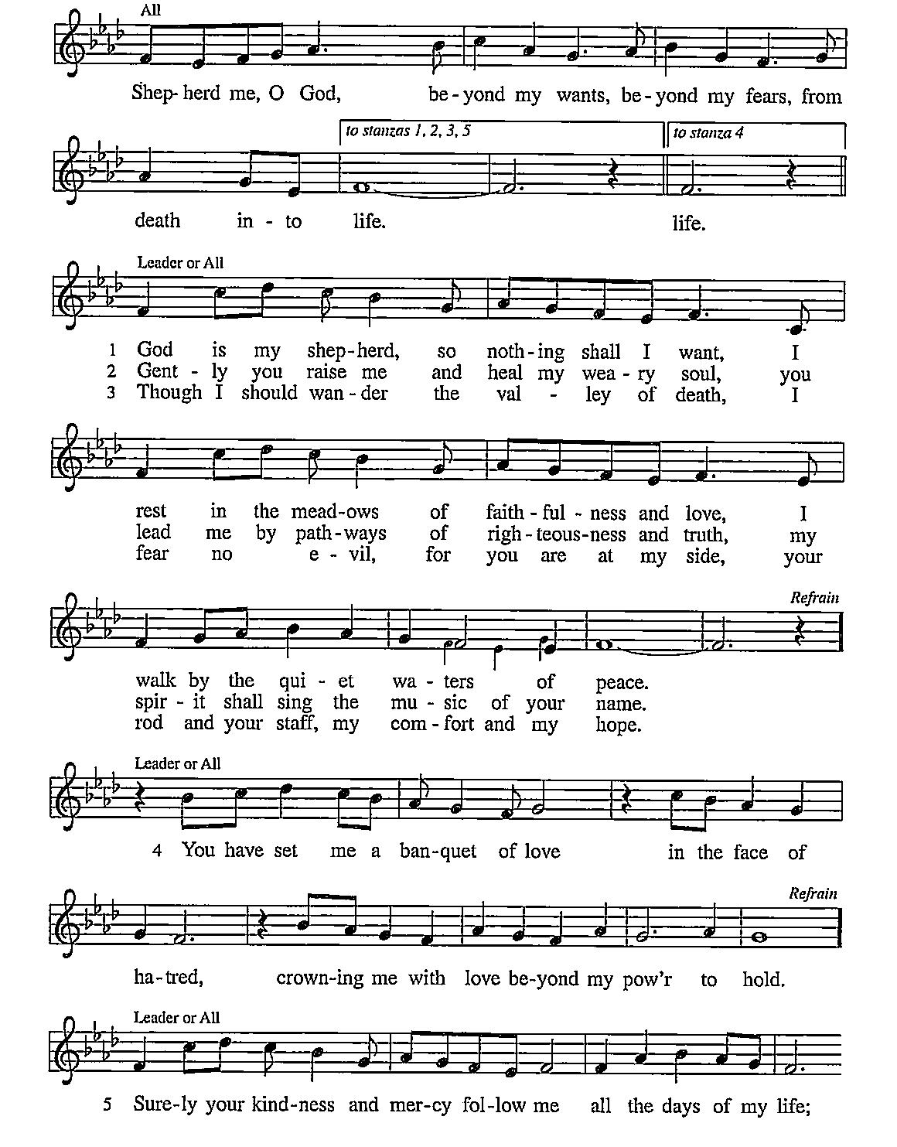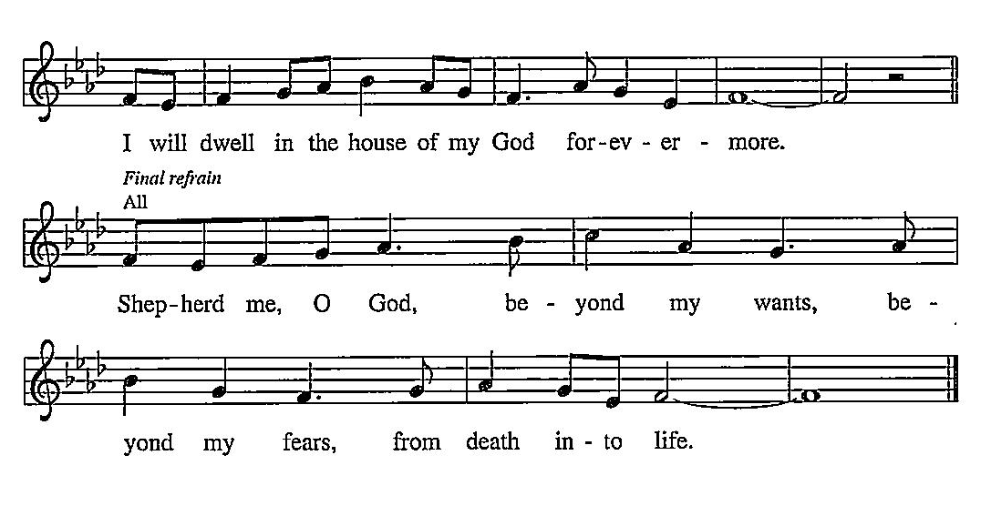

ELW 502 The King of Love My Shepherd Is
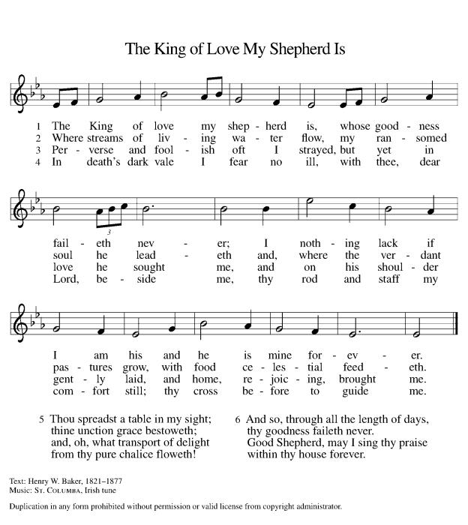

P: The body and blood of our Lord Jesus Christ strengthen you and keep you in his grace. C: Amen!

*Prayer after Communion
A: Holy One,
through this meal you have made your home among us
and are making all things new.
Send us now to speak peace to anxious hearts,
to love our enemies,
and to bring your healing to the nations.
In the name of Jesus,
C: Amen.

+Sending+

*Blessing
P: God Almighty, who is the beginning and the end,
Jesus Christ, the firstborn of the dead,
and the Spirit, our advocate and peace,
☩ bless you now and forever.
C: Amen!

*Sending Hymn ELW 789 Savior, Like a Shepherd Lead Us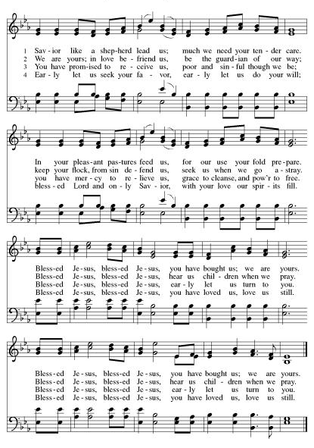
*Dismissal
A: Go in peace. Praise the Lord. Alleluia!
C: Thanks be to God. Alleluia!
Postlude

Copyright © 2020 Augsburg Fortress. All rights reserved. Reprinted by permission under Augsburg Fortress Liturgies Annual License #SB106907. New Revised Standard Version Bible, Copyright © 1989, Division of Christian Education of the National Council of the Churches of Christ in the United States of America. Used by permission. All rights reserved. Revised Common Lectionary, Copyright © 1992 Consultation on Common Texts, admin Augsburg Fortress. Used by permission.
Treasurer’s Report


March giving totaled $24,026, putting us ahead of pace toward our 2026 Challenge goal of $244,000, with 39% raised in just 25% of the year. Continued participation through regular or additional Challenge gifts will help ensure we fully fund HTLC’s ministry and mission in the months ahead.

Worship Volunteer Schedule
Date | Asst. Min | Usher | Sacristan | Lector | Counter
April 26 | Charlie Rugg | Keith Bennett | Joanne Giordano | Rosemary Lane | Kazmac/Bradford
May 3 | Keith Bennett | Kathy Caputo | Sherry Lee | Bill Spreen | Socha/Cheek
May 10 | Keith Bennett | Dan Grillon | Helga Britton | Cynthia Kazmac | Carleo/Spreen
May 17 | Chris Foard | The Gripps | Nancy Poole | Molly Foard | Foss/Foard
May 24 | Charlie Rugg | Andy Wehr/Dan Grillon | Joanne Giordano | Rosemary Lane | Bradford/Coleman

Coffee Hour- The Doyles
Altar Flowers- In honor or Janice Tyrell’s 75th Birthday!!

ANNOUNCEMENTS Thank you! To all who consistently support our church and ministries through your time, talent, and treasure. Please help us grow by inviting your friends and family to worship and events. You are what makes Holy Trinity a wonderful church family!

Stay in touch! Please visit our church website, www.htlcredbank.org for updates and information. You can also find us on Facebook and view services online. The office is open from 9am to 2pm, Monday to Thursday.

Car Wash-The car wash will start at 10 AM with churchgoers cars washed first, then will open up to the general public from noon till 2:00 PM. We will need volunteers to wash the cars, dry cars, manage supplies and supervise. Please sign up in the Red Book. Contact Lauren Bennett with questions period proceeds will support Cross Roads Day Camp.

100 Anniversary Committee- Meeting Sunday April 26: All are welcome to the initial meeting of the planning committee for 100th anniversary of Holy Trinity Evangelical Lutheran Church. Let’s gather after church on April 26 to get this committee up and running and develop a meeting schedule. This initial meeting should not take long.

Interested in becoming an usher? Would you like to be a substitute if needed? Or maybe you need to brush up on your skills? Dan Grillon will be leading an Usher Training/Refresher class Sunday, May 24, after worship service. Sign up below, all are welcome!

Name Tag Sundays: On the first Sunday of each month, names tags and markers will be at each entrance of the sanctuary. Please fill out a tag and wear one for worship and for coffee hour to welcome visitors and help newcomers put names to faces.

Sunday School in the New Year, we will continue to study stories and lessons from the Old Testament beginning with Jacob. Kids will love the crafts, songs and games that accompany each lesson.
The following dates there will be Sunday School:
April- 12 and 26, May- 3, 17 and 31, June- 7 and 14
As was done in the fall, there will be opportunities to volunteer as SS lead teacher. A signup will be emailed out shortly and will also be posted in the red binder. Consider signing up! All lesson materials will be supplied and laid out and a leader guide will be emailed to volunteers approximately 1 week in advance. Blessings for a wonderful 2026!~Lauren

Choir The Holy Trinity Choir welcomes our singers back for a preparation rehearsal on Sunday, September 7th at 9am in the church hall. All are welcome to join us in song as often as you are able. Choir meets each Sunday at 9am to practice and prepare our music. Join us and help us grow by spreading the word about the HTLC Choir!

Quilting- The Quilters need gently used any bed sheets of any size! Please leave any donations in the quilters closet in Fellowship Hall. Thank you!

Quilters Need Help
If anyone is traveling through Mechanicsville, PA (near Peddler’s Village), and can add a few extra minutes to your trip, the warehouse for shipping quilts, school kits, etc is located directly off one of the exits.
We accumulate many quilts throughout the year and we would appreciate sending some quilts with you to deliver. Any questions, please call Sherry Lee or Elaine Theophall.

Weekly Quilting on Wednesdays at 9:30. Bring your lunch and enjoy some fellowship at noon. All are welcome.

Social Ministry
*Year-round collections will continue for food items for Lunch Break. There is a sign-up sheet in the red book for those who can help drop these items to Lunch Break.
*We will also collect adult men's socks to periodically drop at the Red Bank Warminq Center.
*For those interested in the Heartwarminq Center — the new women's shelter is adjacent to the First Baptist Church of Red Bank at 90 Maple Ave. You can follow up on this mission through their website - https://www.thefeastnj.org- On this site, they also include wish list items that can be purchased through amazon. We will be exploring purchasing some of these through a Thrivent card. If you want to purchase on your own, you can leave items at church, and the Social Ministry will deliver them.

JBJ Soul Kitchen Day of Hope Walk– Tuesday, May 12, 2026
Holy Trinity Church has participated in this event for several years. We’re excited to participate again this year in the annual Day of Hope Walk on Tuesday, May 12th! There will be a sign up in the red book.
Event Details:Location: Begins at Riverside Gardens Park, Red Bank & concludes at JBJ Soul Kitchen Check-in: 10:00AM Walk Begins: 11:00AM Refreshments: Available at JBJ Soul Kitchen after the walk.

Pastoral Care and Prayer... We are here to care for and pray! Please contact the office to add or adjust prayer requests. If you or someone you know needs pastoral care, please contact the office and Pastor Mack!

THANK YOU for supporting and sustaining our church and ministries! All are welcome here! Please invite your family and friends to worship with us! Find us online at www.htlcredbank.org

Dear Members of Holy Trinity,
We invite you to attend a Special Congregational Meeting today, April 26, 2026 immediately following worship, to consider an exciting opportunity for our church.
The NJ Synod has launched a Mortgage Capital Match Grant program, offering a 2-to-1 match on funds raised for mortgage reduction. For Holy Trinity, this means that if we raise $25,000, we can pay off our $75,000 mortgage in full.
This is a one-time opportunity, made possible by funds from the NJ Synod.
To participate, we must receive congregational approval to begin a capital campaign. The meeting will be brief and focused, with:
- A short presentation from the Finance Committee
- A single vote to authorize the campaign
Additional details about the campaign will be shared at the meeting and in the weeks ahead.

