All Saints Anglican Church
6904 Lougheed Highway, Agassiz, B.C. V0M 1A0
Bulletin April 20th, 2026 – April 26th, 2026

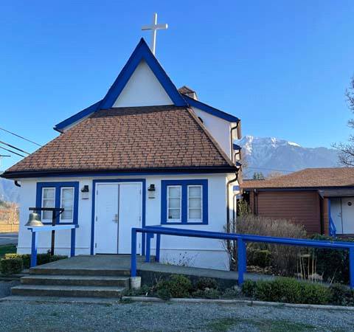

‘The ground we walk does not belong to us; for thousands of years it has been - and remains - the territory of the Stó:lō. We are grateful for their sharing.

Phone: 604-796-3553
Website: www.allsaints-agassiz.ca
https://www.facebook.com/groups/AllSaintsFamily
OUR DOOR IS OPEN AND ALL ARE WELCOME
April 26th, 2026, Fourth Sunday of Easter
Priest in Charge: The Reverend Philip Barker
Hosts: Graham Featherstone/Jennifer Pinlac
Intercessor: Lynn Laughlin
Lay Administrator: Dorothy Cresswell
Announcer: Virginia Jennings
Organ/Piano: Francesca Froehlich
Readers: Graham Featherstone/Liane Loeppky
Vicar’s cell phone: Revd. Philip Barker. 778-867-2461

Vicar’s Warden: Ginny Jennings. 604-796-2206
People’s Warden: Lynn Laughlin. 604-799-5131
Parish email: revpb1950@gmail.com
Please contact either warden if you have an issue that needs to be brought to the attention of the Vicar - or contact the Vicar direct (see above for details).

All Saint’s Calendar/Announcements:

- Book Club – On April 8th Book Club will resume Zoom meetings on Wednesdays at 5.00 pm. The first week will be a discussion of the 3 books that were read by members during Lent.

The next book will be "The Last Week: What the Gospels really teach about Jesus' final days in Jerusalem", by Marcus J. Borg and John Dominic Crosson. This will be an appropriate follow on from Holy Week.
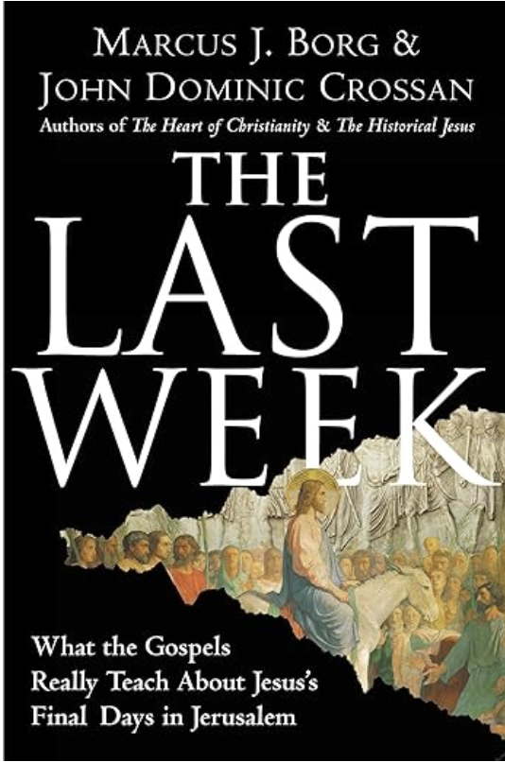
The book is $21.00 in paperback on Amazon and also
available on Kindle.

If you would like to join the group or have a copy of the
book, please contact Sheila at sjbarker0379@gmail.com

- Bible Study with Karol is every Saturday morning 0830-0900 on Zoom.

- Prayer Requests can be given on a piece of paper to either of the Wardens or the Vicar or entered in the Prayer Request Book on the lectern. Alternatively, you can contact Anthea Lewis at antheamlewis@shaw.ca for Pray First Prayer Circle, which is a confidential online prayer circle.

- Music Requests may be given to the Wardens or the Vicar.

- AA meets in the hall every Tuesday and Friday at noon.

- Every Thursday in the hall 1100-1200 we have a social time with coffee, games if you like or just talk.

- At 1000-1100 on Thursdays there is an Interactive Bible Study on the day’s Lectionary readings. All are welcome – discover the treasures in this amazing book!

- 5th Sunday of each month will be a potluck lunch after the service.

Ministerial Meandering
J’aurais pu…j’aurais du…

Aaahhh - the future conditional tense! The tense of ‘ought’ and ‘should’ - the tense of obligation so beloved of people-pleasers, perhaps even their ‘raison d’être’ - (to stay with the French). It is also the voice of guilt, the echo of self-denial and altruism, the sound of worthlessness rattling around in an empty wine silo.

I touched tangentially on value with regard to self last week, and I need to continue a little along that line today. There are people that one meets who are clearly genuinely concerned for the welfare of others; I’d like to think that I was occasionally among their number. There are others, however, who seem to be unsatisfied unless they have torn themselves emotionally and physically into shreds of discarded clothing, fit only for stuffing cushions or starting fires.

But then - perhaps that’s exactly what they are trying to do by their continual self-sacrifice - start a fire of guilt in others. Perhaps the ability to make others feel uncomfortable by witnessing their praiseworthy discomfort and self-denial is what actually floats their boat. Is there not an element of Uriah Heep in this attitude, which reeks of a certain hypocrisy?

“Ah, you’re an old cynic!” you might well say, but I would ask you to examine yourself carefully - as I have had to do - and ask whether there isn’t a certain satisfaction in being seen to be more charitable and giving of your time and goods than others - but only so long as others know it? There are (of course) injunctions in the bible against such behaviour - and those which cover the practice of fasting as well. We are encouraged, when fasting, to wash our faces and and anoint our heads (Matthew 6), and so appear to the world as though it’s just a normal day - not going around looking pale, haggard, and wan, complaining that you haven’t eaten in days. I have to say that the practice of fasting has never been one that appealed to me!

But to go back to the self-sacrifice of giving; this also carries with it some instruction from Jesus in the same chapter of Matthew. The goal is to avoid seeking human applause or validation; Jesus says, "Be careful not to practice your righteousness in front of others to be seen by them. If you do, you will have no reward from your Father in heaven. So when you give to the needy, do not announce it with trumpets, as the hypocrites do in the synagogues and on the streets, to be honoured by others. Truly I tell you, they have received their reward in full”

So to return to my first paragraph, I would ask myself if the term, ‘people-pleasers’ is even correct. Because is it not the act of giving that pleases the giver? Is not the person doing the giving the one who is being pleased? Does this then not become a selfish act? If that is true, how then can one ever be entirely unselfish?
This is something of a conundrum or paradox, because the future conditional would then cease to have any power - or even exist at all - if ‘I could’, ‘I should’, and ‘I ought’, actually mean ‘I want to’.

I have no intention of untangling this today, but rather I plan to leave you to wrestle with it over the week - as I shall - and see if we can find some sort of solution that will sit more comfortably with us than the current bed of barbed wire.

Philip+

A Little Chuckle…



Birthdays this Month  April

Rev. Philip Barker – 1 Dorothy Cresswell – 2
Lynn Laughlin – 12 Anthea Lewis – 12
Peggy Arndt – 14 Jennifer Pinlac – 15
Sheila Barker – 19 Helene Atkinson – 27

Diocesan Cycle of Prayer: We Pray for the Clergy and Congregation:

The Deanery of Oakridge – The Revd Melanie Calabrigo, Regional Dean; Synod Office Staff; St. Titus, Oakridge -The Revd Marion Wong; The Diocese of the Yukon - Bishop Lesley Wheeler-Dame

Anglican Church of Canada Cycle of Prayer – We Pray for:

The Rt. Rev. Todd Townshend, Bishop, and the clergy and people of the Diocese of Huron

Collect

O God of peace, who brought again from the dead our Lord Jesus Christ, that great shepherd of the sheep, by the blood of the eternal covenant, make us perfect in every good work to do your will, and work in us that which is well-pleasing in your sight; through Jesus Christ our Lord.

Acts 2:42-47 Graham Featherstone

⁴² They devoted themselves to the apostles’ teaching and to fellowship, to the breaking of bread and to prayer. ⁴³ Everyone was filled with awe at the many wonders and signs performed by the apostles. ⁴⁴ All the believers were together and had everything in common. ⁴⁵ They sold property and possessions to give to anyone who had need. ⁴⁶ Every day they continued to meet together in the temple courts. They broke bread in their homes and ate together with glad and sincere hearts, ⁴⁷ praising God and enjoying the favor of all the people. And the Lord added to their number daily those who were being saved.

Psalm 100

¹ Shout for joy to the Lord, all the earth.
² Worship the Lord with gladness;
come before him with joyful songs.
³ Know that the Lord is God.
It is he who made us, and we are his;
we are his people, the sheep of his pasture.

⁴ Enter his gates with thanksgiving
and his courts with praise;
give thanks to him and praise his name.
⁵ For the Lord is good and his love endures forever;
his faithfulness continues through all generations.

1 Peter 2:19-25 Liane Loeppky

¹⁹ For it is commendable if someone bears up under the pain of unjust suffering because they are conscious of God. ²⁰ But how is it to your credit if you receive a beating for doing wrong and endure it? But if you suffer for doing good and you endure it, this is commendable before God. ²¹ To this you were called, because Christ suffered for you, leaving you an example, that you should follow in his steps.

²² “He committed no sin,
and no deceit was found in his mouth.”

²³ When they hurled their insults at him, he did not retaliate; when he suffered, he made no threats. Instead, he entrusted himself to him who judges justly. ²⁴ “He himself bore our sins” in his body on the cross, so that we might die to sins and live for righteousness; “by his wounds you have been healed.” ²⁵ For “you were like sheep going astray,” but now you have returned to the Shepherd and Overseer of your souls.

John 10:1-10 Vicar Philip Barker

¹ “Very truly I tell you Pharisees, anyone who does not enter the sheep pen by the gate, but climbs in by some other way, is a thief and a robber. ² The one who enters by the gate is the shepherd of the sheep. ³ The gatekeeper opens the gate for him, and the sheep listen to his voice. He calls his own sheep by name and leads them out. ⁴ When he has brought out all his own, he goes on ahead of them, and his sheep follow him because they know his voice. ⁵ But they will never follow a stranger; in fact, they will run away from him because they do not recognize a stranger’s voice.” ⁶ Jesus used this figure of speech, but the Pharisees did not understand what he was telling them.

⁷ Therefore Jesus said again, “Very truly I tell you, I am the gate for the sheep. ⁸ All who have come before me are thieves and robbers, but the sheep have not listened to them. ⁹ I am the gate; whoever enters through me will be saved. They will come in and go out, and find pasture. ¹⁰ The thief comes only to steal and kill and destroy; I have come that they may have life, and have it to the full.

Odds and Ends



“Facts Behind Faith” is a collection of Philip’s sermons put together in a booklet.

If you would like a copy of this Philip Barker Collection, the cost is $10.00 and any additional donations are greatly appreciated.



