This Week at PPBC
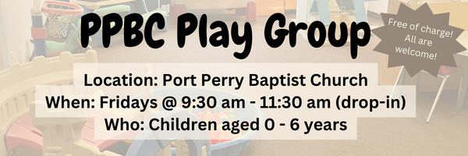
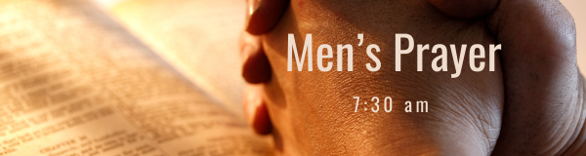



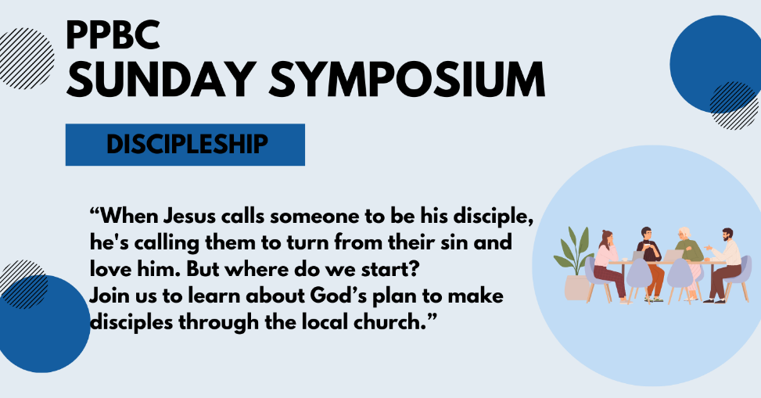
April 26th, 2026


May 9th, 2026
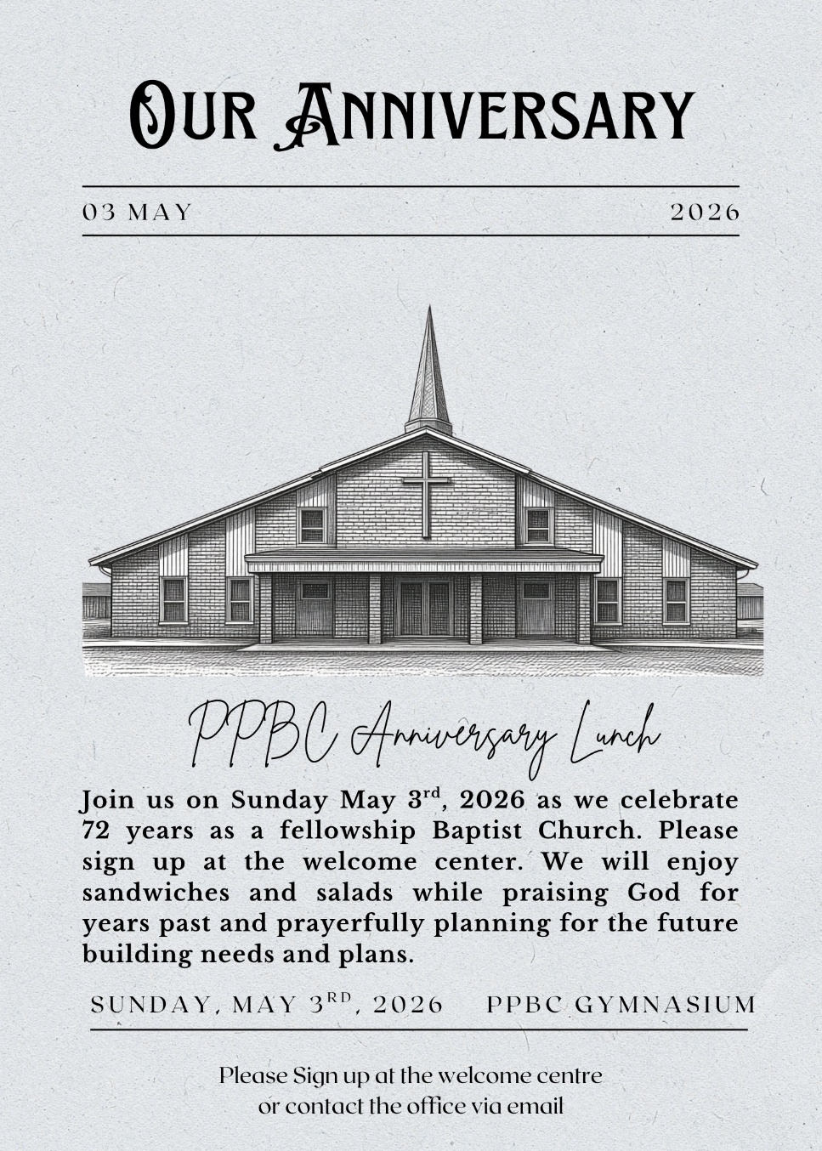

Sunday Ministry Schedules
Below are ministry schedules for Nursery, Jr. Church, Greeters, Ushers, and Sound & Video:
Nursery
April 26: Kathryn denOuden, Alyssa Summers
May 3: Jan Gerrow, Hannah Colwell
Infant Nursery
April 26: Karen Clemens, Rosalie McLaren
May 3: Laura Saunders, Elise Anderson
Jr. Church; ages 3 to grade 1
April 26: Deb Brown, Abby Saunders
May 3: Ellianne McLaren, Mikayla Ferguson
Jr. Church; Grades 2 to 6
April 26: Gregg & Karen Anderson, Lena Sammut
May 3: Tracy Ballanger, Kim St-Onge
Greeters
April 26: Tracy & Karen Ballanger
May 3: Fern & Kim St-Onge
Ushers
April 26: Graeme Foster, Eric Duchesne
May 3: Matt Saunders, Gregg Anderson
Sound & Video
April 26: Sound: Wyatt Werner | Video: Josh Bolsonello
May 3: Sound: Eric Duchesne | Video: Josh Myers

Sunday Service
Song – All Glory Be to Christ
Welcome
Song – Praise to The Lord the Almighty
Scripture
Song – By Faith
Song – My Faith Has Found a Resting Place
Scripture
Prayer
Message – Pastor Jim Clemens
Song – All Glory Be to Christ
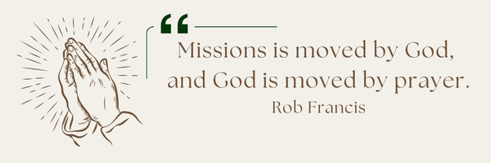
A Prayer Request from Maria: Pray for the Lord's wisdom and discernment to provide proper biblical guidance to Spanish women who need help in their personal lives. For my own discipline, to organize 2 team's (English & Spanish) for evangelism, to disciple others and spiritual growth in their lives for the new Spanish believers. (90% first generation of believers).

Praise & Prayer Highlights
PRAY for Joan Mabley who has been moved to Glen Hill Strathaven in Bowmanville. Please PRAY for Joan’s comfort and peace.
PRAY for John & Joan Mank and their ongoing health concerns.
PRAY for Martin & Tina McCurley and their ongoing health concerns. PRAY for them as they prepare to move the end of April.
PRAY for Jordan & Stephanie Anderson. PRAY for Jordan as he undergoes training in Quebec.
PRAY for Laurie Buismans sister Debbie and their family. Debbie is in Lakeridge health Hospital under observation. PRAY for the family and the doctors who are caring for them.
PRAY for Darren & Brooke VanUden. They are expecting a baby in May 2026. PRAY for Brooke and the little ones health as they approach the due date and delivery.
PRAY for Betty Collins cousin Pat and her ongoing concerns. PRAY for her healing for her neck and that the doctors and nurses would have wisdom in caring for her.

Giving
Just as a reminder, there are several ways you can give:
In Person using the offering box located on the back wall of the sanctuary. Donation envelopes are available at the Welcome Centre. Please contact the church office if you would like a box of donation envelopes (office@portperrybaptist.ca)
Through your online banking, you may send electronic transfers to ppbcdonations@gmail.com.
You can also give through Canada Helps. Donation receipts will be provided by Canada Helps, and transaction fees apply.
***********************************************************************
Weekly Newsletter
The PPBC Newsletter is emailed to the church family every Friday. If you would like to be added to the weekly email list, please contact the office by phone: 905-985-8681 or by email: office@portperrybaptist.ca.
*****************************************************************
Church Information:
Location:
2210 Hwy 7A
Port Perry, ON
L9L 1B4
Office Hours:
Monday: 8:30am – 4:00pm
Tuesday: 8:30am – 4:00pm
Wednesday: Closed
Thursday: 8:30am – 4:00pm
Friday: 8:30 am - 3:00 pm
Contact:
Phone: 905.985.8681
Email: office@portperrybaptist.ca
Website: www.portperrybaptist.ca
Staff:
Sr. Pastor – Rev. Jim Clemens
Administrative Assistant – Madeline Werner
Family Ministries Director – Josh Anderson
Pastoral Intern – Scott McKenzie

PPBC Newsletter
Sunday, April 26, 2026


Sunday Starting Point
Sunday, April 26, 2026 - 9:30 am
“Beginning the day with the Word and prayer”
Adults:
Adults will meet in the sanctuary for a time of study and prayer.
Youth:
Jr High (Grades 7-8) will meet in room 18 with Kate Anderson to study Thessalonians.
Children:
Children ages 3 - grade 6 will meet in room 26.
(Please note nursery is unavailable during Starting Point)
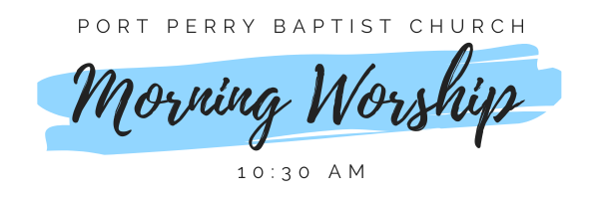Sunday Morning Worship
Sunday, April 26, 2026 - 10:30 am
We are meeting in the sanctuary and will continue to live-stream for those who are unable to attend.
Message: Holy Matrimony
Scripture: 1 Corinthians 7:1-7
Pastor Jim Clemens

