Holy Trinity Evangelical Lutheran Church

The Fourth Sunday of Easter

April 26, 2026, at 10:30 am

Pastor Tina Crog

*Prelude

* Welcome and Announcements Worship Assistant

* Opening Hymn "Have No Fear, Little Flock" ELW 764

1.Have no fear, little flock; have no fear, little flock, for the Father has chosen to give you the kingdom; have no fear, little flock.

2. Have good cheer, little flock; have good cheer, little flock, for the Father will keep you in his love forever; have good cheer, little flock.

3.Praise the Lord high above; praise the Lord high above, for he stoops down to heal you, uplift and restore you; praise the Lord high above.

4. Thankful hearts raise to God; thankful hearts raise to God, for he stays close beside you, in all things works with you; thankful
Hearts raise to God!

* Confession and Forgiveness Pastor Tina
Trusting in the mercy of God, let us confess our sin.
Gracious God, we confess that we have not always lived as Easter people. We cling to fear when you offer peace. We hold onto doubt without seeking you. We close doors that you long to open. Forgive us for the ways we resist your resurrection life. Breathe your Spirit into us again, that we may live as your forgiven and renewed people. Through Jesus Christ, our risen Lord. Amen.

Hear the good news: Christ is risen, and nothing—not even sin or death—can separate us from the love of God. In the mercy of almighty God, your sins are forgiven. You are made new in Christ. Thanks be to God.

* Canticle of Praise “This is the Feast” ELW pg. 149
Refrain: This is the feast of victory for our god, Al-le-lu-ia.
1.Worthy is Christ, the lamb who was slain, whose blood set us free to be people of God. Power and riches and wisdom and
strength, and honor and blessing and glory are his.

Refrain: This is the feast of victory for our god, Al-le-lu-ia.
2.sing with all the people of God and join in the hymn of all creation: Blessing and honor and glory and might be to god and the Lamb forever. amen.

Final Refrain: this is the feast of victory for our god, for the lamb who was slain has begun his reign, al-le-lu-ia. al-le-lu-ia.

*Greeting Pastor Tina

*Prayer of the Day Worship Assistant
O God our shepherd, you know your sheep by name and lead us to safety through the valleys of death. Guide us by your voice, that we may walk in certainty and security to the joyous feast prepared in your house, through Jesus Christ, our Savior and Lord, who lives and reigns with you and the Holy Spirit, one God, now and forever. Amen.

* Passing of the Peace Worship Assistant
May the peace of christ be with you always. and also with you.

Please share the love of christ with one another with a wave.

* Children’s Moment Pastor Tina

*First Lesson: Ezekiel 34:7-15 Reader
⁷ Therefore, you shepherds, hear the word of the Lord: ⁸ As I live, says the Lord God, because my sheep have become a prey and my sheep have become food for all the wild animals, since there was no shepherd, and because my shepherds have not searched for my sheep, but the shepherds have fed themselves and have not fed my sheep, ⁹ therefore, you shepherds, hear the word of the Lord: ¹⁰ Thus says the Lord God: I am against the shepherds, and I will hold them accountable for my sheep and put a stop to their feeding the sheep; no longer shall the shepherds feed themselves. I will rescue my sheep from their mouths, so that they may not be food for them.
¹¹ For thus says the Lord God: I myself will search for my sheep and will sort them out. ¹² As shepherds sort out their flocks when they are among scattered sheep, so I will sort out my sheep. I will rescue them from all the places to which they have been scattered on a day of clouds and thick darkness. ¹³ I will bring them out from the peoples and gather them from the countries and bring them into their own land, and I will feed them on the mountains of Israel, by the watercourses, and in all the inhabited parts of the land. ¹⁴ I will feed them with good pasture, and the mountain heights of Israel shall be their pasture; there they shall lie down in good grazing land, and they shall feed on rich pasture on the mountains of Israel. ¹⁵ I myself will be the shepherd of my sheep, and I will make them lie down, says the Lord God.

The Word of the Lord. Thanks be to God.

*Second Lesson: 1 Peter 2:19-25 Reader
¹⁹ It is a commendable thing if, being aware of God, a person endures pain while suffering unjustly. ²⁰ If you endure when you are beaten for doing wrong, what credit is that? But if you endure when you do good and suffer for it, this is a commendable thing before God. ²¹ For to this you have been called, because Christ also suffered for you, leaving you an example, so that you should follow in his steps.
²² “He committed no sin,
and no deceit was found in his mouth.”
²³ When he was abused, he did not return abuse; when he suffered, he did not threaten, but he entrusted himself to the one who judges justly. ²⁴ He himself bore our sins in his body on the cross, so that, having died to sins, we might live for righteousness; by his wounds you have been healed. ²⁵ For you were going astray like sheep, but now you have returned to the shepherd and guardian of your souls.
The Word of the Lord. Thanks be to God.

* Gospel Acclamation Blessed is the One ACS 929
One License A-700000
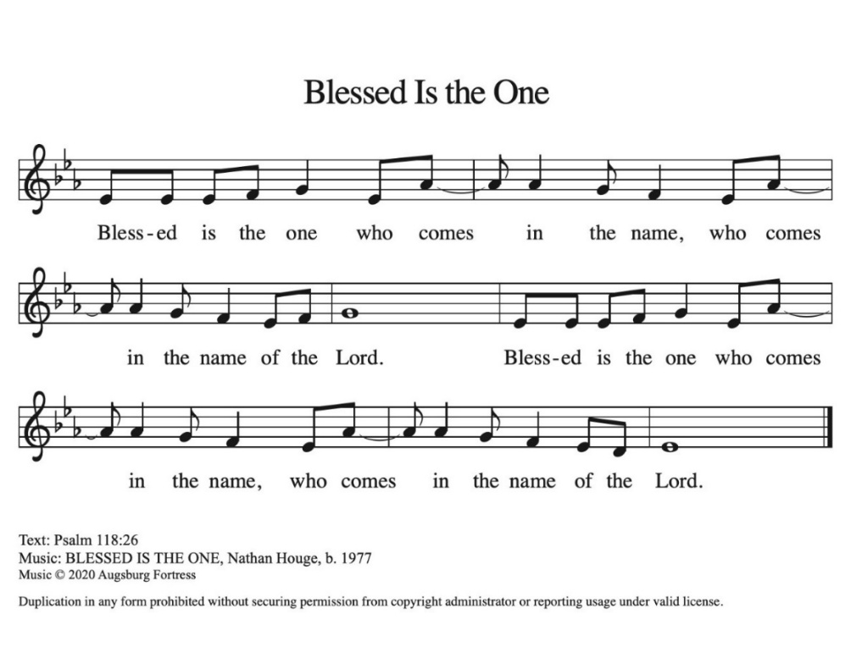

* Gospel: John 10:1-10 Pastor Tina
The Holy Gospel according to John, the 10th chapter. Glory to you, O Lord.

[Jesus said:] ¹ “Very truly, I tell you, anyone who does not enter the sheepfold by the gate but climbs in by another way is a thief and a bandit. ² The one who enters by the gate is the shepherd of the sheep. ³ The gatekeeper opens the gate for him, and the sheep hear his voice. He calls his own sheep by name and leads them out. ⁴ When he has brought out all his own, he goes ahead of them, and the sheep follow him because they know his voice. ⁵ They will not follow a stranger, but they will run from him because they do not know the voice of strangers.” ⁶ Jesus used this figure of speech with them, but they did not understand what he was saying to them.
⁷ So again Jesus said to them, “Very truly, I tell you, I am the gate for the sheep. ⁸ All who came before me are thieves and bandits, but the sheep did not listen to them. ⁹ I am the gate. Whoever enters by me will be saved and will come in and go out and find pasture. ¹⁰ The thief comes only to steal and kill and destroy. I came that they may have life and have it abundantly.”

The Gospel of the Lord. Praise to you, O Christ.

*Sermon Pastor Tina

* Hymn of the Day "As We Gather at Your Table" ELW 522

1.As we gather at your table, as we listen to your word, help us
know, O God, your presence; let our hearts and minds be stirred.
Nourish us with sacred story till we claim it as our own; teach us through this holy banquet how to make Love’s vict’ry known.

2.Turn our worship into witness in the sacrament of life; send us
forth to love and serve you, bringing peace where there is strife.
Give us, Christ, your great compassion to forgive as you forgave; may we still behold your image in the world you died to save.

3.Gracious Spirit, help us summon other guests to share that feast where triumphant Love will welcome those who had been last and least. There no more will envy blind us nor will pride our peace destroy, as we join with saints and angels to repeat the sounding joy.

* Apostle’s Creed worship assistant
Let us proclaim our faith in the words of the Apostle’s creed.

I believe in God, the Father almighty,
creator of heaven and earth.
I believe in Jesus Christ, God's only Son, our Lord,
who was conceived by the power of the Holy Spirit,
born of the Virgin Mary,
suffered under Pontius Pilate,
was crucified, died, and was buried;
he descended to the dead.
On the third day he rose again;
he ascended into heaven,
he is seated at the right hand of the Father,
and he will come to judge the living and the dead.
I believe in the Holy Spirit,
the holy catholic Church,
the communion of saints,
the forgiveness of sins,
the resurrection of the body,
and the life everlasting. Amen.

* Prayers of Intercession Pastor Tina
Be Seated.
Prayer requests or joys to share
God of resurrection and new life, we come before you in prayer for the church, the world, and all who are in need.

Shepherding God, draw all people to yourself and lead them in paths of righteousness. Embolden your church to enter the valleys of the world and guide us beside the still waters of your grace. We pray for military and prison chaplains, especially Pastor Ash Welch from Christ Lutheran, serving near and far. Merciful God, receive our prayer.

Creator God, by the resurrection of your Son, show us your steadfast love and instruct our hearts in your ways. Help us to revere and protect the wonders of your creation. Merciful God, receive our prayer.

Righteous Judge, strengthen and uphold those who work for justice and advocate for human rights. Bring an end to oppression and save us from the temptation of violence or vengeance. Merciful God, receive our prayer.

Great Physician, walk with those who are grieving, and anoint those who are ill or injured (especially). Restore them to health of body, mind, and spirit. Merciful God, receive our prayer.

Good Shepherd, continually seek us out as lambs of your flock, and form us into a community where all are honored and cared for. Spread a feast before us and fill our cups to overflowing. Merciful God, receive our prayer.

Living God, we praise you for the saints who have died in faith and now dwell in your love. At our end, bring us, with them, to our heavenly home. Merciful God, receive our prayer.
We commend these and all our prayers to you, O God, trusting that you are always with us; in the name of Jesus Christ, our risen Savior. Amen.

*Offering Worship Assistant
The monthly Mission for April is for “the Funeral Meal Supplies.” Let us give to god what he has first given us.

*Offering Music by jared

* Offering Hymn “Come to the Table of Mercy” ELW 481
CCLI 11222261
Come to the table of mercy, prepared with the wind and the bread. All who are hungry and thirsty, come, and your souls will be fed. Come at the Lord’s invitation; receive from his nail- scarred hand. Eat of the bread of salvation; drink of the blood of the Lamb.

* Offering Prayer Worship assistant and congregation
Generous and Abundant God, all that we have comes from your hand—bread from the earth, water that sustains, love that binds us together. Bless these gifts we bring today. May they nourish the hungry, strengthen the weary, and build communities of justice and care, as signs of your new creation. In Christ’s name we pray, Amen.

* Liturgy of Holy Communion
- The Great Thanksgiving ELW pg. 152
The Lord be with you. And Also with you.
Lift up your hearts. We lift them to the Lord.
Let us give thanks to the Lord our God
It is right to give our thanks and praise.

- Holy, Holy, Holy ELW pg. 153
Holy, holy, holy Lord. Lord God of pow’r and might:
Heav’n and earth are full of your glory.
Hosanna in the highest. Blessed is he who comes
In the name of the Lord. Hosanna in the highest.

- Thanksgiving at the Table ELW pg 153
Christ has died. Christ is risen. christ will come again.

* Lord’s Prayer ELW pg. 154
Our Father, who art in heaven, hallowed be thy name, thy kingdom come, thy will be done, on earth as it is in heaven.
Give us this day our daily bread; and forgive us our trespasses,
as we forgive those who trespass against us; and lead us not into temptation, but deliver us from evil. For thine is the kingdom, and the power, and the glory, forever and ever. Amen.

* Lamb of God ELW pg. 154
Lamb of God, you take away the sin of the world; have mercy on us. Lamb of God, you take away the sin of the world; have mercy
on us. Lamb of God, you take away the sin of the world, grant us peace.
*Special Music during Holy Communion by jared.

*Post Communion Blessing

* Post Communion Hymn “Be Not Afraid” ELW #388 (sing 2x)
Be not afraid, sing out for joy! Christ is risen, Al-le-lu-ia!
Be not afraid, sing out for joy! Christ is risen, Al-le-lu-ia!

* Prayer After Communion Pastor Tina and congregation
Holy One, you have fed us with your abundant grace and gathered us into your love. As we have been nourished at this table, send us out to feed, tend, and love as Christ commands. May we be signs of your new creation, where all are welcomed, all are cherished, and all are made whole. Amen.

* Blessing Pastor Tina

* Closing Hymn "My Shepherd, You Supply My Need" ELW 782

1.My Shepherd, you supply my need; most holy is your name.
In pastures fresh you make me feed, beside the living stream.
You bring my wand’ring spirit back when I forsake your ways,
and lead me, for your mercy’s sake, in paths of truth and grace.

2.When I walk through the shades of death, your presence is my stay; one word of your supporting breath drives all my fears away. Your hand, in sight of all my foes, does still my table spread; my cup with blessings overflows, your oil anoints my head.

3.The sure provisions of my God attend me all my days; oh, may your house be my abode and all my word be praise. Here would I find a settled rest, while others go and come; no more a stranger
or a guest, but like a child at home.

* Dismissal Worship Assistant
Go in peace. Share the good news: Christ is risen!
Christ is risen indeed. Alleluia!

*Postlude

The Offering Prayer and Prayer After Communion are by Rev. Kristina N. Crog, 2025

