EAST FAIRFIELD UNITED METHODIST CHURCH
Pastor: Rev. Lisa Courtwright
Organist: Ruth Rowley Ministers: The Congregation
Pianist: Nancy Setinsek Choir Director: Randy Hart

Sunday, April 26, 2026
Fourth Sunday of Easter

*Please stand in body or spirit as you are able

Welcome! We invite you to take this time to prepare for worship. In these
moments, quiet your inner voice, become aware of being in community with
others, and open your heart and mind to the leading of the Holy Spirit.

GATHERING “Stand Up, Stand Up For Jesus” - Sprunger
“I’ll Fly Away” - Brumley

CHRIST LIGHT ENTERS

MISSIONS AND MINISTRY UPDATEs Deann Davis, Liturgist

PREPARING OUR HEARTS AND MINDS FOR WORSHIP

WORDS OF PREPARATION AND CENTERING

PRELUDE “Where He Leads Me” - Norris
*CALL TO WORSHIP
Christ is alive and moving among us, calling us into life.
We come to follow where He leads.
He is the one who gathers us in, who opens the way before us.
We come seeking the path that leads to life.

Jesus says, “I am the door.”
Through him, we enter into grace, into safety, into abundant life.
Come, let us worship the One who leads us in and leads us on.
Let us enter through the Door and worship Christ our Lord.

*OPENING PRAYER
Loving Shepherd, you call us through Christ, the Door, into life that is full and abundant. Open our hearts to your voice, that we may follow where you lead and rest in your care.

Meet us in this time of worship and draw us closer to you
in love and truth. In Jesus’ name we pray, Amen.

*OPENING HYMN “Lord of the Dance” UMH #261

READING FROM THE PSALMS Psalm 23 (NIV) pg 441

CHILDREN’S MOMENT

CHOIR ANTHEM “Softly and Tenderly” - Thompson

OFFERING OURSELVES & OUR GIFTS
INVITATION
OFFERTORY “Sunshine in My Soul” - Sweney
*DOXOLOGY UMH #95
*DEDICATION OF GIFTS

SEEKING GOD’S WORD

OLD TESTAMENT READING Ezekiel 34:11-16 (NIV) pg 704

SHARING OF JOYS & CONCERNS
SILENT PRAYER
PASTORAL PRAYER
THE LORD’S PRAYER

*HYMN “Savior, Like a Shepherd Lead Us” UMH #381

SERMON TEXT John 10:1-10 (NIV) pg 870
SERMON The Door Pastor Lisa

RESPONDING TO GOD’S WORD

*CLOSING HYMN “To God Be the Glory” UMH #98

SENDING FORTH WITH BLESSING
*BLESSING
LIGHT OF CHRIST GOES INTO THE WORLD

~ Go with joy to serve the Lord ~

As we conclude our service, please join us downstairs for a time to relax, continue conversations, and enjoy coffee and refreshments.

Sound: Bill Rowley Livestream: Hannah Vollnogle Computer: Vicki Freeman

Liturgist Next Sunday, May 3: Jon Vollnogle
Please keep in mind that the service is live-streamed and
recorded for public access. Please keep prayer requests
brief and do not use last names or identifying details.

PRAYER REQUESTS APRIL 26, 2026
To submit a prayer request call Denise at 330-457-2465 or 330-727-9832

If you desire a home or hospital visit call Pastor Lisa (440-339-6463)

Prayer Blankets: call Joyce Ward (330-692-3346)

Bill – Injured his toe. Awaiting surgery.
Jim (Alisha’s dad) – in the hospital. Having surgery.
Dick – back surgery April 23
Cyndi S – was in hospital. Doctors have a plan toward hip replacement.
Mike (Alisha’s friend) – surgery for shattered tibia. Had complications.
Nate (Jim & JoAnne’s son-in-law) – collapsed at home after hip surgery.
Will have surgery to repair the hip & femur fracture. Needs pacemaker.
Unspoken Prayer Request
Georgia – Please continue prayers.
Dale (Keith’s brother) – healing from open-heart surgery. Continue prayers.
Dolly K
Sue (Kermit’s wife) – at Briarfield in Boardman for rehab.
Anita M – health issues.
Perry Bilsky (Denise & Anita’s nephew) – Fighting cancer.

HOMEBOUND
Dolly K. Bill & Barb H. Anita M.
Tom & Marie Linda S. Walt D. (Whispering Pines)
Dorothy F. Esther C. Zelda C. (Whispering Pines)

IN MINISTRY
Lisa Courtwright Edie Boles Jeff Pellin

Ch Ph: 330-457-2465 Pastor: 440-339-6463
Email: revlisa18@gmail.com Ch Email:efumc@comcast.net Website: www.eastfairfieldumc.com CCLI # 1994841 CVLI #504 011 134


East Fairfield
United Methodist Church

April 26, 2026
9:30 AM

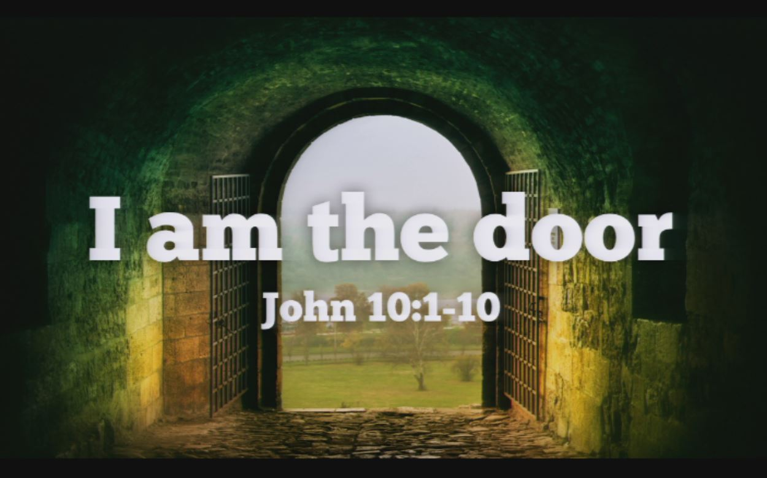

Rev. Lisa Courtwright
440-339-6463
45675 State Route 558
New Waterford, OH 44445

“Working, playing, and praying together on our
faith journey, to share Jesus Christ with everyone.”

Sun | Mon | Tue | Wed | Thu | Fri | Sat
April 26  9:30 Worship  10:30 Coffee  - BAKE SALE  10:45 Sunday  School  5:00 Potluck  Fellowship at  Emmanuel UMC | April 27  12:00 Joy  Circle  Lunch  6:00 Cub  Scouts | April 28  8:00 Men’s  Coffee at  the church  Newsletter  Deadline | April 29  7:00 Choir  Practice | April 30  9:00 Mailing  Committee | May 1  Pastors Day Off  Office Closed  9:00-2:00  Rummage  Sale at  Emmanuel  UMC | May 2  9:00-2:00  Rummage  Sale at  Emmanuel  UMC
May 3  9:30 Worship  10:30 Coffee  10:45 Sunday  School  (1:00-4 Crestview Little Rebels Cheer & Football  Registration - Ali Cusick) | May 4  Pastors Day Off | May 5  Pastors Day Off  8:00 Men’s  Coffee at  Larrys pavilion | May 6  Rev. Lisa at Clergy Executive Session at Lakeside  (10:00-1:00  Crestview Little  Rebels Cheer  & Football  Registration -  Ali Cusick) | May 7 | May 8  Pastors Day Off  Office Closed | May 9
May 10  MOTHER’S DAY  9:30 Worship  10:30 Coffee  10:45 Sunday  School | May 11 | May 12  8:00 Men’s  Coffee at  Larrys pavilion  (Ladies Day) | May 13  7:00  Scripture  & Suds at  Brew Lounge | May 14 | May 15  Pastors Day Off  Office Closed | May 16
May 17  PENTECOST  9:30 Worship  10:30 Coffee  10:45 Sunday  School | May 18  7:00  LEADERSHIP  BOARD | May 19  8:00 Men’s  Coffee at  Larrys pavilion | May 20 | May 21 | May 22  Pastors Day Off  Office closed | May 23  8:30-10:00  Caring for  God’s  Lambs
May 24  9:30 Worship  10:30 Coffee  10:45 Sunday  School  12:30 Memorial  Service and  PICNIC at the  Pavilion | May 25 | May 26  8:00 Men’s  Coffee at  Larrys pavilion  Newsletter  Deadline | May 27 | May 28  9:00 Mailing Committee  7:00 Scripture & Suds at Sundog | May 29  Pastors Day Off  Office Closed | May 30

LAST WEEK’S ATTENDANCE (April 19)

In-Person: 67
Online: 43

Update on Mission Giving for 2026
FUND | NAME OF FUND | NEED | RECEIVED | STILL NEED
2 | General Mission Fund | 5,099 | 2,320 | 2,779
33 | 4C’s | 125 | 175 | 0
32 | Cub Scouts | 150 | 405 | 0
37 | Way Station | 150 | 75 | 75
22 | Flat Rock | 175 | 265 | 0
64 | Farmer to Farmer - Liberia | 300 | 155 | 145
13 | UMCOR Sunday | Any  Donation | 75
21 | UMCOR – U.S. Disasters | Any  Donation | 5
14 | Blanket Sunday | Any  Donation | 65
15 | Peace With Justice | Any  Donation | 0
16 | World Communion | Any  Donation | 0
17 | Student Day | Any  Donation | 0
46 | Heroes & Halos | Any  Donation | 100
63 | InStep Program | Any  Donation | 10
38 | Operation Christmas Child Boxes ($118) |  | 0

Fund Balances as of end of March
Fund # 1 Ministry Operating -10,673
Fund # 2 Mission Fund 2,526
Fund # 3 Building Fund 61,545
Fund # 28 Elevator Fund 3,966

Mission of the Month
The Way Station – Fund #37

The Way Station (a 501(c)3 nonprofit) is a staple within the community for individuals and families in need. Agencies
and organizations throughout Columbiana County and beyond
use The Way Station as a resource for emergency assistance, nutrition, clothing, household items, job training,
and emotional support.

4C’s Item – Cereal

Memorial Service and Picnic
Sunday, May 24 at 12:30 PM

We will have a Memorial Service outside (weather permitting)
at the pavilion area at 12:30 PM. This will be followed by a picnic. The Fellowship Committee will provide hot dogs,
cheesy potatoes, beverages, and table service.
Please bring a side dish or dessert to share.

Concert in the Park
Sunday, June 14 at 2:00 PM

East Fairfield UMC will sponsor the Concert in the Park in Columbiana on June 14. Leeann Binder will be performing.

Farewell Picnic for Pastor Lisa
Sunday, June 21 at 12:30 PM

A Farewell Lunch for Rev. Lisa will be held at 12:30 to honor her ministry within our churches and our community and extend best wishes as she transitions to her new appointment.

Weather permitting, the event will take place outdoors in the pavilion. Hot dogs, cheesy potatoes, beverages, and tableware will be provided. Attendees are invited to contribute a covered dish or dessert for sharing.

Welcome Picnic for Pastor Kristen
Sunday, July 5 at 12:30 PM

You're invited to help us welcome Pastor Kristen to our church family on Sunday, July 5 at 12:30 pm. We'll gather for lunch outside in the pavilion, weather permitting. Hot dogs, cheesy potatoes, drinks, and tableware will be provided. Feel free to bring a covered dish or dessert to share.

Geranium Order Form 2026

If you would like to order geraniums for
PENTECOST SUNDAY, May 24 please fill
out this form and return it with your payment.
( Deadline to order is Sunday, May 10 )

Name |  | Church Env #
Phone
I’d like ____ Geraniums (5½”) @ $6.00 |  | $ _________
In
Honor of
In
Memory of


The Joy Circle Bake Sale is TODAY !!!
during coffee time immediately following
the worship service (around 10:30 or so).

Be sure to stop by the Fellowship Hall and purchase
some tasty treats made by our Joy Circle members.
We appreciate your support!

* * * Volunteer Needed * * *

We need people who are interested in training as a
substitute to run the virtual service on Sunday mornings.
We need someone to fill in on May 17, June 14, and July 26.
If interested, or need more info, talk to Hannah Vollnogle.

