City Road United Methodist Church
A Lighthouse Congregation

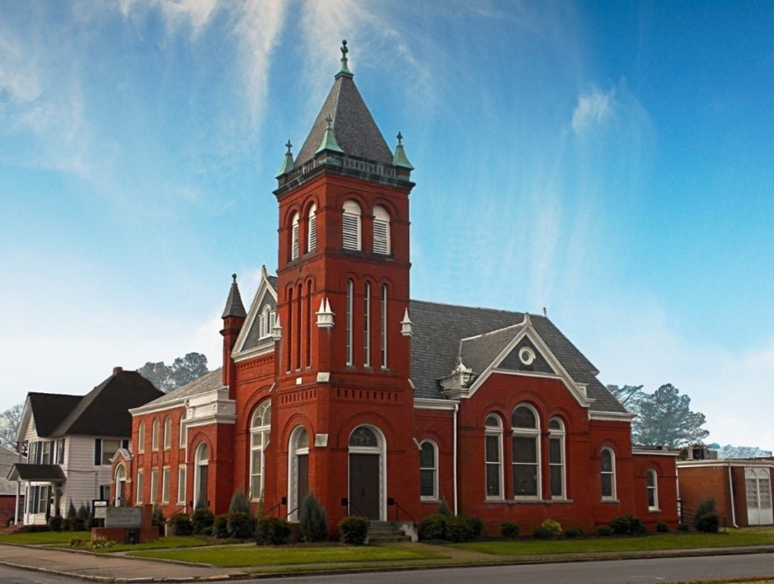
Rev. Josh Tester, Pastor

Office: (252) 335-2658
cityroadec.net crumcec@gmail.com

Facebook: https://www.facebook.com/CityRoadUMC

Sunday School: 10:00 a.m.
Sanctuary Worship: 11:00 a.m.

Tommy Venters- Organist/Choir Director
Dawn Baker- Secretary/Technology Specialist
JoAnn Herring- We Care

Service of Word & Table
Season of Easter
April 26th, 2026 11:00 am
Gathering
Prelude
Introit “People Need the Lord”
Words of Welcome Pastor Josh
*Call to Worship
Lord, our God, you invite us to practice both justice and mercy.
Move us toward what can be.
“Justice at its best is power correcting everything that stands against love.” (MLK, Jr.)
Move us toward what needs to be.
Lord, our God, you teach us that we embrace you as we embrace “the least of these.”
Move us toward what must be.
All: We can move, Lord God. We can move, in word and deed, towards true respect and compassion, honoring the image of God in everyone. You call us to do this as we oppose and take action against systems and structures that break people.

*Prayer of Approach
Jesus, when do we see you in our day-to-day routines? Are you in the checkout line at the grocery store ahead of us, choosing which items you’ll have to put back in order to make ends meet? Are you the one waiting on our table, barely making a living wage? Are you the one panhandling whom we have learned not to see? Are you the one we keep saying we’ll visit tomorrow, tomorrow, tomorrow…? We praise you for calling our attention to the least, the lost, and the lonely. We praise you for being God-with-Them and God-with-Us. Help us to see you in each one we meet, until the walls of privilege and status are torn down forever and we serve each other in Beloved Community. Amen.

*Sharing Peace
As a people forgiven and freed, we reach out to lift others up, offering the peace of Christ. Peace be with you!
And also with you!
You are invited to share the Peace with those around you [remembering to send your peace through the camera to those worshiping remotely*

Hymn of Praise “To God be the Glory” UMH 98

Proclamation & Response
Call to Prayer
Prayers of the People
The Lord’s Prayer
Our Father who art in heaven, hallowed be thy name. Thy kingdom come; thy will be done on earth as it is in heaven. Give us this day our daily bread, and forgive us our trespasses, as we forgive those who trespass against us; and lead us not into temptation but deliver us from evil. For thine is the kingdom, and power, and glory forever. Amen

Children’s Time
Call to the Offering
Offertory
*Doxology
*Prayer of Dedication

Hymn of Preparation “Savior Like a Shepherd Lead Us” UMH 381

Anthem Chancel Choir

Gospel Lesson John 21:15-17
New Testament Lesson Acts 4:32-35
Message “Moving Towards Beloved Community” Pastor Josh

Sending Fourth
*Sending Hymn “God be with You Til we Meet Again” UMH 672
*Benediction

