Parkside Lutheran Church
Rediscovering the Radical Love of Jesus
Gathering All
Serving All
Caring For All

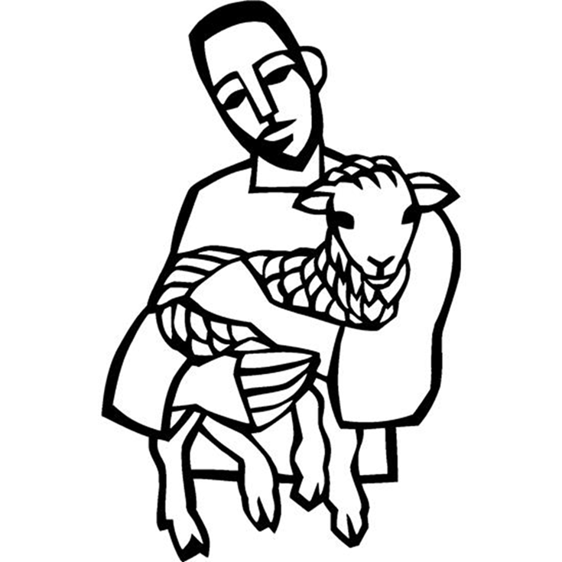

April 26th, 2026
Fourth Sunday of Easter
Holy Communion 10:00am
Rev. Jeremiah Smith
Parkside Lutheran Values

Proclaiming Grace - Jesus shared and lived out a message of grace, love, and new life. We believe these promises come from God freely, as a gift for all. We are loved and the Spirit inspires us to share this good news in accessible, relevant, and new ways. Luke 4:17-19, John 1:16-17, John 3:16-17, Ephesians 2:8-9

Practicing Hospitality – Jesus welcomed the little children, broke bread with outcasts, and proclaimed the Good News to all. Whether you are strong in faith, wrestling with doubt, or somewhere in between, we affirm that you are welcome here. Jesus is for everyone. Leviticus 19:34, Matthew 9:10, Matthew 19:14, Hebrews 13:2

Loving Boldly - Jesus challenged traditions to demonstrate God’s justice and love of neighbor. His compassionate and sacrificial love inspires us to take risks. Striving to follow his command to love neighbor, our ministries serve, transform, and advocate for folks near and far. Micah 6:8, Mark 11:15-17, Luke 10:25-28, John 15:12-13

Cultivating Community - Jesus built communities that transformed lives. We are the body of Christ and we are called to continue this ministry of transformation. Guided by the Holy Spirit, we build connections within and outside of these walls, and with all of God’s creation. Ecclesiastes 4:9-12, Matthew 28:16-20, 1 Corinthians 12:12-14, Galatians 3:26-29

Welcome Visitors!
Please use QR code to let us know you were here today or to sign up for our weekly enewsletter. Find us on Facebook & Instagram
WIFI: Balcony password: FreeGrace

For your safety in the event of an emergency: In addition to the three exits in the back of the sanctuary, there are exits on either side of the altar (on left side: floor level near piano and up steps past altar. On right side: up steps to the altar, past band area)

Contact us: (716) 836-1361
2 Wallace Ave. Buffalo, NY 14214
parksidelutheran.org | parksidelutheran@gmail.com

GATHER
The Holy Spirit calls us together as the people of God.

Introduction to the Day: Today is sometimes called “Good Shepherd Sunday.” Jesus is called the “gate” of the sheep in today’s gospel. The risen Christ opens the way to abundant life. He anoints our hearts with oil and guides us beside the still waters of our baptism. Each Sunday he spreads a feast before us amid the world’s violence and war. We go forth to be signs of the resurrection and extend God’s tender care to all creation.

Prelude Michael Hooker, Music Director

Call to Worship Please stand as you are able
WA: I AM the good shepherd—
C: the one who tends us, guides us into pastures, who recognizes the sounds of our names.
WA: I AM the good shepherd—
C: the one who bends to heal us, travels through the deepest valleys with us, who gives up everything for us all.
WA: I AM the good shepherd—
C: the one whose rod and staff comfort us, whose strength and love holds us, whose cup of love runs over.
WA: I AM the good shepherd—
C: and we will dwell in the house of the Lord forever.
WA: Let us gather here—
C: God’s People in God’s love for God’s world.

+Gathering Hymn: Come, Thou Fount of Every Blessing ELW #807
(printed next page)

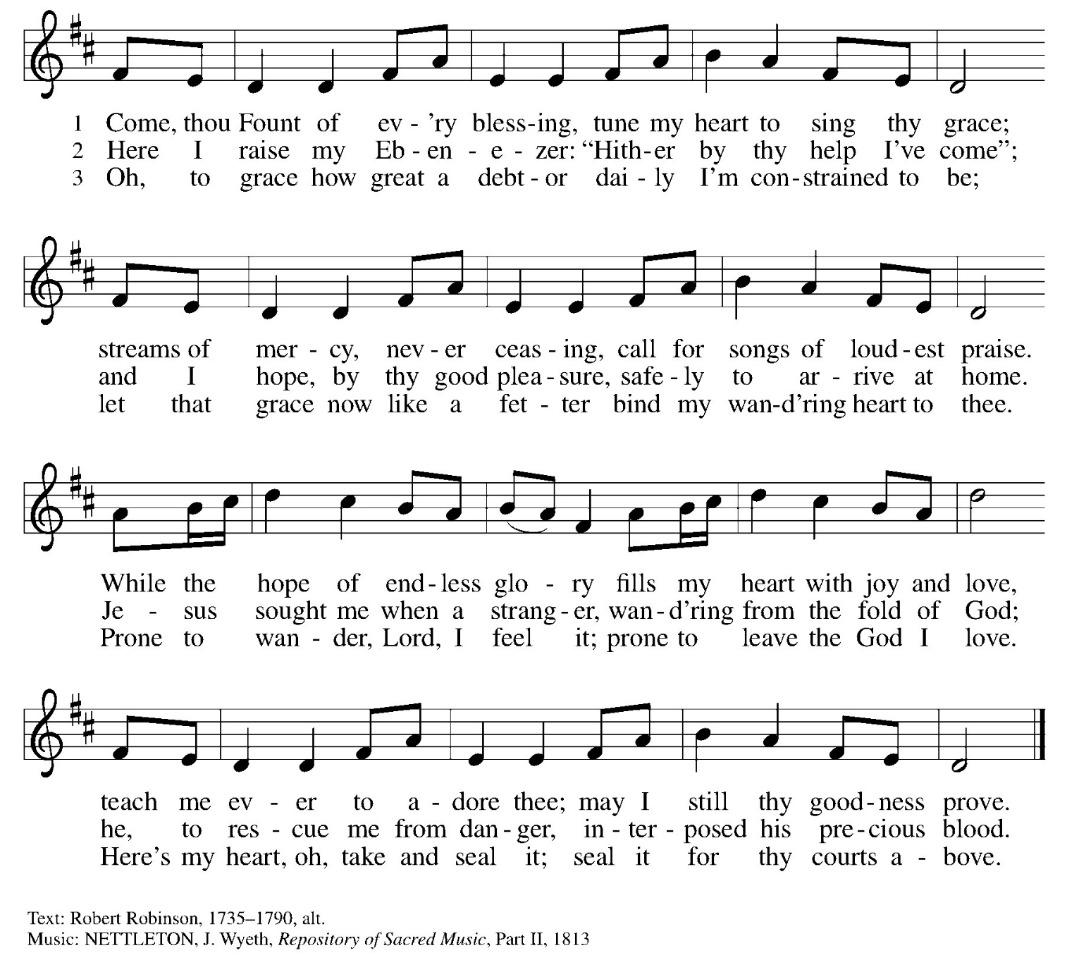

Welcome and Announcements

Temple Talk Melanie Rushforth, CEO
Lutheran Charities of WNY

Thanksgiving for Baptism
P: Alleluia! Christ is risen.
C: Christ is risen indeed. Alleluia!
P: Salvation belongs to our God who is seated on the throne and to the Lamb!
C: Amen.
P: Let us give thanks for the gifts of baptism.
Water may be poured into the font as the presiding minister continues.
P: Merciful God, you are the one who was, who is, and who is to come. You lead us beside still waters. We thank you for the waters of creation: morning dew, gentle rain, roaring waves. We thank you for the waters that nourish us.
Blessed are you.
C: You guide us to springs of the water of life.
P: Jesus Christ, you are the faithful witness who accompanies us on our journeys.
We give you thanks for your life-giving death and resurrection. We praise you for joining us in joy and sorrow. Blessed are you.
C: You guide us to springs of the water of life.
P: Holy Spirit, you anoint our head with oil and our cup overflows. Break down barriers that divide us. Fill us with the breath of peace. Blessed are you.
C: You guide us to springs of the water of life.
P: Holy One, we thank you for the gifts and grace of baptism, and for making us a new creation. We join with saints and angels, giving you honor and praise,
now and forever.
C: Amen.

Greeting

WA: The grace of our Lord, Jesus Christ, the love of God, and the communion of the Holy Spirit be with you all. C: And also with you.

Canticle of Praise ELW p. 149
(printed next page)

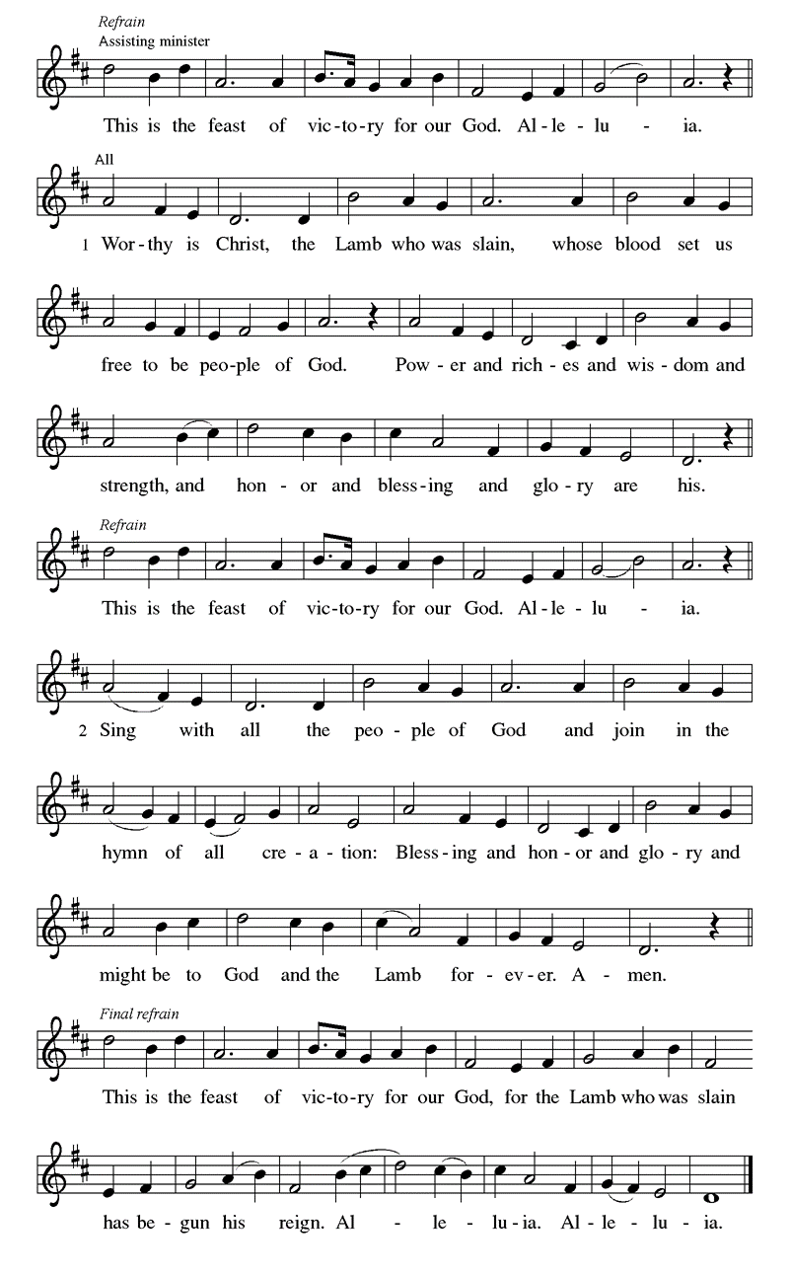
Prayer of the Day
WA: Let us pray together.
C: O God our shepherd, you know your sheep by name and lead us to safety through the valleys of death. Guide us by your voice, that we may walk in certainty and security to the joyous feast prepared in your house, through Jesus Christ, our Savior and Lord, who lives and reigns with you and the Holy Spirit, one God, now and forever. Amen.

Children’s Sermon: Jesus said, “Let the little children come to me!”
We welcome children in worship.

WORD
God speaks to us in scripture readings, preaching and song.

First Reading: Acts 2:42-47
Today’s reading is a description of life in the community following Peter’s sermon on the day of Pentecost, when the Spirit was poured out on God’s people. The new community is sustained in worship and fellowship, shares what they have, and ensures that everyone has enough.

L: ⁴² [The baptized] devoted themselves to the apostles’ teaching and fellowship, to the breaking of bread and the prayers.
⁴³ Awe came upon everyone because many wonders and signs were being done through the apostles. ⁴⁴ All who believed were together and had all things in common; ⁴⁵ they would sell their possessions and goods and distribute the proceeds to all, as any had need. ⁴⁶ Day by day, as they spent much time together in the temple, they broke bread at home and ate their food with glad and generous hearts, ⁴⁷ praising God and having the goodwill of all the people. And day by day the Lord added to their number those who were being saved. L: Word of God, word of life. C: Thanks be to God.

Psalm: Psalm 23 The Lord is my shepherd; I shall not be in want. (Ps 23:1)
L: ¹ The Lord is my shepherd; I shall not be in want.
C: ² The Lord makes me lie down in green pastures
and leads me beside still waters.
L: ³ You restore my soul, O Lord,
and guide me along right pathways for your name’s sake.
C: ⁴ Though I walk through the valley of the shadow of death, I shall fear no evil;
for you are with me; your rod and your staff, they comfort me.
L: ⁵ You prepare a table before me in the presence of my enemies;
you anoint my head with oil, and my cup is running over.
C: ⁶ Surely goodness and mercy shall follow me all the days of my life,
and I will dwell in the house of the Lord forever. L: Word of God, word of life. C: Thanks be to God.

Second Reading: 1 Peter 2:1-10, 25
L: ¹ Rid yourselves, therefore, of all malice and all guile, insincerity, envy, and all slander. ² Like newborn infants, long for the pure, spiritual milk, so that by it you may grow into salvation ³ if indeed you have tasted that the Lord is good.
⁴ Come to him, a living stone, though rejected by mortals yet chosen and precious in God’s sight, and ⁵ like living stones let yourselves be built into a spiritual house, to be a holy priesthood, to offer spiritual sacrifices acceptable to God through Jesus Christ. ⁶ For it stands in scripture:
“See, I am laying in Zion a stone, a cornerstone chosen and precious,
and whoever believes in him will not be put to shame.”
⁷ This honor, then, is for you who believe, but for those who do not believe,
“The stone that the builders rejected has become the very head of the corner,”
⁸ and
“A stone that makes them stumble and a rock that makes them fall.”
They stumble because they disobey the word, as they were destined to do.
⁹ But you are a chosen people, a royal priesthood, a holy nation, God’s own people, in order that you may proclaim the excellence of him who called you out of darkness into his marvelous light.
¹⁰ Once you were not a people, but now you are God’s people; once you had not received mercy, but now you have received mercy.
L: Word of God, word of life. C: Thanks be to God

Please stand as you are able

Gospel Acclamation ELW #174
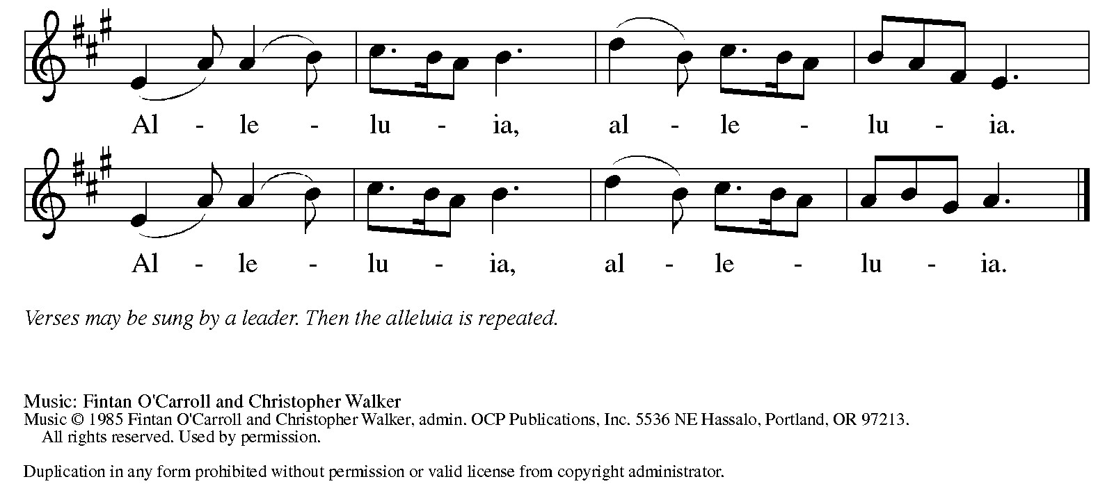
Gospel Reading: John 10:1-10
Jesus uses an image familiar to the people of his day to make a point about spiritual leadership. Those who listen to Jesus are led to abundant life.

P: The Holy Gospel according to John. C: Glory to you, O Lord.
P: [Jesus said:] ¹ “Very truly, I tell you, anyone who does not enter the sheepfold by the gate but climbs in by another way is a thief and a bandit. ² The one who enters by the gate is the shepherd of the sheep. ³ The gatekeeper opens the gate for him, and the sheep hear his voice. He calls his own sheep by name and leads them out. ⁴ When he has brought out all his own, he goes ahead of them, and the sheep follow him because they know his voice. ⁵ They will not follow a stranger, but they will run from him because they do not know the voice of strangers.” ⁶ Jesus used this figure of speech with them, but they did not understand what he was saying to them.
⁷ So again Jesus said to them, “Very truly, I tell you, I am the gate for the sheep. ⁸ All who came before me are thieves and bandits, but the sheep did not listen to them. ⁹ I am the gate. Whoever enters by me will be saved and will come in and go out and find pasture. ¹⁰ The thief comes only to steal and kill and destroy. I came that they may have life and have it abundantly.”
P: The Gospel of the Lord. C: Praise to you, O Christ.

Sermon Rev. Jeremiah Smith

Please stand as you are able

+Hymn of the Day: Shepherd Me, O God ELW #780
(printed next page)

Nicene Creed WA: Let us confess the faith using the words of the Nicene Creed.
C: We believe in one God, the Father, the Almighty, maker of heaven and earth, of all that is, seen and unseen.
We believe in one Lord, Jesus Christ, the only Son of God, eternally begotten of the Father, God from God, Light from Light,
true God from true God, begotten, not made, of one Being with the Father; through him all things were made. For us and for our salvation he came down from heaven, was incarnate of the Holy Spirit and the virgin Mary and became truly human. For our sake he was crucified under Pontius Pilate; he suffered death and was buried. On the third day he rose again in accordance with the scriptures; he ascended into heaven and is seated at the right hand of the Father. He will come again in glory to judge the living and the dead, and his kingdom will have no end.
We believe in the Holy Spirit, the Lord, the giver of life, who proceeds from the Father and the Son, who with the Father and the Son is worshiped and glorified, who has spoken through the prophets. We believe in one holy catholic and apostolic church. We acknowledge one baptism for the forgiveness of sins. We look for the resurrection of the dead, and the life of the world to come. Amen.

Prayers of the People WA: Trusting in the power of Christ’s resurrection to heal and redeem our broken world, let us pray for the needs of all creation. (a brief silence)
WA: Shepherding God, draw all people to yourself and lead them in paths of righteousness. Embolden your church to enter the valleys of the world and guide us beside the still waters of your grace. We pray for military and prison chaplains serving near and far. Merciful God, C: receive our prayer.
WA: Righteous Judge, strengthen and uphold those who work for justice and advocate for human rights. Bring an end to oppression and save us from the temptation of violence or vengeance. Merciful God, C: receive our prayer.
WA: Great Physician, walk with those who are grieving, and anoint those who are ill or injured. Restore them to health of body, mind, and spirit. We pray especially for those we name aloud or in the silence of our hearts. Merciful God, C: receive our prayer.

WA: Good Shepherd, continually seek us out as lambs of your flock, and form us into a community where all are honored and cared for. Spread a feast before us and fill our cups to overflowing. Merciful God, C: receive our prayer.

WA: Living God, we praise you for the saints who have died in faith and now dwell in your love. At our end, bring us, with them, to our heavenly home. Merciful God, C: receive our prayer.

WA: God of resurrection power, use us and these prayers to proclaim the good news of new life to all the world, through Jesus Christ, our risen Savior. C: Amen.

Peace
P: The peace of Christ be with you always. C: And also with you.

Meal - God feeds us with the presence of Jesus Christ

Offering
We are grateful to those who help sustain our mission. To donate online, please use QR code:


+ Offering Prayer
WA: Let us pray together:
C: Merciful God, accept the fruits of our labor, gathered to give you glory. You have set a table before us, a glimpse of that great day when we will hunger and thirst no more. Nourish us with the body and blood of Jesus, that goodness and mercy may follow us, and bless the world you love. In the name of Jesus. Amen.

+ Offertory Song
Praise God, from whom all blessings flow;
praise God, all creatures here below;
praise God above, ye heav’nly host;
praise Father, Son, and Holy Ghost. Amen.

Great Thanksgiving
P: The Lord be with you. C: And also with you.
P: Lift up your hearts. C: We lift them to the Lord.
P: Let us give thanks to the Lord our God.
C: It is right to give our thanks and praise.

Preface
P: It is indeed right, our duty and our joy, that we should at all times and in all places give thanks and praise to you, almighty and merciful God for the glorious resurrection of our Savior Jesus Christ, the true Paschal Lamb who gave himself to take way our sin, who in dying has destroyed death, and in rising has brought us to eternal life. And so, with Mary Magdalene and Peter and all the witnesses of the resurrection, with earth and sea and all their creatures, and with angels and archangels, cherubim and seraphim, we praise your name and join their unending hymn:

Holy Holy Holy ELw setting 4 (p. 153)
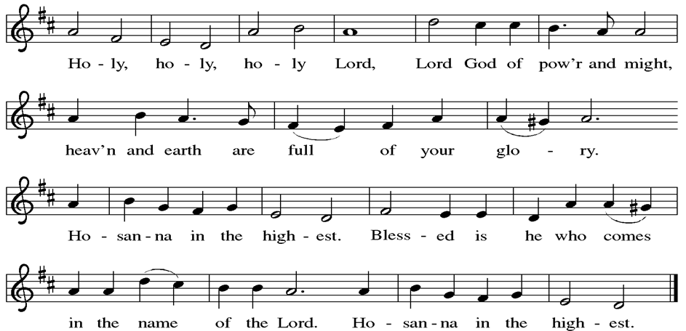

Thanksgiving at the Table

P: Blessed are you, O God of the universe. Your mercy is everlasting and your faithfulness endures from age to age.
Praise to you for creating the heavens and the earth. Praise to you for saving the earth from the waters of the flood. Praise to you for bringing the Israelites safely through the sea. Praise to you for leading your people through the wilderness to the land of milk and honey. Praise to you for the words and deeds of Jesus, your anointed one. Praise to you for the death and resurrection of Christ. Praise to you for your Spirit poured out on all nations.
In the night in which he was betrayed, our Lord Jesus took bread, and gave thanks; broke it, and gave it to his disciples, saying: Take and eat; this is my body, given for you. Do this for the remembrance of me. Again, after supper, he took the cup, gave thanks, and gave it for all to drink, saying: This cup is the new covenant in my blood, shed for you and for all people for the forgiveness of sin.
Do this for the remembrance of me.
With this bread and cup we remember our Lord’s passover from death to life
as we proclaim the mystery of faith:
C: Christ has died. Christ is risen. Christ will come again.
P: O God of resurrection and new life: Pour out your Holy Spirit on us
and on these gifts of bread and wine. Bless this feast. Grace our table with your presence.
C: Come, Holy Spirit.
P: Reveal yourself to us in the breaking of the bread. Raise us up as the body of Christ for the world. Breathe new life into us. Send us forth, burning with justice, peace, and love.
C: Come, Holy Spirit.
P: With your holy ones of all times and places, with the earth and all its creatures, with sun and moon and stars, we praise you, O God, blessed and holy Trinity, now and forever. C: Amen.

Lord’s Prayer
P: Lord, remember us in your kingdom and teach us to pray.
C: Our Father, who art in heaven, hallowed be thy name, thy kingdom come, thy will be done, on earth as it is in heaven. Give us this day our daily bread; and forgive us our trespasses, as we forgive those who trespass against us; and lead us not into temptation, but deliver us from evil. For thine is the kingdom, and the power, and the glory, forever and ever. Amen.

Invitation to the Table
At Parkside Lutheran Church we have an open table. We believe the invitation to receive comes from Jesus himself and all are welcome at Christ’s table. More than just Bread and Wine these are tangible signs of God’s love for you! If you do not wish to receive communion but would like a blessing, come forward and cross your arms over your chest. The Pastor will give you a blessing before you return to your seat via the side aisle. You’ll receive a communion wafer* in your hands. You may dip it in the cup of wine or juice. When giving the bread and cup, the communion ministers say: “The body of Christ, given for you. The blood of Christ, shed for you.”
and each person may respond : Amen
*Please let Pastor know if you need a gluten-free wafer
P: Come to the table of new life. Receive the risen Lord.

The Communion Distribution

Communion Song ELW setting 4 (p. 154)
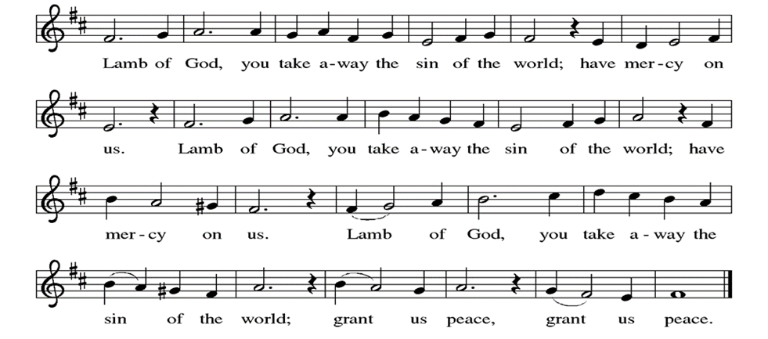

Communion Song: I am the Bread of Life ELW # 485
(printed next page)

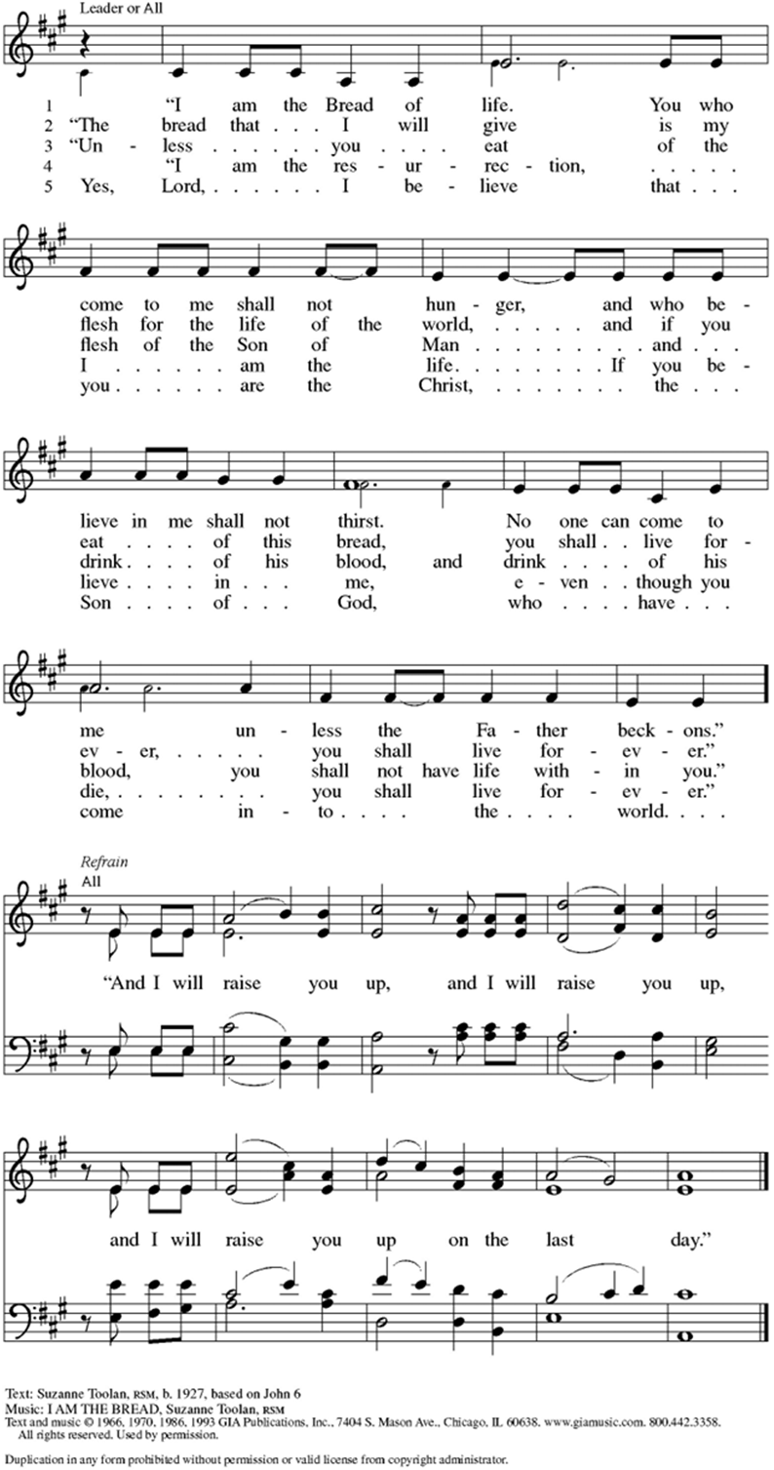
Communion Song: Sanctuary
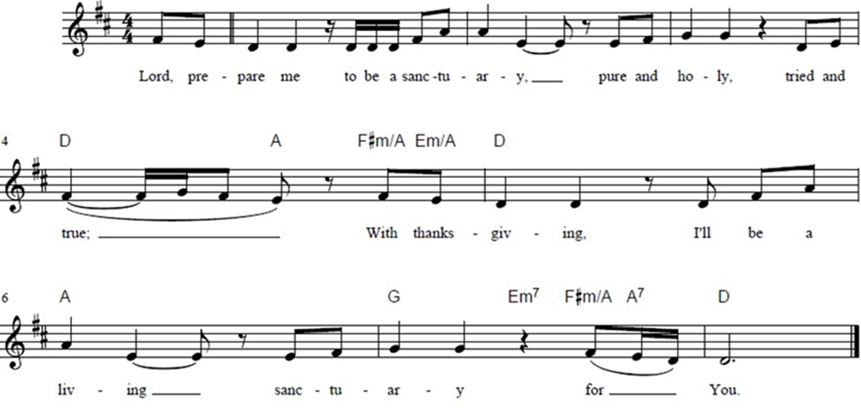

Post Communion Blessing
P: The Body and Blood of our Lord and Savior, Jesus Christ, strengthen you and keep you in God's grace. C: Amen.

Prayer After Communion
WA: Let us pray together.
C: Holy One, through this meal you have made your home among us and are making all things new. Send us now to speak peace to anxious hearts, to love our enemies, and to bring your healing to the nations. In the name of Jesus. Amen.

Sending - God blesses us and sends us in mission to the world.
Blessing
P: God Almighty, who is the beginning and the end, Jesus Christ, the firstborn of the dead, and the Spirit, our advocate and peace, + bless you now and forever. C: Amen

Sending Hymn: What a Fellowship, What a Joy Divine ELW #774
(printed next page)

Dismissal and Postlude
P: Parkside Lutheran Church is rediscovering the radical love of Jesus.
C: Gathering All, Serving All, Caring for All
P: Go in peace. Praise the Lord. Alleluia!
C: Thanks be to God. Alleluia! Alleluia!

ELW Music licensed from Sundays & Seasons, Augsburg Fortress CCLI MUSIC License # 11440069 , CCLI Streaming License#21835523 Do not duplicate any music or Liturgy herein without license and permission
scripture readings adapted and written by susan lukey

