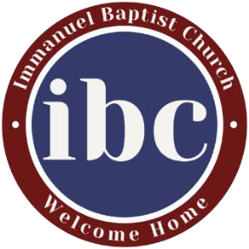

Quiet Time Questions from April 19, 2026
Main Point of the Sermon: God is Faithful to Fulfill His Covenant.
Verse for Memorization and Meditation: Until the time that his word came to pass, the word of Yahweh refined him. (Psalm 105:19)

- Read Genesis 37. Looking back, where can you now see God’s hand at work in a situation where you didn’t recognize it at the time? How does that shape the way you view your current circumstances?

- Read Genesis 37 and Genesis 15:13–16. What do these passages reveal about God’s work over time—even through suffering and confusion? How should that shape the way you trust Him in your life right now?

- Read Genesis 37. Even when Joseph and his family could not see it, God’s grace and mercy were at work in their lives. How should the truth that God is faithful to fulfill His covenant shape your worship this week?

