Holy Trinity Lutheran Church
150 River Road Red Bank, NJ 07701
Church Office: (732) 741-9241 Fax: (732) 741-9577
email: holytrinitychurch4@verizon.net
Website: htlcredbank.org
Pastor: Rev. John Mack, Jr.
Cell: (336)-392-5839
Minister of Music: Peter Isherwood
Parish Administrator: Deanna Vergari
Council President: Cynthia Kazmac

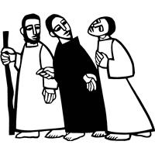

April 19, 2026

Third Sunday of Easter

Introduction
Today’s gospel begins with two disciples walking to Emmaus, overcome with sadness, loss, and disappointment. They had hoped Jesus, who was crucified, would be the one to redeem Israel! Yet the risen Christ walks with them and then opens their eyes in the breaking of the bread. Each Sunday our hearts burn within us as the scriptures are proclaimed and Christ appears to us as bread is broken and wine is poured. The story of Emmaus becomes the pattern of our worship each Lord’s day.

Welcome & Announcements (Please remember to silence your cell phone!)

Please, welcome Kristina, Zachary and Jett Allred.

Prelude (We prayerfully prepare our hearts and minds to worship!)

+ GATHERING +

Thanksgiving for Baptism
All may make the sign of the cross, the sign that is marked at baptism, as the presiding minister begins.
P:Alleluia! Christ is risen.
C:Christ is risen indeed. Alleluia!
P:Salvation belongs to our God who is seated on the throne
and to the Lamb!
C:Amen.
P:Let us give thanks for the gifts of baptism.
Water may be poured into the font as the presiding minister continues.
P:Merciful God,
you are the one who was, who is, and who is to come.
You lead us beside still waters.
We thank you for the waters of creation:
morning dew, gentle rain, roaring waves.
We thank you for the waters that nourish us (local waters may be named).
Blessed are you.
C:You guide us to springs of the water of life.
P:Jesus Christ, you are the faithful witness
who accompanies us on our journeys.
We give you thanks for your life-giving death and resurrection.
We praise you for joining us in joy and sorrow.
Blessed are you.
C:You guide us to springs of the water of life.
P:Holy Spirit, you anoint our head with oil and our cup overflows.
Break down barriers that divide us.
Fill us with the breath of peace.
Blessed are you.
C:You guide us to springs of the water of life.
P:Holy One, we thank you for the gifts and grace of baptism,
and for making us a new creation.
We join with saints and angels, giving you honor and praise,
now and forever.
C:Amen.

*Gathering Hymn ELW 373 Christ the Lord is Risen Today!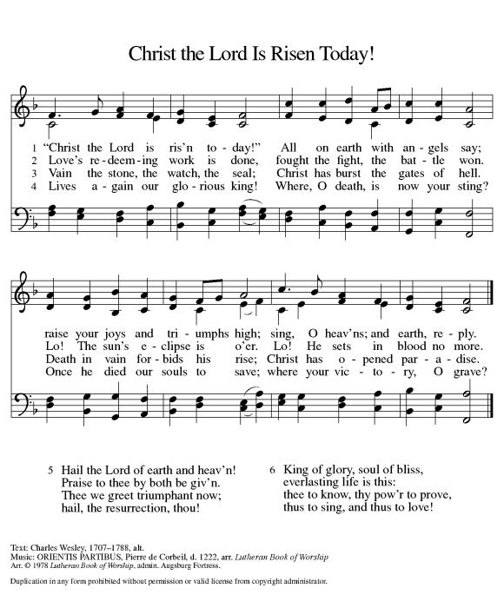

*Pastoral Greeting

P: The Grace of our Lord Jesus Christ, the love of God, and the communion of the Holy Spirit be with you all.

C: And also with you!

The assembly can be seated.
Presentation
P: God, who is rich in mercy and love, gives us a new birth into a living hope
through the sacrament of baptism. By water and the Word God delivers us from sin and death and raises us to new life in Jesus Christ. We are united with all the baptized in the one body of Christ, anointed with the gift of the Holy Spirit, and joined in God’s mission for the life of the world.

The presiding minister addresses the family:
P: Called by the Holy Spirit, trusting in the grace and love of God, do you desire to have your child baptized into Christ?
R: We do.
P: As you bring Jett to receive the gift of baptism, you are entrusted
with the responsibilities:
to live with him among God’s faithful people,
bring him to the word of God and the holy supper,
teach him the Lord’s Prayer, the Creed, and the Ten Commandments,
place in his hands the holy scriptures,
and nurture him in faith and prayer,
so that he may learn to trust God,
proclaim Christ through word and deed,
care for others and the world God made,
and work for justice and peace.

P: Do you promise to help your child grow in the Christian faith and life?
R: We do.

The presiding minister addresses the sponsors:
P: Sponsors, do you promise to nurture Jett in the Christian faith as you are empowered by God’s Spirit, and to help him live in the covenant of baptism and in communion with the church?
R: We do.

The presiding minister addresses the assembly:
P: People of God, do you promise to support Jett and pray for him in his life in Christ?
C: We do.

The assembly stands.
Profession of Faith
P: I ask you and this assembly to profess your faith in Christ Jesus, reject sin, and confess the faith of the Church, the faith in which we baptize.
Do you renounce the devil, and all the forces that defy God, the powers of this world that rebel against God, and the ways of sin that draw you from God?
C: We renounce them.
P: Do you believe in God the Father?
C: I believe in God, the Father almighty, creator of heaven and earth.
P: Do you believe in Jesus Christ, the Son of God?
C: I believe in Jesus Christ, his only Son, our Lord.
He was conceived by the power of the Holy Spirit
and born of the virgin Mary.
He suffered under Pontius Pilate,
was crucified, died, and was buried.
He descended into hell.
On the third day he rose again.
He ascended into heaven,
and is seated at the right hand of the Father.
He will come again to judge the living and the dead.

Do you believe in God the Holy Spirit?
C: I believe in the Holy Spirit,
the holy catholic Church,
the communion of saints,
the forgiveness of sins,
the resurrection of the body,
and the life everlasting. Amen

Thanksgiving at the Font (children are invited forward)
P: The Lord be with you.
C: And also, with you.
P: Let us give thanks to the Lord our God.
C: It is right to give thanks and praise.

P: We give you thanks, O God, for in the beginning your Spirit moved over the waters and by your Word you created the world, calling forth life in which you took delight. Through the waters of the flood, you delivered Noah and his family, and through the sea you led your people Israel from slavery into freedom. At the river your Son was baptized by John and anointed with the Holy Spirit. By the baptism of Jesus’ death and resurrection you set us free from the power of sin and death and raise us up to live in you. Pour out your Holy Spirit, the power of your living Word, that those who are washed in the waters of baptism may be given new life. To you be given honor and praise through Jesus Christ our Lord, in the unity of the Holy Spirit, now and forever.
C: Amen.

The assembly can be seated.
Baptism
P: Jett, I baptize you in the name of the Father, and of the Son, and of the Holy Spirit.
C: Amen.

Prayer For the Holy Spirit
The presiding minister continues:
P: Let us pray. We give you thanks, O God, that through water and the Holy Spirit you give your daughters and sons new birth, cleanse them from sin, and raise them to eternal life.
Sustain Jett with the gift of your Holy Spirit:
the spirit of wisdom and understanding,
the spirit of counsel and might,
the spirit of knowledge and the fear of the Lord,
the spirit of joy in your presence, both now and forever.
C: Amen.

Signing of the Cross
The minister marks the sign of the cross on the forehead of the baptized as the minister says:
P: Jett, child of God, you have been sealed by the Holy Spirit and marked with the cross of Christ forever.

(A lighted candle is given to the baptized by the assisting minister)
A: Let your light shine before others that they may see your good works and glorify your Father in heaven.

Family Blessing
P: O God, the giver of all life, look with kindness upon Kristina and Zachary and all who help raise this child in faith. Let them ever rejoice in the gift you have given them. Make them teachers and examples of righteousness. Strengthen them in their own Baptism so they may share eternally the salvation you have given them, through Jesus Christ our Lord.
C: Amen.

P: Let us welcome the newly baptized:
C: We welcome you into the body of Christ and into the mission we share: join us giving thanks and praise to God and bearing God’s creative and redeeming word to all the world.

(Please stand)
Baptismal Hymn ELW #453 Baptized and Set Free
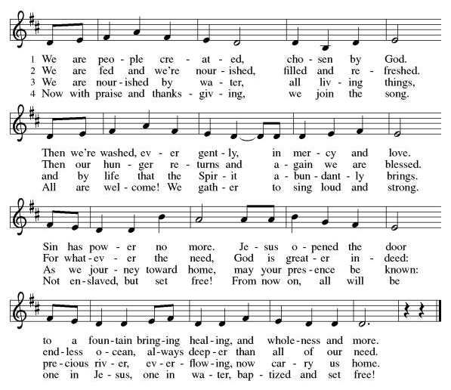

Prayer of the Day
P: O God, your Son makes himself known to all his disciples in the breaking of bread. Open the eyes of our faith, that we may see him in his redeeming work, who lives and reigns with you and the Holy Spirit, one God, now and forever.
C: Amen!

+WORD+

First Reading: Acts 2:14a, 36-41
Today’s reading is the conclusion of Peter’s sermon preached following the giving of the Holy Spirit to the apostles on the day of Pentecost. The center of his preaching is the bold declaration that God has made the crucified Jesus both Lord and Christ.

^{14a} Peter, standing with the eleven, raised his voice and addressed [the crowd]: ³⁶ “Therefore let the entire house of Israel know with certainty that God has made him both Lord and Messiah, this Jesus whom you crucified.”
³⁷ Now when they heard this, they were cut to the heart and said to Peter and to the other apostles, “Brothers, what should we do?” ³⁸ Peter said to them, “Repent and be baptized every one of you in the name of Jesus Christ so that your sins may be forgiven, and you will receive the gift of the Holy Spirit. ³⁹ For the promise is for you, for your children, and for all who are far away, everyone whom the Lord our God calls to him.” ⁴⁰ And he testified with many other arguments and exhorted them, saying, “Save yourselves from this corrupt generation.” ⁴¹ So those who welcomed his message were baptized, and that day about three thousand persons were added.

Psalm: Psalm 116:1-4, 12-19
I will call on the name of the Lord. (Ps. 116:13)

¹ I love the Lord, who has | heard my voice,
and listened to my | supplication,
² for the Lord has given | ear to me
whenev- | er I called.
³ The cords of death entangled me; the anguish of the grave | came upon me;
I came to | grief and sorrow.
⁴ Then I called upon the name | of the Lord:
“O Lord, I pray you, | save my life.”
¹² How shall I re- | pay the Lord
for all the good things God has | done for me?
¹³ I will lift the cup | of salvation
and call on the name | of the Lord.
¹⁴ I will fulfill my vows | to the Lord
in the presence of | all God’s people.
¹⁵ Precious in your | sight, O Lord,
is the death | of your servants.
¹⁶ O Lord, truly I | am your servant;
I am your servant, the child of your handmaid; you have freed me | from my bonds.
¹⁷ I will offer you the sacrifice | of thanksgiving
and call upon the name | of the Lord.
¹⁸ I will fulfill my vows | to the Lord
in the presence of | all God’s people,
¹⁹ in the courts of | the Lord’s house,
in the midst of you, O Jerusalem. | Hallelujah!

Second Reading: 1 Peter 1:17-23
The imagery of exile is used to help the readers of this letter understand that they are strangers in a strange land. Christians no longer belong to this age. Through the death of Christ we belong to God, so that our focus, faith, and hope are no longer on such things as silver or gold.

¹⁷ If you invoke as Father the one who judges impartially according to each person’s work, live in fear during the time of your exile. ¹⁸ You know that you were ransomed from the futile conduct inherited from your ancestors, not with perishable things like silver or gold ¹⁹ but with the precious blood of Christ, like that of a lamb without defect or blemish. ²⁰ He was destined before the foundation of the world but was revealed at the end of the ages for your sake. ²¹ Through him you have come to trust in God, who raised him from the dead and gave him glory, so that your trust and hope are in God.
²² Now that you have purified your souls by your obedience to the truth so that you have genuine mutual affection, love one another deeply from the heart. ²³ You have been born anew, not of perishable but of imperishable seed, through the living and enduring word of God.

*Gospel Acclamation
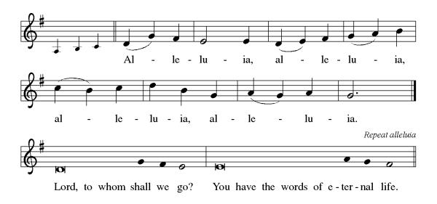

P: The Holy Gospel According to St. Luke 24th Chapter
C: Glory to You O Lord!

Gospel: Luke 24:13-35
The colorful story of Jesus’ appearance to two disciples on the road to Emmaus answers the question of how Jesus is to be recognized among us. Here, he is revealed through the scriptures and in the breaking of bread.

¹³ Now on that same day two [disciples] were going to a village called Emmaus, about seven miles from Jerusalem, ¹⁴ and talking with each other about all these things that had happened. ¹⁵ While they were talking and discussing, Jesus himself came near and went with them, ¹⁶ but their eyes were kept from recognizing him. ¹⁷ And he said to them, “What are you discussing with each other while you walk along?” They stood still, looking sad. ¹⁸ Then one of them, whose name was Cleopas, answered him, “Are you the only stranger in Jerusalem who does not know the things that have taken place there in these days?” ¹⁹ He asked them, “What things?” They replied, “The things about Jesus of Nazareth, who was a prophet mighty in deed and word before God and all the people, ²⁰ and how our chief priests and leaders handed him over to be condemned to death and crucified him. ²¹ But we had hoped that he was the one to redeem Israel. Yes, and besides all this, it is now the third day since these things took place. ²² Moreover, some women of our group astounded us. They were at the tomb early this morning, ²³ and when they did not find his body there they came back and told us that they had indeed seen a vision of angels who said that he was alive. ²⁴ Some of those who were with us went to the tomb and found it just as the women had said, but they did not see him.” ²⁵ Then he said to them, “Oh, how foolish you are and how slow of heart to believe all that the prophets have declared! ²⁶ Was it not necessary that the Messiah should suffer these things and then enter into his glory?” ²⁷ Then beginning with Moses and all the prophets, he interpreted to them the things about himself in all the scriptures.
²⁸ As they came near the village to which they were going, he walked ahead as if he were going on. ²⁹ But they urged him strongly, saying, “Stay with us, because it is almost evening and the day is now nearly over.” So he went in to stay with them. ³⁰ When he was at the table with them, he took bread, blessed and broke it, and gave it to them. ³¹ Then their eyes were opened, and they recognized him, and he vanished from their sight. ³² They said to each other, “Were not our hearts burning within us while he was talking to us on the road, while he was opening the scriptures to us?” ³³ That same hour they got up and returned to Jerusalem, and they found the eleven and their companions gathered together. ³⁴ They were saying, “The Lord has risen indeed, and he has appeared to Simon!” ³⁵ Then they told what had happened on the road and how he had been made known to them in the breaking of the bread.

P: The Gospel of the Lord
C: Praise to you, O Christ!
Sermon
*Hymn of the Day ELW 392 Alleluia! Sing to Jesus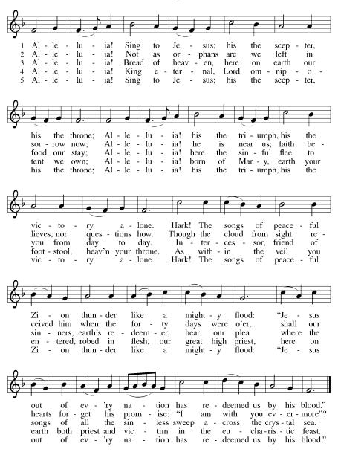

*Prayers of Intercession
Trusting in the power of Christ’s resurrection to heal and redeem our broken world, let us pray for the needs of all creation.
A brief silence.
Living Savior, just as you journeyed with the disciples to Emmaus, accompany us on our journey of faith. Gather us at your table, that we recognize you in the breaking of the bread. Merciful God,
C:receive our prayer.
Almighty God, you provide for the needs of all creation. Bless the fields that are being prepared for planting, and send favorable weather so that the soil may yield an abundant harvest. Merciful God,
C:receive our prayer.
God of justice, where leaders abuse power, confront them and call them to repentance. Where there is corruption, bring integrity; where there is violence, sow peace. Merciful God,
C:receive our prayer.
Healing Savior, your resurrection brings hope to a hurting world. Heal those who are sick (especially). Strengthen the weary, give courage to the despairing, and comfort the dying. Merciful God,
C:receive our prayer.
Gracious One, you have made us your own through the gift of baptism. Unite us in genuine love for one another and uphold this community in your name. Merciful God,
C:receive our prayer.
Here other intercessions may be offered.
Eternal Light, we give thanks for (Olavus Petri, Laurentius Petri and) all who have nurtured your church’s life in ages past. Bring us at last with them to the brightness of your glorious presence. Merciful God,
C:receive our prayer.
God of resurrection power, use us and these prayers to proclaim the good news of new life to all the world, through Jesus Christ, our risen Savior.
C: Amen.

Greeting of Peace
P: The peace of Christ be with you always!
C: And also with you!

Offering (Thank you for your support for our ministry!)

*Doxology ELW 384 v.4 That Easter Day with Joy Was Bright (Please stand and join in singing as we share our gifts!)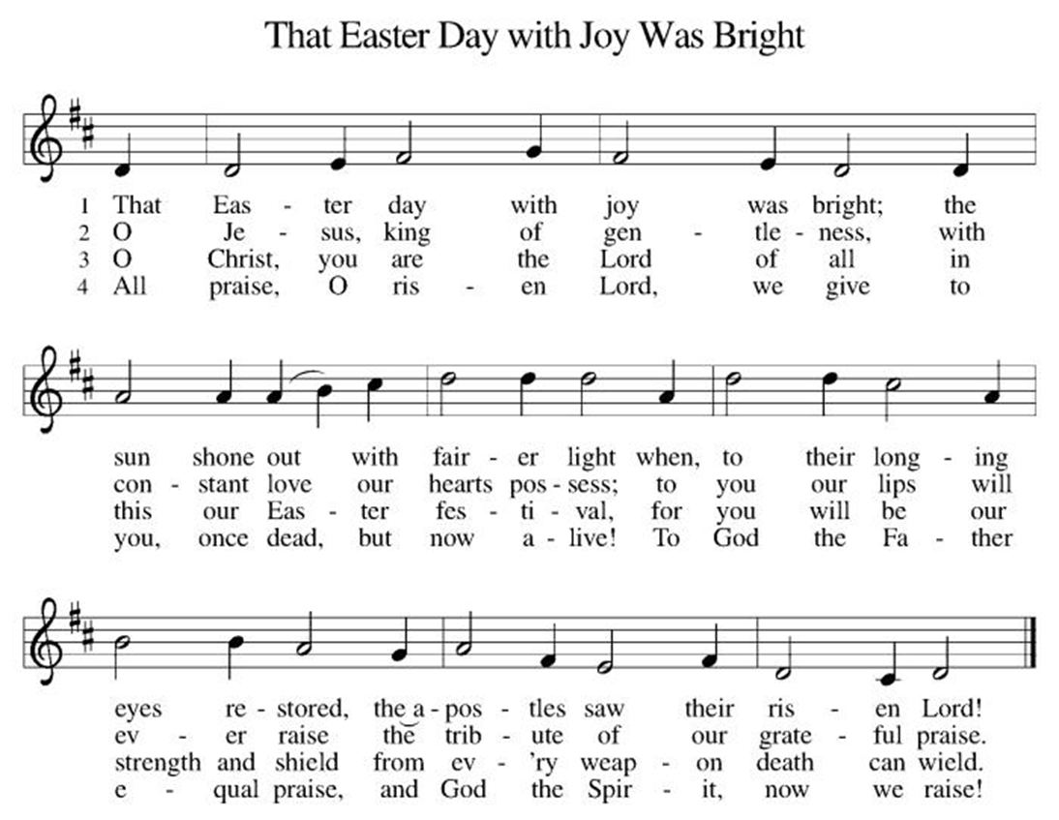

*Offering Prayer
A: Merciful God,
C: accept the fruits of our labor, gathered to give you glory.
You have set a table before us, a glimpse of that great day
when we will hunger and thirst no more.
Nourish us with the body and blood of Jesus,
that goodness and mercy may follow us
and bless the world you love.
In the name of Jesus,
Amen!

+MEAL+
*Great Thanksgiving
P: The Lord be with you.
C: And also with you.

P: Lift up your hearts.
C: We lift them to the Lord.

P: Let us give thanks to the Lord our God.
C: It is right to give our thanks and praise.

P: It is indeed right, our duty and our joy,
that we should at all times and in all places
give thanks and praise to you, almighty and merciful God,
for the glorious resurrection of our Savior Jesus Christ,
the true Paschal Lamb who gave himself to take away our sin;
who in dying has destroyed death,
and in rising has brought us to eternal life.
And so, with Mary Magdalene and Peter and all the witnesses of the resurrection, with earth and sea and all their creatures,
and with angels and archangels, cherubim and seraphim,
we praise your name and join their unending hymn:

*Sanctus
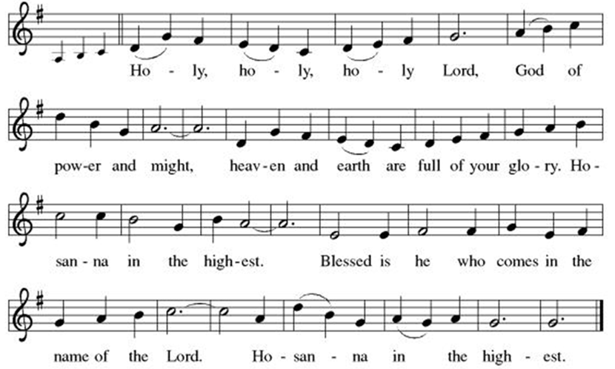

*Eucharistic Prayer
P: Holy, mighty, and merciful Lord,
heaven and earth are full of your glory.

In great love you sent to us Jesus, your Son,
who reached out to heal the sick and suffering,
who preached good news to the poor,
and who, on the cross, opened his arms to all.

In the night in which he was betrayed,
our Lord Jesus took bread, and gave thanks;
broke it, and gave it to his disciples, saying:
Take and eat; this is my body, given for you.
Do this for the remembrance of me.

Again, after supper, he took the cup, gave thanks,
and gave it for all to drink, saying:
This cup is the new covenant in my blood,
shed for you and for all people for the forgiveness of sin.
Do this for the remembrance of me.

Remembering, therefore, his death, resurrection, and ascension,
we await his coming in glory.

Pour out upon us the Spirit of your love, O Lord,
and unite the wills of all who share this heavenly food,
the body and blood of Jesus Christ, our Lord;
to whom, with you and the Holy Spirit,
be all honor and glory, now and forever.

C: Amen!

*THE LORD’S PRAYER
Our Father, who art in heaven,
hallowed be thy name,
thy kingdom come,
thy will be done,
on earth as it is in heaven.
Give us this day our daily bread;
and forgive us our trespasses,
as we forgive those
who trespass against us;
and lead us not into temptation,
but deliver us from evil.
For thine is the kingdom,
and the power, and the glory,
forever and ever. Amen.
*Lamb of God
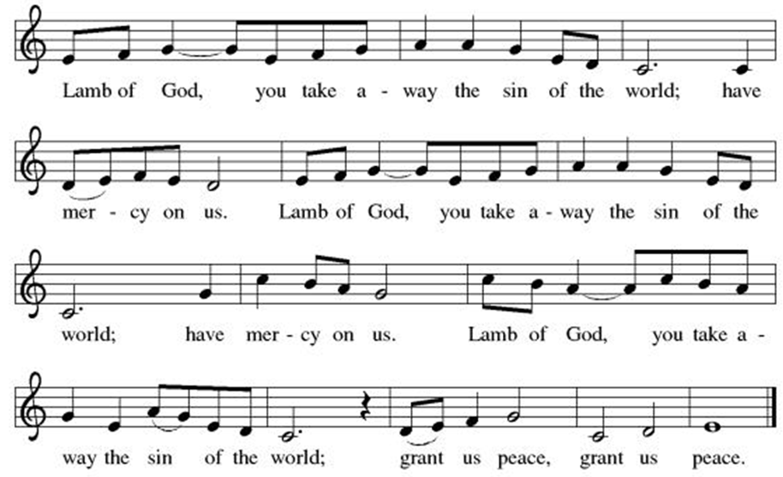
Spiritual Communion Prayer
P: Let us pray for the communion of all present here, those viewing our service virtually, those in our hearts and in our world.
C: Lord Jesus, I believe you are truly present in the Sacrament of Holy Communion. When I cannot receive Communion, I pray that you come into my heart. I know that nothing in Heaven or on earth can separate me from your love. Amen.

Invitation to Communion
P: Come to the table of new life.
Receive the risen Lord.

C: Thanks be to God!

(All are invited to the communion rail following the guidance of the ushers. Communion will be shared through the host and individual cups. If you would like communion but are unable to join us at the rail, please alert the usher!)
Communion Hymns (Please join in singing!)
ELW 661 I Love to Tell the Story
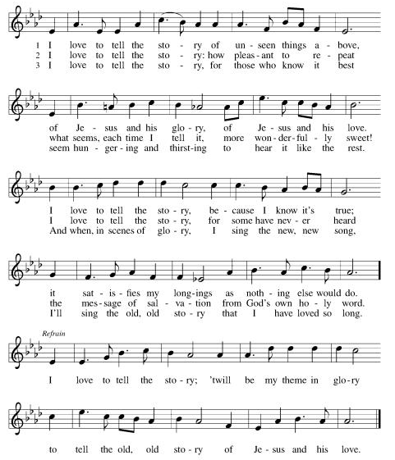

ELW 374 Day of Arising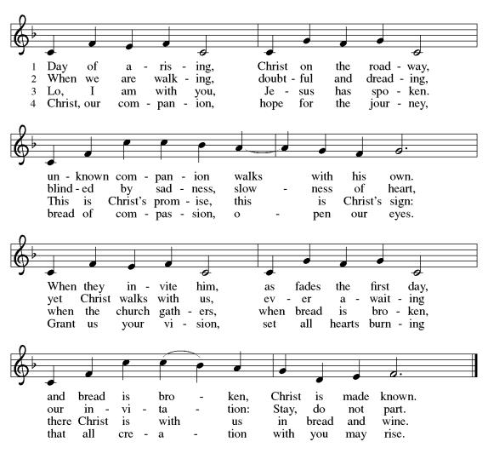

P: The body and blood of our Lord Jesus Christ strengthen you and keep you in his grace. C: Amen!

*Prayer after Communion
A: Holy One,
through this meal you have made your home among us
and are making all things new.
Send us now to speak peace to anxious hearts,
to love our enemies,
and to bring your healing to the nations.
In the name of Jesus,
C: Amen.

+Sending+

*Blessing
P: God Almighty, who is the beginning and the end,
Jesus Christ, the firstborn of the dead,
and the Spirit, our advocate and peace,
☩ bless you now and forever.
C: Amen!

*Sending Hymn ELW 825 You Servants of God
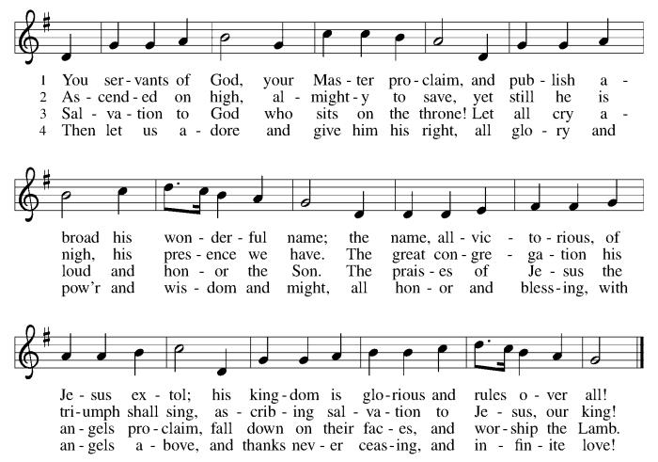

*Dismissal
A: Go in peace. Praise the Lord. Alleluia!
C: Thanks be to God. Alleluia!
Postlude

Copyright © 2020 Augsburg Fortress. All rights reserved. Reprinted by permission under Augsburg Fortress Liturgies Annual License #SB106907. New Revised Standard Version Bible, Copyright © 1989, Division of Christian Education of the National Council of the Churches of Christ in the United States of America. Used by permission. All rights reserved. Revised Common Lectionary, Copyright © 1992 Consultation on Common Texts, admin Augsburg Fortress. Used by permission.

Treasurer’s Report


March giving totaled $24,026, putting us ahead of pace toward our 2026 Challenge goal of $244,000, with 39% raised in just 25% of the year. Continued participation through regular or additional Challenge gifts will help ensure we fully fund HTLC’s ministry and mission in the months ahead.
Worship Volunteer Schedule
Date | Asst. Min | Usher | Sacristan | Lector | Counter
April 19 | Chris Foard | Jill Socha | Pat Pienkos | Emily Kaster | Volk/Bohner
April 26 | Charlie Rugg | Keith Bennett | Joanne Giordano | Rosemary Lane | Kazmac/Bradford
May 3 | Keith Bennett | Kathy Caputo | Sherry Lee | Bill Spreen | Socha/Cheek
May 10 | Keith Bennett | Dan Grillon | Helga Britton | Cynthia Kazmac | Carleo/Spreen

Coffee Hour-

ANNOUNCEMENTS Thank you! To all who consistently support our church and ministries through your time, talent, and treasure. Please help us grow by inviting your friends and family to worship and events. You are what makes Holy Trinity a wonderful church family!

Stay in touch! Please visit our church website, www.htlcredbank.org for updates and information. You can also find us on Facebook and view services online. The office is open from 9am to 2pm, Monday to Thursday.

Car Wash-The car wash will start at 10 AM with churchgoers cars washed first, then will open up to the general public from noon till 2:00 PM. We will need volunteers to wash the cars, dry cars, manage supplies and supervise. Please sign up in the Red Book. Contact Lauren Bennett with questions period proceeds will support Cross Roads Day Camp.

100 Anniversary Committee- All are welcome for the initial meeting of the planning committee for the 100th anniversary of Holy Trinity Evangelical Lutheran Church.
Let’s gather after church on April 26 to get this committee up and running and develop a meeting schedule. This initial meeting should not take long.

Name Tag Sundays: On the first Sunday of each month, names tags and markers will be at each entrance of the sanctuary. Please fill out a tag and wear one for worship and for coffee hour to welcome visitors and help newcomers put names to faces.

Sunday School in the New Year, we will continue to study stories and lessons from the Old Testament beginning with Jacob. Kids will love the crafts, songs and games that accompany each lesson.
The following dates there will be Sunday School:
April 26, May- 3, 17 and 31, June- 7 and 14
As was done in the fall, there will be opportunities to volunteer as SS lead teacher. A signup will be emailed out shortly and will also be posted in the red binder. Consider signing up! All lesson materials will be supplied and laid out and a leader guide will be emailed to volunteers approximately 1 week in advance. Blessings for a wonderful 2026!~Lauren

Choir The Holy Trinity Choir welcomes our singers back for a preparation rehearsal on Sunday, September 7th at 9am in the church hall. All are welcome to join us in song as often as you are able. Choir meets each Sunday at 9am to practice and prepare our music. Join us and help us grow by spreading the word about the HTLC Choir!

Quilting- The Quilters need gently used any bed sheets of any size! Please leave any donations in the quilters closet in Fellowship Hall. Thank you!

Quilters Need Help
If anyone is traveling through Mechanicsville, PA, and can add a few extra minutes to your trip, the warehouse for shipping quilts, school kits, etc is located directly off one of the exits.
We accumulate many quilts throughout the year and we would appreciate sending some quilts with you to deliver. Any questions, please call Sherry Lee or Elaine Theophall.

Weekly Quilting on Wednesdays at 9:30. Bring your lunch and enjoy some fellowship at noon. All are welcome.

Social Ministry
*Year-round collections will continue for food items for Lunch Break. There is a sign-up sheet in the red book for those who can help drop these items to Lunch Break.
*We will also collect adult men's socks to periodically drop at the Red Bank Warminq Center.
*For those interested in the Heartwarminq Center — the new women's shelter is adjacent to the First Baptist Church of Red Bank at 90 Maple Ave. You can follow up on this mission through their website - https://www.thefeastnj.org- On this site, they also include wish list items that can be purchased through amazon. We will be exploring purchasing some of these through a Thrivent card. If you want to purchase on your own, you can leave items at church, and the Social Ministry will deliver them.

Pastoral Care and Prayer... We are here to care for and pray! Please contact the office to add or adjust prayer requests. If you or someone you know needs pastoral care, please contact the office and Pastor Mack!

THANK YOU for supporting and sustaining our church and ministries! All are welcome here! Please invite your family and friends to worship with us! Find us online at www.htlcredbank.org

Special Congregational Meeting – Mortgage Payoff Opportunity
April 29, 2026 | Immediately following worship
Holy Trinity has a unique opportunity to eliminate our remaining mortgage through a new NJ Synod Mortgage Capital Match Grant. Through this program, every dollar we raise will be matched 2-to-1—meaning $25,000 raised could retire our entire $75,000 mortgage.
This is a one-time opportunity made possible by funds from the NJ Synod.
To participate, we must approve a capital fundraising effort at a brief congregational meeting. The meeting will include:
- A short overview from the Finance Committee
- A single vote to authorize the campaign
More details will be shared at the meeting and in upcoming communications.

