THE WARS OF THE JEWS
OR HISTORY OF THE DESTRUCTION OF JERUSALEM
By Flavius Josephus (Translated by William Whiston)

BOOK II, Chapter XIII, 5. *
5. But there was an Egyptian false prophet that did the Jews more mischief than the former; for he was a cheat, and pretended to be a prophet also, and got together thirty thousand men that were deluded by him; these he led round about from the wilderness to the mount which was called the Mount of Olives, and was ready to break into Jerusalem by force from that place; and if he could but once conquer the Roman garrison and the people, he intended to domineer over them by the assistance of those guards of his that were to break into the city with him. But Felix prevented his attempt, and met him with his Roman soldiers, while all the people assisted him in his attack upon them, insomuch that when it came to a battle, the Egyptian ran away, with a few others, while the greatest part of those that were with him were either destroyed or taken alive; but the rest of the multitude were dispersed every one to their own homes, and there concealed themselves.

* Josephus gives a similar account in his Antiquities, Book XX, Chapter 8.6

Temple Warning Inscription

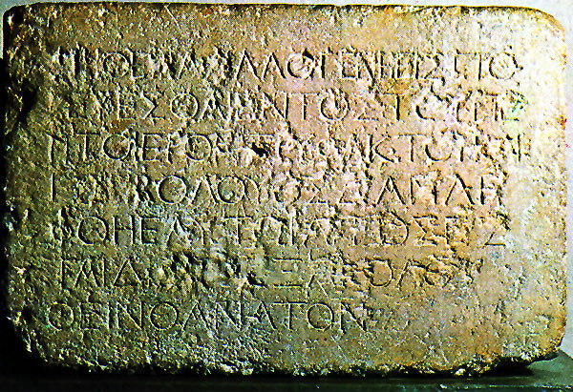

"No Gentile may enter beyond the dividing wall into the court around the Holy Place; whoever is caught will be to blame for his subsequent death."

