All Saints Anglican Church
6904 Lougheed Highway, Agassiz, B.C. V0M 1A0
Bulletin April 13th, 2026 – April 19th, 2026

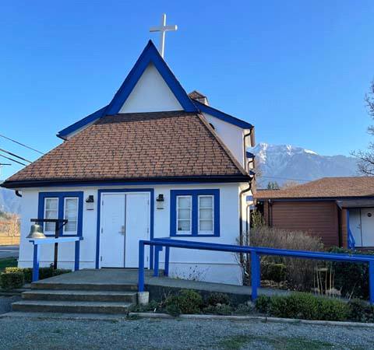

‘The ground we walk does not belong to us; for thousands of years it has been - and remains - the territory of the Stó:lō. We are grateful for their sharing.

Phone: 604-796-3553
Website: www.allsaints-agassiz.ca
https://www.facebook.com/groups/AllSaintsFamily
OUR DOOR IS OPEN AND ALL ARE WELCOME
April 19th, 2026, Third Sunday of Easter
Priest in Charge: The Reverend Philip Barker
Hosts: Graham Featherstone/Jennifer Pinlac
Intercessor: Graham Featherstone
Lay Administrator: Dorothy Cresswell
Announcer: Virginia Jennings
Organ/Piano: Francesca Froehlich
Readers: Lynn Laughlin/Keith Fossey
Vicar’s cell phone: Revd. Philip Barker. 778-867-2461

Vicar’s Warden: Ginny Jennings. 604-796-2206
People’s Warden: Lynn Laughlin. 604-799-5131
Parish email: revpb1950@gmail.com
Please contact either warden if you have an issue that needs to be brought to the attention of the Vicar - or contact the Vicar direct (see above for details).

All Saint’s Calendar/Announcements:

- Book Club – On April 8th Book Club will resume Zoom meetings on Wednesdays at 5.00 pm. The first week will be a discussion of the 3 books that were read by members during Lent.

The next book will be "The Last Week: What the Gospels really teach about Jesus' final days in Jerusalem", by Marcus J. Borg and John Dominic Crosson. This will be an appropriate follow on from Holy Week.
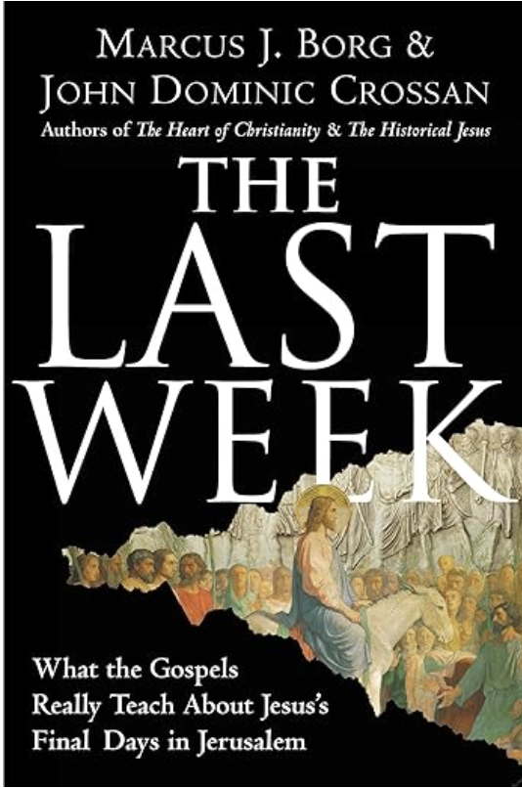
The book is $21.00 in paperback on Amazon and also
available on Kindle.

If you would like to join the group or have a copy of the
book, please contact Sheila at sjbarker0379@gmail.com

- Bible Study with Karol is every Saturday morning 0830-0900 on Zoom.

- Prayer Requests can be given on a piece of paper to either of the Wardens or the Vicar or entered in the Prayer Request Book on the lectern. Alternatively, you can contact Anthea Lewis at antheamlewis@shaw.ca for Pray First Prayer Circle, which is a confidential online prayer circle.

- Music Requests may be given to the Wardens or the Vicar.

- AA meets in the hall every Tuesday and Friday at noon.

- Every Thursday in the hall 1100-1200 we have a social time with coffee, games if you like or just talk.

- At 1000-1100 on Thursdays there is an Interactive Bible Study on the day’s Lectionary readings. All are welcome – discover the treasures in this amazing book!

- 5th Sunday of each month will be a potluck lunch after the service.

Ministerial Meandering
Je veux…

If you sat down in a French restaurant and started to order with the words, ‘Je veux…’, you would probably get a roll of Gallic eyeballs and an unconcealed sigh of disgust, before the price for your cinnamon café latte with almond milk and chocolate sprinkles trebled in price.
Such a beginning would be similar to our eldest grandson (now off to college this fall) banging the table with his knife and fork when aged about three, and yelling, “Where’s my chicken!”
Whilst the Canadian attitude to such behaviour is likely to be one of amused tolerance, the words, ‘je veux…’ - ‘I WANT…’ do not go down well when looking for sustenance (or anything else) in France.

However, I now find myself in a bit of a quandary - which is somewhat like a whale’s stomach only with less mucus - but equally difficult to get out of. Most people have a degree of self-interest. To be devoid of any would be to regard yourself of no worth at all. Nevertheless, selfishness is also perceived as an unattractive quality. How do we find the balance between being generous enough, but not so generous that we give away everything?

When I was a medical student in London (UK), we had a mission that resulted in the coming to Christ of several of us in the Medical School. One of my fellow students went overboard with the altruism; he invited a tramp (street person) into his flat (apartment), and gave him his bed, food, money, and clothes. Soon he was out on the street himself, cold and hungry - and in trouble from his landlord for ‘sub-letting’. One can take generosity too far. ‘That’, Sheila would say, ‘is why the church advises ‘tithing’, or giving a tenth of your earnings to the church.

Since I have had little or nothing to do with our finances over the almost five decades of our marriage, I cannot say for certain exactly how much we, as a couple, have given to the church and other worthy causes, but I can say for certain that it has been at least a tenth of our income. The ‘other worthy causes’ have sometimes been charities of our choice - and sometimes it has included family - n’importe.

The dilemma arises around the issue of whether you think you are worth giving to, yourself. Where is the line in the sand that defines what is reasonable to give to yourself - because you also have worth - and when you should not, because to do so would be purely greedy and utterly selfish? I think the answer to this has partly to do with what you have done with your life, and where you are on the journey.

I don’t believe that youngsters setting out on life’s road with little or no experience have acquired sufficient entitlement to be utterly selfish; they still need to know what it is to need to save, and to give where nothing is returned. That might be to a charitable collection or a loan to a friend that is never repaid. Not for nothing did Polonius advise his son Laertes, ‘…neither a borrower nor a lender be…’

At some point, perhaps quite a way along the path, you may reach a spot where it feels right to spend some of what you have earned - be it time or money, or both - on yourself, because you have earned it, and you also have worth. This should not engender guilt, though there will be many who will encourage you to feel that way - not least yourself, particularly if you are a ‘people-pleaser’. There will always be the deserving poor, but making yourself into one of them does nothing for your self-esteem, nor does it honour your creator. I am not creeping surreptitiously into the ‘Prosperity’ gospel here, but just making the point that it is OK - when you have earned it - to occasionally give yourself nice things.

Philip+

A Little Chuckle…



Birthdays this Month  April

Rev. Philip Barker – 1 Dorothy Cresswell – 2
Lynn Laughlin – 12 Anthea Lewis – 12
Peggy Arndt – 14 Jennifer Pinlac – 15
Sheila Barker – 19 Helene Atkinson – 27

Diocesan Cycle of Prayer: We Pray for the Clergy and Congregation:

The Deanery of North Vancouver - The Revd Helen Dunn, Regional Dean; The children and youth of our church, and those ministries by, with and for them: The Diocesan Youth Movement and parish youth leaders , ; All Saints, Agassiz, The Revd Philip Barker ; The Territory of the People – The Revd Clara Plamondon, Bishop-elect

Anglican Church of Canada Cycle of Prayer – We Pray for:

The Most Rev. Anne Germond, Archbishop, and the clergy and people of the Diocese of Algoma. Climate justice and healthy relationships with the earth.

Collect

O God, your Son made himself known to his disciples in the breaking of bread.
Open the eyes of our faith, that we may see him in his redeeming work, who is alive and reigns with you and the Holy Spirit, one God, now and for ever.

Acts 2:14a, 36-41 Lynn Laughlin

^{14a}Then Peter stood up with the Eleven, raised his voice and addressed the crowd: “Fellow Jews and all of you who live in Jerusalem, let me explain this to you; listen carefully to what I say.

³⁶ “Therefore let all Israel be assured of this: God has made this Jesus, whom you crucified, both Lord and Messiah.”

³⁷ When the people heard this, they were cut to the heart and said to Peter and the other apostles, “Brothers, what shall we do?”

³⁸ Peter replied, “Repent and be baptized, every one of you, in the name of Jesus Christ for the forgiveness of your sins. And you will receive the gift of the Holy Spirit. ³⁹ The promise is for you and your children and for all who are far off—for all whom the Lord our God will call.”

⁴⁰ With many other words he warned them; and he pleaded with them, “Save yourselves from this corrupt generation.” ⁴¹ Those who accepted his message were baptized, and about three thousand were added to their number that day.

Psalm 34:1-10

¹ I will extol the Lord at all times;
his praise will always be on my lips.
² I will glory in the Lord;
let the afflicted hear and rejoice.
³ Glorify the Lord with me;
let us exalt his name together.

⁴ I sought the Lord, and he answered me;
he delivered me from all my fears.
⁵ Those who look to him are radiant;
their faces are never covered with shame.
⁶ This poor man called, and the Lord heard him;
he saved him out of all his troubles.
⁷ The angel of the Lord encamps around those who fear him,
and he delivers them.

⁸ Taste and see that the Lord is good;
blessed is the one who takes refuge in him.
⁹ Fear the Lord, you his holy people,
for those who fear him lack nothing.
¹⁰ The lions may grow weak and hungry,
but those who seek the Lord lack no good thing.

1 Peter 1:17-23 Keith Fossey

¹⁷ Since you call on a Father who judges each person’s work impartially, live out your time as foreigners here in reverent fear. ¹⁸ For you know that it was not with perishable things such as silver or gold that you were redeemed from the empty way of life handed down to you from your ancestors, ¹⁹ but with the precious blood of Christ, a lamb without blemish or defect. ²⁰ He was chosen before the creation of the world, but was revealed in these last times for your sake. ²¹ Through him you believe in God, who raised him from the dead and glorified him, and so your faith and hope are in God.

²² Now that you have purified yourselves by obeying the truth so that you have sincere love for each other, love one another deeply, from the heart. ²³ For you have been born again, not of perishable seed, but of imperishable, through the living and enduring word of God.

Luke 24:13-25 Vicar Philip Barker

¹³ Now that same day two of them were going to a village called Emmaus, about seven miles from Jerusalem. ¹⁴ They were talking with each other about everything that had happened. ¹⁵ As they talked and discussed these things with each other, Jesus himself came up and walked along with them; ¹⁶ but they were kept from recognizing him.

¹⁷ He asked them, “What are you discussing together as you walk along?”

They stood still, their faces downcast. ¹⁸ One of them, named Cleopas, asked him, “Are you the only one visiting Jerusalem who does not know the things that have happened there in these days?”

¹⁹ “What things?” he asked.

“About Jesus of Nazareth,” they replied. “He was a prophet, powerful in word and deed before God and all the people. ²⁰ The chief priests and our rulers handed him over to be sentenced to death, and they crucified him; ²¹ but we had hoped that he was the one who was going to redeem Israel. And what is more, it is the third day since all this took place. ²² In addition, some of our women amazed us. They went to the tomb early this morning ²³ but didn’t find his body. They came and told us that they had seen a vision of angels, who said he was alive. ²⁴ Then some of our companions went to the tomb and found it just as the women had said, but they did not see Jesus.”

²⁵ He said to them, “How foolish you are, and how slow to believe all that the prophets have spoken! ²⁶ Did not the Messiah have to suffer these things and then enter his glory?” ²⁷ And beginning with Moses and all the Prophets, he explained to them what was said in all the Scriptures concerning himself.

²⁸ As they approached the village to which they were going, Jesus continued on as if he were going farther. ²⁹ But they urged him strongly, “Stay with us, for it is nearly evening; the day is almost over.” So he went in to stay with them.

³⁰ When he was at the table with them, he took bread, gave thanks, broke it and began to give it to them. ³¹ Then their eyes were opened and they recognized him, and he disappeared from their sight. ³² They asked each other, “Were not our hearts burning within us while he talked with us on the road and opened the Scriptures to us?”

³³ They got up and returned at once to Jerusalem. There they found the Eleven and those with them, assembled together ³⁴ and saying, “It is true! The Lord has risen and has appeared to Simon.” ³⁵ Then the two told what had happened on the way, and how Jesus was recognized by them when he broke the bread.

Odds and Ends

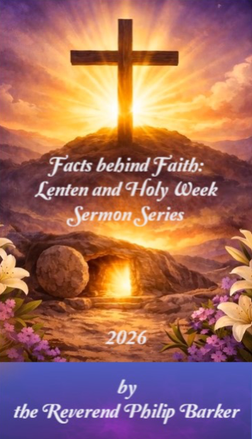

“Facts Behind Faith” is a collection of Philip’s sermons put together in a booklet.

If you would like a copy of this Philip Barker Collection, the cost is $10.00 and any additional donations are greatly appreciated.

