Welcome to Worship

3rd Sunday after Easter ~ April 19, 2026

PRESERVICE MUSIC

WELCOME AND ANNOUNCEMENTS

CONFESSION and FORGIVENESS:
Blessed be the holy Trinity, ☩ one God,
who forgives all our sin, whose mercy endures forever. Amen.

God of all mercy and consolation, come to the help of your people, turning us from our sin to live for you alone. Give us the power of your Holy Spirit that we may confess our sin, receive your forgiveness, and grow into the fullness of Jesus Christ, our Savior and Lord. Amen.

Let us confess our sin in the presence of God and of one another.

Gracious God … have mercy on us.
We confess that we have turned from you and given ourselves into the power of sin. We are truly sorry and humbly repent. In your compassion forgive us our sins, known and unknown, things we have done and things we have failed to do. Turn us again to you, and uphold us by your Spirit, so that we may live and serve you in newness of life through Jesus Christ, our Savior and Lord. Amen.

God, who is rich in mercy, loved us even when we were dead in sin, and made us alive together with Christ. By grace you have been saved. In the name of Jesus Christ, your sins are forgiven. Almighty God strengthen you with power through the Holy Spirit, that Christ may live in your hearts through faith.
Amen.

GATHERING SONG: “Lamb of God” ELW 336

GREETING:
The grace of our Lord Jesus Christ, the love of God, and the communion of the Holy Spirit be with you all. And also with you.

PRAYER OF THE DAY: O God, your Son makes himself known to all his disciples in the breaking of bread. Open the eyes of our faith, that we may see him in his redeeming work, who lives and reigns with you and the Holy Spirit, one God, now and forever.
Amen.

RECOGNITION OF MOE QUILTERS

QUILT BLESSING:
God of creativity and joy, we give thanks for the hands that have served in this ministry of collecting, sorting, and working to fashion these colorful, beautiful quilts.
God of grace, bless our quilters!

Suffering neighbors around the world need signs of hope and comfort. We long to share your loving presence with neighbors in need, both here at home and across the globe.
God of grace, bless our neighbors!

May the work of Lutheran World Relief staff and partners be blessed. May they be a beacon of hope in the face of war and natural disaster.
God of grace, bless our ministry partners!

God of grace and love, we ask you to bless these quilts. As our quilts are received, bless those who will use them. Wrap our neighbors in love, that may they know your goodness and care. We ask this in the name of Jesus, the One who is our hope. Amen.

FIRST READING: Acts 2:14a, 36-41
^{14a} Peter, standing with the eleven, raised his voice and addressed [the crowd]: ³⁶ “Therefore let the entire house of Israel know with certainty that God has made him both Lord and Messiah, this Jesus whom you crucified.”
³⁷ Now when they heard this, they were cut to the heart and said to Peter and to the other apostles, “Brothers, what should we do?” ³⁸ Peter said to them, “Repent and be baptized every one of you in the name of Jesus Christ so that your sins may be forgiven, and you will receive the gift of the Holy Spirit. ³⁹ For the promise is for you, for your children, and for all who are far away, everyone whom the Lord our God calls to him.” ⁴⁰ And he testified with many other arguments and exhorted them, saying, “Save yourselves from this corrupt generation.” ⁴¹ So those who welcomed his message were baptized, and that day about three thousand persons were added.

The Word of the Lord. Thanks be to God.

PSALM:116:1-4, 12-19

¹ I love the Lord, who has | heard my voice,
and listened to my | supplication,
² for the Lord has given | ear to me
whenev- | er I called.
³ The cords of death entangled me; the anguish of the grave | came upon me;
I came to | grief and sorrow.
⁴ Then I called upon the name | of the Lord:
“O Lord, I pray you, | save my life.”
¹² How shall I re- | pay the Lord
for all the good things God has | done for me?
¹³ I will lift the cup | of salvation
and call on the name | of the Lord.
¹⁴ I will fulfill my vows | to the Lord
in the presence of | all God’s people.
¹⁵ Precious in your | sight, O Lord,
is the death | of your servants.
¹⁶ O Lord, truly I | am your servant;
I am your servant, the child of your handmaid; you have freed me | from my bonds.
¹⁷ I will offer you the sacrifice | of thanksgiving
and call upon the name | of the Lord.
¹⁸ I will fulfill my vows | to the Lord
in the presence of | all God’s people,
¹⁹ in the courts of | the Lord’s house,
in the midst of you, O Jerusalem. | Hallelujah!

SECOND READING: 1 Peter 1:17-23

¹⁷ If you invoke as Father the one who judges impartially according to each person’s work, live in fear during the time of your exile. ¹⁸ You know that you were ransomed from the futile conduct inherited from your ancestors, not with perishable things like silver or gold ¹⁹ but with the precious blood of Christ, like that of a lamb without defect or blemish. ²⁰ He was destined before the foundation of the world but was revealed at the end of the ages for your sake. ²¹ Through him you have come to trust in God, who raised him from the dead and gave him glory, so that your trust and hope are in God.
²² Now that you have purified your souls by your obedience to the truth so that you have genuine mutual affection, love one another deeply from the heart. ²³ You have been born anew, not of perishable but of imperishable seed, through the living and enduring word of God.

The Word of the Lord. Thanks be to God.

GOSPEL ACCLAMATION: ELW Setting 10, page 205
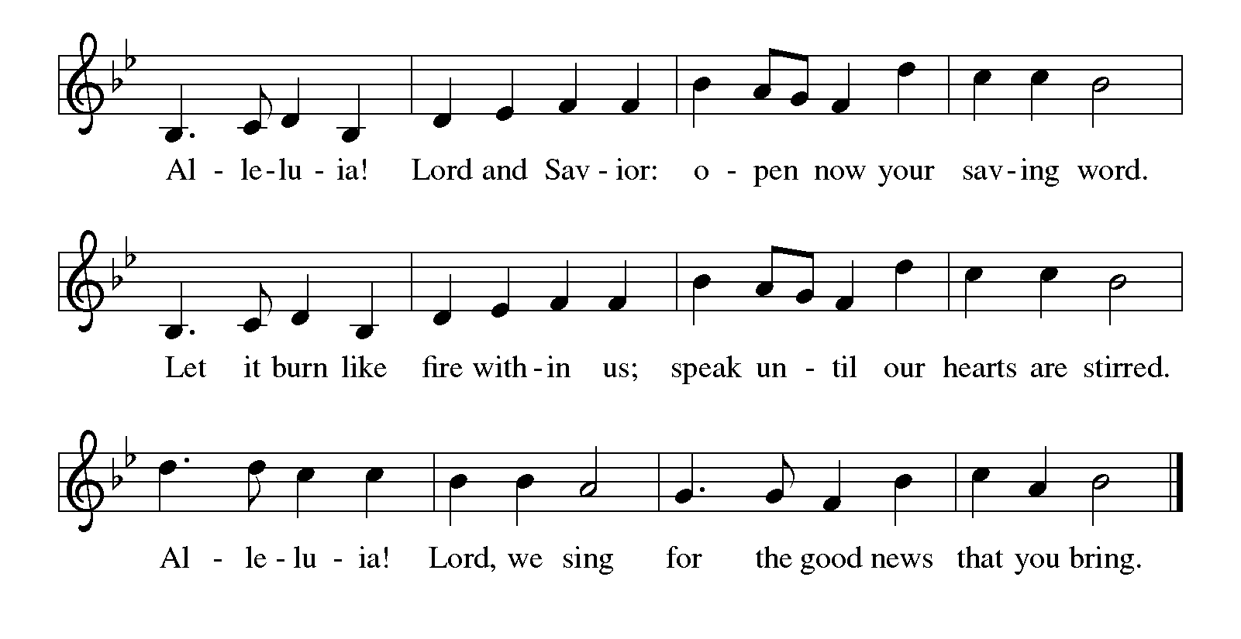GOSPEL: Luke 24:13-35

L: The Holy Gospel according to Luke, the 24th Chapter.
C: Glory to you, O Lord.

¹³ Now on that same day two [disciples] were going to a village called Emmaus, about seven miles from Jerusalem, ¹⁴ and talking with each other about all these things that had happened. ¹⁵ While they were talking and discussing, Jesus himself came near and went with them, ¹⁶ but their eyes were kept from recognizing him. ¹⁷ And he said to them, “What are you discussing with each other while you walk along?” They stood still, looking sad. ¹⁸ Then one of them, whose name was Cleopas, answered him, “Are you the only stranger in Jerusalem who does not know the things that have taken place there in these days?” ¹⁹ He asked them, “What things?” They replied, “The things about Jesus of Nazareth, who was a prophet mighty in deed and word before God and all the people, ²⁰ and how our chief priests and leaders handed him over to be condemned to death and crucified him. ²¹ But we had hoped that he was the one to redeem Israel. Yes, and besides all this, it is now the third day since these things took place. ²² Moreover, some women of our group astounded us. They were at the tomb early this morning, ²³ and when they did not find his body there they came back and told us that they had indeed seen a vision of angels who said that he was alive. ²⁴ Some of those who were with us went to the tomb and found it just as the women had said, but they did not see him.” ²⁵ Then he said to them, “Oh, how foolish you are and how slow of heart to believe all that the prophets have declared! ²⁶ Was it not necessary that the Messiah should suffer these things and then enter into his glory?” ²⁷ Then beginning with Moses and all the prophets, he interpreted to them the things about himself in all the scriptures.
²⁸ As they came near the village to which they were going, he walked ahead as if he were going on. ²⁹ But they urged him strongly, saying, “Stay with us, because it is almost evening and the day is now nearly over.” So he went in to stay with them. ³⁰ When he was at the table with them, he took bread, blessed and broke it, and gave it to them. ³¹ Then their eyes were opened, and they recognized him, and he vanished from their sight. ³² They said to each other, “Were not our hearts burning within us while he was talking to us on the road, while he was opening the scriptures to us?” ³³ That same hour they got up and returned to Jerusalem, and they found the eleven and their companions gathered together. ³⁴ They were saying, “The Lord has risen indeed, and he has appeared to Simon!” ³⁵ Then they told what had happened on the road and how he had been made known to them in the breaking of the bread.

The Gospel of the Lord. Praise to you, O Christ.

SERMON SONG: “Lord, Speak to Us, That We May Speak” ELW 676

SERMON

APOSTLES’ CREED
I believe in God, the Father almighty,
creator of heaven and earth,

I believe in Jesus Christ, God’s only Son, our Lord,
who was conceived by the Holy Spirit,
born of the virgin Mary,
suffered under Pontius Pilate,
was crucified, died, and was buried;
he descended to the dead.
On the third day he rose again;
He ascended into heaven,
He is seated at the right hand of the Father,
And he will come to judge the living and the dead.

I believe in the Holy Spirit,
The holy catholic church,
The communion of saints,
The forgiveness of sins,
The resurrection of the body,
And the life everlasting. Amen.

PRAYERS: Trusting in the power of Christ’s resurrection to heal and redeem our broken world, let us pray for the needs of all creation.
A brief silence.

Living Savior, just as you journeyed with the disciples to Emmaus, accompany us on our journey of faith. Gather us at your table, that we recognize you in the breaking of the bread. Merciful God, receive our prayer.

Almighty God, you provide for the needs of all creation. Bless the fields that are being prepared for planting, and send favorable weather so that the soil may yield an abundant harvest. Merciful God, receive our prayer.

God of justice, where leaders abuse power, confront them and call them to repentance. Where there is corruption, bring integrity; where there is violence, sow peace. Merciful God, receive our prayer.

Healing Savior, your resurrection brings hope to a hurting world. Heal those who are sick (especially). Strengthen the weary, give courage to the despairing, and comfort the dying. Merciful God, receive our prayer.

Gracious One, you have made us your own through the gift of baptism. Unite us in genuine love for one another and uphold this community in your name. Merciful God, receive our prayer.

Here other intercessions may be offered.

Eternal Light, we give thanks for (Olavus Petri, Laurentius Petri and) all who have nurtured your church’s life in ages past. Bring us at last with them to the brightness of your glorious presence. Merciful God,
receive our prayer.

God of resurrection power, use us and these prayers to proclaim the good news of new life to all the world, through Jesus Christ, our risen Savior.
Amen.

OFFERING

OFFERTORY: We give thee but thine own, Whatev’r that gift may be.
All that we have is thine alone, A trust O Lord from thee.

GREAT THANKSGIVING:
The Lord be with you. And also with you.
Lift up your hearts. We lift them to the Lord.
Let us give thanks to the Lord our God.
It is right to give our thanks & praise.
WORDS OF INSTITUTION
In the night in which he was betrayed,
our Lord Jesus took bread, and gave thanks;
broke it, and gave it to his disciples, saying:
Take and eat; this is my body, given for you.
Do this for the remembrance of me.

Again, after supper, he took the cup, gave thanks,
and gave it for all to drink, saying:
This cup is the new covenant in my blood,
shed for you and for all people for the forgiveness of sin.
Do this for the remembrance of me.

LORD’S PRAYER:
Our Father, who art in heaven, hallowed be thy name, thy kingdom come, thy will be done, on earth as it is in heaven. Give us this day our daily bread; and forgive us our trespasses, as we forgive those who trespass against us; and lead us not into temptation but deliver us from evil. For thine is the kingdom, and the power, and the glory, forever and ever. Amen.

INVITATION to COMMUNION:
Come and receive the gifts of God for the people of God!

HOLY COMMUNION

POST COMMUNION BLESSING: Holy One, through this meal you have made your home among us and are making all things new. Send us now to speak peace to anxious hearts, to love our enemies, and to bring your healing to the nations. In the name of Jesus,
Amen.

BENEDICTION:

The Lord bless you and keep you,
the Lord make his face to shine upon you and be gracious to you,
the Lord look upon you with favor and give you his peace.

SENDING SONG: “For the Bread Which You Have Broken”

ELW 494

DISMISSAL: Go in peace, Serve the Lord. Thanks be to God

Adapted from Sundays and Seasons.com.
Copyright 2026 Augsburg Fortress. All rights reserved.
Reprinted by permission under Augsburg Fortress Liturgies Annual License #20648.

