Holy Trinity Evangelical Lutheran Church

The Third Sunday of Easter

April 19, 2026, at 10:30 am

Lay Speaker, Bill Pim

*Prelude

* Welcome and Announcements Worship Assistant

* Gathering Hymn “Alleluia! Jesus is Risen!” ELW 377 vs. 1, 2, 4, 5
One License A-700000
1. Al-le-lu-ia! Jesus is risen! Trumpets resounding in glorious
light! Splendor, the Lamb, heaven forever! Oh, what a miracle God has in sight.
Refrain: Jesus is risen and we shall arise. Give God the glory!
Al-le-lu-ia!

2.Walking the way, Christ in the center telling the story to open
our eyes; breaking the bread, giving us glory: Jesus our blessing, our constant surprise.
Refrain: Jesus is risen and we shall arise. Give God the glory!
Al-le-lu-ia!

4.Weeping, be gone; sorrow, be silent: death put asunder, and
Easter is bright. Cherubim sing: O grave, be open! Clothe us in wonder, adorn us in light.
Refrain: Jesus is risen and we shall arise. Give God the glory!
Al-le-lu-ia!

5.City of God, Easter forever, golden Jerusalem. Jesus the Lamb,
river of life, saints and archangels, sing with creation to God the I Am.
Refrain: Jesus is risen and we shall arise. Give God the glory!
Al-le-lu-ia!

* Confession and Forgiveness Bill Pim
Trusting in the mercy of God, let us confess our sin.
Gracious God, we confess that we have not always lived as Easter people. We cling to fear when you offer peace. We hold onto doubt without seeking you. We close doors that you long to open. Forgive us for the ways we resist your resurrection life. Breathe your Spirit into us again, that we may live as your forgiven and renewed people. Through Jesus Christ, our risen Lord. Amen.

Hear the good news: Christ is risen, and nothing—not even sin or death—can separate us from the love of God. In the mercy of almighty God, your sins are forgiven. You are made new in Christ. Thanks be to God.

* Canticle of Praise “This is the Feast” ELW pg. 149
refrain: This is the feast of victory for our god. al-le-lu-ia.
1.worthy is christ, the Lamb who was slain, whose blood set us
free to be people of god. Power and riches and wisdom and
strength, and honor and blessing and glory are his.

refrain: this is the feast of victory for our god. al-le-lu-ia.
sing with all the people of god and join in the hymn of all creation: Blessing and honor and glory and might be to god and the lamb forever. amen.

final refrain: This is the feast of victory for our God, for the Lamb who was slain has begun his reign, al-le-lu-ia. al-le-lu-ia.

*Greeting Bill Pim
The grace of our lord, jesus christ, the love of god and the communion of the holy spirit be withy you all. and also with you.

* Prayer of the Day Worship assistant
O God, your Son makes himself known to all his disciples in the breaking of bread. Open the eyes of our faith, that we may see him in his redeeming work, who lives and reigns with you and the Holy Spirit, one God, now and forever. Amen.

*Passing of the Peace Worship Assistant
May the peace of christ be with you always. and also with you.

please share the love of christ with a wave.

*Children’s Moment pulpit prequel Bill Pim

*First Reading: Acts 2:14a, 36-41 Reader
^{14a} Peter, standing with the eleven, raised his voice and addressed [the crowd]: ³⁶ “Therefore let the entire house of Israel know with certainty that God has made him both Lord and Messiah, this Jesus whom you crucified.”
³⁷ Now when they heard this, they were cut to the heart and said to Peter and to the other apostles, “Brothers, what should we do?” ³⁸ Peter said to them, “Repent and be baptized every one of you in the name of Jesus Christ so that your sins may be forgiven, and you will receive the gift of the Holy Spirit. ³⁹ For the promise is for you, for your children, and for all who are far away, everyone whom the Lord our God calls to him.” ⁴⁰ And he testified with many other arguments and exhorted them, saying, “Save yourselves from this corrupt generation.” ⁴¹ So those who welcomed his message were baptized, and that day about three thousand persons were added.

The Word of the Lord. Thanks be to God.

*Second Reading: 1 Peter 1:17-23 Reader
¹⁷ If you invoke as Father the one who judges impartially according to each person’s work, live in fear during the time of your exile. ¹⁸ You know that you were ransomed from the futile conduct inherited from your ancestors, not with perishable things like silver or gold ¹⁹ but with the precious blood of Christ, like that of a lamb without defect or blemish. ²⁰ He was destined before the foundation of the world but was revealed at the end of the ages for your sake. ²¹ Through him you have come to trust in God, who raised him from the dead and gave him glory, so that your trust and hope are in God.
²² Now that you have purified your souls by your obedience to the truth so that you have genuine mutual affection, love one another deeply from the heart. ²³ You have been born anew, not of perishable but of imperishable seed, through the living and enduring word of God.

The Word of the Lord. Thanks be to God.
* Gospel Acclamation Blessed is the One ACS 929
One License A-700000
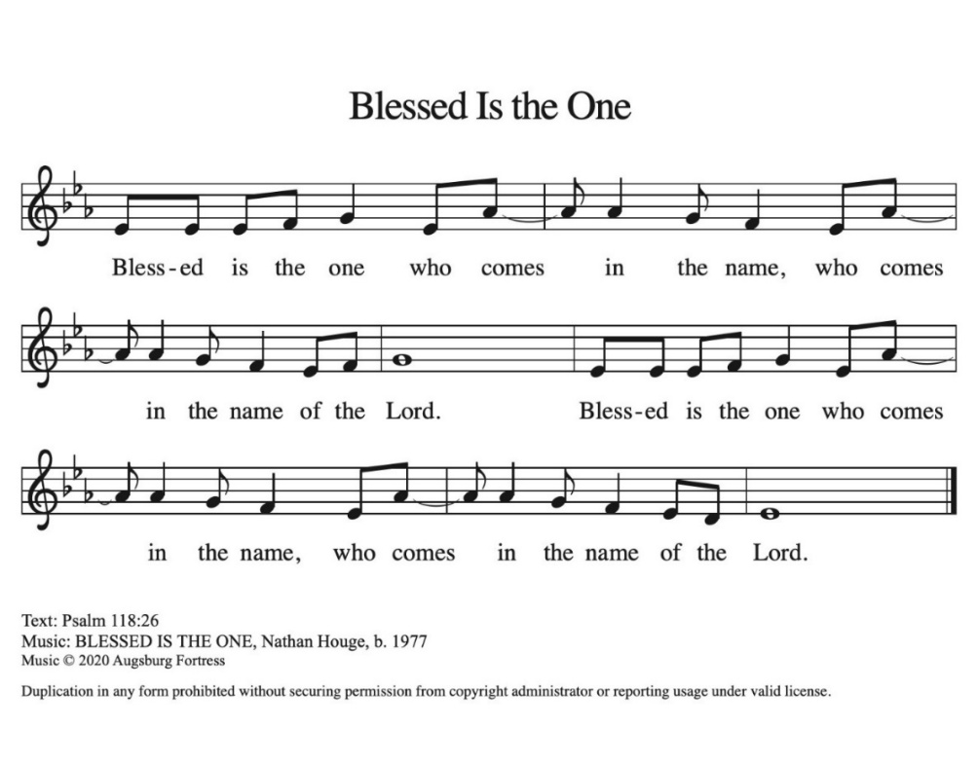

* Gospel Lesson – Luke 24:13-35 Bill Pim
The Holy Gospel according to Luke, the 24th chapter. Glory to you, O Lord.

¹³ Now on that same day two [disciples] were going to a village called Emmaus, about seven miles from Jerusalem, ¹⁴ and talking with each other about all these things that had happened. ¹⁵ While they were talking and discussing, Jesus himself came near and went with them, ¹⁶ but their eyes were kept from recognizing him. ¹⁷ And he said to them, “What are you discussing with each other while you walk along?” They stood still, looking sad. ¹⁸ Then one of them, whose name was Cleopas, answered him, “Are you the only stranger in Jerusalem who does not know the things that have taken place there in these days?” ¹⁹ He asked them, “What things?” They replied, “The things about Jesus of Nazareth, who was a prophet mighty in deed and word before God and all the people, ²⁰ and how our chief priests and leaders handed him over to be condemned to death and crucified him. ²¹ But we had hoped that he was the one to redeem Israel. Yes, and besides all this, it is now the third day since these things took place. ²² Moreover, some women of our group astounded us. They were at the tomb early this morning, ²³ and when they did not find his body there they came back and told us that they had indeed seen a vision of angels who said that he was alive. ²⁴ Some of those who were with us went to the tomb and found it just as the women had said, but they did not see him.” ²⁵ Then he said to them, “Oh, how foolish you are and how slow of heart to believe all that the prophets have declared! ²⁶ Was it not necessary that the Messiah should suffer these things and then enter into his glory?” ²⁷ Then beginning with Moses and all the prophets, he interpreted to them the things about himself in all the scriptures.
²⁸ As they came near the village to which they were going, he walked ahead as if he were going on. ²⁹ But they urged him strongly, saying, “Stay with us, because it is almost evening and the day is now nearly over.” So he went in to stay with them. ³⁰ When he was at the table with them, he took bread, blessed and broke it, and gave it to them. ³¹ Then their eyes were opened, and they recognized him, and he vanished from their sight. ³² They said to each other, “Were not our hearts burning within us while he was talking to us on the road, while he was opening the scriptures to us?” ³³ That same hour they got up and returned to Jerusalem, and they found the eleven and their companions gathered together. ³⁴ They were saying, “The Lord has risen indeed, and he has appeared to Simon!” ³⁵ Then they told what had happened on the road and how he had been made known to them in the breaking of the bread.
The Gospel of the Lord. Praise to you, O Christ.

*Sermon - “The High Bidder” Lay Speaker, Bill Pim

* Hymn of the Day “In the Garden”
Public Domain
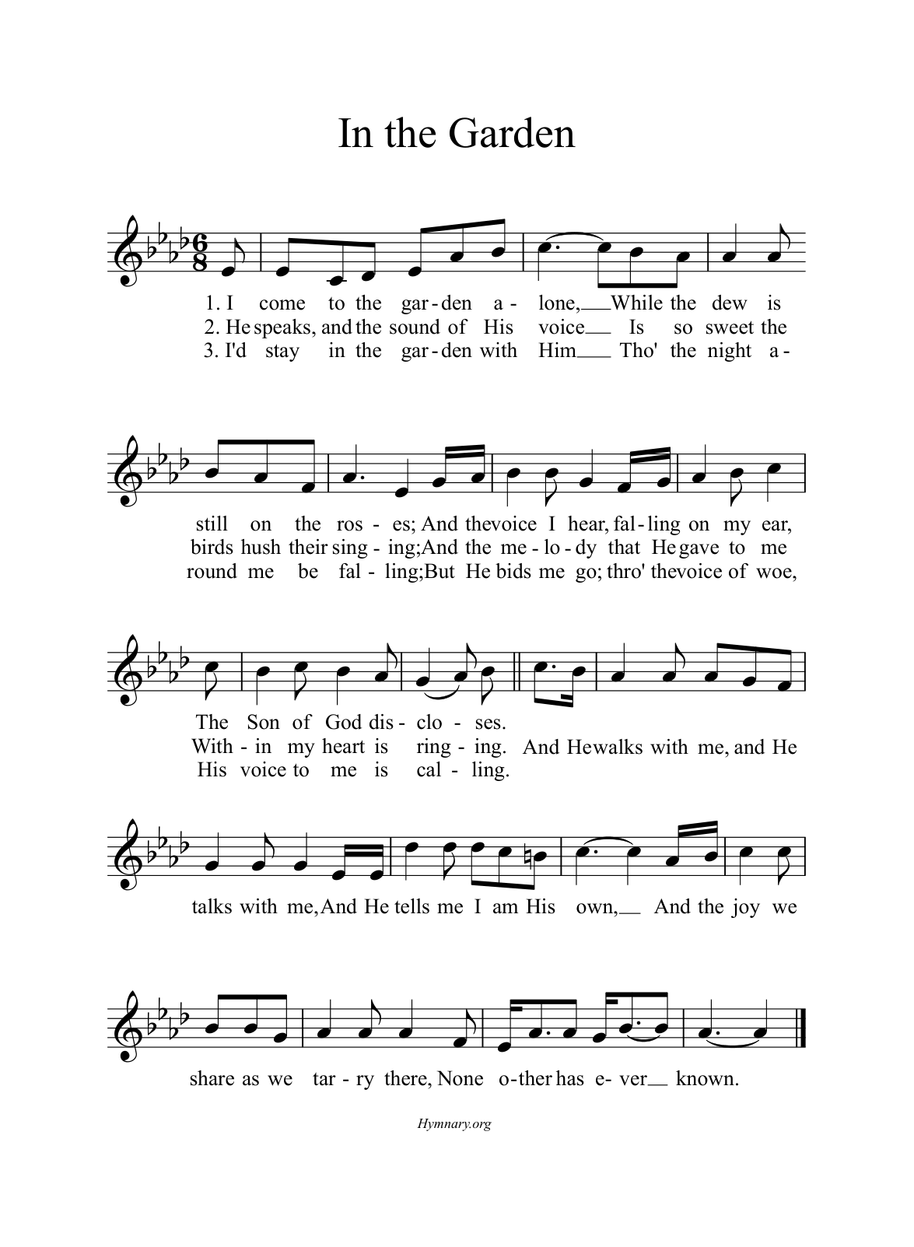

* Apostle’s Creed Worship assistant
Let us proclaim our faith in the words of the apostle’s creed.
I believe in God, the Father almighty,
creator of heaven and earth.
I believe in Jesus Christ, God's only Son, our Lord,
who was conceived by the power of the Holy Spirit,
born of the Virgin Mary,
suffered under Pontius Pilate,
was crucified, died, and was buried;
he descended to the dead.
On the third day he rose again;
he ascended into heaven,
he is seated at the right hand of the Father,
and he will come to judge the living and the dead.
I believe in the Holy Spirit,
the holy catholic Church,
the communion of saints,
the forgiveness of sins,
the resurrection of the body,
and the life everlasting. Amen.

* Prayers of Intercession Bill Pim
Be Seated
Prayer Requests or Joys to Share
Trusting in the power of Christ’s resurrection to heal and redeem our broken world, let us pray for the needs of all creation.

A brief silence.

Living Savior, just as you journeyed with the disciples to Emmaus, accompany us on our journey of faith. Gather us at your table, that we recognize you in the breaking of the bread. Merciful God, receive our prayer.

Almighty God, you provide for the needs of all creation. Bless the fields that are being prepared for planting, and send favorable weather so that the soil may yield an abundant harvest. Merciful God, receive our prayer.
God of justice, where leaders abuse power, confront them and call them to repentance. Where there is corruption, bring integrity; where there is violence, sow peace. Merciful God, receive our prayer.

Healing Savior, your resurrection brings hope to a hurting world. Heal those who are sick (especially). Strengthen the weary, give courage to the despairing, and comfort the dying. Merciful God, receive our prayer.

Gracious One, you have made us your own through the gift of baptism. Unite us in genuine love for one another and uphold this community in your name. Merciful God, receive our prayer.

Eternal Light, we give thanks for all who have nurtured your church’s life in ages past. Bring us at last with them to the brightness of your glorious presence. Merciful God, receive our prayer.

God of resurrection power, use us and these prayers to proclaim the good news of new life to all the world, through Jesus Christ, our risen Savior. men.

* Offering Worship assistant
The monthly mission in April is for “the funeral meal supplies.”
Let us give to god what he has first given us.

- Offering Music by Jared

* Offering Hymn “Be Not Afraid” ELW #388 (sing 2x)
One License A-700000
Be not afraid, sing out for joy! Christ is risen, al-le-lu-ia.
Be not afraid, sing out for joy! Christ is risen, al-le-lu-ia.

* Offertory Prayer:
Risen Christ, all that we have is a gift from you. Receive these offerings as signs of our gratitude and use them to bring life, hope, and peace into the world. In your holy name we pray. Amen.

*The Lord’s Prayer pg 154
Our father, who are in heaven, hallowed be thy name, thy kingdom come, thy will be done, on earth as it is in heaven.
give us this day our daily bread, and forgive us our trespasses,
as we forgive those who trespass against us; and lead us not into temptation, but deliverer us from evil. for thine is the kingdom, and the power, and the glory, forever and ever. amen.

* Blessing
The risen Christ stands among you and says, “Peace be with you.” May that peace guard your hearts and minds, now and forever. Amen.

*Hymnology Story Bill Pim

* Closing Hymn “Beautiful Savior” ELW 838
Public Domain
1.Beautiful Savior, King of creation, Son of God and Son of
Man! Truly I’d love thee, truly I’d serve thee, light of my soul, my
joy, my crown.

2.Fair are the meadows, fair are the woodlands, robed in flow’rs
of blooming spring; Jesus is fairer, Jesus is purer, he makes our sorrowing spirit sing.

3.Fair is the sunshine, fair is the moonlight, bright the sparkling
stars on high; Jesus shines brighter, Jesus shines purer than all
the angels in the sky.

4.Beautiful Savior, Lord of the nations, Son of God and Son of
Man! Glory and honor, praise, adoration, now and forevermore be thine!

* Dismissal
Go in peace. Share the good news: Christ is risen!
Christ is risen indeed. Alleluia!

*Postlude

