Announcements

Monday, April 20
UCW Executive meeting Board room 1:00p.m.
UCW Unite meeting Banquet hall 2:00p.m.
Beaver Valley Band Banquet hall 5:30p.m.
Choral works Sanctuary 7:00p.m.

Tuesday, April 21
Bell practice Banquet hall 7:00p.m.

Wednesday, April 22
Bay Wind Flutes Banquet hall 5:30p.m.
Choir practice Banquet hall 7:00p.m.

Thursday, April 23
North Simcoe Muskoka
Special Geriatrics Services Banquet hall 8:00a.m.
Thursday night group Banquet hall 8:00p.m.

Friday, April 24
Roger Cooper Memorial Service Sanctuary 1:00p.m.

Affirming Vote
We will be having a congregational meeting on May 3rd after service to vote on two motions.
- To become an affirming ministry
- To accept the Vision statement which has been developed by the Affirming group.

The vote will be a secret ballot and those of you who join us on Zoom will be able to vote via zoom anonymously. Only the people who attend the congregational meeting on the day will be allowed to vote. There will be no advance or proxy voting.

The percentage will be determined by the number of positive votes in relation to the number of positive and negative votes. We need to have a 75% positive vote to become an affirming ministry.

Services for Rodger Cooper will be held at Trinity on Friday April 24, 2026. Visitation begins at 12 p.m. The service will take place at 1 p.m. and a reception will follow.
All are welcome to celebrate Rodger's life.

Regional Representative
Trinity Church Board is very appreciative of Barbara Downie’s role as our Regional
Representative for the past 30 some years! Thank you, Barbara for all your hard work and time spent on various sub-committees, first with ‘Presbytery ‘and culminating with Western Ontario Waterways Region. Barbara will retire from this role as of the May Regional Meeting.
We have one representative currently, Ruth Crittenden. With the size of our congregation, we can have two. If anyone is interested in becoming a Regional Representative, please contact one of the Board Chairs or the office.
As AI explains, “the role of a Regional Representative within the Western Ontario Waterways (WOW) Regional Council (a United Church of Canada entity) is to serve as a vital link between local Communities of Faith (congregations) and the broader Regional Council, facilitating communication, supporting shared ministry, participating in decision-making, and fostering connections within the Tri-Region (with Antler River Watershed and Horseshoe Falls).”

Outdoor Warming Closet
The warming closet is now looking for spring appropriate clothing such as raincoats, spring weight jackets and rainboots

Help with recycling
Please consider taking a bag of recycling home with you when you’re able. If you’re at the church, you can ask David, our custodian, or check to see if there are any recycling bags that need to be taken out. Thank you for helping keep our space clean and cared for!

Camping Sunday
Camping Sunday is April 26th the last Sunday of April
Hotdogs will be cooked during service, we are asking folks to bring dessert or a salad to augment.

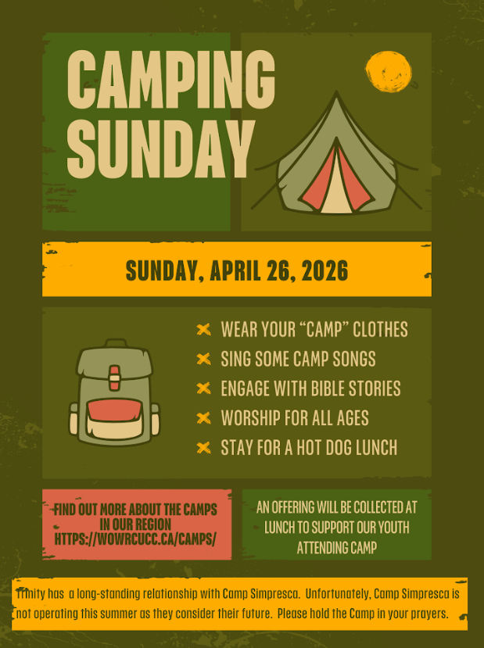
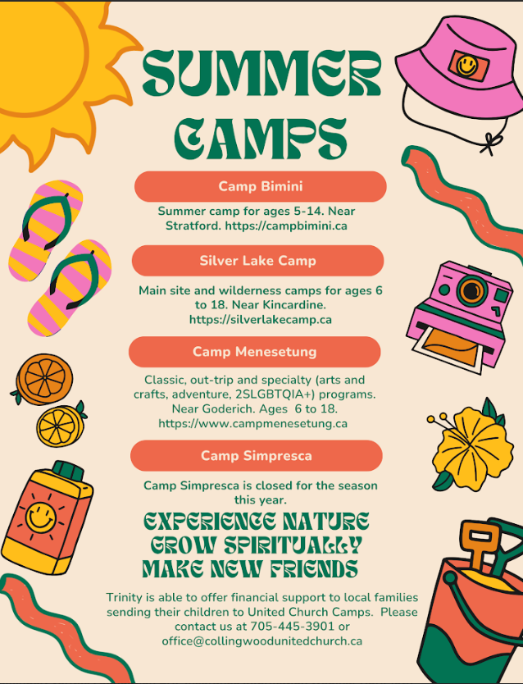

Rev. Beth Kerr (she/her)
Diaconal Minister
Trinity United Church
140 Maple Street,
Collingwood, ON L9Y 2P8
www.collingwoodunitedchurch.ca
705-445-3901 (church)
204-872-2370 (cell)
Please note: Friday and Saturday are my sabbath days. I will reply to emails received on those days on the following Monday. For emergencies, please contact my cell phone.

