This Week at PPBC
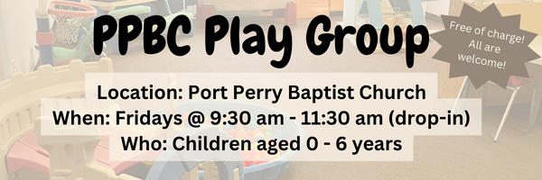


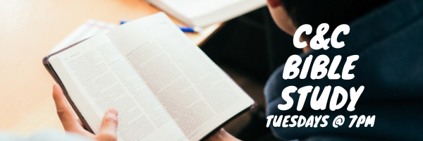

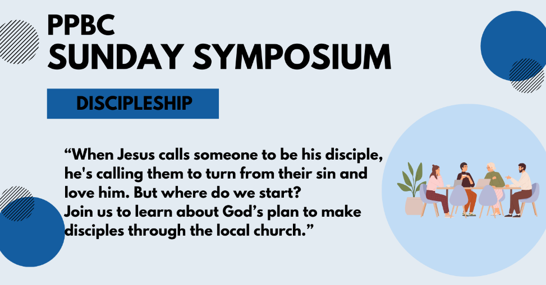
April 26th, 2026


May 9th, 2026
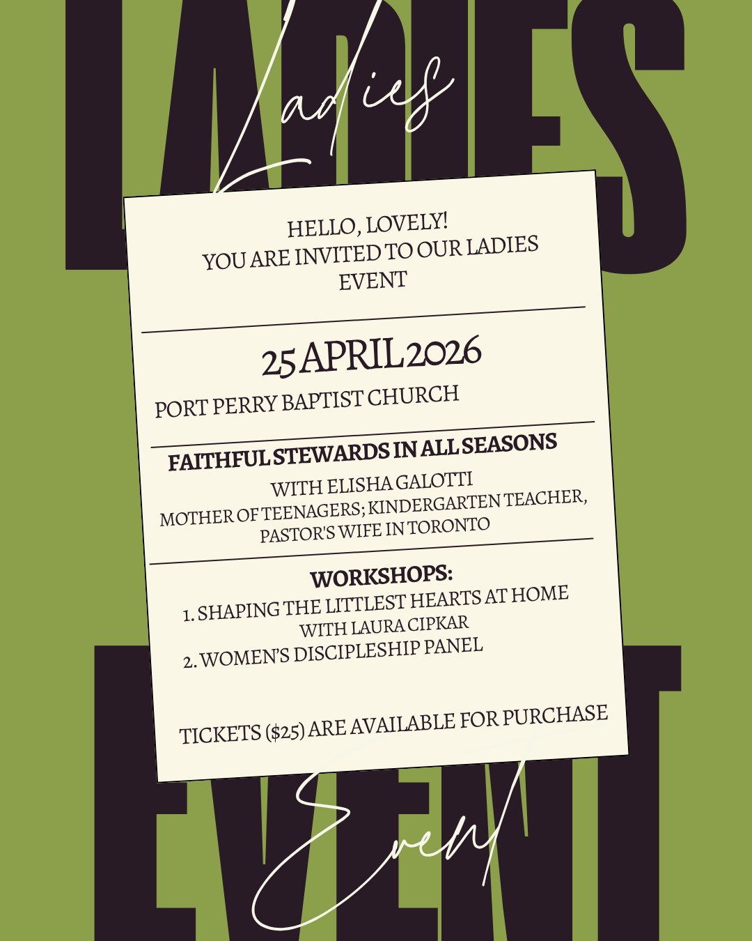

Sunday Ministry Schedules
Below are ministry schedules for Nursery, Jr. Church, Greeters, Ushers, and Sound & Video:
Nursery
April 19: Brenda Clemens, Brantley Colwell
April 26: Kathryn denOuden, Alyssa Summers
Infant Nursery
April 19: Laura Saunders, Amber Saunders
April 26: Karen Clemens, Rosalie McLaren
Jr. Church; ages 3 to grade 1
April 19: Justine McKenzie, Kelsey Schoenrock
April 26: Deb Brown, Abby Saunders
Jr. Church; Grades 2 to 6
April 19: Miriam Bolsonello, Jen Owens
April 26: Gregg & Karen Anderson, Lena Sammut
Greeters
April 19: Leno & Donna Araujo
April 26: Tracy & Karen Ballanger
Ushers
April 19: Roy Wilson, Paul Sammut
April 26: Graeme Foster, Eric Duchesne
Sound & Video
April 19: Sound: Charlie Deane | Video: William Conley
April 26: Sound: Wyatt Werner | Video: Josh Bolsonello

Sunday Service
Welcome
Song – My Soul Will Wait(Psalm 62)
Song – Jesus What a Friend for Sinners
Scripture
Prayer
Song – And Can It Be
Song – I Set My Hope on Jesus
Message – Pastor Jim Clemens
Song – My Jesus I Love Thee

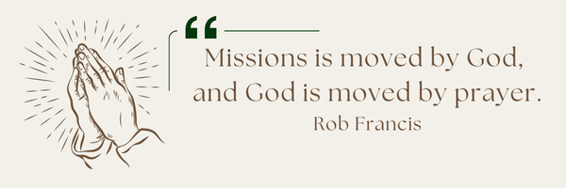
A Prayer Request from the Merajis: For Iranians and those that are believers here in Canada as they are fearful for their families still in Iran. As they hope for change and because they cannot be there to support the efforts

Praise & Prayer Highlights
PRAY for Joan Mabley who has been moved to Glen Hill Strathaven in Bowmanville. Please PRAY for Joan’s comfort and peace.
PRAY for John & Joan Mank and their ongoing health concerns.
PRAY for Martin & Tina McCurley and their ongoing health concerns. PRAY for them as they prepare to move the end of April.
PRAY for Jordan & Stephanie Anderson. PRAY for Jordan as he undergoes training in Quebec.
PRAY for Laurie Buismans sister Debbie and their family. Debbie is in Lakeridge health Hospital under observation. PRAY for the family and the doctors who are caring for them.
PRAY for Darren & Brooke VanUden. They are expecting a baby in May 2026. PRAY for Brooke and the little ones health as they approach the due date and delivery.
PRAY for Betty Collins cousin Pat and her ongoing concerns. PRAY for her healing for her neck and that the doctors and nurses would have wisdom in caring for her.

Giving
Just as a reminder, there are several ways you can give:
In Person using the offering box located on the back wall of the sanctuary. Donation envelopes are available at the Welcome Centre. Please contact the church office if you would like a box of donation envelopes (office@portperrybaptist.ca)
Through your online banking, you may send electronic transfers to ppbcdonations@gmail.com.
You can also give through Canada Helps. Donation receipts will be provided by Canada Helps, and transaction fees apply.
***********************************************************************
Weekly Newsletter
The PPBC Newsletter is emailed to the church family every Friday. If you would like to be added to the weekly email list, please contact the office by phone: 905-985-8681 or by email: office@portperrybaptist.ca.
*****************************************************************
Church Information:
Location:
2210 Hwy 7A
Port Perry, ON
L9L 1B4
Office Hours:
Monday: 8:30am – 4:00pm
Tuesday: 8:30am – 4:00pm
Wednesday: Closed
Thursday: 8:30am – 4:00pm
Friday: 8:30 am - 3:00 pm
Contact:
Phone: 905.985.8681
Email: office@portperrybaptist.ca
Website: www.portperrybaptist.ca
Staff:
Sr. Pastor – Rev. Jim Clemens
Administrative Assistant – Madeline Werner
Family Ministries Director – Josh Anderson
Pastoral Intern – Scott McKenzie

PPBC Newsletter
Sunday, April 19, 2026


Sunday Starting Point
Sunday, April 19, 2026 - 9:30 am
“Beginning the day with the Word and prayer”
Adults:
Adults will meet in the sanctuary for a time of study and prayer.
Youth:
Jr High (Grades 7-8) will meet in room 18 with Kate Anderson to study Thessalonians.
Children:
Children ages 3 - grade 6 will meet in room 26.
(Please note nursery is unavailable during Starting Point)
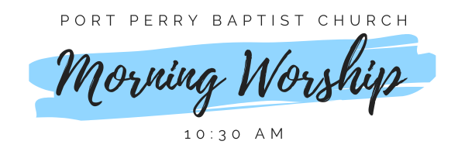Sunday Morning Worship
Sunday, April 19, 2026 - 10:30 am
We are meeting in the sanctuary and will continue to live-stream for those who are unable to attend.
Message: Good Hearing
Scripture: 1 Corinthians 7
Pastor Jim Clemens

