City Road United Methodist Church
A Lighthouse Congregation

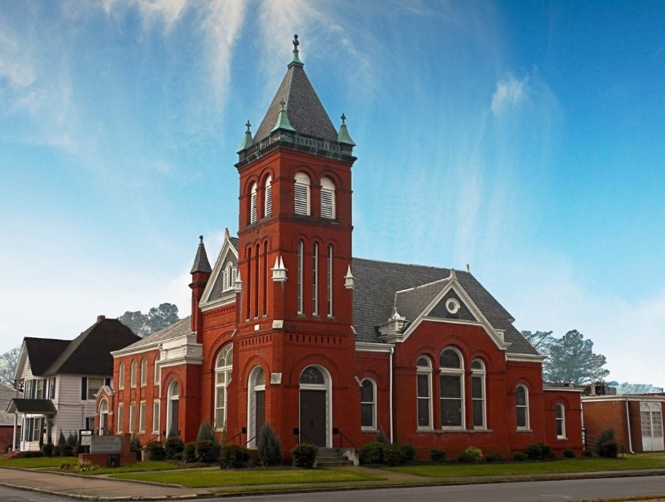
Rev. Josh Tester, Pastor

Office: (252) 335-2658
cityroadec.net crumcec@gmail.com

Facebook: https://www.facebook.com/CityRoadUMC

Sunday School: 10:00 a.m.
Sanctuary Worship: 11:00 a.m.

Tommy Venters- Organist/Choir Director
Dawn Baker- Secretary/Technology Specialist
JoAnn Herring- We Care

Service of Word & Table
Season of Easter

April 19th, 2026 11:00 am
Gathering
Prelude
Introit “People Need the Lord”
Words of Welcome Pastor Josh
*Call to Worship
God, you send us prophets, so we know how to live into your kin-dom on earth.
Let us listen to the truthtellers.
God, you desire to gather us together, but we are not always willing, and you lament.
Let us embrace each other.
God, we need to practice your ways of equity, inclusion, and mutuality instead of inequality and oppression.
Let us listen to one another’s struggles with new ears.
Lord God, when we live in denial instead of facing necessary truths, we are left with broken community. Grant us the humility we need to match what we profess, to learn from you and our actions, so that we embody our call to be Beloved Community.

*Prayer of Approach
Holy God, you call us to practice what we preach and not just pretend to be religious. As we come to you in worship today, purify our motives. Give us the courage to act where we need to act, to tell the truth even when it puts us at risk, and to step out of the way so that people can see your glory. Help us to remove the barriers to Beloved Community within ourselves and the world around us. Amen.

*Sharing Peace
As a people forgiven and freed, we reach out to lift others up, offering the peace of Christ. Peace be with you!
And also with you!
You are invited to share the Peace with those around you [remembering to send your peace through the camera to those worshiping remotely*

Hymn of Praise “Leaning on the Everlasting Arms” UMH 133

Proclamation & Response
Call to Prayer
Prayers of the People
The Lord’s Prayer
Our Father who art in heaven, hallowed be thy name. Thy kingdom come; thy will be done on earth as it is in heaven. Give us this day our daily bread, and forgive us our trespasses, as we forgive those who trespass against us; and lead us not into temptation but deliver us from evil. For thine is the kingdom, and power, and glory forever. Amen

Children’s Time
Call to the Offering
Offertory
*Doxology UMH 94
*Prayer of Dedication

Hymn of Preparation “Turn your Eyes upon Jesus” UMH 349

Anthem Chancel Choir

Gospel Lesson John 21:4-14
New Testament Lesson 1 Corinthians 11:17-22
Message “What Hinders Beloved Community” Pastor Josh

Sending Fourth
*Sending Hymn “Here I am, Lord” UMH 593
*Benediction

