PARISH HOUSE: Items for March
Items Needed: Canned Corn, Jelly (non-glass),
Cereal, Toothpaste, Deodorant

Upcoming Events:
April 1st – 6:30pm Choir Practice
– 7:00pm Leadership Team
April 2nd – Maundy Thursday
- 6:30pm Simple Meal and
Communion- Tennerton UMC
April 3rd - 6:30pm Good Friday Service
West Buckhannon UMC
April 5th – 7:00am Easter Sunrise Service
Mt. Lebanon UMC
Breakfast to follow
- 10:15am Sunday School
- 11:00am Easter Worship Service

MARCH BIRTHDAYS
Shahna West – 6th, Shelia Hodges– 7th, Shane West – 20th,
Ina Jean Cutright – 25th, Lynn Frum – 29th

MARCH ANNIVERSARIES

Benny & Betty Smith – 2nd

Tithes and Offerings: Give your gifts,
tithes, and offerings through PayPal. It is
quick, easy, and safe! Just use the
camera on your phone to scan the QR
Code. All donations will be placed into
our General Account unless otherwise
stated.

TENNERTON
United Methodist Church
March 29, 2026
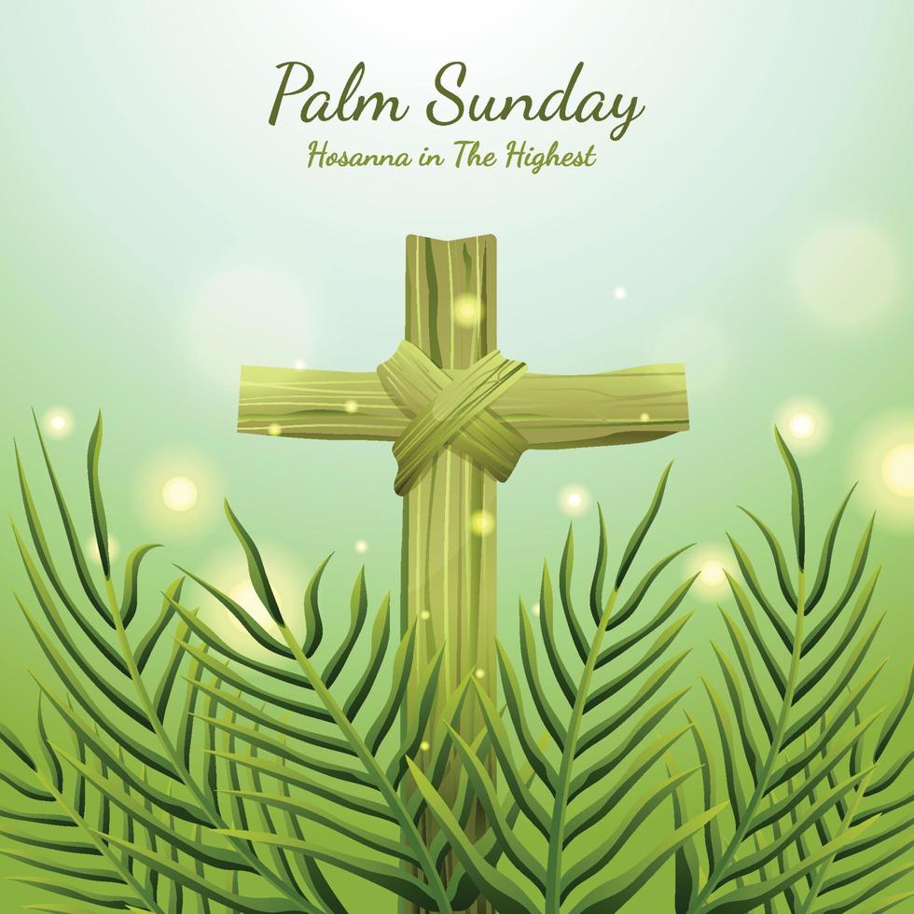
Pastor Jim Minutelli
304-629-9398

Office: 126 Tallmansville Rd.
Buckhannon, WV 26201
Office Phone: 304-472-1064
Sermon by Phone: 304-460-0029
Website: https://tennertonumc.org
Email: umc.tennerton@gmail.com
Facebook: https://www.facebook.com/thetennertonumc
Prayer Concerns: Call Candy George @ 304-613-6424

JOYS & CONCERNS
WELCOME/OPENING PRAYER Pastor
*OPENING HYMN: “Spirit of the Living God”
14/4 UMH 393

CALL TO WORSHIP: Sixth Sunday in Lent
Palm Sunday
Based on Psalm 118: 1-2, 19-29

Leader: Give thanks to the Lord, for God is
good; God’s love endures forever.
People: We rejoice and say: “Your love,
Lord, endures forever.”
Leader: Open wide the entrance to this place of
worship so those made righteous may enter.
People: We will give you thanks, God, for you
answered us; God alone is our salvation.
Leader: The stone the builders rejected has
become the cornerstone; the Lord has done this,
and it is marvelous in our eyes.
People: The Lord has done it this very day;
let us rejoice today and be glad.
Leader: Blessed is the One who comes in the
name of the Lord. From our place of worship
we bless you. Walking in the light, with boughs
in hand, we join the jubilant parade.
All: You are our God, and I will praise you;
you are our God, and I will exalt you!

*OFFERING/DOXOLOGY/PRAYER UMH 95
CHOIR: “Hosanna, Loud Hosanna” 9/12 UMH 278
CHILDREN MESSAGE Vickie Snyder
ANNOUNCEMENTS (ON BACK PAGE)
READING: Philippians 2: 5 – 11

*HYMN: “Come, Christians, Join to Sing”
5/7 UMH 158
SCRIPTURE READING:
SERMON:

*CLOSING HYMN: “Trust and Obey”
16/14 UMH 467
*BENEDICTION

*Please stand if you are able. Don’t Forget to Feed the Pig

GREETERS & WORSHIP LEADERS
If you would like to be a greeter or lead worship service,
print your name on the clip board on the front pew.
This Week
GREETER(S): Shahna West
WORSHIP LEADER: Vickie Snyder

Next Week
GREETER(S): Rick Black
WORSHIP LEADER: Vickie Snyder

