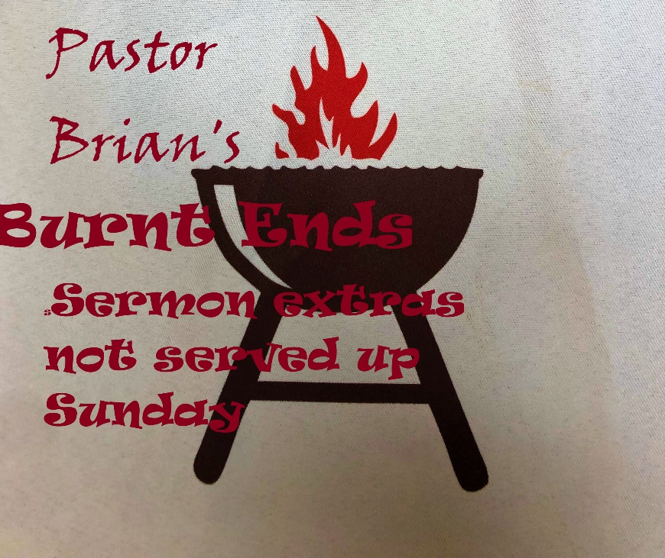
Lent Week One: 2/23
Burnt End: Desert Wisdom

DUNE, is my favorite fiction book; Frank Herbert’s masterpiece whose main character is the desert planet, Arrakis. Herbert’s intent when he wrote the science fiction novel is a warning against the extremes of vain power wielded by humanity. Especially in terms of: religious fundamentalism mixed with imperialistic and totalitarian government, greed and consumerism running amuck over environmental and humanitarian needs, and our unhealthy reliance on ‘thinking-machines.’
…Only Science Fiction, right!? *
everything that makes Star Wars an incredible story was stolen from Herbert’s Dune! I’ve read every book Frank Herbert wrote. Outside of the original Dune series, my favorites are Soul Catcher, The Santaroga Barrier, and Man of Two World co-authored with his son Brian.
Fremen are to me the most fascinating of all the diverse peoples illustrated in Dune. The Fremen are the indigenous culture of the spice-producing desert planet. They are absolute masters of living off the harsh land and being in-tune with their sacred environment. They have still-suits that capture all the water depleted from the body. While traveling in their still-suits over sand dunes, they ‘walk without rhythm’ so as not to make repetitive sounds that could attract a terrifying sandworm, whom they revere. If one were to be able to scope out a Fremen walking the ever-changing terrain, one might mistake their unique stride for dancing, or at least a very Sily Walk!
As we are called to follow Jesus out into the desert wilderness during Lent, we could learn a lot from a fictional people who thrive in the sand dune covered habitat. Fremen believe that water is sacred and the most valuable possession someone has for the lively-hood of the tribe. Fremen are so rooted in the concept of community that even the water inside one’s body belong to the whole tribe! That takes the command to share common goods at the onset of the development of a Christian community in Acts to a whole deeper level. In fact, in the Dune epic when a Fremen dies their remaining internal water is drained from their body and stored together in a secret underground pool- the most holy site in their society, with the water from all the other Fremen who have died in that tribe/ stietch. Fremen share everything, water is sacred and not to ever be taken for granted.
Share everything and value water- good advice. We all were supposed to learn the first lesson in kindergarten, but obviously just the fact that we have billionaires proves as a society we are not sharing well at all! The second lesson: value water, is worth spending some time in discernment. I have very fond memories of going to Schlitterbahn water-park as a kid, and I was blessed to grow up down the street from the neighborhood communal pool. Honestly, while waiting in the longline to climb the mountain of stairs to get to the top of the big blue slide with the hundreds of other kids, did I ever even once consider just how much water was being gleefully used?! Meanwhile in youth group at my home UMC we were raising money to drill a well in Africa.
How much do we value having access to free clean water? Or do we take drinking water for granted? How much do we value the waters of our baptism? Or maybe we’ve never even thought about baptism. Water can be a ‘touchstone’ of gratitude for us. Every time you wash your hands, remember your baptism. When you slash cool water on your face, remember you are a Beloved Child of God. Every time you turn on the tap and clean water comes out, give thanks. When you go to the store and see an entire aisle of water choices, for different kinds of; bottled, distilled, flavored, vitamin-infused, regional, sparkling, sugar-free, caffeinated…WATER! Consider making a donation to drill for a new well in a place where one has to walk miles for a daily supply… or donate to FOA so that you can help pay towards the next utility bill a neighbor can’t afford.
No doubt that Frank Herbert was a visionary, real life science is starting to resemble some of his fictional technology. And we have Fremen of sorts in our own Christian tradition, sometimes called the Desert Fathers/Mothers or referred to as Desert Mystics.
Read from the Center for Action and Contemplation founded by Franciscan Richard Rohr:
(the desert mystics) It is a unique window into how Jesus was first understood, before the church became an imperial highly organized, competitive religion.” Practicing ‘letting go’ in contemplation allowed the desert mystics -and allows us- to access our spiritual selves…Laura Swan explains: “Apatheia is purity of heart. The ammas (desert mothers) teach us to intentionally let go of all that keeps us from the single-minded pursuit of God: feelings and thoughts that bind us, cravings and addictions that diminish our sense of worth, and attachments to self-imposed perfectionism. Apatheia is nourished by simplicity grounded in abundance of the soul.”
“The ancient path of the desert mystics invites us to disrupt the patterns of ego and empire through the courageous pursuit of inner liberation.” Stephen Copeland.
You have heard me paraphrase one of these wise Desert Mothers many times, St. Teresa of Aliva; “Christ has no body but yours…yours are the eyes through which He looks compassion on this world. Yours are the feet with which He walks to do good. Your are the hands through which he blesses all the world.” 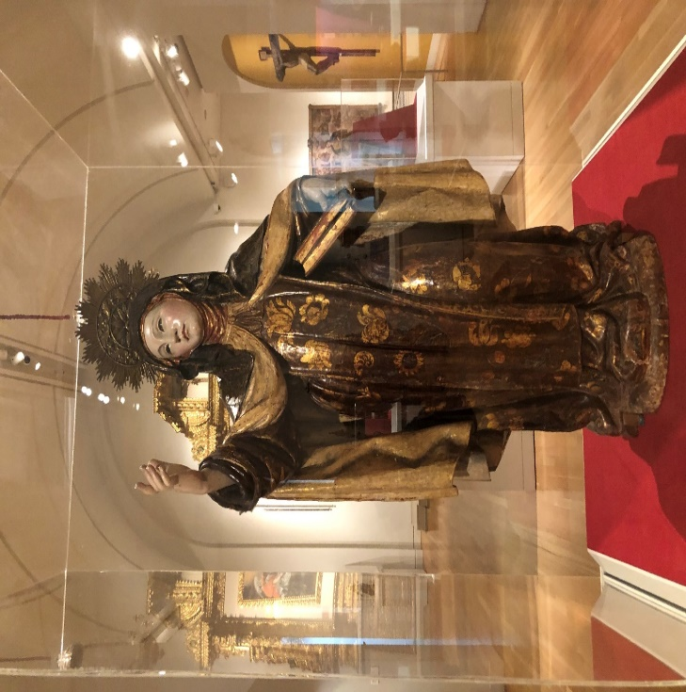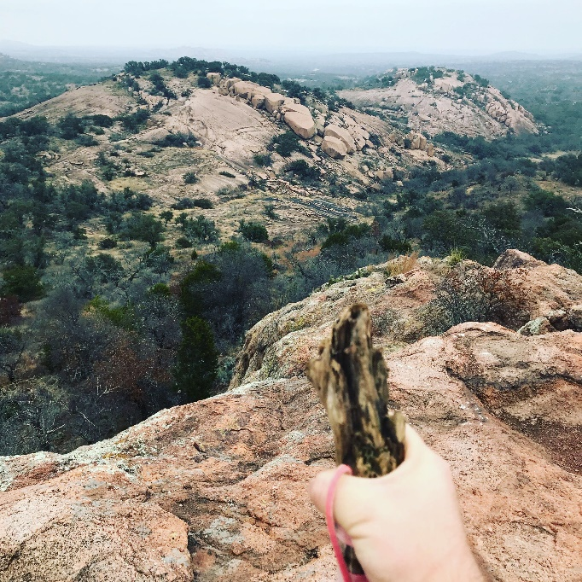
Following in their footsteps came Carlo Carretto. From Letters from the Desert; “The desert has always been looked upon as s an anvil on which the human spirit can be shaped. John the Baptist, Jesus and the Desert Fathers evidence the close connections between the origin of Christianity and the desert as a place almost uniquely suited for communion with God.”… “God’s call is mysterious; it comes in the darkness of faith. It is so fine, so subtle, that it is only with the deepest silence within us that we can hear it. And yet noting is so decisive and overpowering for a man on this earth, nothing surer or stronger. This call is uninterrupted: God is always calling us!”
Thomas Merton and Henri Nouwen are two other monumental theologians that are usually associated with the Desert Mystics. Nouwen’s The Wounded Healer is my top book recommendation for anyone discerning a call to ordained ministry!
So what is in your to-go box, from this 1st edition of Burnt Ends?
During Lent: use water as a touchstone for gratitude. Spend time in your own desert, in solitude and contemplation. If it is helpful, crave away ‘x’ minutes a day in your own desert ‘cave,’ listen to God in the stillness, and/or pray. Read a passage or book of one of the authors I mentioned, currently I’d recommend Richard Rohr. I have several of most of the theologians’ books I referenced in my office. Go on physical hike in a park, walk the dog, or walk around the neighborhood, try a guided-meditation prayer-walk. Reach out to someone who you feel like might be experiencing ‘wilderness’ right now… and/or simply: ‘Let Go!’

