Holy Trinity Lutheran Church
150 River Road Red Bank, NJ 07701
Church Office: (732) 741-9241 Fax: (732) 741-9577
email: holytrinitychurch4@verizon.net
Website: htlcredbank.org
Pastor: Rev. John Mack, Jr.
Cell: (336)-392-5839
Minister of Music: Peter Isherwood
Parish Administrator: Deanna Vergari
Council President: Cynthia Kazmac



April 12, 2026

Second Sunday of Easter

Introduction
In today’s gospel the risen Christ appears to the disciples and offers them the gift of peace. Even amid doubts and questions, we experience the resurrection in our Sunday gathering around word and meal, and in our everyday lives. Throughout the coming Sundays of Easter the first two readings will be from the Acts of the Apostles and the first letter of Peter. Even as the early Christians proclaimed the resurrection, we rejoice in the new birth and living hope we receive in baptism.

Welcome & Announcements (Please remember to silence your cell phone!)

Prelude (We prayerfully prepare our hearts and minds to worship!)

+ GATHERING +

Thanksgiving for Baptism
All may make the sign of the cross, the sign that is marked at baptism, as the presiding minister begins.
P:Alleluia! Christ is risen.
C:Christ is risen indeed. Alleluia!
P:Salvation belongs to our God who is seated on the throne
and to the Lamb!
C:Amen.
P:Let us give thanks for the gifts of baptism.
Water may be poured into the font as the presiding minister continues.
P:Merciful God,
you are the one who was, who is, and who is to come.
You lead us beside still waters.
We thank you for the waters of creation:
morning dew, gentle rain, roaring waves.
We thank you for the waters that nourish us (local waters may be named).
Blessed are you.
C:You guide us to springs of the water of life.
P:Jesus Christ, you are the faithful witness
who accompanies us on our journeys.
We give you thanks for your life-giving death and resurrection.
We praise you for joining us in joy and sorrow.
Blessed are you.
C:You guide us to springs of the water of life.
P:Holy Spirit, you anoint our head with oil and our cup overflows.
Break down barriers that divide us.
Fill us with the breath of peace.
Blessed are you.
C:You guide us to springs of the water of life.
P:Holy One, we thank you for the gifts and grace of baptism,
and for making us a new creation.
We join with saints and angels, giving you honor and praise,
now and forever.
C:Amen.

*Gathering Hymn ELW 361 The Day of Resurrection!
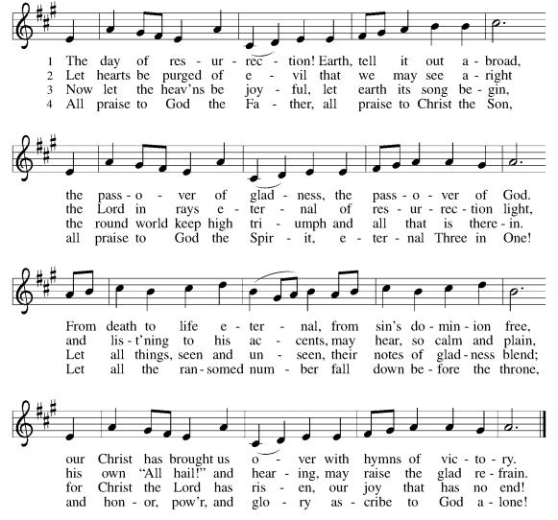

*Pastoral Greeting

P: The Grace of our Lord Jesus Christ, the love of God, and the communion of the Holy Spirit be with you all.

C: And also with you!

Hymn of Praise

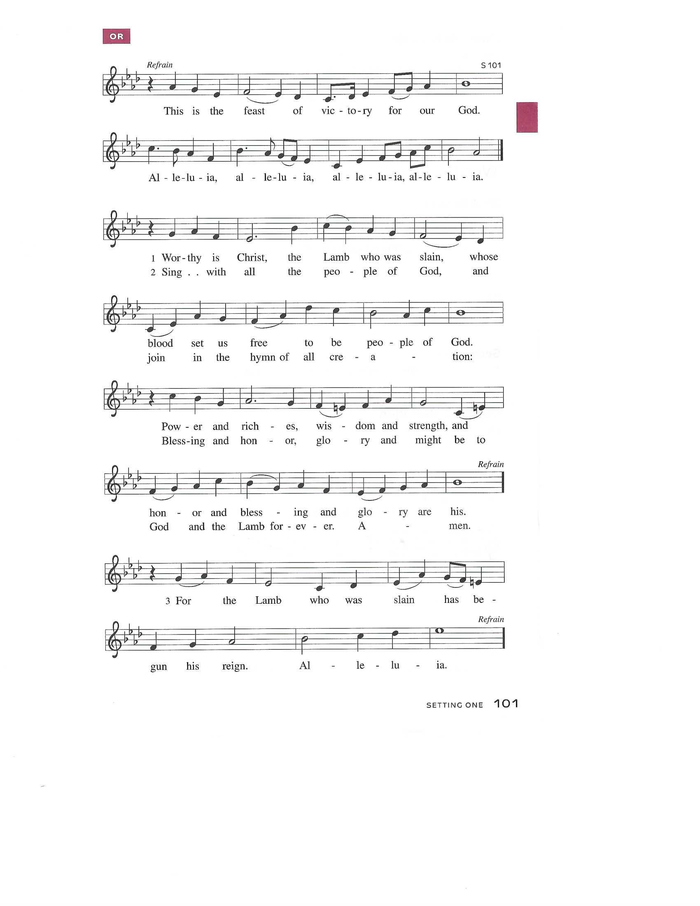

Prayer of the Day
P: Almighty and eternal God, the strength of those who believe and the hope of those who doubt, may we, who have not seen, have faith in you and receive the fullness of Christ’s blessing, who lives and reigns with you and the Holy Spirit, one God, now and forever.
C: Amen!

+WORD+

First Reading: Acts 2:14a, 22-32
After the Holy Spirit comes to the apostles on Pentecost, Peter preaches the gospel to the gathered crowd. He tells them that Jesus, who obediently went to his death according to God’s plan, was raised from the dead by God. Finally, he appeals to scripture, quoting Psalm 16:8-11, to show that Jesus is the Messiah: though crucified, the risen Jesus is now enthroned.

^{14a} Peter, standing with the eleven, raised his voice and addressed [the crowd]: ²² “Fellow Israelites, listen to what I have to say: Jesus of Nazareth, a man attested to you by God with deeds of power, wonders, and signs that God did through him among you, as you yourselves know ²³ this man, handed over to you according to the definite plan and foreknowledge of God, you crucified and killed by the hands of those outside the law. ²⁴ But God raised him up, having released him from the agony of death, because it was impossible for him to be held in its power. ²⁵ For David says concerning him,
‘I saw the Lord always before me,
for he is at my right hand so that I will not be shaken;
²⁶ therefore my heart was glad, and my tongue rejoiced;
moreover, my flesh will live in hope.
²⁷ For you will not abandon my soul to Hades
or let your Holy One experience corruption.
²⁸ You have made known to me the ways of life;
you will make me full of gladness with your presence.’
²⁹ “Fellow Israelites, I may say to you confidently of our ancestor David that he both died and was buried, and his tomb is with us to this day. ³⁰ Since he was a prophet, he knew that God had sworn with an oath to him that he would put one of his descendants on his throne. ³¹ Foreseeing this, David spoke of the resurrection of the Messiah, saying,
‘He was not abandoned to Hades,
nor did his flesh experience corruption.’
³² “This Jesus God raised up, and of that all of us are witnesses.”

Psalm: Psalm 16
In your presence there is fullness of joy. (Ps. 16:11)

¹ Protect me, O God, for I take ref- | uge in you;
I have said to the Lord, “You are my Lord, my good a- | bove all other.”
² All my delight is in the godly that are | in the land,
upon those who are noble a- | mong the people.
³ But those who run after | other gods
shall have their troubles | multiplied.
⁴ I will not pour out drink offerings | to such gods,
never take their names up- | on my lips.
⁵ O Lord, you are my portion | and my cup;
it is you who up- | hold my lot.
⁶ My boundaries enclose a | pleasant land;
indeed, I have a | rich inheritance.
⁷ I will bless the Lord who | gives me counsel;
my heart teaches me night | after night.
⁸ I have set the Lord al- | ways before me;
because God is at my right hand, I shall | not be shaken.
⁹ My heart, therefore, is glad, and my spir- | it rejoices;
my body also shall | rest in hope.
¹⁰ For you will not abandon me | to the grave,
nor let your holy one | see the pit.
¹¹ You will show me the | path of life;
in your presence there is fullness of joy, and in your right hand are pleasures for- | evermore.

Second Reading: 1 Peter 1:3-9
This epistle was written to encourage Christians experiencing hardships and suffering because of their faith in Christ. The letter opens by blessing God for the living hope we have through Christ’s resurrection even amid difficult circumstances and surroundings.

³ Blessed be the God and Father of our Lord Jesus Christ! By his great mercy he has given us a new birth into a living hope through the resurrection of Jesus Christ from the dead ⁴ and into an inheritance that is imperishable, undefiled, and unfading, kept in heaven for you, ⁵ who are being protected by the power of God through faith for a salvation ready to be revealed in the last time. ⁶ In this you rejoice, even if now for a little while you have had to suffer various trials, ⁷ so that the genuineness of your faith—being more precious than gold that, though perishable, is tested by fire—may be found to result in praise and glory and honor when Jesus Christ is revealed. ⁸ Although you have not seen him, you love him, and even though you do not see him now, you believe in him and rejoice with an indescribable and glorious joy, ⁹ for you are receiving the outcome of your faith, the salvation of your souls.

*Gospel Acclamation
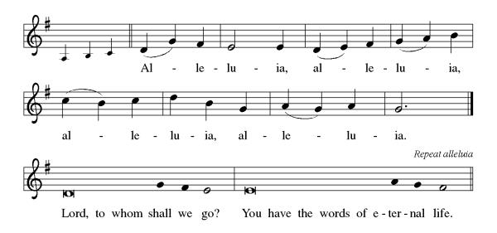

P: The Holy Gospel According to St. John 20th Chapter
C: Glory to You O Lord!

Gospel: John 20:19-31
The risen Jesus appears to his disciples, offering them a benediction, a commission, and the gift of the Holy Spirit. But one of their number is missing, and his unbelief prompts another visit from the Lord.

¹⁹ When it was evening on that day, the first day of the week, and the doors were locked where the disciples were, for fear of the Jews, Jesus came and stood among them and said, “Peace be with you.” ²⁰ After he said this, he showed them his hands and his side. Then the disciples rejoiced when they saw the Lord. ²¹ Jesus said to them again, “Peace be with you. As the Father has sent me, so I send you.” ²² When he had said this, he breathed on them and said to them, “Receive the Holy Spirit. ²³ If you forgive the sins of any, they are forgiven them; if you retain the sins of any, they are retained.”
²⁴ But Thomas (who was called the Twin), one of the twelve, was not with them when Jesus came. ²⁵ So the other disciples told him, “We have seen the Lord.” But he said to them, “Unless I see the mark of the nails in his hands and put my finger in the mark of the nails and my hand in his side, I will not believe.”
²⁶ A week later his disciples were again in the house, and Thomas was with them. Although the doors were shut, Jesus came and stood among them and said, “Peace be with you.” ²⁷ Then he said to Thomas, “Put your finger here and see my hands. Reach out your hand and put it in my side. Do not doubt but believe.” ²⁸ Thomas answered him, “My Lord and my God!” ²⁹ Jesus said to him, “Have you believed because you have seen me? Blessed are those who have not seen and yet have come to believe.”
³⁰ Now Jesus did many other signs in the presence of his disciples that are not written in this book. ³¹ But these are written so that you may continue to believe that Jesus is the Messiah, the Son of God, and that through believing you may have life in his name.

P: The Gospel of the Lord
C: Praise to you, O Christ!
Sermon
*Hymn of the Day ELW 386 O Sons and Daughters, Let Us Sing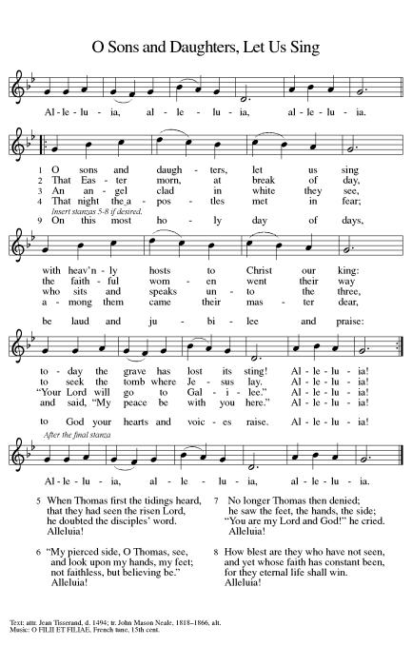
*Nicene Creed
We believe in one God,
the Father, the Almighty,
maker of heaven and earth,
of all that is, seen and unseen.
We believe in one Lord, Jesus Christ,
the only Son of God,
eternally begotten of the Father,
God from God, Light from Light,
true God from true God,
begotten, not made,
of one Being with the Father;
through him all things were made.
For us and for our salvation
he came down from heaven,
was incarnate of the Holy Spirit and the Virgin Mary
and became truly human.
For our sake he was crucified under Pontius Pilate;
he suffered death and was buried.
On the third day he rose again
in accordance with the Scriptures;
he ascended into heaven
and is seated at the right hand of the Father.
He will come again in glory to judge the living and the dead,
and his kingdom will have no end.
We believe in the Holy Spirit, the Lord, the giver of life,
who proceeds from the Father and the Son,
who with the Father and the Son is worshiped and glorified,
who has spoken through the prophets.
We believe in one holy catholic and apostolic church.
We acknowledge one baptism for the forgiveness of sins.
We look for the resurrection of the dead,
and the life of the world to come. Amen.

*Prayers of Intercession
Trusting in the power of Christ’s resurrection to heal and redeem our broken world, let us pray for the needs of all creation.
A brief silence.
Almighty God, you give life to the dead and call into existence things that do not exist. Breathe your Spirit upon us, that our faith may be renewed day by day. Merciful God,
C:receive our prayer.
Maker of heaven and earth, your mercies are new every morning. Open us to the wonders of creation, from the beauty of flowers to the complexity of subatomic particles. Merciful God,
C:receive our prayer.
God of peace, in every place where conflict rages, sow seeds of calm and openness to reconciliation. Strengthen the resolve of leaders and citizens to work for peace in their nations. Merciful God,
C:receive our prayer.
Healing God, come alongside all who are doubting, fearful, or suffering in any way (especially). Reveal to them your presence and assure them of the inheritance you have prepared for them. Merciful God,
C:receive our prayer.
Giver of joy, let this assembly be a place of genuine love and mutual affection. Deepen our care for one another and help us to embody your forgiving and sacrificial love. Merciful God,
C:receive our prayer.
Here other intercessions may be offered.
Eternal One, we give thanks for saints who were faithful unto death and have joined the church triumphant. Inspire us by their witness and bring us with them into your glorious presence. Merciful God,
C:receive our prayer.
God of resurrection power, use us and these prayers to proclaim the good news of new life to all the world, through Jesus Christ, our risen Savior.
C: Amen.

Greeting of Peace
P: The peace of Christ be with you always!
C: And also with you!

Offering (Thank you for your support for our ministry!)

*Doxology ELW 384 v.4 That Easter Day with Joy Was Bright (Please stand and join in singing as we share our gifts!)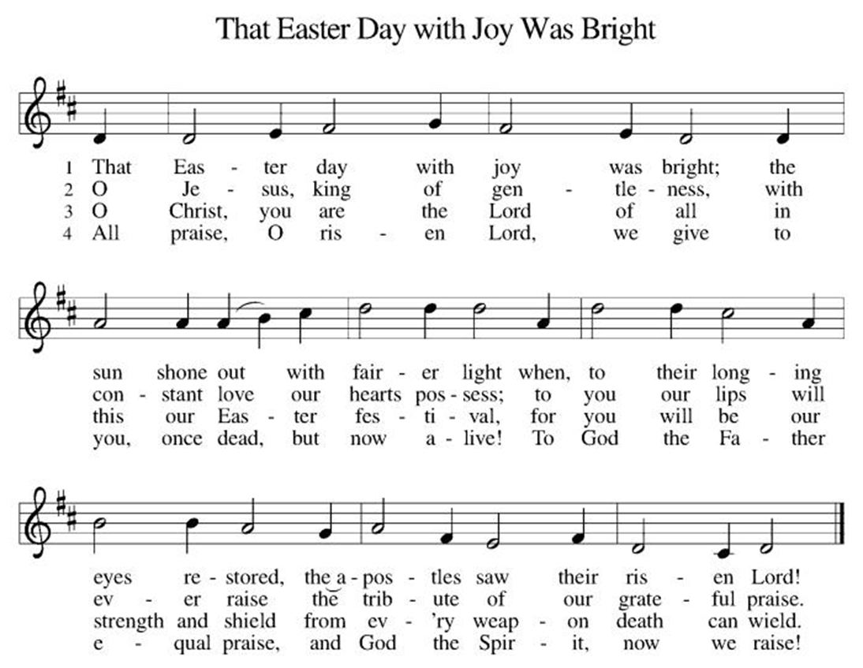

*Offering Prayer
A: Merciful God,
C: accept the fruits of our labor, gathered to give you glory.
You have set a table before us, a glimpse of that great day
when we will hunger and thirst no more.
Nourish us with the body and blood of Jesus,
that goodness and mercy may follow us
and bless the world you love.
In the name of Jesus,
Amen!

+MEAL+
*Great Thanksgiving
P: The Lord be with you.
C: And also with you.

P: Lift up your hearts.
C: We lift them to the Lord.

P: Let us give thanks to the Lord our God.
C: It is right to give our thanks and praise.

P: It is indeed right, our duty and our joy,
that we should at all times and in all places
give thanks and praise to you, almighty and merciful God,
for the glorious resurrection of our Savior Jesus Christ,
the true Paschal Lamb who gave himself to take away our sin;
who in dying has destroyed death,
and in rising has brought us to eternal life.
And so, with Mary Magdalene and Peter and all the witnesses of the resurrection, with earth and sea and all their creatures,
and with angels and archangels, cherubim and seraphim,
we praise your name and join their unending hymn:

*Sanctus
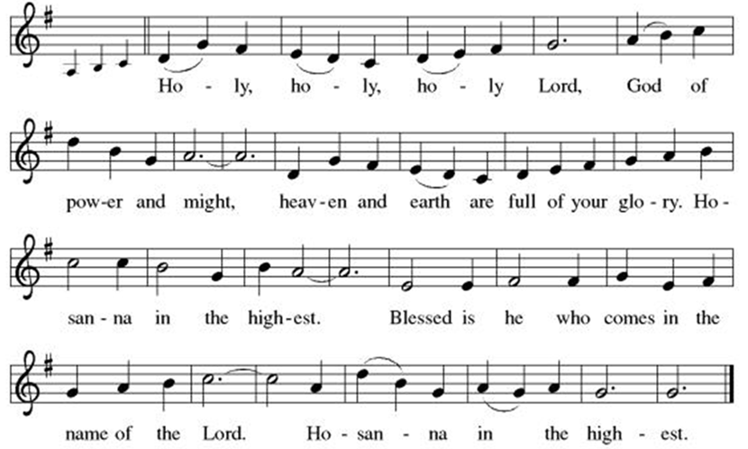

*Eucharistic Prayer
P: Holy, mighty, and merciful Lord,
heaven and earth are full of your glory.

In great love you sent to us Jesus, your Son,
who reached out to heal the sick and suffering,
who preached good news to the poor,
and who, on the cross, opened his arms to all.

In the night in which he was betrayed,
our Lord Jesus took bread, and gave thanks;
broke it, and gave it to his disciples, saying:
Take and eat; this is my body, given for you.
Do this for the remembrance of me.

Again, after supper, he took the cup, gave thanks,
and gave it for all to drink, saying:
This cup is the new covenant in my blood,
shed for you and for all people for the forgiveness of sin.
Do this for the remembrance of me.

Remembering, therefore, his death, resurrection, and ascension,
we await his coming in glory.

Pour out upon us the Spirit of your love, O Lord,
and unite the wills of all who share this heavenly food,
the body and blood of Jesus Christ, our Lord;
to whom, with you and the Holy Spirit,
be all honor and glory, now and forever.

C: Amen!

*THE LORD’S PRAYER
Our Father, who art in heaven,
hallowed be thy name,
thy kingdom come,
thy will be done,
on earth as it is in heaven.
Give us this day our daily bread;
and forgive us our trespasses,
as we forgive those
who trespass against us;
and lead us not into temptation,
but deliver us from evil.
For thine is the kingdom,
and the power, and the glory,
forever and ever. Amen.
*Lamb of God
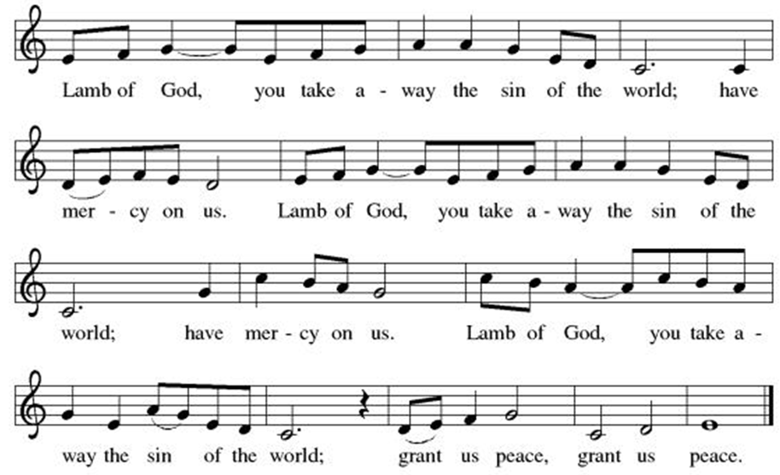
Spiritual Communion Prayer
P: Let us pray for the communion of all present here, those viewing our service virtually, those in our hearts and in our world.
C: Lord Jesus, I believe you are truly present in the Sacrament of Holy Communion. When I cannot receive Communion, I pray that you come into my heart. I know that nothing in Heaven or on earth can separate me from your love. Amen.

Invitation to Communion
P: Come to the table of new life.
Receive the risen Lord.

C: Thanks be to God!

(All are invited to the communion rail following the guidance of the ushers. Communion will be shared through the host and individual cups. If you would like communion but are unable to join us at the rail, please alert the usher!)
Communion Hymns (Please join in singing!)
WOV 675 We Walk by Faith and Not by Sight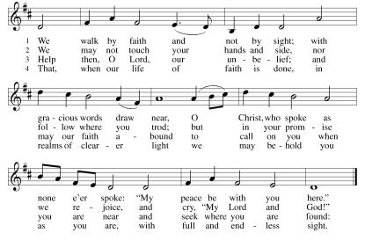

ELW 384 The Easter Day with Joy was Bright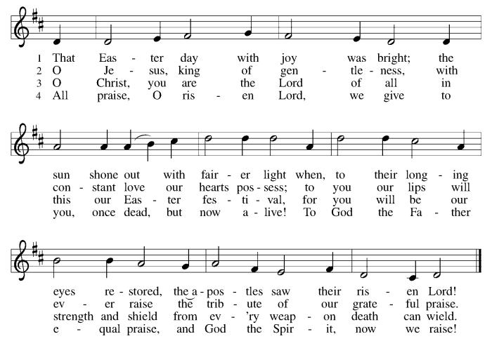

P: The body and blood of our Lord Jesus Christ strengthen you and keep you in his grace. C: Amen!

*Prayer after Communion
A: Holy One,
through this meal you have made your home among us
and are making all things new.
Send us now to speak peace to anxious hearts,
to love our enemies,
and to bring your healing to the nations.
In the name of Jesus,
C: Amen.

+Sending+

*Blessing
P: God Almighty, who is the beginning and the end,
Jesus Christ, the firstborn of the dead,
and the Spirit, our advocate and peace,
☩ bless you now and forever.
C: Amen!

*Sending Hymn ELW 390 The Risen Christ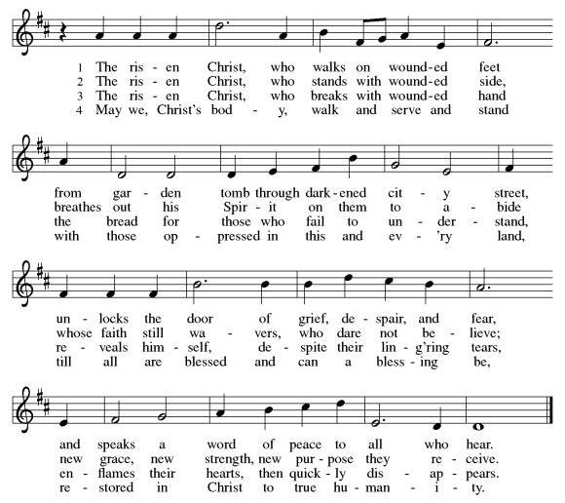

*Dismissal
A: Go in peace. Praise the Lord. Alleluia!
C: Thanks be to God. Alleluia!
Postlude

Copyright © 2020 Augsburg Fortress. All rights reserved. Reprinted by permission under Augsburg Fortress Liturgies Annual License #SB106907. New Revised Standard Version Bible, Copyright © 1989, Division of Christian Education of the National Council of the Churches of Christ in the United States of America. Used by permission. All rights reserved. Revised Common Lectionary, Copyright © 1992 Consultation on Common Texts, admin Augsburg Fortress. Used by permission.

Treasurer’s Report


March giving totaled $24,026, putting us ahead of pace toward our 2026 Challenge goal of $244,000, with 39% raised in just 25% of the year. Continued participation through regular or additional Challenge gifts will help ensure we fully fund HTLC’s ministry and mission in the months ahead.

Worship Volunteer Schedule
Date | Asst. Min | Usher | Sacristan | Lector | Counter
April 12 | Keith Bennett | The Gripps | Sherry Lee | Jeff Ridberg | Foss/Foard
April 19 | Chris Foard | Keith Bennett | Pat Pienkos | Emily Kaster | Volk/Bohner
April 26 | Charlie Rugg | Jill Socha | Joanne Giordano | Rosemary Lane | Kazmac/Giordano
May 3 | Linda Coleman | Kathy Caputo | Sherry Lee | Bill Spreen | Socha/Cheek

Coffee Hour- WELCA

ANNOUNCEMENTS Thank you! To all who consistently support our church and ministries through your time, talent, and treasure. Please help us grow by inviting your friends and family to worship and events. You are what makes Holy Trinity a wonderful church family!

Stay in touch! Please visit our church website, www.htlcredbank.org for updates and information. You can also find us on Facebook and view services online. The office is open from 9am to 2pm, Monday to Thursday.

Car Wash-The car wash will start at 10 AM with churchgoers cars washed first, then will open up to the general public from noon till 2:00 PM. We will need volunteers to wash the cars, dry cars, manage supplies and supervise. Please sign up in the Red Book. Contact Lauren Bennett with questions period proceeds will support Cross Roads Day Camp.

100 Anniversary Committee- Meeting Sunday April 26: All are welcome to the initial meeting of the planning committee for 100th anniversary of Holy Trinity Evangelical Lutheran Church. Let’s gather after church on April 26 to get this committee up and running and develop a meeting schedule. This initial meeting should not take long.

Name Tag Sundays: On the first Sunday of each month, names tags and markers will be at each entrance of the sanctuary. Please fill out a tag and wear one for worship and for coffee hour to welcome visitors and help newcomers put names to faces.

Sunday School in the New Year, we will continue to study stories and lessons from the Old Testament beginning with Jacob. Kids will love the crafts, songs and games that accompany each lesson.
The following dates there will be Sunday School:
April- 12 and 26, May- 3, 17 and 31, June- 7 and 14
As was done in the fall, there will be opportunities to volunteer as SS lead teacher. A signup will be emailed out shortly and will also be posted in the red binder. Consider signing up! All lesson materials will be supplied and laid out and a leader guide will be emailed to volunteers approximately 1 week in advance. Blessings for a wonderful 2026!~Lauren

Choir The Holy Trinity Choir welcomes our singers back for a preparation rehearsal on Sunday, September 7th at 9am in the church hall. All are welcome to join us in song as often as you are able. Choir meets each Sunday at 9am to practice and prepare our music. Join us and help us grow by spreading the word about the HTLC Choir!

Quilting- The Quilters need gently used any bed sheets of any size! Please leave any donations in the quilters closet in Fellowship Hall. Thank you!

Quilters Need Help
If anyone is traveling through Mechanicsville, PA, and can add a few extra minutes to your trip, the warehouse for shipping quilts, school kits, etc is located directly off one of the exits.
We accumulate many quilts throughout the year and we would appreciate sending some quilts with you to deliver. Any questions, please call Sherry Lee or Elaine Theophall.

Weekly Quilting on Wednesdays at 9:30. Bring your lunch and enjoy some fellowship at noon. All are welcome.

Social Ministry
*Year-round collections will continue for food items for Lunch Break. There is a sign-up sheet in the red book for those who can help drop these items to Lunch Break.
*We will also collect adult men's socks to periodically drop at the Red Bank Warminq Center.
*For those interested in the Heartwarminq Center — the new women's shelter is adjacent to the First Baptist Church of Red Bank at 90 Maple Ave. You can follow up on this mission through their website - https://www.thefeastnj.org- On this site, they also include wish list items that can be purchased through amazon. We will be exploring purchasing some of these through a Thrivent card. If you want to purchase on your own, you can leave items at church, and the Social Ministry will deliver them.

Pastoral Care and Prayer... We are here to care for and pray! Please contact the office to add or adjust prayer requests. If you or someone you know needs pastoral care, please contact the office and Pastor Mack!

THANK YOU for supporting and sustaining our church and ministries! All are welcome here! Please invite your family and friends to worship with us! Find us online at www.htlcredbank.org

