TRINITY MEMORIAL UNITED CHURCH
Good News: Much of what you see, hear, and experience
during our worship is Metaphorical and Symbolic
April 12, 2026
Second Sunday of Easter
Holy Humour Sunday

We Approach
Acknowledgement of Territory & Statement of Inclusivity
Announcements, Joys, Celebrations
Lighting of the Christ Candle
On this 2nd Sunday of Easter, we shout and sing the glad news! Jesus Christ is risen indeed!
We light the candle because he is here among us.
Hallelujah! Amen.
Sing: “She Comes Sailing on the Wind” VU 380 (chorus)
She comes sailing on the wind,
her wings flashing in the sun,
on a journey just begun, she flies on.
And in the passage of her flight,
her song rings out through the night,
full of laughter, full of light, she flies on.

Call to Worship:
Jesus calls us with a rollicking sense of humour, chuckling at our faltering steps.
We find it hard to believe that we are loved so deeply, so we giggle with the nervous laughter of disbelief.
God calls us amidst our everyday living, grinning at the irony of our actions.
May we, too, grin and allow laughter to fill our worship,
feed our faith, and rejuvenate our spirit.

Hymn: “Joy comes With the Dawn” VU 166
Opening Prayer:
God of merriment, beckon us into the frolic of worship, that we may grasp your hand of new life. You are the joy in our happiness and in our sorrow. We pray for the gift of a holy sense of humour, the ability to laugh at ourselves, the ability to keep life in perspective. We rejoice in our transformation into people of joy and embracing our identity as your children. Amen.

Prayer of Confession:
We are O God, a foolish people. We chase after seductions of the world, seeking self-importance in material possessions. We search for justification in life, but find ourselves making foolish choices, choosing power over instead of service with. We only see in a mirror darkly, and the murky reflection seems laughable. Show us, O God, the wholeness of our created nature and our potential for new ways of living. Come into our open hearts now, O God, helping us to laugh at our old ways, leading us into new lives of joy and love. Amen.

Sung Assurance: “Allelujah”
Left: Allelu, Allelu, Allelu, Allelujah!
Right: Praise Ye the Lord!
Left: Allelu, Allelu, Allelu, Allelujah!
Right: Praise Ye the Lord!

Right: Praise Ye the Lord!
Left: Allelujah!
Right: Praise Ye the Lord!
Left: Allelujah!
Right: Praise Ye the Lord!
Left: Allelujah!
ALL: PRAISE YE THE LORD!

Passing the Peace: Peace of Christ be with you.
And also with you.
Take time to say hello to those in attendance.

Young @ Heart: “Joking Around”

Hymn: “Sing a Happy Hallelujah” VU 224
Service of the Word
Hebrew Scripture: Genesis 17: 1 – 8, 15 – 19
Hear what the Spirit is saying to the Church!
Write these words in our hearts, Dear God.
Anthem: “Be Thou My Vision” – Piano & Organ Duet

Message: “Where is God?” Rev. Tracy Fairfield

Song: “Ha, Ha, Song” – Linnea Good (see insert)

“We Keep Watch” – Prayers
After each prayer request, we will respond with:
One: God of Peace,
All: Be with your people in their time of need.

Prayers of the People and for the World

Lord’s Prayer (sung VU 959)

Invitation to the Offering

The Offering “Halle, Halle, Hallelujah” (twice) VU 958
Halle, halle, hallelujah
Halle, halle, hallelujah,
Halle, halle, hallelujah,
Hallelujah, hallelujah

Prayer of Dedication
Hymn: “Give to us Laughter” (Bonus verse) VU 624

Commissioning & Benediction
Sing: “You Shall Go Out With Joy” VU 884

Music Reproduced with permission under One License
Copyright Cleared Music for Churches #605530
Minister: Rev. Tracy Fairfield
Choir Director: Ron Schaufert
Pianist: Christine Schaufert
Organist: Donna Poncelet
Song Leader: Jerry Johnson____________________

TRINITY MEMORIAL UNITED CHURCH
We envision a Spiritual home, as a church and followers of Jesus Christ, where all people can fully participate in all aspects of our shared life and ministry and feel safe.
April 12, 2026
Second Sunday of Easter
Holy Humour Sunday
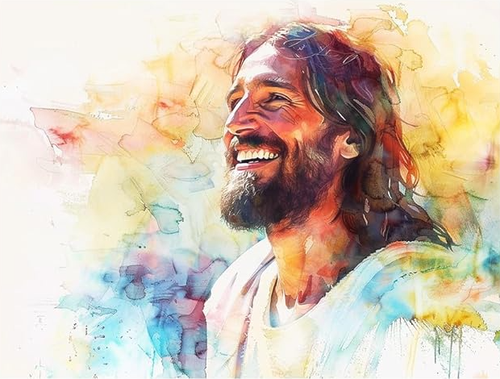
Trinity Memorial is a member church of
Affirm United/S’affirmer ensemble

We are a community of inclusive spirituality, caring fellowship, and welcoming outreach; one that purposefully seeks to embody the love and respect of God towards all people and Creation.

