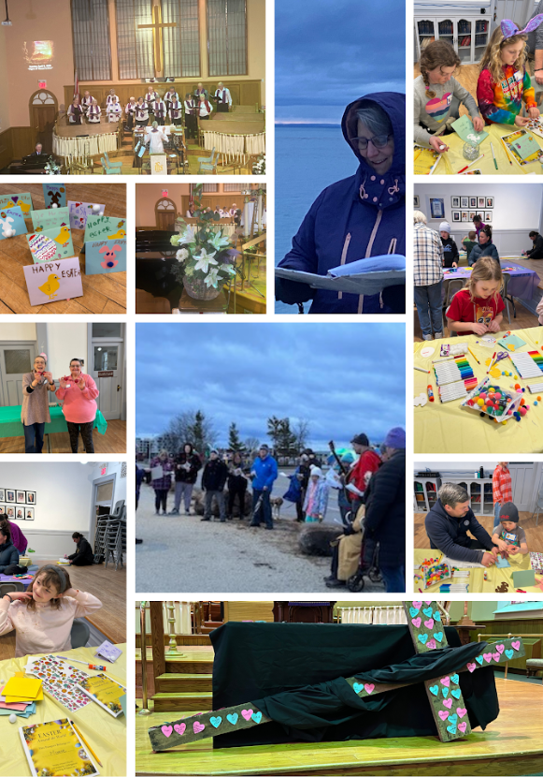

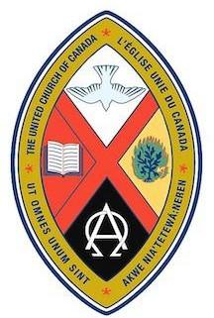
Trinity United Church
April 12, 2026
Easter 2
“Thomas, the Brave"

Land Acknowledgement
We acknowledge that for many thousands of years the Indigenous peoples of Turtle Island walked on this land. We are thankful to share in the special spirit of this place, rich in the energy of Mother Earth and the love of all creation.

God Welcomes Each One of Us with Loving Grace

Lighting the Christ Candle
We light the Christ candle each week, reminding ourselves of Christ’s presence with us. May Christ illumine our way.

Introit - VU 396 “Jesus Stand Among Us”

Announcements and Opportunities @Trinity

Gathering Words (modified from a prayer by Stephanie Richmond)
One: We come today as we are.
All: God welcomes all with loving acceptance.
One: We come with questions, doubts, and fears.
All Jesus meets us where we are and offers us peace.
One: Let us worship God together sharing in the spirit of love and peace.

Opening Hymn: VU 175 “This is the Day that God has Made”

Opening Prayer
O God, your Easter message remains confusing to us, just as it was for those first disciples. We too can easily find ourselves locked in cycles of despair or hiding in fear. Come amongst us this morning and offer us the same hopeful words you offered to those frightened disciples that Easter evening long ago. May your peace fill this time and space of worship. Amen.

Prayer of Confession (modified from a prayer by John Birch)
One: When our faith stands at the grave, grieving for a stone that's rolled away,
All: forgive us.

One: When our faith is short of understanding though the truth is there to see,
All: forgive us.
One: When our faith, beset by doubt, sees no further than an empty tomb today,
All: forgive us.
One: Bring to mind the cry of Mary, ‘I have seen the Lord!'
All: and grant us faith to believe!

… a pause for silent contemplation

Words of Assurance (by Scott Cervas)
This is Good News: God does not mock us when we fail to trust, but invites us into a deeper, more intimate relationship. Put your finger here. Look at my hands. Put your hand in my side. Trust me! God does not shame us when our faith waivers, but challenges us to be strengthened by God’s promises. Happy are those who don’t see…and yet trust! God’s purpose is not to tear us down…but to build us up… forgiven…refreshed…and renewed! So let’s sing and give thanks to God!

Sung Response - VU 179 (chorus only) “Hallelujah, Hallelujah, Give Thanks”

Theme Conversation (Children’s Time) - “Do you believe me?

Hymn - VU 185 “You Tell Me That the Lord is Risen”

Profession of Faith - David Jeffrey Collinson

Congregational Commitment
One: Let us stand, and pledge to David our continued support and care.
All: We will support you, walk with you and grow in faith with you. With God’s help, we will live out our baptism as a loving community in Christ: nurturing one another in faith, upholding one another in prayer, encouraging one another in God’s work.

Affirmation of Faith
One: Let us join in a statement of our communal faith.
All: We are not alone, we live in God's world.
We believe in God: who has created and is creating, who has come in Jesus, the Word made flesh, to reconcile and make new, who works in us and others by the Spirit.
We trust in God.
We are called to be the Church: to celebrate God's presence, to live with respect in creation, to love and serve others, to seek justice and resist evil, to proclaim Jesus, crucified and risen, our judge and our hope.
In life, in death, in life beyond death,
God is with us. We are not alone. Thanks be to God.

Rite of Confirmation

Reception of Transfers - Barbara and David Collinson Sr.
God Speaks to Us with Peace and Assurance

Prayer for Illumination (modified from a prayer by Gord Dunbar)
One: Come and free us, O God, with your creative word.
All: May your word be a lamp to light our path.
May your word spill from us in compassion and justice.
May your word be the sure foundation of our lives.
May your word live in our hearts, that we may be an Easter people. Amen.

Scripture Readings
- Psalm 16 (VU 738)
- John 20: 19-31

Special Music A FESTIVE ALLELUIA
BY Mary Lynn Lightfoot

Message: “Thomas, the Brave”
Hymn - VU 166 “Joy Comes with the Dawn”

God Supports and Lifts Us

Pastoral Prayer and Prayer of Jesus

Acknowledging our Offerings in Support of Trinity United’s ministries
Life has lots of room for doubt and uncertainty, let’s celebrate the ways we can face all of that together as a church who invests in love, hope, justice and joy in our community and the world. Your offering helps us to do that. Cash or cheques can be left in the offering plate at either entrance or mailed or dropped off at the church office. You can also give by e-transfer to office@collingwoodunitedchurch.ca or by signing up to donate monthly through PAR. f this is your first donation, please make sure we have your name and address and email address (if available) for tax receipt purposes. Thank you for all the ways you support us with your time, your talents and your financial resources. With grateful hearts we pray:

Generous God, we bring these offerings for the work of your church, here and in other places. May they help us to foster love in the face of hate, hope in the face of despair, justice in the face of oppression and joy in the midst of grief. Amen.

Closing Hymn - VU 158 “Christ is Alive”

Commissioning (Modified from a prayer by Bill Perry)
Let us go out as disciples who can’t quite describe precisely what the resurrected Jesus is like, but are willing to explore and discover his Way, day by day.

Benediction (by United Church of Canada)
May the blessing of God, the giver of every good and perfect gift; and of Christ, who summons us to service; and of the Holy Spirit, who inspires generosity and love, be with us all.

Choral Blessing - VU 974 “Amen, Hallelujah, Amen”

Music to Inspire our Serving
*************************************************************

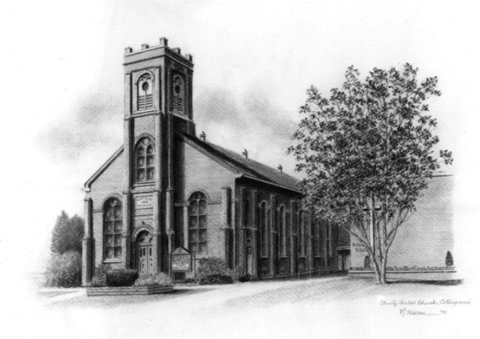

Trinity United .Church: Collingwood
Minister: Rev. Beth Kerr, 204.872.2370 (cell)
Minister’s Email minister@collingwoodunitedchurch.ca
Ministry of Music: Paul Sloan, 705.730.3121 (cell)
Choir Director: Lesley Joosten, 705.984.3243
Handbell Director: Maryellen Burgess, 705.443.1422 (cell)
UCW President: Joy Barr 705.445.0726
Office Assistant: Lori Forsythe
Church Office: office@collingwoodunitedchurch.ca
Office Hours: Tuesday to Friday, 8:30 am-12:00 pm
140 Maple Street, Collingwood, ON L9Y 2P8
Telephone: 705.445.3901
Website: www.collingwoodunitedchurch.ca

