All Saints Anglican Church
6904 Lougheed Highway, Agassiz, B.C. V0M 1A0
Bulletin April 6th, 2026 – April 12th, 2026

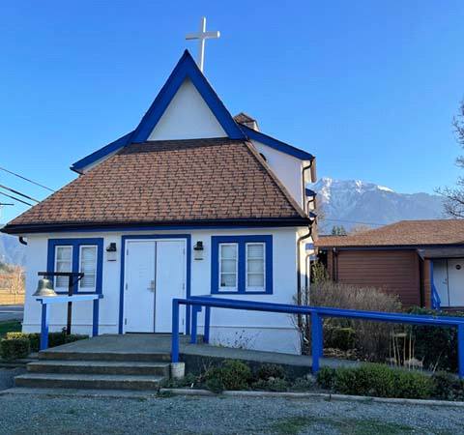

‘The ground we walk does not belong to us; for thousands of years it has been - and remains - the territory of the Stó:lō. We are grateful for their sharing.

Phone: 604-796-3553
Website: www.allsaints-agassiz.ca
https://www.facebook.com/groups/AllSaintsFamily
OUR DOOR IS OPEN AND ALL ARE WELCOME
April 12th, 2026, Second Sunday of Easter
Priest in Charge: The Reverend Philip Barker
Hosts: Graham Featherstone/Jennifer Pinlac
Intercessor: Jennifer Pinlac
Lay Administrator: Dorothy Cresswell
Announcer: Virginia Jennings
Organ/Piano: Francesca Froehlich
Readers: Sheila Barker/Ginny Jennings
Vicar’s cell phone: Revd. Philip Barker. 778-867-2461

Vicar’s Warden: Ginny Jennings. 604-796-2206
People’s Warden: Lynn Laughlin. 604-799-5131
Parish email: revpb1950@gmail.com
Please contact either warden if you have an issue that needs to be brought to the attention of the Vicar - or contact the Vicar direct (see above for details).

All Saint’s Calendar/Announcements:

- Book Club – On April 8th Book Club will resume Zoom meetings on Wednesdays at 5.00 pm. The first week will be a discussion of the 3 books that were read by members during Lent.

The next book will be "The Last Week: What the Gospels really teach about Jesus' final days in Jerusalem", by Marcus J. Borg and John Dominic Crosson. This will be an appropriate follow on from Holy Week.
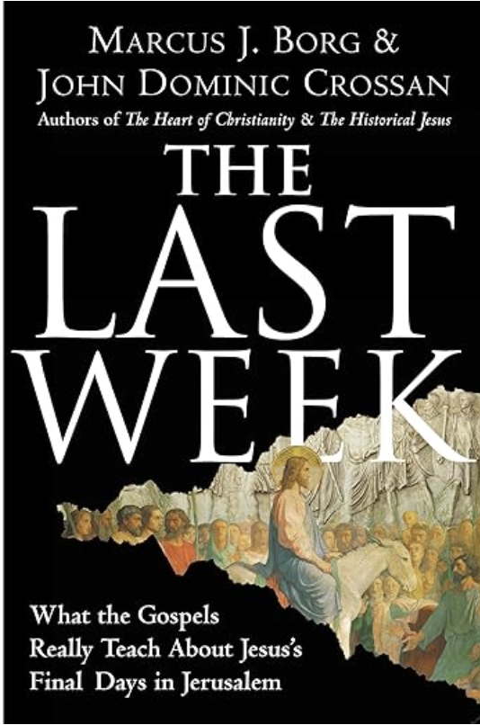
The book is $21.00 in paperback on Amazon and also
available on Kindle.

If you would like to join the group or have a copy of the
book, please contact Sheila at sjbarker0379@gmail.com

- Bible Study with Karol is every Saturday morning 0830-0900 on Zoom.

- Prayer Requests can be given on a piece of paper to either of the Wardens or the Vicar or entered in the Prayer Request Book on the lectern. Alternatively, you can contact Anthea Lewis at antheamlewis@shaw.ca for Pray First Prayer Circle, which is a confidential online prayer circle.

- Music Requests may be given to the Wardens or the Vicar.

- AA meets in the hall every Tuesday and Friday at noon.

- Every Thursday in the hall 1100-1200 we have a social time with coffee, games if you like or just talk.

- At 1000-1100 on Thursdays there is an Interactive Bible Study on the day’s Lectionary readings. All are welcome – discover the treasures in this amazing book!

- 5th Sunday of each month will be a potluck lunch after the service.

Ministerial Meandering
Neighbours

Some people like ‘em - I’m not so good at it if I’m honest. I just wish that they weren’t quite so close.
Just in the last week we’ve had to deal with three out of five that impinge directly onto our property, and in the last month - a fourth. To be fair, it hasn’t been entirely their fault - but who wants to be fair?
We had a ‘significant’ wind storm about a month ago, which knocked down the fences abutting three of our ‘impingers’, and these had to be repaired with some haste, as all but one of said neighbours have dogs.

I found out about the damage following the wind storm the next morning, when I went to let Gracie out into the yard. On opening the back door, we came face to face with a large Bernese Mountain dog. Gracie - about half the size - made it very clear in a matter of seconds that this was her yard, and interlopers, however beautiful, were not invited.

So with some Heath-Robinson techniques, I managed, with help, to patch up two of the fences; the third was dealt with by the neighbour himself. Later, one of the other neighbours felt that a better job was required - and, for a monetary agreement, did a much improved repair. I would like to point out that said neighbours are around thirty or more years younger than I am, and seem to have access to instant concrete and 4x4s. That’s the wood - not the vehicle.

The fourth neighbour has a tree. This tree wants very much to be on our driveway; and we very much don’t want it to be. The tree - a fine specimen that periodically needs attention from BC Hydro, because it bangs in a threatening way on our power cables, and is only an ace away from bringing them and the adjoining pole down - also happens to be behind a corner of our neighbour’s white plastic fence.
However, with each wind storm - for which Agassiz is famous - the trunk of this quite considerable tree leans like a tired elephant into the side of the fence and bends it, with accompanying squeaks and squeals of terrified plastic, such that passers-by look to see who is doing what to their pet pig.

But my neighbour likes his tree. He doesn’t want to cut it down, nor does he intend doing anything about the bowed and complaining fence, which is now cracked, and part of which is promising to join my car on the drive. For the above reasons - I don’t like his tree.
This is not the first time I have spoken to him about his arboreal imperative - nor, indeed, is it for Sheila. He stubbornly refuses to do diddly-squat about it.

Oh - I nearly forgot to tell you about the last neighbour’s fence repair. Since the fence at the end of his garden (not adjoining our property) also fell down in the storm, he decided to replace the whole surround of his garden with new fencing. In black metal. Sheila was - and is - horrified, since the job was finished this afternoon. We now live next door to a gulag whose appearance would do credit to the Gates of Hell. But - of course - our neighbour likes it.

I have to say I’m really pleased we’re moving to France in 6 months - to a rental with no visible domicile nearby. I guess I’m just not too neighbourly…or is it them?

Philip+

A Little Chuckle…


Birthdays this Month  April

Rev. Philip Barker – 1 Dorothy Cresswell – 2
Lynn Laughlin – 12 Anthea Lewis – 12
Peggy Arndt – 14 Jennifer Pinlac – 15
Sheila Barker – 19 Helene Atkinson – 27

Diocesan Cycle of Prayer: We Pray for the Clergy and Congregation:

The Deanery of Kingsway – ; All Saints, Ladner – The Revd Liz Hamel; Sorrento Retreat and Conference Centre – The Revd Michael Shapcott, Executive Director, Staff and Board of Directors

Anglican Church of Canada Cycle of Prayer – We Pray for:

The Provincial Synod of the Ecclesiastical Province of Ontario

Collect

Almighty and eternal God, the strength of those who believe and the hope of those who doubt, may we, who have not seen, have faith and receive the fullness of Christ’s blessing, who is alive and reigns with you and the Holy Spirit, one God, now and for ever.

Acts 2:14a, 22-32 Sheila Barker

14 Then Peter stood up with the Eleven, raised his voice and addressed the crowd: “Fellow Jews and all of you who live in Jerusalem, let me explain this to you; listen carefully to what I say.

²² “Fellow Israelites, listen to this: Jesus of Nazareth was a man accredited by God to you by miracles, wonders and signs, which God did among you through him, as you yourselves know. ²³ This man was handed over to you by God’s deliberate plan and foreknowledge; and you, with the help of wicked men, put him to death by nailing him to the cross. ²⁴ But God raised him from the dead, freeing him from the agony of death, because it was impossible for death to keep its hold on him. ²⁵ David said about him:

“‘I saw the Lord always before me.
Because he is at my right hand,
I will not be shaken.
²⁶ Therefore my heart is glad and my tongue rejoices;
my body also will rest in hope,
²⁷ because you will not abandon me to the realm of the dead,
you will not let your holy one see decay.
²⁸ You have made known to me the paths of life;
you will fill me with joy in your presence.’

²⁹ “Fellow Israelites, I can tell you confidently that the patriarch David died and was buried, and his tomb is here to this day. ³⁰ But he was a prophet and knew that God had promised him on oath that he would place one of his descendants on his throne. ³¹ Seeing what was to come, he spoke of the resurrection of the Messiah, that he was not abandoned to the realm of the dead, nor did his body see decay. ³² God has raised this Jesus to life, and we are all witnesses of it.

Psalm 111

¹ Praise the Lord.

I will extol the Lord with all my heart
in the council of the upright and in the assembly.

² Great are the works of the Lord;
they are pondered by all who delight in them.
³ Glorious and majestic are his deeds,
and his righteousness endures forever.
⁴ He has caused his wonders to be remembered;
the Lord is gracious and compassionate.
⁵ He provides food for those who fear him;
he remembers his covenant forever.

⁶ He has shown his people the power of his works,
giving them the lands of other nations.
⁷ The works of his hands are faithful and just;
all his precepts are trustworthy.
⁸ They are established for ever and ever,
enacted in faithfulness and uprightness.
⁹ He provided redemption for his people;
he ordained his covenant forever—
holy and awesome is his name.

¹⁰ The fear of the Lord is the beginning of wisdom;
all who follow his precepts have good understanding.
To him belongs eternal praise.

1 Peter 1:3-9 Ginny Jennings

³ Praise be to the God and Father of our Lord Jesus Christ! In his great mercy he has given us new birth into a living hope through the resurrection of Jesus Christ from the dead, ⁴ and into an inheritance that can never perish, spoil or fade. This inheritance is kept in heaven for you, ⁵ who through faith are shielded by God’s power until the coming of the salvation that is ready to be revealed in the last time. ⁶ In all this you greatly rejoice, though now for a little while you may have had to suffer grief in all kinds of trials. ⁷ These have come so that the proven genuineness of your faith—of greater worth than gold, which perishes even though refined by fire—may result in praise, glory and honor when Jesus Christ is revealed. ⁸ Though you have not seen him, you love him; and even though you do not see him now, you believe in him and are filled with an inexpressible and glorious joy, ⁹ for you are receiving the end result of your faith, the salvation of your souls.

John 20:19-31 Vicar Philip Barker
¹⁹ On the evening of that first day of the week, when the disciples were together, with the doors locked for fear of the Jewish leaders, Jesus came and stood among them and said, “Peace be with you!” ²⁰ After he said this, he showed them his hands and side. The disciples were overjoyed when they saw the Lord.

²¹ Again Jesus said, “Peace be with you! As the Father has sent me, I am sending you.” ²² And with that he breathed on them and said, “Receive the Holy Spirit. ²³ If you forgive anyone’s sins, their sins are forgiven; if you do not forgive them, they are not forgiven.”

²⁴ Now Thomas (also known as Didymus), one of the Twelve, was not with the disciples when Jesus came. ²⁵ So the other disciples told him, “We have seen the Lord!”

But he said to them, “Unless I see the nail marks in his hands and put my finger where the nails were, and put my hand into his side, I will not believe.”

²⁶ A week later his disciples were in the house again, and Thomas was with them. Though the doors were locked, Jesus came and stood among them and said, “Peace be with you!” ²⁷ Then he said to Thomas, “Put your finger here; see my hands. Reach out your hand and put it into my side. Stop doubting and believe.”

²⁸ Thomas said to him, “My Lord and my God!”

²⁹ Then Jesus told him, “Because you have seen me, you have believed; blessed are those who have not seen and yet have believed.”

³⁰ Jesus performed many other signs in the presence of his disciples, which are not recorded in this book. ³¹ But these are written that you may believe that Jesus is the Messiah, the Son of God, and that by believing you may have life in his name.

Odds and Ends

