

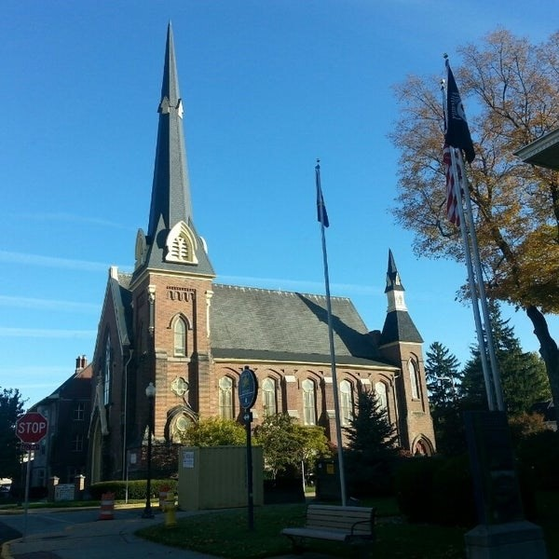
March 25, 2026

A Global Methodist Church
214 S. 5th Street
Goshen, IN 46528
Phone: 574-533-9518
Web Site: goshenfirstgmc.org

Office Hours: Monday-Friday,
8:00 a.m.-12:00 noon
Worship: 9:00 a.m.
Sunday School: 10:30 a.m.
Pastor Jeff & Lisa
Associate Pastor Rich Hull
OUR VISION: “Growing in Faith, Gathering in Community, and Giving in Love”.


LENTEN BREAKFASTS
The schedule for the 2026 Lenten Breakfasts is finalized. Plan on an 8:30 a.m. start time, and everything will run the same as years past. All are welcome!
March 28 - Jamestown United Methodist Church

Sunday School classes will not meet on Easter Sunday; however, we will still have Coffee Hour.

VOLUNTEERS – Thank you for your service! Sunday morning, March 29
Greeters: Sandy Priem, Sharon Hull VIP: Patty Krebs
Elevator Hosts: John Allyn, Kathy Robarge
Ushers: Randy Cripe, Pam Lichty, Dan Seltenright,Mateo Tenorio, Williston Tenorio
Scripture Reader: Carter Martin
Elementary Junior Church: Rachel Parsons, Kelley Leeper
Junior High Church: Linda Russell
Coffee Hour: J.D. & Linda Russell
Bus Driver: Al Eppert

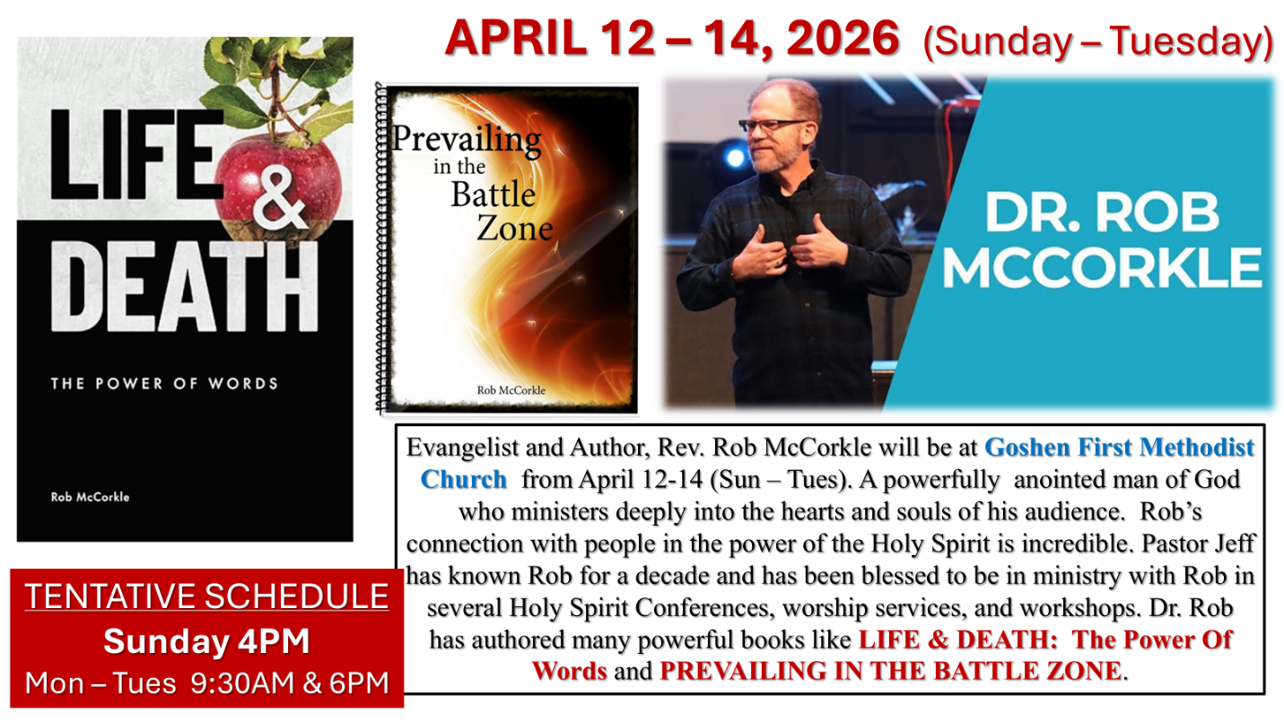

OUR STAFF
Pastor Jeff Bealmear – pastorjeff@goshenfirstgmc.org
Associate Pastor Rich Hull – rich@goshenfirstgmc.org
Pastor Emeritus Ben Whirledge – benwhirledge@goshenfirstgmc.org
Harriet Martin, Office Administrator – harrietmartin@goshenfirstgmc.org
Scott Carter, Director of Music Ministry – carters@westview.k12.in.us
Rachel Parsons, Children/Youth Director – rachel@goshenfirstgmc.org
Linda Ponce, Treasurer – lcponce1@gmail.com
DeDe Russell, Caring Ministries Coordinator – russelldede@yahoo.com
Kimberly Lichty-Nyce, Social Media Editor – klichty-nyce@comcast.net
John Jinright, Organist – jjinrig@troy.edu
Joel Lane, Pianist – joell12068@gmail.com
Rodney Troyer, Custodian – troyerstc@gmail.com
Jazlyn Troyer, Chris & Gretchen Martin - Sound Techs
HOLY WEEK SCHEDULE



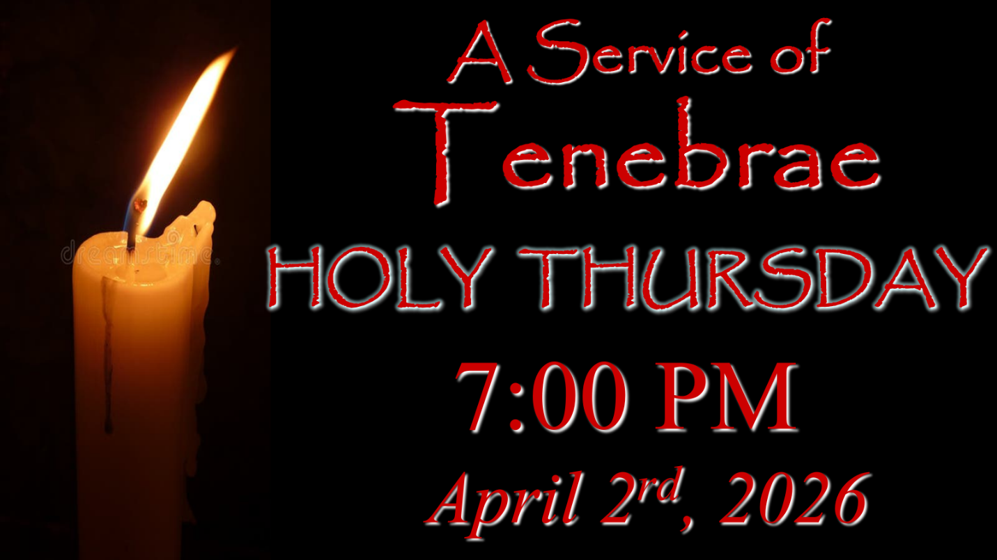

HOLY WEEK SCHEDULE

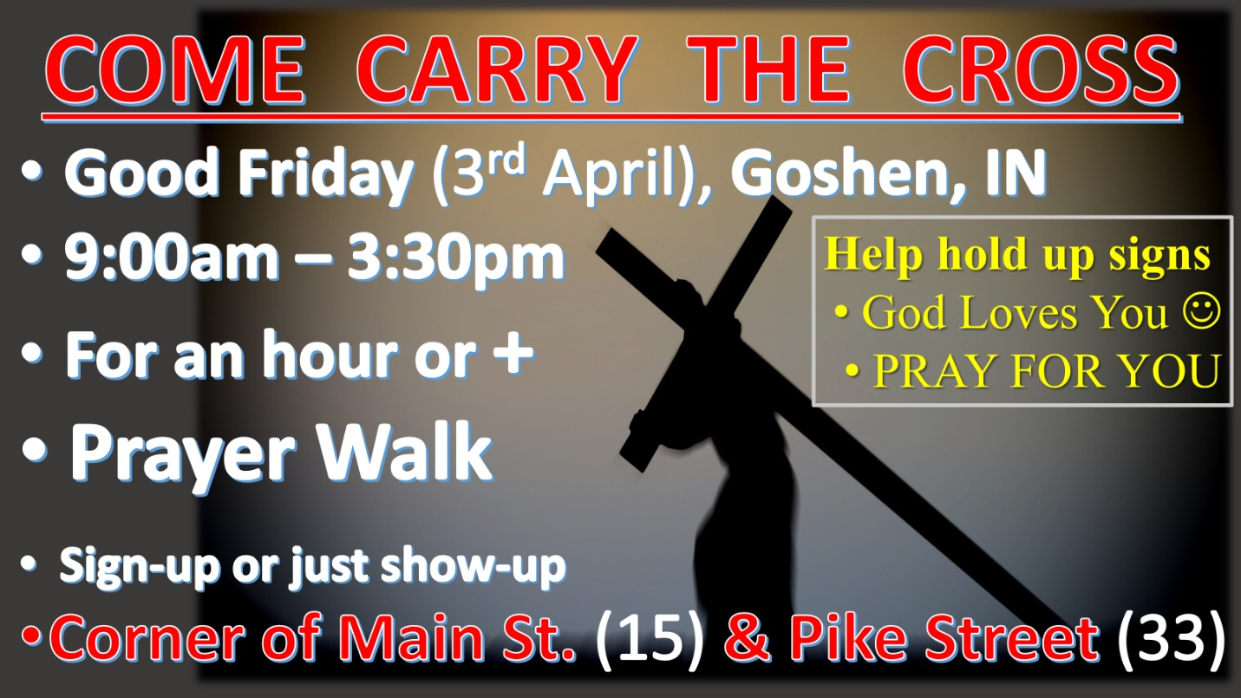

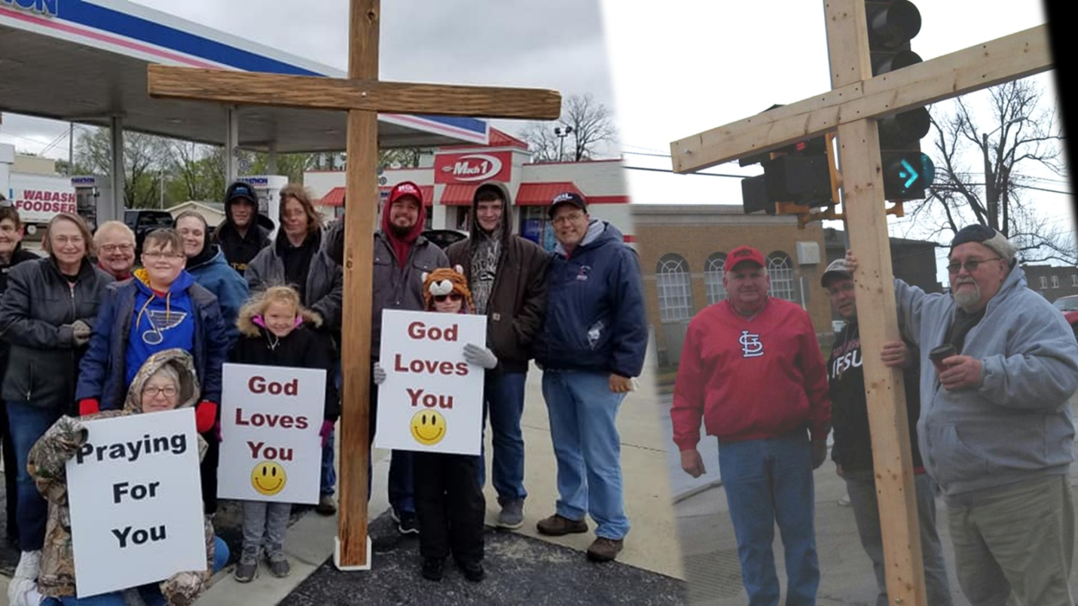

HOLY WEEK SCHEDULE





