Date: 04/11/26 Season: EASTER 2 (WHITE)
PASTOR Rev. Orin W Cummings, PhD ASSISTING Katie Dogwiler
LECTOR Cathy Murrell ORGANIST Marilyn Boston
A/V Sarah Gunion DISTRIBUTION MINISTER Katie Dogwiler

PRELUDE

WELCOME AND ANNOUNCEMENTS

GATHERING
The Holy Spirit Calls us together as the people of God.

CALL TO WORSHIP

In celebration of our baptism, we worship
In the name of God: Father, ☩ Son, and Holy Spirit.
Amen.

CONFESSION AND FORGIVENESS OF SINS

Let us give thanks for the gifts of baptism.
Water may be poured into the font as the presiding minister continues.

Merciful God,
you are the one who was, who is, and who is to come.
You lead us beside still waters.
We thank you for the waters of creation:
morning dew, gentle rain, roaring waves.
We thank you for the waters that nourish us (local waters may be named).
Blessed are you.
You guide us to springs of the water of life.

Jesus Christ, you are the faithful witness
who accompanies us on our journeys.
We give you thanks for your life-giving death and resurrection.
We praise you for joining us in joy and sorrow.
Blessed are you.
You guide us to springs of the water of life.

Holy Spirit, you anoint our head with oil and our cup overflows.
Break down barriers that divide us.
Fill us with the breath of peace.
Blessed are you.
You guide us to springs of the water of life.

Holy One, we thank you for the gifts and grace of baptism,
and for making us a new creation. We join with saints and angels,
giving you honor and praise, now and forever.
Amen.

GATHERING HYMN ELW 379
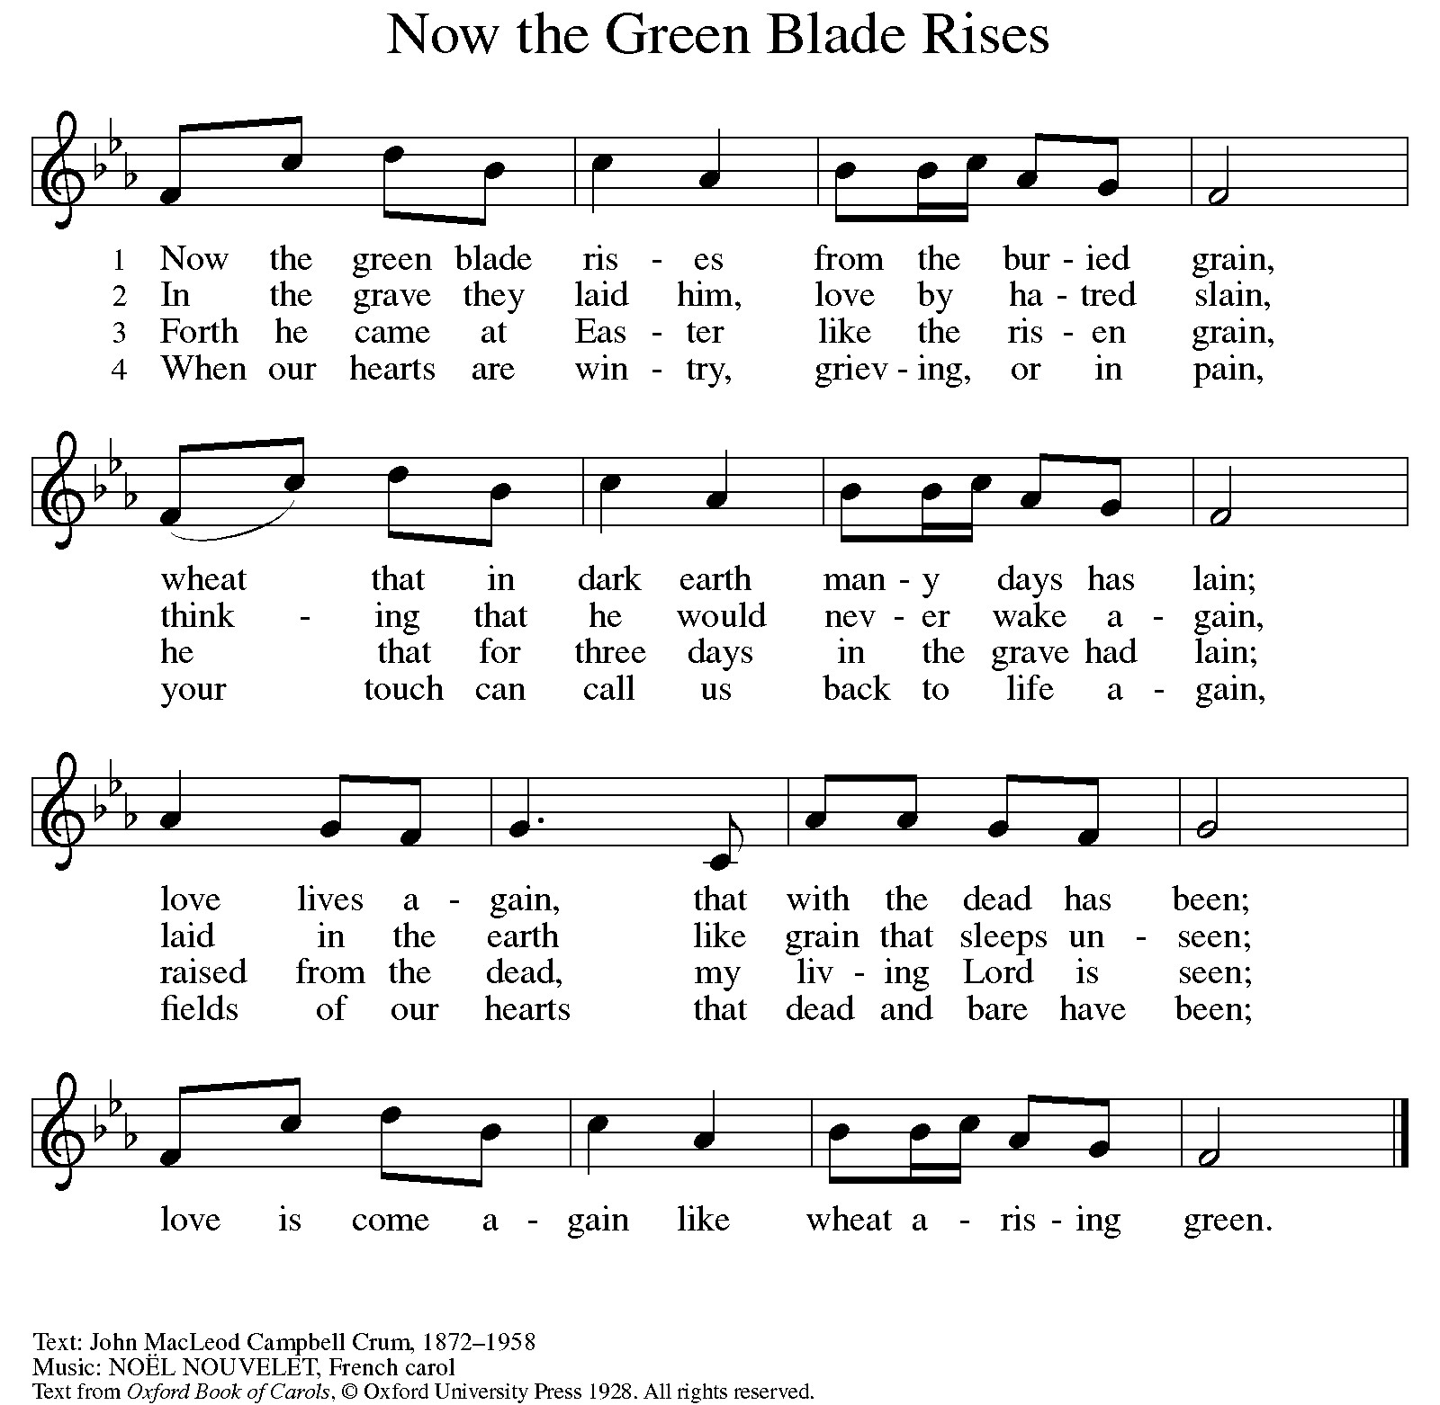
APOSTOLIC GREETING

The grace of our Lord Jesus Christ, the Love of God, and the communion of the Holy Spirit be with you all.
And also with you.

PRAYER OF THE DAY

Almighty and eternal God, the strength of those who believe and the hope of those who doubt, may we, who have not seen, have faith in you and receive the fullness of Christ’s blessing, who lives and reigns with you and the Holy Spirit, one God, now and forever.
Amen.

WORD
God speaks to us in scripture reading, preaching, and song.

THE FIRST READING FROM ACTS 2:14a, 22-32

^{14a} Peter, standing with the eleven, raised his voice and addressed [the crowd]: ²² “Fellow Israelites, listen to what I have to say: Jesus of Nazareth, a man attested to you by God with deeds of power, wonders, and signs that God did through him among you, as you yourselves know ²³ this man, handed over to you according to the definite plan and foreknowledge of God, you crucified and killed by the hands of those outside the law. ²⁴ But God raised him up, having released him from the agony of death, because it was impossible for him to be held in its power. ²⁵ For David says concerning him,
‘I saw the Lord always before me,
for he is at my right hand so that I will not be shaken;
²⁶ therefore my heart was glad, and my tongue rejoiced;
moreover, my flesh will live in hope.
²⁷ For you will not abandon my soul to Hades
or let your Holy One experience corruption.
²⁸ You have made known to me the ways of life;
you will make me full of gladness with your presence.’
²⁹ “Fellow Israelites, I may say to you confidently of our ancestor David that he both died and was buried, and his tomb is with us to this day. ³⁰ Since he was a prophet, he knew that God had sworn with an oath to him that he would put one of his descendants on his throne. ³¹ Foreseeing this, David spoke of the resurrection of the Messiah, saying,
‘He was not abandoned to Hades,
nor did his flesh experience corruption.’
³² “This Jesus God raised up, and of that all of us are witnesses.”

The Word of the Lord
Thanks be to God.

SPECIAL MUSIC He’s Resurrected and He’s Living Lana Kucherenko Tsiliskyi

THE SECOND READING FROM 1 PETER 1:3-9

³ Blessed be the God and Father of our Lord Jesus Christ! By his great mercy he has given us a new birth into a living hope through the resurrection of Jesus Christ from the dead ⁴ and into an inheritance that is imperishable, undefiled, and unfading, kept in heaven for you, ⁵ who are being protected by the power of God through faith for a salvation ready to be revealed in the last time. ⁶ In this you rejoice, even if now for a little while you have had to suffer various trials, ⁷ so that the genuineness of your faith—being more precious than gold that, though perishable, is tested by fire—may be found to result in praise and glory and honor when Jesus Christ is revealed. ⁸ Although you have not seen him, you love him, and even though you do not see him now, you believe in him and rejoice with an indescribable and glorious joy, ⁹ for you are receiving the outcome of your faith, the salvation of your souls.

The Word of the Lord
Thanks be to God.

GOSPEL

The Holy Gospel according to John the 20th Chapter
Glory to you, O Lord.

Narrator – Assistant Minister, Pastor – Jesus, Congregation – Disciples, Cathy – Thomas

Narrator (low, tense): It was evening on the first day of the week. The doors of the house were locked—bolted tight, fearing those who had taken him. Inside, the disciples waited in silence. (Pause) Suddenly, Jesus stood among them.
Jesus (calm, steady): Peace be with you.
Narrator (softening): He showed them his hands and his side. (Pause, then rising emotion) And when they saw him, they rejoiced.

Jesus (with purpose): Peace be with you. As the Father has sent me so I send you.

Narrator (reverent): And when he had said this, he breathed on them.

Jesus (gentle, powerful): Receive the Holy Spirit. If you forgive the sins of any, they are forgiven. If you retain the sins of any, they are retained.

Narrator (shifting tone): But Thomas—called the Twin—one of the twelve was not with them. So, the others told him.

Disciples (urgent, overlapping): We have seen the Lord!

Thomas (firm, guarded): Unless I see the mark of the nails in his hands and put my finger into the mark and my hand into his side, I will not believe.

Narrator (measured): A week later the doors were shut again. This time, Thomas was with them. (Pause) And again Jesus came and stood among them.

Jesus (steady, inviting): Peace be with you.

Narrator (quiet intensity):
Then he turned to Thomas.

Jesus (gentle, direct): Put your finger here. See my hands. Reach out your hand—and put it in my side. Do not doubt but believe.

Narrator (soft): Thomas answered him—

Thomas (overcome, reverent): My Lord and my God!

Jesus (warm, knowing): Have you believed because you have seen me? Blessed are those who have not seen—and yet have come to believe.

Narrator (closing, reflective): Now Jesus did many other signs in the presence of his disciples—signs not written in this book. But these are written so that you may believe that Jesus is the Messiah, the Son of God—and that through believing you may have life in his name.

The Gospel of the Lord.
Praise to you, O Christ.

SERMON Pastor Orin W Cummings

HYMN OF THE DAY ELW 635
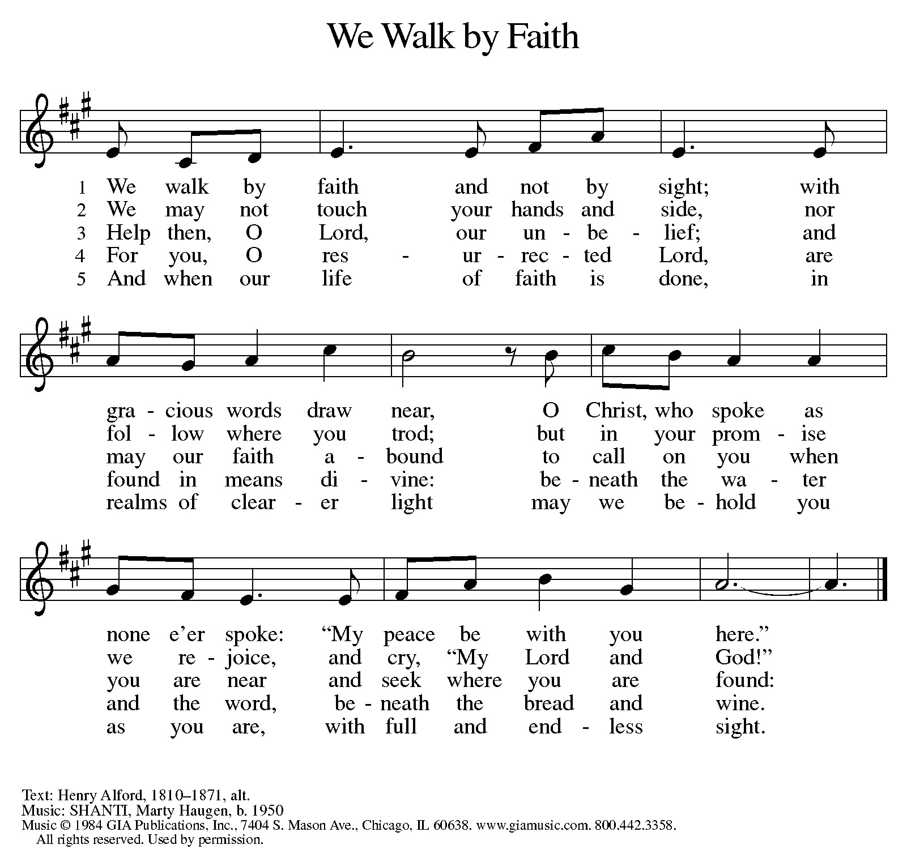

APOSTLES’ CREED

With the whole church, let us affirm our faith with the Apostles’ Creed:
I believe in God, the Father almighty,
creator of heaven and earth.

I believe in Jesus Christ, God’s only Son, our Lord,
who was conceived by the Holy Spirit,
born of the virgin Mary,
suffered under Pontius Pilate,
was crucified, died, and was buried;
he descended to the dead.
On the third day he rose again;
he ascended into heaven,
he is seated at the right hand of the Father,
and he will come to judge the living and the dead.

I believe in the Holy Spirit,
the holy catholic church,
the communion of saints,
the forgiveness of sins,
the resurrection of the body,
and the life everlasting.

SHARING OF THE PEACE

The Peace of the Lord be with you always.
And also with you.
Please share a sign of God’s peace with one another.

PRAYERS OF INTERCESSION

Trusting in the power of Christ’s resurrection to heal and redeem our broken world, let us pray for the needs of all creation and open our hearts to God’s will.
A brief silence.
Almighty God, you give life to the dead and call into existence things that do not exist. Breathe your Spirit upon us, that our faith may be renewed day by day. Merciful God,
receive our prayer.

Maker of heaven and earth, your mercies are new every morning. Open us to the wonders of creation, from the beauty of flowers to the complexity of subatomic particles. Merciful God,
receive our prayer.

God of peace, in every place where conflict rages, especially in Eastern Europe, the Middle East, Asia, Africa and the Americas, sow seeds of calm and openness to reconciliation. Strengthen the resolve of leaders and citizens to work for peace in their nations and regions. Merciful God,
receive our prayer.

Healing God, come alongside all who are doubting, fearful, or suffering in any way especially Natalie, David Adams, Angie Myers, Marge Fisher, Allie, Cherie McCarter, Allison Gregory, Madison Herrod, Steve and Cheryl Williams, Mike Long, Dorothy Benthine, Edward Dykman, Tommy Brewer, Cathy Carleton, Rob Rushton, Sally McCarville, Gabe Derr, Terry Touhey, Mary Jane Auld, Linden Cummings, Lou Echols, Larry Sorenson, Juanita Steinbaugh, Andrew Langr, Mark Krueger, Bob White, and Beverly Carlson. Reveal to them your presence and assure them of your salvation. Merciful God,
receive our prayer.

Giver of joy, let this assembly be a place of genuine love and mutual affection. Deepen our care for one another and help us to embody your forgiving and sacrificial love within these walls and in the wider community. Merciful God,
receive our prayer.

Eternal One, we give thanks for saints who were faithful unto death and have joined the church triumphant, especially Addison Ann Wehrle and Joe Davis. Inspire us by their witness and bring us with them into your glorious presence. Merciful God,
receive our prayer.

Lord in your mercy, grant protection and safety to Kyle C as he is deployed to the Middle East in this time of war. O God of resurrection power, use us and these prayers to proclaim the good news of new life to all the world, through Jesus Christ, our risen Savior.
Amen.
MEAL
God feeds us with the presence of Jesus Christ.

WORDS OF INSTITUTION
In the night in which he was betrayed,
our Lord Jesus took bread, and gave thanks;
broke it, and gave it to his disciples, saying:
Take and eat; this is my body, given for you.
Do this for the remembrance of me.

Again, after supper, he took the cup, gave thanks,
and gave it for all to drink, saying:
This cup is the new covenant in my blood,
shed for you and for all people for the forgiveness of sin.
Do this for the remembrance of me.

THE LORD’S PRAYER

Lord, remember us in your kingdom and teach us to pray:
Our Father in heaven,
hallowed be your name,
your kingdom come,
your will be done, on earth as in heaven.
Give us today our daily bread.
Forgive us our sins
as we forgive those who sin against us.
Save us from the time of trial and deliver us from evil.
For the kingdom, the power, and the glory are yours,
now and forever.
Amen.

INVITATION TO COMMUNION

Come to the table of new life.
Receive the risen Lord.

COMMUNION DISTRIBUTION

DISTRIBUTION HYMN ELW 461
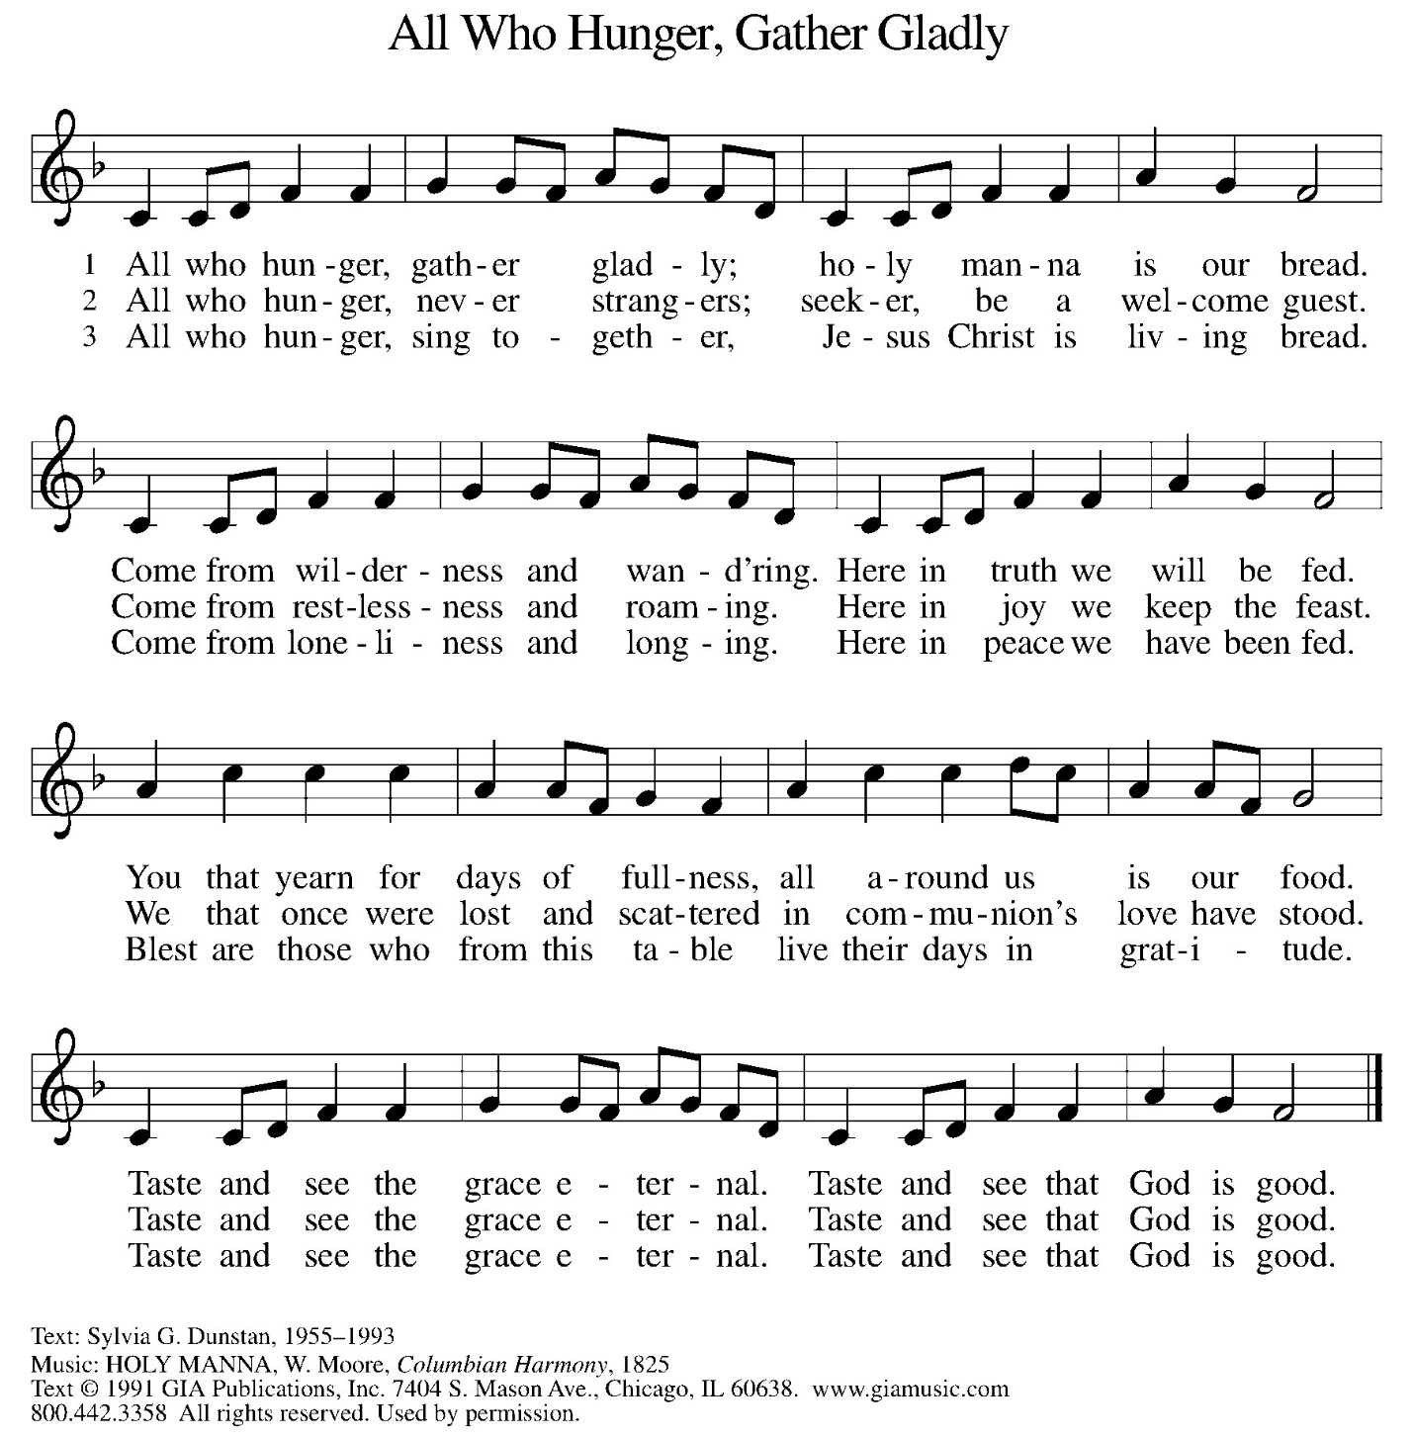

DISTRIBUTION HYMN ELW 482
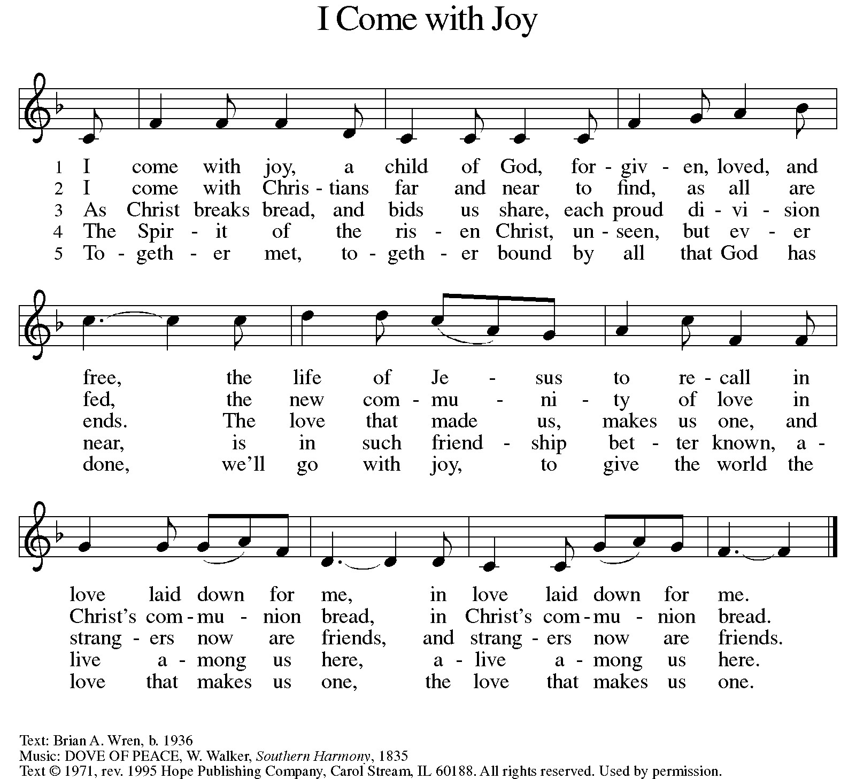

TABLE BLESSING

POST COMMUNION PRAYER

Holy One,
through this meal you have made your home among us
and are making all things new.
Send us now to speak peace to anxious hearts,
to love our enemies,
and to bring your healing to the nations.
In the name of Jesus,
Amen.

SENDING
God blesses us and sends us in mission to the world.
BLESSING

God Almighty, who is the beginning and the end,
Jesus Christ, the firstborn of the dead,
and the Spirit, our advocate and peace,
☩ bless you now and forever.
Amen.

SENDING HYMN ELW 380
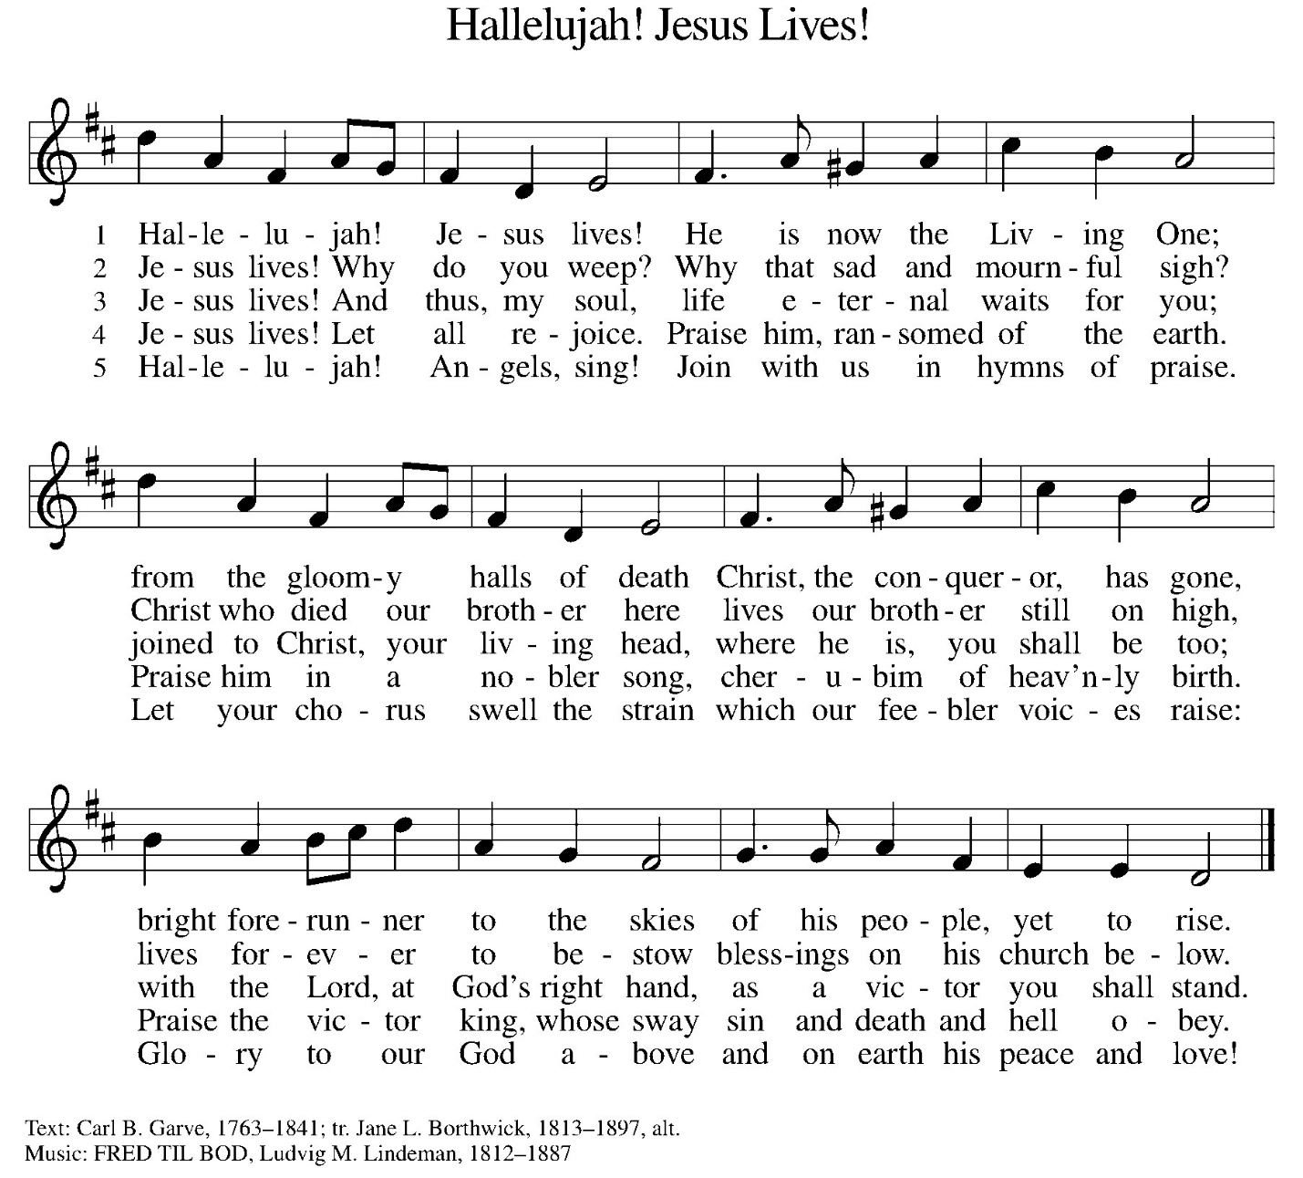

MISSION STATEMENT

Guided by the Gospel, we:
Welcome all to worship;
Make disciples;
Hunger for ministry;
Nurture youth;
Gather resources for growing ministries;
Offer healing and care to all in need.

DISMISSAL

Go in peace. Praise the Lord. Alleluia!
Thanks be to God. Alleluia!

OFFERING
(Please place gifts in the plates as you leave)

POSTLUDE

