Evangelical United Methodist
Chicken BBQ
includes 1/2 chicken, baked potato, applesauce, roll, butter
(Desserts are available for a donation.)
April 18, 2026
*Ticket holders pick up from 11AM – 1PM
*Walk-ins pick up from 11AM – 1:30PM -or- until sold out.
$14 - Tickets will be on sale March 10 - April 11.
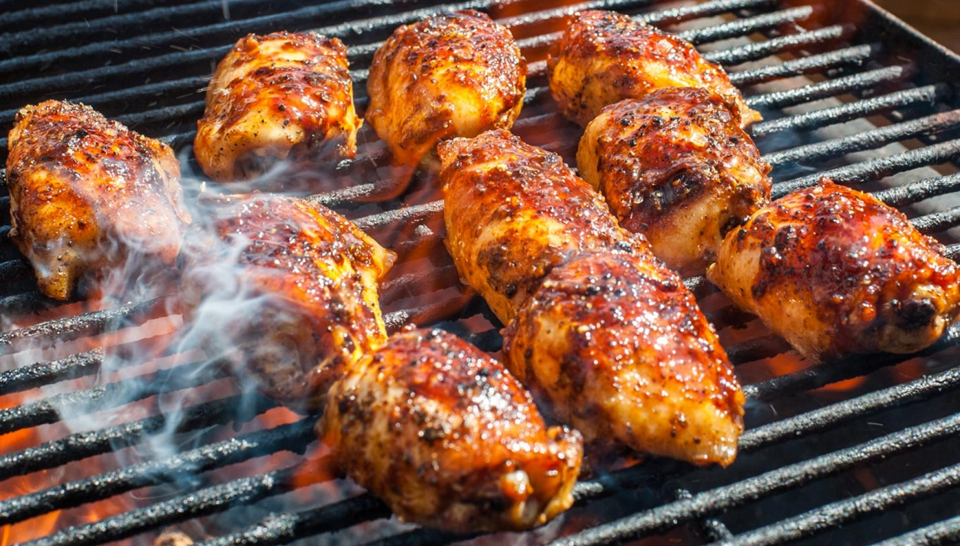Call 717-944-6181 or stop in the EUMC office 9-12 to purchase a ticket!

EUMC 157 E. Water St., Middletown
717-944-6181

Evangelical United Methodist
Chicken BBQ
includes 1/2 chicken, baked potato, applesauce, roll, butter
(Desserts are available for a donation.)
April 18, 2026
*Ticket holders pick up from 11AM – 1PM
*Walk-ins pick up from 11AM – 1:30PM -or- until sold out.
$14 - Tickets will be on sale March 10 - April 11.
Call 717-944-6181 or stop in the EUMC office 9-12 to purchase a ticket!

EUMC 157 E. Water St., Middletown
717-944-6181

