City Road United Methodist Church
A Lighthouse Congregation

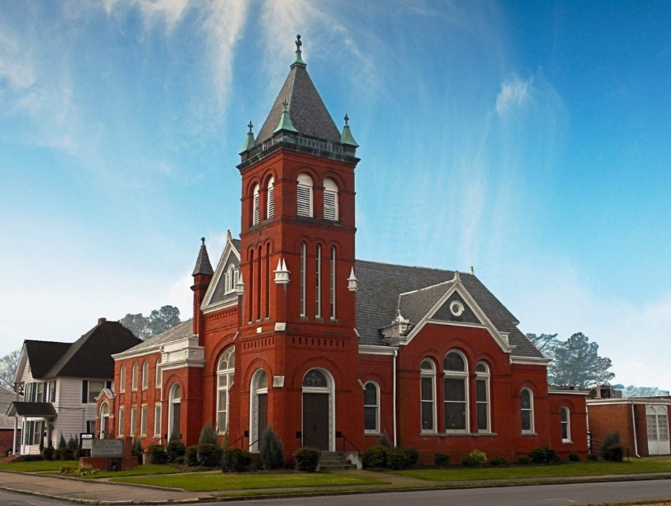
Rev. Josh Tester, Pastor

Office: (252) 335-2658
cityroadec.net crumcec@gmail.com

Facebook: https://www.facebook.com/CityRoadUMC

Sunday School: 10:00 a.m.
Sanctuary Worship: 11:00 a.m.

Tommy Venters- Organist/Choir Director
Dawn Baker- Secretary/Technology Specialist
JoAnn Herring- We Care

Service of Word & Table
Season of Easter

April 12th, 2026 11:00 am
Gathering
Prelude
Introit “He is Lord” UMH 177
Words of Welcome Pastor Josh
*Call to Worship
Creator God, you instill in us the need and desire for belonging and community.
Open our eyes and ears to each other, O Creator -
Redeemer God, you have shown us how to practice agape love, to accept and include everyone, especially those we have marginalized.
Open our eyes and ears to each other, O Redeemer -
Sustainer God, you surround us as we go about the hard work of living and working to ensure that everyone flourishes, everywhere, right now.
Open our hearts to you, O Sustainer -
Creator, Redeemer, Sustainer God, open us to generate, manifest and protect your Beloved Community, where we affirm our differences and offer hospitality that stretches our image of ourselves.

*Prayer of Approach
Lord, we come from different neighborhoods, different backgrounds, different interests, and different ideas. Through your Holy Spirit, make us one today. Transcend our divisions and show us how to live together in unity. Pour out your Holy Spirit upon us and give us the power to love in ways we never thought possible. Amen.

*Sharing Peace
As a people forgiven and freed, we reach out to lift others up, offering the peace of Christ. Peace be with you!
And also with you!
You are invited to share the Peace with those around you [remembering to send your peace through the camera to those worshiping remotely*

Hymn of Praise “Love Divine All Love Excelling” UMH 384

Proclamation & Response
Call to Prayer
Prayers of the People
The Lord’s Prayer
Our Father who art in heaven, hallowed be thy name. Thy kingdom come; thy will be done on earth as it is in heaven. Give us this day our daily bread, and forgive us our trespasses, as we forgive those who trespass against us; and lead us not into temptation but deliver us from evil. For thine is the kingdom, and power, and glory forever. Amen

Children’s Time
Call to the Offering
Offertory
*Doxology UMH 94
*Prayer of Dedication

Hymn of Preparation “O Master, Let Me Walk with Thee” UMH 430

Anthem Chancel Choir

Gospel Lesson John 20:19-23
New Testament Lesson Acts 2:37-42
Message “The Vision of Beloved Community” Pastor Josh

Sending Fourth
*Sending Hymn “Easter People Raise Your Voices” UMH 304
*Benediction

