City Road United Methodist Church
A Lighthouse Congregation

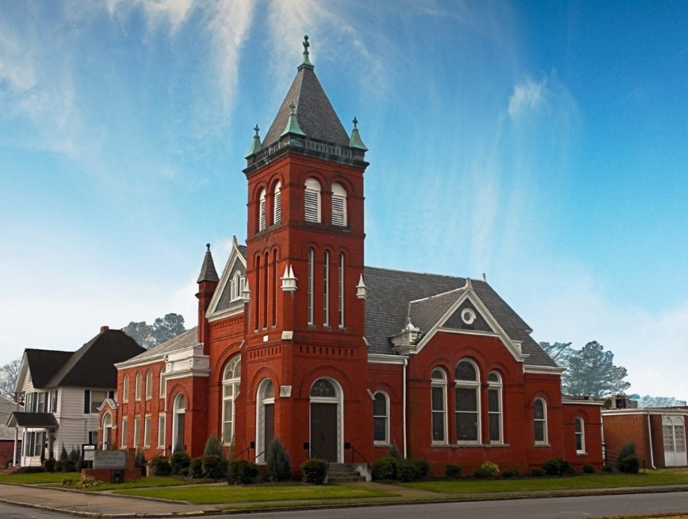
Rev. Josh Tester, Pastor

Office: (252) 335-2658
cityroadec.net crumcec@gmail.com

Facebook: https://www.facebook.com/CityRoadUMC

Sunday School: 10:00 a.m.
Sanctuary Worship: 11:00 a.m.

Tommy Venters- Organist/Choir Director
Dawn Baker- Secretary/Technology Specialist
JoAnn Herring- We Care

Service of Word & Table
Easter Sunday

April 5th, 2026 11:00 am
Gathering
Prelude
Introit “Majesty, Worship His Majesty” UMH 176
Words of Welcome Pastor Josh
*Call to Worship
Christ is Risen
Christ is Risen Indeed X3

*Prayer of Approach
Resurrected Christ, you bring hope for all creation! The good news of resurrection is so irresistible that all the earth sings. We offer our praise and alleluias for the world-changing hope of new creation through Jesus! Alleluia! Amen!

*Sharing Peace
As a people forgiven and freed, we reach out to lift others up, offering the peace of Christ. Peace be with you!
And also with you!
You are invited to share the Peace with those around you [remembering to send your peace through the camera to those worshiping remotely*

Hymn of Praise “Christ the Lord is Risen Today” UMH 302
Verses 1,2,4

Proclamation & Response

Call to Prayer
Prayers of the People

Children’s Time
Call to the Offering
Offertory
*Doxology UMH 94
*Prayer of Dedication

Who’s Who at Easter Introduction
*Hymn of Preparation “Blessed Assurance” UMH 369
Verse 1
Who’s Who at Easter
“Lift up the Cross” Chancel Choir
Jesus Anointed at Bethany
Mary, friend of Jesus
Jesus says he will be betrayed
Judas
“The Power of the Cross” Chancel Choir

Jesus put on trial
Simon Peter
Jesus is led to Calvary
Roman Centurian
“It Took the Cross” Chancel Choir
Jesus cares for his mother
Mary, mother of Jesus
The women at the Cross
Salome
“Goodness of God” Chancel Choir
Early Sunday Morning
A Modern Disciple
“Christ Is Risen”

Holy Communion
*Invitation
*Prayer of Confession 12
*Psalter of Assurance excerpts from Psalm 22

In the name of Christ, you are forgiven.
In the name of Christ, you are forgiven.
Glory to God, Amen!
Prayer of Great Thanksgiving 9
The Lord’s Prayer 10
Receiving the Bread and Cup
Prayer after Communion 11
Eternal God,
we give you thanks for this holy mystery in which you have given yourself to us.
Grant that we may go into the world in the strength of your Spirit,
to give ourselves for others, in the name of Jesus Christ our Lord. Amen.

Sending Fourth

*Sending Hymn “Take My Life, and Let It Be” UMH 399
*Benediction
When someone asks you, “What are you up to?”
you can respond,
“With God’s help, I’m up to something good!”
Let the people say, Amen!
Amen!

