

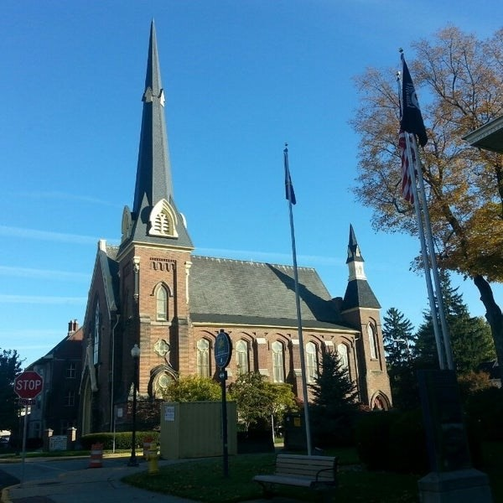
April 8, 2026

A Global Methodist Church
214 S. 5th Street
Goshen, IN 46528
Phone: 574-533-9518
Web Site: goshenfirstgmc.org

Office Hours: Monday-Friday,
8:00 a.m.-12:00 noon
Worship: 9:00 a.m.
Sunday School: 10:30 a.m.
Pastor Jeff & Lisa
Associate Pastor Rich Hull
OUR VISION: “Growing in Faith, Gathering in Community, and Giving in Love”.


The Primetimers will have an outing on Wednesday, April 15. We will have lunch at the Sports Time Family Pub & Grill in Elkhart at 11:15 a.m. After lunch, we will tour the Midwest Museum of American Art in Elkhart at 1:00 p.m. There is a $10 charge for the tour.
Everyone is welcome!

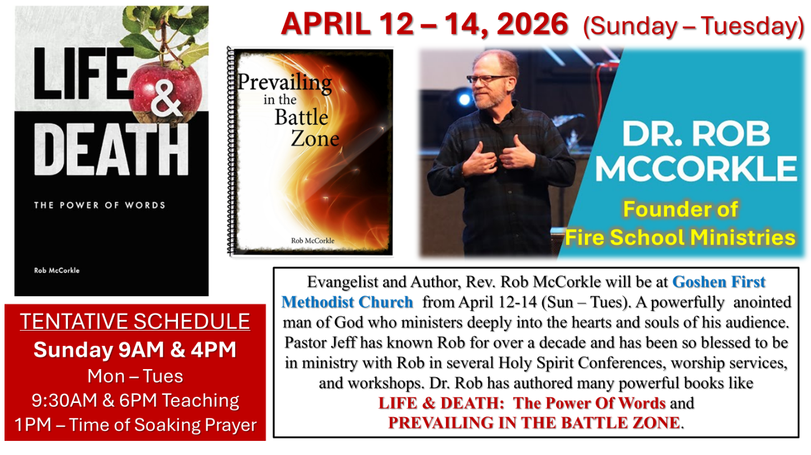

VOLUNTEERS – Thank you for your service! Sunday morning, April 12
Greeters: Steve & Lori Warner VIP: Loraine Troyer
Elevator Hosts: Donna Solyom, Janet Taylor
Ushers: Gary Miller, Patty Krebs, Jeff Showalter, Ron Troyer, Hudson Martin
Scripture Reader: Jeff Griffin
Elementary Junior Church: Kelley Leeper, Patty Krebs
No Junior High Church
Coffee Hour: Steve & Lori Warner, Ron & Loraine Troyer
Bus Driver: Randy Cripe

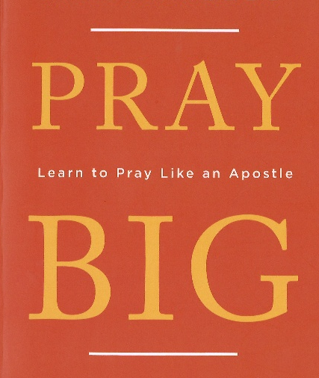
PRAY BIG!
Beginning on April 20, our Monday morning Bible study will begin a four-week study of the Apostle Paul’s prayers. All are welcome! Come and join us at 9:30 a.m., at the church!

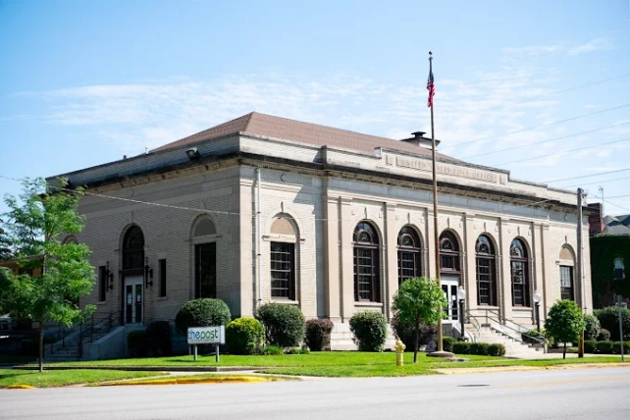
Our Mission of the Month for April -
“The Post.”
The Post is a Christ-centered non-profit youth center located in the historic old post office at 301 E. Lincoln Avenue in Goshen. The Post is open to 6th – 12th graders, Monday through Friday, from after school until 9pm. They provide a safe, positive space for teens to gather. The Post has programs with a curriculum designed to point teens toward finding their identity in Christ, as well as equip them with skills that they can use in everyday life. Programs include: I Am Second/Bible Study, Smart Goals, Life Skills, and Friday open gym and outings. Our church has supported The Post for the past five years through our April mission giving and by providing a meal on the 2nd Thursday of each month. For further information regarding The Post, check out www.the-post.org or contact Linda Russell, JDLR801@gmail.com or 574-238-2084. Thanks for supporting The Post!

THE GRAVE ROBBER OF EASTER
Jesus is into emptying graves. When Jesus begins emptying graves all will know: you will know, your friends will know, your loved ones will know without a doubt, that Jesus is exactly who He claimed to be - The Grave Robber. Let’s look at the Word - Luke 24:1-6, “But very early on Sunday morning the women came to the tomb… They found that the stone covering the entrance had been rolled aside. So they went in. Suddenly, two men appeared to them, clothed in dazzling robes. The women were terrified and bowed low before them. Then the angels asked, Why are you looking in a tomb for someone who is alive? He isn’t here! Jesus has risen from the dead!”. Isn’t it fantastic that the Grave Robber robbed His own Grave! That’s what Resurrection Sunday is all about: death being defeated. Now I wish I could say that I have celebrated every Resurrection Sunday with great love, respect, and holiness to God, but I can’t. I wish I could tell you how I looked forward to going to all the Resurrection services throughout my life, but I can’t. I wish had mountain top experiences with God every Easter, but I don’t. But Resurrection Sunday isn’t about wishing. It’s about embracing the historical fact that outside the city walls of the old city of Jerusalem, there was a tomb. Within that tomb was a dead and decaying Man. That decaying Man had a name – Jesus. And although He had been convicted for claiming to be the Son of God (from the very nature and substance of God), they killed Him and put Him in a tomb and set guards around it. And guess what? The Grave still got robbed anyway! My friends, early that resurrection morning the wish of all wishes - the hope of all hopes – the yearnings and cravings of all eternity - got up and left that tomb. For Jesus is ALIVE! May you embrace the power of Christ’s resurrection and find yourself in the presence of Holy Eternity. God Is Good! ATT!

Pastor Jeff & Lisa

CHURCH CALENDAR – APRIL

MONDAYS
9:30 a.m. – Bible Study – for men and women
10:45 a.m. – Exercise (PIYO)
6:00 p.m. – Handbells

TUESDAYS
9:00-9:45 a.m. – Exercise class (Shred 60)
6:00 p.m. – Prayer at church (first and third Tuesdays)
5:30-6:00 p.m. – Exercise class (High Intensity Interval Training)

WEDNESDAYS
10:00 a.m. – Painting class
3:00 p.m. – Church Council (April 8)
5:30 p.m. – Meal
6:00 p.m. – Classes
7:00 p.m. – Choir practice

THURSDAYS
9:00-9:45 a.m. – Exercise class (Shred 60)
12:00-1:00 p.m. – Men’s Brown Bag Lunch (every week)
11:15 a.m – Primetimers (April 15)
5:30-6:00 p.m. – Exercise class (High Intensity Interval Training)

SATURDAYS
5:30-10:00 p.m. – Contra Dance (April 4)

SUNDAYS
9:00 a.m. – Worship
10:30 a.m. – Sunday School
4:00 p.m. – “The Edge”

