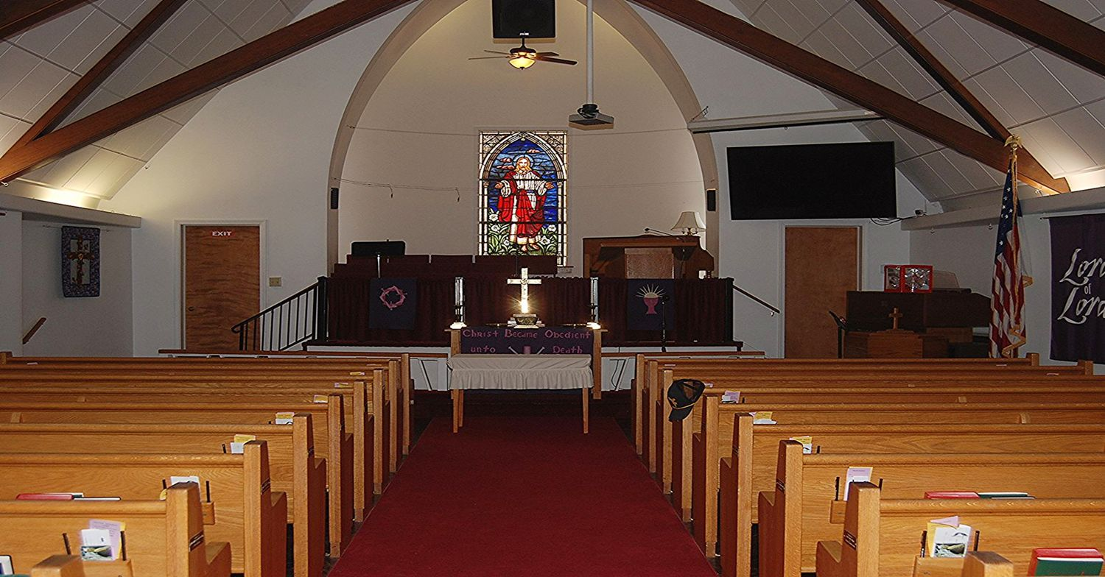  Sanctuary  Facilities  - Restrooms located 1st and 2nd floors in the main hallway by the stairs  - Nursery located 1st floor down the main hallway next to conference room. Nursery staff and all children’s ministry workers have completed a background check and comply with our Safe Sanctuary policy.  - Conference room (aka Blue Room) located 1st floor down the main hallway farthest from the sanctuary (handicap entrance)  - Pastor’s office located 1st floor mid-way down the main hallway  - Administration office located 1st floor near the stairs  - Classrooms located 2nd floor  - Fellowship Hall located in the basement downstairs from the sanctuary | Ways to Worship  It is easy to join us at 10 am for our weekly service. If you’re traveling, not feeling well enough to join in person, or gathering with family in a favorite location we offer online options, too!  Our Sunday services are in-person and live streamed on Facebook. The services are recorded; audio and video on Facebook, Audio only on our website.  Seasonal Services that fall during the week are live streamed on Facebook.  https://www.facebook.com/morrisvilleumc  https://morrisvilleumc.org/  https://morrisvilleumc.org/listen-to-sermons/  Contact Us  Phone: 540-439-2594  Email: morrisvilleumc@verizon.net  Web: morrisvilleumc.org
  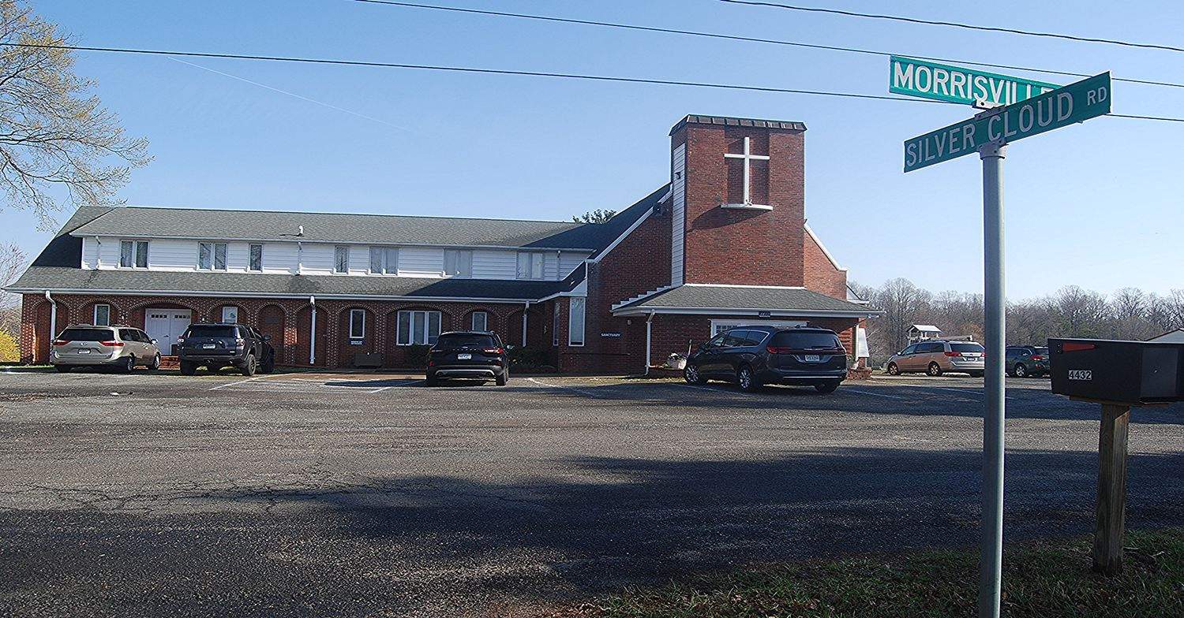
  Morrisville United Methodist Church
    - 
    - Open Hearts - Open Minds - Open doors
  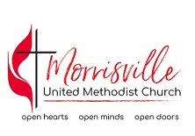 | Morrisville United Methodist Church  4432 Morrisville Rd. Bealeton, VA 22712
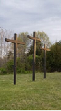  3 Crosses  Ways to get involved  Various Ministries & Groups  - Greeters, Acolytes and Ushers  - Hospitality Ministry  - Bible Study Groups  - Prayer Ministry  - Adult & Children’s Choir  - Mary Walter Meal Program  - Fauquier Food Pantry  - Sunday School  - Men’s Group  - Women’s Group  - Gardening Ministry  - Firewood Ministry  - Media Team |  | 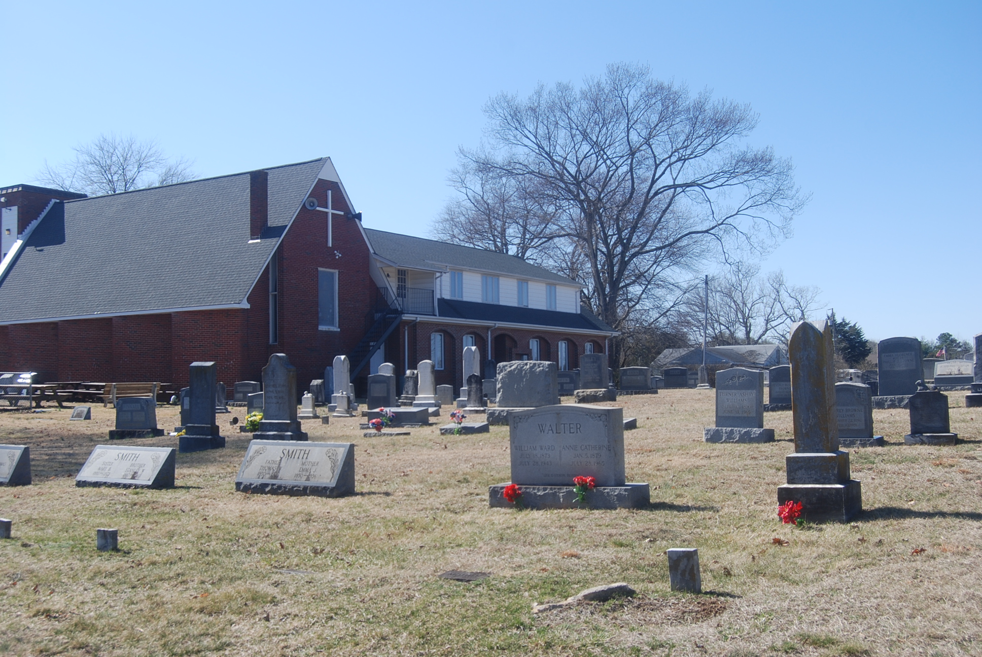  Cemetery  We have 30 veterans laid to rest in the cemetery, including Civil War, WWI, WWII, and Korean War. We honor them on Memorial Day and Veterans Day with graveside American flags place by the local American Legion. In December, we participate in Wreaths Across America to honor the service and sacrifice of all who served.  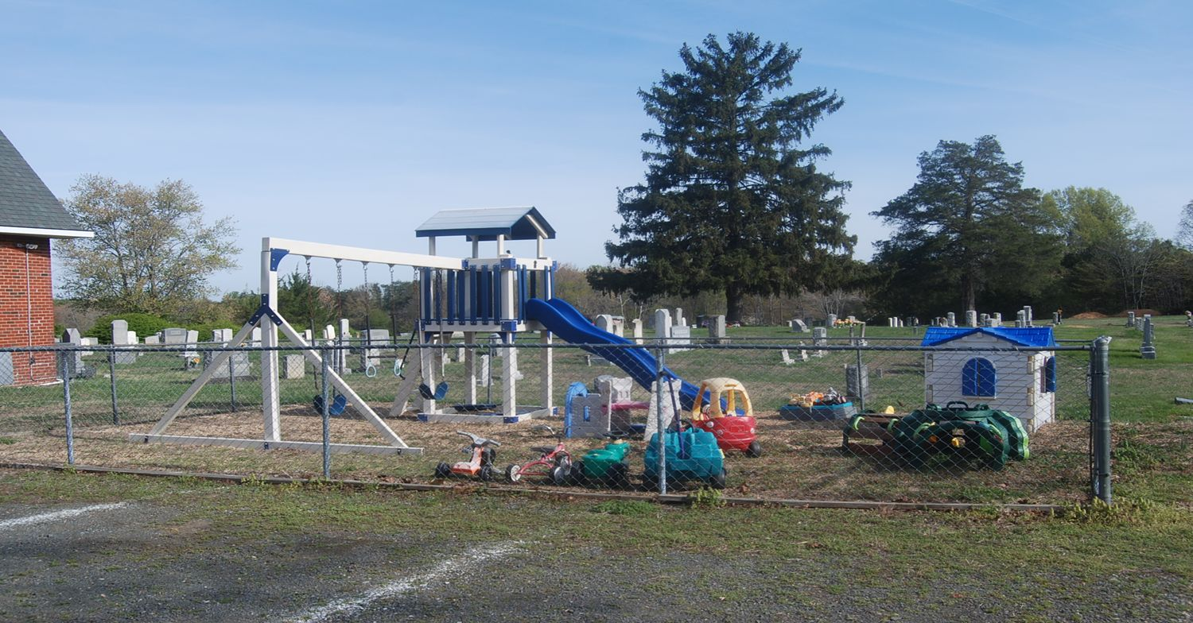  Playground  Always big fun for our energetic kids! Fenced and protected the kids can enjoy the slide, swings, and toys.
  Who We Are
  About Us
  Welcome to Morrisville United Methodist Church! We are pleased you can join us in worship.
  Our church has been active in the community since before the Civil War.
  Our current monthly opportunities include Communion Services (1st Sunday of the month), Men’s group preparing and serving breakfast (3rd Sunday of the month), Youth Group (3rd Sunday of the month), Women’s Group (monthly - date varies).
  Weekly opportunities are for adult choir, youth choir, children’s church, and weekday and Sunday small groups and Bible studies.
  Community Connections include Mary Walter Elementary School Meal Program, Fauquier Food Pantry, Firewood Ministry, Prayer Ministry, Benevolence Ministry, Relay for Life, Youth Group events, and Wreaths Across America.

