THE ANGLICAN PARISH OF ST. MARK
“Drawing People to the Light”
Part of the Diocese of British Columbia
www.stmarkqualicum.ca https://bc.anglican.ca

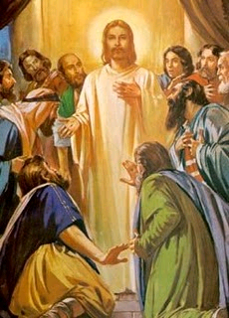

2ND Sunday after EASTER
APRIL 12, 2026
10:00 am Holy Communion

Celebrant: The Reverend Deborah Rivet
Verger: Paul
Sub Deacon: Michael Liturgical Assistant: Wendy
Before the service, please observe silence so that we can be in quiet prayer.

Call to Worship To those who sit in darkness, light has dawned.
To those who dwell in gloom and despair,
God’s glorious presence has appeared.
God is indeed our light and our salvation.
We will follow, unafraid, where God and Jesus lead us.
Let us worship our God of light and promise.
Let us celebrate the hope and joy of our salvation.

The Gathering of the Community

Processional Hymn: “Alleluia No.1” CP 405

The Greeting

Celebrant Welcome to you
For we are Christ’s body
We are Christ’s work in the world
Welcome to you whose baptism makes you
Salt of the earth and light to the world.
Welcome to all who have joined us this morning
Who are seekers, seekers after the Truth.
For Jesus Christ is Truth and light.
Rejoice and be glad
Praise our Creator who gives us forgiveness and hope.
New Zealand Prayer Book
People: Christ be our light
The joy of our salvation. Amen.

Celebrant Almighty God,
People to you all hearts are open, all desires known, and from you no secrets are hidden. Cleanse the thoughts of our hearts by the inspiration of your Holy Spirit, that we may perfectly love you, and worthily magnify your holy name; through Christ our Lord. Amen.

The Gloria: Hymn: “Glory to God on High” CP 365

The Collect of the Day

Almighty and Eternal God,
the strength of those who believe
and the hope of those who doubt,
may we, who have not seen, have faith
and receive the fullness of Christ’s blessing,
who lives and reigns with you and the Holy Spirit,
one God, now and forever.
Amen.

The Proclamation of the Word

First Reading: Acts 2:14a, 22-32
Introduction to the reading: In today’s reading from Acts, we hear Peter’s powerful message to the crowd gathered in Jerusalem. Just weeks after denying Jesus, Peter now stands filled with the Holy Spirit, proclaiming the Good News with clarity and conviction. He reminds the people of Jesus’ life, death, and resurrection—not as random events, but as part of God’s divine purpose. Peter’s words call us to respond with faith and awe, recognizing that the risen Christ is not only alive, but active in our lives today.
A reading from Acts.

Hear what the Spirit is saying to the Church.
Thanks be to God.

Psalm 16 (read responsively by the full verse)

Protect me, O God, for in you I take refuge.
I say to the Lord, ‘You are my Lord;
I have no good apart from you.’

As for the holy ones in the land, they are the noble,
in whom is all my delight.

Those who choose another god multiply their sorrows;
their drink-offerings of blood I will not pour out
or take their names upon my lips.

The Lord is my chosen portion and my cup;
you hold my lot.
The boundary lines have fallen for me in pleasant places;
I have a goodly heritage.

I bless the Lord who gives me counsel;
in the night also my heart instructs me.
I keep the Lord always before me;
because he is at my right hand, I shall not be moved.

Therefore, my heart is glad, and my soul rejoices;
my body also rests secure.
For you do not give me up to Sheol,
or let your faithful one see the Pit.

You show me the path of life.
In your presence there is fullness of joy;
in your right hand are pleasures for evermore.

Psalm Prayer: Gracious God, we bless your holy name for the heritage you have given us. Show us the path of life, that we may follow it in hope, and come to know the joy of the resurrection of your Son, Jesus Christ.
Amen

Second Reading 1 Peter 1:3-9

Readers Introduction: In this passage, Peter offers a powerful reminder of the living hope we have through the resurrection of Jesus Christ. Writing to believers facing trials, he encourages them to rejoice—even in suffering—because their faith, tested and refined like gold, leads to salvation. Though they have not seen Christ, they love and trust Him, and this trust brings a joy that is inexpressible and filled with glory. This reading invites us to reflect on the strength and beauty of faith that endures.

A reading from 1st Peter
Hear what the Spirit is saying to the Church.
Thanks be to God.

Hymn: “We Walk by Faith, and not by Sight” CP 244, v 1-3

Gospel Reading: John 20.19-31
Readers Introduction: In today’s Gospel, the risen Jesus appears to His disciples as they hide behind locked doors, offering them peace, reassurance, and the gift of the Holy Spirit. We also hear the story of Thomas, whose honest doubts lead to a profound confession of faith when he encounters the risen Lord. This passage invites us to recognize how Christ meets us in our fears, strengthens our faith, and blesses all who believe without seeing.

A reading from John:

When it was evening on that day, the first day of the week, and the doors of the house where the disciples had met were locked for fear of the Jews, Jesus came and stood among them and said, ‘Peace be with you.’ After he said this, he showed them his hands and his side. Then the disciples rejoiced when they saw the Lord. Jesus said to them again, ‘Peace be with you. As the Father has sent me, so I send you.’ When he had said this, he breathed on them and said to them, ‘Receive the Holy Spirit. If you forgive the sins of any, they are forgiven them; if you retain the sins of any, they are retained.’
But Thomas (who was called the Twin), one of the twelve, was not with them when Jesus came. So the other disciples told him, ‘We have seen the Lord.’ But he said to them, ‘Unless I see the mark of the nails in his hands, and put my finger in the mark of the nails and my hand in his side, I will not believe.’
A week later his disciples were again in the house, and Thomas was with them. Although the doors were shut, Jesus came and stood among them and said, ‘Peace be with you.’ Then he said to Thomas, ‘Put your finger here and see my hands. Reach out your hand and put it in my side. Do not doubt but believe.’ Thomas answered him, ‘My Lord and my God!’ Jesus said to him, ‘Have you believed because you have seen me? Blessed are those who have not seen and yet have come to believe.’
Now Jesus did many other signs in the presence of his disciples, which are not written in this book. But these are written so that you may come to believe that Jesus is the Messiah, the Son of God, and that through believing you may have life in his name.
The Lord be with you
And also with you
The Holy Gospel of our Lord Jesus Christ according to John

The Gospel of Christ.
Praise to you, Lord Jesus Christ

Hymn: “We Walk by Faith, and not by Sight” CP 244, v 4

Homily Rev. Deborah
Period of silent reflection

Choir Anthem We Have Seen the Risen Lord (Stan Pethel)

The Affirmation
You, O God, are supreme and holy. You create our world and give us life. Your purpose overarches everything we do. You have always been with us. You are God.
You, O God, are infinitely generous, good beyond all measure. You came to us before we came to you. You have revealed and proved your love for us in Jesus Christ, who lived and died and rose again. You are with us now. You are God.
You, O God, are Holy Spirit. You empower us to be your gospel in the world. You reconcile and heal; you overcome death.
You are our God. We worship you.
New Zealand Prayer Book
The Prayers of the People

Commissioning of the Verger: Paul Gillan

Confession and Absolution

Celebrant Dear friends in Christ, God is steadfast in love and infinite in mercy; God welcomes sinners and invites us to this table. Let us confess our sins, confident in God’s forgiveness.
Silence is kept

Celebrant: Most merciful God,
We confess that we have sinned against you in thought, word, and deed, by what we have done, and by what we have left undone. We have not loved you with our whole heart; we have not loved our neighbours as ourselves. We are truly sorry and we humbly repent. For the sake of your Son Jesus Christ, have mercy on us and forgive us, that we may delight in your will, and walk in your ways, to the glory of your name. Amen.

Almighty God have mercy upon you, pardon and deliver you from all your sins, confirm and strengthen you in all goodness, and keep you in eternal life; through Jesus Christ our Lord. Amen.

Celebrant: The risen Christ came and stood among his disciples and said, “Peace be with you.”
Then were they glad when they saw the Lord.
My friends in Christ, on this joyful Easter Season, we greet one another not with the peace the world gives, but with the peace that flows from the empty tomb—the peace of the One who has conquered death and opened to us the gate of life.
May the peace of the risen Lord fill your hearts, strengthen your faith, and renew your hope.
The peace of the Lord be always with you.

People And also with you.

Offertory Hymn: “I Am the Light of the World” SGP 24
Refrain:
I am the Light of the World
You people come and follow me.
If you follow and love, You'll learn the mystery
Of what you were meant to do and be.
1. When the song of the angels is stilled.
When the star in the sky is gone.
When the kings and the shepherds have found their way home.
The work of Christmas is begun!
Refrain
2. To find the lost and lonely one,
To heal that broken soul with love,
To feed the hungry children with warmth and good food,
To feel the earth below the sky above!
Refrain
3. To free the prisoner from his chains,
To make the powerful care,
To rebuild the nations with strength and goodwill,
To call a man your brother everywhere.
Refrain
4. To bring hope to every task you do,
To dance at a baby's new birth,
To make music in an old man's heart,
And sing to the colors of the earth!

The Holy Eucharist
Prayer over the Gifts
God of grace,
you have freed us from our sins
and made us a kingdom in your Son
Jesus Christ our Lord.
Accept all we offer you this day,
and strengthen us in the new life you have given us
through Jesus Christ our Lord.

Celebrant: Let us give thanks to God, our Creator.
People: It is right to give our thanks and praise.
Celebrant: It is indeed right that we offer you thanks and praise,
for in this joyful Easter Season you have raised Jesus Christ from the dead and opened to us the way of everlasting life.
In him, light has triumphed over darkness, love has conquered fear,
and the grave has lost its power.
And so, with all who have been touched by resurrection hope—
with angels, archangels, and the whole company of heaven—
we join in the unending hymn of your glory:
All: Holy, holy, holy Lord, God of power and might,
heaven and earth are full, of your glory.
Hosanna in the highest. Hosanna in the highest.
Blessed is he who comes in the name of the Lord.
Hosanna in the highest. Hosanna in the highest.

Celebrant: Source of all life,
you created the world in goodness and entrusted it to our care.
Even when we turned from you,
your mercy remained steadfast.
In the fullness of time
you sent Jesus, your Son,
to live among us as one of us,
teaching, healing, and revealing your compassion.
On the night before he died, Jesus took bread,
when he had given thanks,
he broke it, gave it to his disciples, and said:
Take, eat, this is my body
which is given for you; do this to remember me.
After supper he took the cup;
when he had given thanks,
he gave it to them and said:
Drink this all of you.
This is my blood of the new covenant,
Poured out for you and for many;
do this to remember me.
Therefore father, Father according to his command,
We remember his death,
We proclaim his resurrection,
We await his coming in glory:
Celebrant: Recalling his death and resurrection, and trusting that he will come again in glory, we offer you this bread and this cup, giving thanks that you have made us worthy to stand in your presence and serve you.
Send your Holy Spirit upon us and upon these gifts, that we who share this meal may be strengthened in faith, renewed in hope,
and empowered to live as Easter people—bringing reconciliation, justice, and joy to the world you love.
Through Christ, with Christ, and in Christ, in the unity of the Holy Spirit, all honour and glory are yours, now and forever.
All: Amen.

The Lord’s Prayer – (sung) David Haas

The Breaking of the Bread: BAS 213
Celebrant: Lord, we died with you on the cross.
All: Now we are raised to new life.
Celebrant: We were buried in your tomb.
All: Now we share in your resurrection.
Celebrant: Live in us, that we may live in you.

Invitation to The Communion Table
Come to this table,
you who have much faith and you who would like to have more;
you who have been to this sacrament often
and you who have not been for a long time;
you who have tried to follow Jesus and you who have failed.
Come, it is Christ who invites us to meet him here.

The Gifts of God for the People of God
Thanks be to God.

The Healing Ministry Prayer Team and Eucharistic Team
will proceed to the Altar first for Communion.
If you would prefer Holy Communion brought to you in the pew, please stand and the Eucharistic Ministers will come to you.

Communion at the Altar Rail commences
with the Choir Members followed by the Congregation

Prayer Ministry
Our healing prayer team invites you to join them to pray or give thanks to God in the narthex (entrance) during or after communion, or in the alcove under the Exit sign after the service. Confidentiality is assured.

Post Communion Hymn: “All Shall Be Well” CP 222
Prayer after Communion:
Father,
we have seen with our eyes
and touched with our hands
the bread of life.
Strengthen our faith
that we may grow in love for you and for each other;
through Jesus Christ the risen Lord.

Celebrant Glory to God,
All whose power, working in us, can do infinitely more than we can ask or imagine. Glory to God from generation to generation, in the Church and in Christ Jesus, for ever and ever. Amen.

Recessional Hymn: “Yours Be the Glory” CP 210

Dismissal

Liturgical Assistant: Alleluia! Christ is risen.
People: The Lord is risen indeed. Alleluia.

Liturgical Assistant: May the joy of the resurrection fill your hearts and strengthen you for the days ahead. Go forth in the peace of the risen Christ, rejoicing in the new life he has given.
People Thanks be to God. Alleluia, alleluia.

_ _ _ _ _ _ _ _ _ _ _ _ _ _ _ _ _ _ _ _ _ _ _ _ _ _ _ _ _ _ _ _ _ _ _ _ _ _ _ _ _ _ _ _ _ _

It is a pleasure to have you visit with us today. If you would like to learn more about our church and how we can serve you or become a member of our parish family please fill in your name/phone number and our priest will be happy to contact you.
Name ____________________________ Phone No._________________________

Cell No. _______________________ email________________________________

(Please detach and hand to one of the Greeters or Place on the Offering Table)

Flowers on the altar today are given by Al Gagnon to the Glory of God
in memory of his wife Doris Gagnon
Thank you to those who assisted in the service today.
Celebrant | Rev. Deborah | Greeters: | Maggie & Neil
Crucifer & Assistant: | Wendy | Reader: | Paul
Chalice: | Wendy & Ryan | Musical Director: Guitarist: | Pippa  Richard
Intercessor: | Joe | Altar Guild: | Nancy
Coffee Hour | Lally | Coffee Hour | Kate

Parish Announcements:

* Welcome to our service this morning. Please join us following the service in the parish hall for fellowship and refreshments.

* Susanne Cunningham, spokesperson for the proposed Qualicum Beach medical centre, will be Guest Speaker on Thursday, April 23 in the parish hall as part of the Men’s Club 100th Anniversary Speaker Series. All parishioners are welcome to attend. Coffee and muffins are available at 9:30 a.m. with the presentation from 10 a.m. to 11 a.m. The proposed not-for-profit clinic on Primrose Ave will include four family physicians and access to 12 specialists. It is supported by the Mid-Island Health Alliance and to date $722,000 has been raised by community partners and donors. The clinic is set open next September.

* Discover the Art of Wine and Food Pairing on Sunday, April 26 from 3-5pm as Rev. Deborah leads us to explore the dynamic relationship between food and wine. You’ll taste a curated selection of four wines, sample food bites, and uncover how flavours interact in surprising ways. Learn how the right pairing can transform a meal—and how your personal palate plays a starring role. Through tiny sips and tiny bites, you’ll come to understand your own palate and what you prefer. This event is limited to 40 participants at a cost of $40.00 per person. Proceeds will be applied to updating the kitchen facilities. Tickets are available at coffee today, and at the Church office Tuesday and Wednesday 9:00am to 2:00pm

* Our Spring Plant and Bake Sale takes place Saturday, May 2nd. We are looking for contributions and help in several areas. Sign up sheets are posted in the church hall. Please take this opportunity to help in one (or more) or these tasks:
- Garden stall - divide & pot up perennials, provide floral and vegetable seedlings, take cuttings, donate garden tools & equipment, etc.
- Sign up to do sales at the stall.
Richard de Candole - 250-752-5384

- Holy Roller Pies - contributions of fruit (berries, apples, rhubarb (thinly sliced, ready for the pie shell). Bring to Kate on Sundays.
- particularly needed are helpers for pie assembly on April 24 and for sales on May 2.
Kate Knappett - kate-k@shaw.ca

- Morning Coffee station - donations of scones, muffins and cookies
- set up, serving, and clean up volunteers
Please sign up on the sheets provided.
Terry & Jennifer Roberts - 250-248-3899 or 250-240- 4330

* At the Annual Vestry meeting in February, our Treasurer Wendy Carriere noted that if everyone gave another $2.25 per week in their offering, we could meet the budget for 2026 and eliminate our deficit. Please consider what you can do to make this happen.

* 8:30 BCP Holy Communion Services resume commencing this Sunday.

* As a lay worship leader, and as a member of our Pastoral Care team in charge of services at retirement and care facilities, Cynthia Preyser will be leading worship at the Eagle Park Care facility and other senior’s residences in QB. Upcoming dates will be available soon. She would be very appreciative of some “helpers”. Please consider being available for this ministry and contact Cynthia at 250-954-9122 if you are interested.

St Mark’s Calendar April 13 – April 19

Monday April 13
9:00 - 12:30 MIFAC

Tuesday April 14
9:00 - 5:00 -Clergy Conference
4:00- 5:00 - Handbells (Church)

Wednesday April 15
9:00 – 12:30 - Clergy Conference
10:00 - Sermon Circle (Narthex)
11:30 - Holy Communion
5:30 - NAC

Thursday April 16
9:00 - PKS Quilter Sew Days (overnight)
9:00 – 11:00 - Closing Eucharist for Clergy Conference (Church)
11:15 - Choir Practice
3:30- 52 Ways to Reconcile

Friday April 17
9:00- 3PM PKS Quilter Sew Days

Saturday April 18
9:00 – 4:00 PKS Quilt Workshop

Sunday April 19
8:30 – Morning Prayer - BCP
10:00 – Morning Prayer - BAS


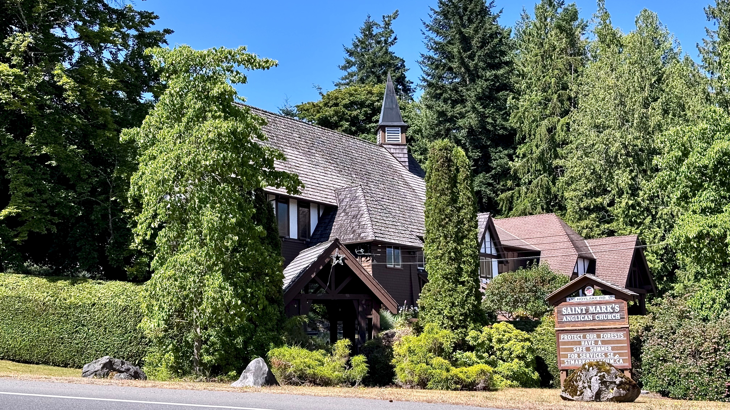

138 Hoylake Rd W
Qualicum Beach, BC V9K 1K3
PARISH OFFICE
+1-250-752-5414
admin@stmarkqualicum.ca
wardens@stmarkqualicum.ca
INTERIM PRIEST
Rev Deborah Rivet
+1-250-709-4017
revdeb@shaw.ca
WEB
https://www.stmarkqualicum.ca

EMERGENCY CONTACTS FOR PASTORAL CARE
Rev Rob Hutchison +1-250-228-8233
+1-250-951-0880
Cynthia Preyser +1-250-954-9122

We draw the circle wide so all will find a home in the House of God
…and a place at the table of the Lord

