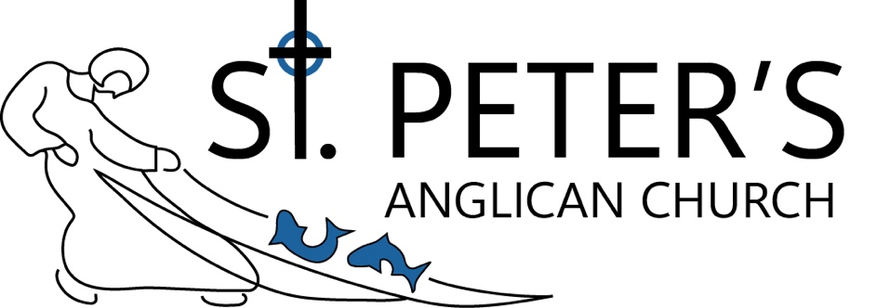
Serving All for the Glory of God
Second Sunday of Easter
April 12, 2026, 10:00 AM
Have you believed, Thomas, because you have seen me?
Blessed are those who have not seen and yet believe. John 20.29

SERVICE OF HOLY EUCHARIST
Liturgy: Book of Alternative Services
Hymns and Sung Responses: Common Praise
The Reverend Bonnie Luft, Incumbent Priest
The Reverend Rob Petkau, Associate Priest
Welcome, friend! We are glad you chose to worship with us today. To learn more about our faith community, please fill out the card in the pew and join us for coffee following the service.
www.stpeterscalgary.org
As the parish of St. Peter’s, we acknowledge that we gather on the traditional territories of the Treaty 7 peoples. We also acknowledge the Métis Nation of Alberta, Region Three.
Interac e-Transfers: donate@stpeterscalgary.ca
THE GATHERING OF THE COMMUNITY
Invitation to Worship Peter L.
Prelude: Reflection (Heather Sorenson), All Creatures of our God and King (arr. Chris Rice)
Processional: 355 “All Creatures of Our God and King” vs. 1-4
Opening Prayers 185ff
Glory to God on High 365
The Collect of the Day 336
THE PROCLAMATION OF THE WORD
First Reading: Acts 2:14, 22-32 Udoka E.
Reader. Alleluia! Christ is Risen! People. The Lord is risen indeed. Alleluia!
Peter, standing with the eleven, raised his voice and addressed the crowd, "You that are Israelites, listen to what I have to say: Jesus of Nazareth, a man attested to you by God with deeds of power, wonders, and signs that God did through him among you, as you yourselves know - this man, handed over to you according to the definite plan and foreknowledge of God, you crucified and killed by the hands of those outside the law. But God raised him up, having freed him from death, because it was impossible for him to be held in its power. For David says concerning him, 'I saw the Lord always before me, for he is at my right hand so that I will not be shaken; therefore my heart was glad, and my tongue rejoiced; moreover my flesh will live in hope. For you will not abandon my soul to Hades, or let your Holy One experience corruption. You have made known to me the ways of life; you will make me full of gladness with your presence.' Fellow Israelites, I may say to you confidently of our ancestor David that he both died and was buried, and his tomb is with us to this day. Since he was a prophet, he knew that God had sworn with an oath to him that he would put one of his descendants on his throne. Foreseeing this, David spoke of the resurrection of the Messiah, saying, 'He was not abandoned to Hades, nor did his flesh experience corruption.' This Jesus God raised up, and of that all of us are witnesses."
Reader. The word of the Lord. People. Thanks be to God. Alleluia!
Psalm 16 719, Led by Udoka E.
Gracious God, we bless your holy name for the heritage you have given us. Show us the path of life, that we may follow it in hope, and come to know the joy of the resurrection of your Son, Jesus Christ. Amen.
Second Reading: 1 Peter 1:3-9 Udoka E.
Blessed be the God and Father of our Lord Jesus Christ! By his great mercy he has given us a new birth into a living hope through the resurrection of Jesus Christ from the dead, and into an inheritance that is imperishable, undefiled, and unfading, kept in heaven for you, who are being protected by the power of God through faith for a salvation ready to be revealed in the last time. In this you rejoice, even if now for a little while you have had to suffer various trials, so that the genuineness of your faith - being more precious than gold that, though perishable, is tested by fire - may be found to result in praise and glory and honour when Jesus Christ is revealed. Although you have not seen him, you love him; and even though you do not see him now, you believe in him and rejoice with an indescribable and glorious joy, for you are receiving the outcome of your faith, the salvation of your souls.
Reader. The word of the Lord. People. Thanks be to God. Alleluia!
Gradual: 219 “The Glory of Our King Was Seen”

THE HOLY GOSPEL: John 20:19-31 The Reverend Bonnie Luft
Gospeller. Alleluia! Christ is Risen! People. The Lord is risen indeed. Alleluia!
Gospeller. The Holy Gospel of Our Lord Jesus Christ according to John.
People. Glory be to thee, O Lord.
When it was evening on that day, the first day of the week, and the doors of the house where the disciples had met were locked for fear of the Jews, Jesus came and stood among them and said, "Peace be with you." After he said this, he showed them his hands and his side. Then the disciples rejoiced when they saw the Lord. Jesus said to them again, "Peace be with you. As the Father has sent me, so I send you." When he had said this, he breathed on them and said to them, "Receive the Holy Spirit. If you forgive the sins of any, they are forgiven them; if you retain the sins of any, they are retained." But Thomas (who was called the Twin), one of the twelve, was not with them when Jesus came. So the other disciples told him, "We have seen the Lord." But he said to them, "Unless I see the mark of the nails in his hands, and put my finger in the mark of the nails and my hand in his side, I will not believe." A week later his disciples were again in the house, and Thomas was with them. Although the doors were shut, Jesus came and stood among them and said, "Peace be with you." Then he said to Thomas, "Put your finger here and see my hands.z Reach out your hand and put it in my side. Do not doubt but believe." Thomas answered him, "My Lord and my God!" Jesus said to him, "Have you believed because you have seen me? Blessed are those who have not seen and yet have come to believe." Now Jesus did many other signs in the presence of his disciples, which are not written in this book. But these are written so that you may come to believe that Jesus is the Messiah, the Son of God, and that through believing you may have life in his name.
Gospeller. This is the Gospel of Christ. People. Praise be to thee, O Christ.
REFLECTIONS The Reverend Bonnie Luft
Silence for quiet meditation may follow.
The Nicene Creed page 188
The Prayers of the People Margaret C.
Confession and Absolution page 191
ANNOUNCEMENTS Peter L.
Sharing the Peace of Christ
THE CELEBRATION OF THE EUCHARIST
Offertory: 244 “We Walk by Faith, and Not by Sight”
The Prayer over the Gifts 337
The Great Thanksgiving, Eucharistic Prayer 1 193
“Holy, Holy, Holy Lord (Sanctus)” sung response 735
The Lord’s Prayer (sung) top of 211
The Breaking of the Bread, Sentence 8 213
“Lamb of God (Agnus Dei)” sung response 690
RECEIVING COMMUNION
All baptized Christians are welcome to receive communion. If you prefer intinction please let the priest know. If you are gluten intolerant, please request a rice wafer from the priest. Those not receiving communion today are encouraged to come forward to receive a blessing, simply cross your arms over your chest.

Communion: 228 “Alleluia! O Sons and Daughters”
Prayer after Communion page 337
CHILDREN’S TEACHING
Doxology bottom of page 214
THE BLESSING
Recessional: 355 “All Creatures of Our God and King” vs. 1, 5-7
DISMISSAL
Deacon Go forth in the name of Christ. People Thanks be to God. Alleluia!
Postlude: O Sons and Daughters, Let Us Sing! (arr. Lani Smith)
“Flowers are given to the Glory of God”
Happy Birthday Linita, May God Almighty Bless You, love Mary & Lincy.
Assisting Today: Director of Music: Patricia Yuen Sparrow; Organist: Colin Redekop (Christ Church); Crucifer: Liam Getty; Administrants: Sade Olutogun, Udoka Ezeaka; Reader: Udoka Ezeaka; Intercessor: Margaret Cull; Sound Tech: Adam Delday; Chancel Guild: Delores James, Sheila Leigh; Sidespersons: Grahame Entwistle, Peter Leigh; Warden on Duty: Peter Leigh
Licensing for Music Rights: OneLicense No. 727664-A


WELCOME
We're so glad you're joining us in our worship today.
Please scan this QR code to complete our online
welcome card, to help us get to know you better.

