TODAY’S WORSHIP TEAM MEMBERS
Pastor Andrew Burd-Harris
Accompanist Andrew Martin
Audio Visual Team Justin Hahn, Steve Moyer, Mike Harris
Children’s Sermon Schlichers
Choir Director Erich Schlicher
Deacon Megan Burd-Harris
Greeter ---
Head Usher Lori Keller
Liturgist Maryann Horner

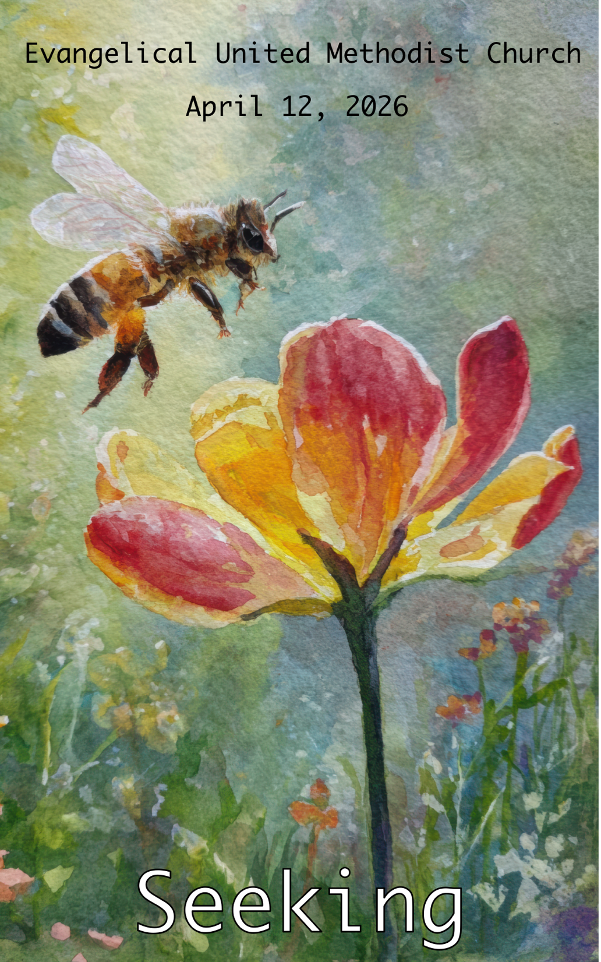

Evangelical United Methodist Church
157 East Water Street, Middletown, Pa. 17057
www.eumch.org; 717.944.6181; office@eumch.org
April 12, 2026
2nd Sunday of Easter
10:15 AM Service
Bold & Italicized print – All in unison l *Please stand if able.
UMH: United Methodist Hymnal l TFWS: The Faith We Sing l W&S: Worship & Song
~Start Live Stream~
Announcements
Worship video
*DIRECTING OUR ATTENTION TOWARD GOD:
*“Christ is Alive” (verse one) UMH 318

Opening Prayer
Loving God, you save all who seek refuge in you. Grant that we who know your salvation may walk always in your light, take courage in your faithfulness, and rejoice in your astounding goodness to us. Through Christ, by the power of the Holy Spirit, we pray. Amen.
(Reprinted by permission of Westminster John Knox Press from Feasting on the Word® Worship Companion. Copyright 2012.)

*Hymn of Praise “Thine Be the Glory” UMH 308
JOYS AND CONCERNS:
We will pass around the microphone. Please remember we are livestreaming the service. Consider not using last names and please do not share concerns that a person would not want widely known. If you would like to add a joy or concern to our “Compassion for the Brethren” list please call our office at 717.944.6181, email the office at office@eumch.org, or fill out a prayer card and drop it in an offering plate.
Pastoral Prayer
Prayer Chorus “Sweet Hour of Prayer” (Verse one) UMH 496
Anthem “Your Love, Oh Lord/I Love You, Lord” Third Day/Marsh

ATTENDING TO GOD’S WORD:
Scripture Lessons Psalm 9:1-10, Matthew 7:7-11
This is God’s Word for everyone. Thanks be to God.

Children’s Sermon
The Lord’s Prayer
*Hymn “I Sought the Lord” UMH 341
Message: “Seeking: Invitation”

RESPONSES TO GOD’S WORD:
Sharing Our Gifts and Offering
Please put your offering in the offering plates located near the entrance(s) before the service starts. You can also give online using the link or QR code below. https://www.eumch.org/give

*Doxology “Praise God, from Whom All Blessings Flow” UMH 95
Affirmation of Faith “The Apostle’s Creed” UMH 881

GOING FORTH TO SHARE THE LIGHT OF CHRIST:
*Hymn “Pass Me Not, O Gentle Savior” UMH 351
Reaffirming God’s Presence
Choral Benediction “He Lives” (verse 3) UMH 310
Postlude
~End Live Stream~

