Holy Trinity Lutheran Church
150 River Road Red Bank, NJ 07701
Church Office: (732) 741-9241
email: holytrinitychurch4@verizon.net
Website: htlcredbank.org
Pastor: Rev. John Mack, Jr.
Cell: (336)-392-5839
Minister of Music: Peter Isherwood
Parish Administrator: Deanna Vergari
Council President: Cynthia Kazmac

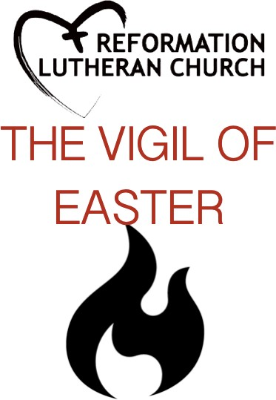

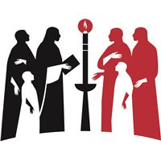
VIGIL OF EASTER: Waiting for Resurrection Saturday, April 04, 2026
GREETING
The presiding minister and the assembly greet each other.
P: The grace of our Lord Jesus Christ, the love of God, and the communion of the Holy Spirit be with you all.
C: And also with you.

The presiding minister may introduce and welcome the assembly to the vigil, using these or similar words.

P: Sisters and brothers in Christ, on this most holy right when our Savior Jesus Christ passed from death to life, we gather with the church throughout the world in vigil and prayer. This is the passover of Jesus Christ. Through light and the word, through water and oil, bread, and wine, we proclaim Christ's death and resurrection, share Christ's triumph over sin and death, and await Christ's coming again in glory.

If it has not been burning, the new fire is lighted. The presiding minister waits until the fires burning before praying.
P: Let us pray! Eternal God, in Jesus Christ you have given the light of life to all the world. Bless this new fire and increase in us a desire to shine forth with the brightness of Christ's rising, until we feast at the banquet of eternal light; through the Sun of righteousness, Jesus Christ our Lord.
C: Amen.

Easter Proclamation

The presiding minister may trace the inscription on the paschal candle, which is held by an assisting minister.

P: Rejoice, now, all heavenly powers!
Sing, choirs of angels!
Exult, all creation around God's throne!
Jesus Christ is risen!
Celebrate the divine mysteries with exultation!
For so great a victory, sound the trumpet of salvation.
Rejoice, O earth, in shining splendor, radiant in the brightness of your king! Christ has conquered! Glory fills you!
Darkness vanishes forever.
Rejoice, O holy church! Exult in glory!
The risen Savior shines upon you!
Let this place resound with joy, echoing the mighty song of all God's people.
P: The Lord be with you!
C: And also with you!
P: Let us give thanks to the Lord our God!
C: It is right, our duty and our joy!

It is indeed right, our duty and our joy, that with full devotion of heart and mind and voice we should praise the invisible God, and the only Son, Jesus Christ our Lord; who, by his precious blood, redeemed us from bondage to the ancient sin. For this indeed is the Paschal Feast in which the true Lamb is slain, by whose blood the doorposts of the faithful are made holy.

This is the night…
in which, in ancient times, you delivered our forebears, the children of Israel, and led them, dry-shod, through the sea.

This is the night…
in which the darkness of sin has been purged away by the rising brightness.

This is the night in which all who believe in Christ are rescued from evil and the gloom of sin, are renewed in grace, and are restored to holiness. This is the night in which, breaking the chains of death, Christ arises from hell in triumph. O night truly blessed which alone was worthy to know the time and hour in which Christ arose again from hell!

This is the night…
of which it is written: "The night is as clear as the day,” and, "then shall my night be turned into day.” The holiness of this night puts to flight the deeds of wickedness; washes away sin; restores innocence to the fallen, and joy to those who mourn; casts out hate; brings peace; and humbles earthly pride.

Therefore, in this night of grace, receive, O God, our praise and thanksgiving for the light of the resurrection of our Lord Jesus Christ, reflected in the burning of this candle.
We sing the glories of this pillar of fire, the brightness of which is not diminished even when its light is divided and borrowed.
For it is fed by the melting wax which the bees, your servants, have made for the substance of this candle.

This is the night…
in which heaven and earth are joined—things human and things divine.

We, therefore, pray to you, O God,
that this candle, burning to the honor of your name, will continue to vanquish the darkness of night and be mingled with the lights of heaven. May Christ the Morning Star find it burning, that Morning Star who never sets, that Morning Star who, rising from the grave, faithfully sheds light on the whole human race.

And we pray, O God, rule, govern, and preserve with your continual protection your whole church, giving us peace in this time of our paschal rejoicing; through the same Lord Jesus Christ, your Son,
who lives and reigns with you and the Holy Spirit, one God, now and forever.
C: Amen.

P: Christ, yesterday and today,
Trace the sign of the cross.
the beginning and the ending.
Trace the Greek letters Alpha and Omega.
To Christ belongs all time
Trace the first numeral at the upper left.
and all the ages;
Trace the second numeral at the upper right.
To Christ belongs glory and dominion
Trace the third numeral at the lower left.
now and forever.
Trace the fourth numeral at the lower right.
C: Amen.

The presiding minister lights the paschal candle, using a stick or taper from the fire, and sings or says:
P: The light of Christ, rising in glory, dispel the darkness of our I hearts and minds.

PROCESSION
The procession begins, led by the assisting minister bearing the paschal candle. During or after the procession, light from the paschal candle may be passed until the people's candles are all lighted.

As the procession begins, the assisting minister sings:
P: The light of Christ!
C: Thanks be to God!
The procession continues, stopping at midpoint. The assisting minister lifts the paschal candle and sings on a higher tone:
P: The light of Christ!
C: Thanks be to God!
The procession continues. The assisting minister takes the paschal candle to its stand, lifts it high, and sings on a still higher tone:
P: The light of Christ!
C: Thanks be to God!

We invite you to read the sacred stories of God’s deliverance throughout time and history.
Liturgy of the Word

First Reading Genesis 1:1—2:4a
The Creation
¹In the beginning when God created the heavens and the earth, ²the earth was a formless void and darkness covered the face of the deep, while a wind from God swept over the face of the waters. ³Then God said, “Let there be light”; and there was light. ⁴And God saw that the light was good; and God separated the light from the darkness. ⁵God called the light Day, and the darkness he called Night. And there was evening and there was morning, the first day.
⁶And God said, “Let there be a dome in the midst of the waters, and let it separate the waters from the waters.” ⁷So God made the dome and separated the waters that were under the dome from the waters that were above the dome. And it was so. ⁸God called the dome Sky. And there was evening and there was morning, the second day.
⁹And God said, “Let the waters under the sky be gathered together into one place, and let the dry land appear.” And it was so. ¹⁰God called the dry land Earth, and the waters that were gathered together he called Seas. And God saw that it was good. ¹¹Then God said, “Let the earth put forth vegetation: plants yielding seed, and fruit trees of every kind on earth that bear fruit with the seed in it.” And it was so. ¹²The earth brought forth vegetation: plants yielding seed of every kind, and trees of every kind bearing fruit with the seed in it. And God saw that it was good. ¹³And there was evening and there was morning, the third day.
¹⁴And God said, “Let there be lights in the dome of the sky to separate the day from the night; and let them be for signs and for seasons and for days and years, ¹⁵and let them be lights in the dome of the sky to give light upon the earth.” And it was so. ¹⁶God made the two great lights—the greater light to rule the day and the lesser light to rule the night—and the stars. ¹⁷God set them in the dome of the sky to give light upon the earth, ¹⁸to rule over the day and over the night, and to separate the light from the darkness. And God saw that it was good. ¹⁹And there was evening and there was morning, the fourth day.
²⁰And God said, “Let the waters bring forth swarms of living creatures, and let birds fly above the earth across the dome of the sky.” ²¹So God created the great sea monsters and every living creature that moves, of every kind, with which the waters swarm, and every winged bird of every kind. And God saw that it was good. ²²God blessed them, saying, “Be fruitful and multiply and fill the waters in the seas, and let birds multiply on the earth.” ²³And there was evening and there was morning, the fifth day.
²⁴And God said, “Let the earth bring forth living creatures of every kind: cattle and creeping things and wild animals of the earth of every kind.” And it was so. ²⁵God made the wild animals of the earth of every kind, and the cattle of every kind, and everything that creeps upon the ground of every kind. And God saw that it was good.
²⁶Then God said, “Let us make humankind in our image, according to our likeness; and let them have dominion over the fish of the sea, and over the birds of the air, and over the cattle, and over all the wild animals of the earth, and over every creeping thing that creeps upon the earth.”
²⁷So God created humankind in his image,
in the image of God he created them;
male and female he created them.
²⁸God blessed them, and God said to them, “Be fruitful and multiply, and fill the earth and subdue it; and have dominion over the fish of the sea and over the birds of the air and over every living thing that moves upon the earth.” ²⁹God said, “See, I have given you every plant yielding seed that is upon the face of all the earth, and every tree with seed in its fruit; you shall have them for food. ³⁰And to every beast of the earth, and to every bird of the air, and to everything that creeps on the earth, everything that has the breath of life, I have given every green plant for food.” And it was so. ³¹God saw everything that he had made, and indeed, it was very good. And there was evening and there was morning, the sixth day.
^{2:1}Thus the heavens and the earth were finished, and all their multitude. ²And on the seventh day God finished the work that he had done, and he rested on the seventh day from all the work that he had done. ³So God blessed the seventh day and hallowed it, because on it God rested from all the work that he had done in creation.
^{4a}These are the generations of the heavens and the earth when they were created.

Response: Psalm 136:1-9, 23-26
God’s mercy endures forever.

¹Give thanks to the Lord, for the | Lord is good,
for God’s mercy en- | dures forever.
²Give thanks to the | God of gods,
for God’s mercy en- | dures forever.
³Give thanks to the | Lord of lords,
for God’s mercy en- | dures forever;
⁴who alone | does great wonders,
for God’s mercy en- | dures forever;
⁵who by wisdom | made the heavens,
for God’s mercy en- | dures forever;
⁶who spread out the earth up- | on the waters,
for God’s mercy en- | dures forever;
⁷who made | the great lights—
for God’s mercy en- | dures forever;
⁸the sun to gov- | ern the day,
for God’s mercy en- | dures forever;
⁹the moon and the stars to gov- | ern the night,
for God’s mercy en- | dures forever;
²³who remembered us in our | low estate,
for God’s mercy en- | dures forever;
²⁴and rescued us | from our enemies,
for God’s mercy en- | dures forever;
²⁵who gives food | to all creatures,
for God’s mercy en- | dures forever.
²⁶Give thanks to the | God of heaven,
for God’s mercy en- | dures forever.
(Silent reflection)

P: Almighty God, you wonderfully created the dignity of human nature and yet more wonderfully restored it. In your mercy, let us share the divine life of the one who came to share our humanity, Jesus Christ, your Son, our Lord, Amen.

Second Reading Exodus 14:10–31; 15:20–21
Deliverance at the Red Sea
¹⁰As Pharaoh drew near, the Israelites looked back, and there were the Egyptians advancing on them. In great fear the Israelites cried out to the Lord. ¹¹They said to Moses, “Was it because there were no graves in Egypt that you have taken us away to die in the wilderness? What have you done to us, bringing us out of Egypt? ¹²Is this not the very thing we told you in Egypt, ‘Let us alone and let us serve the Egyptians’? For it would have been better for us to serve the Egyptians than to die in the wilderness.” ¹³But Moses said to the people, “Do not be afraid, stand firm, and see the deliverance that the Lord will accomplish for you today; for the Egyptians whom you see today you shall never see again. ¹⁴The Lord will fight for you, and you have only to keep still.”
¹⁵Then the Lord said to Moses, “Why do you cry out to me? Tell the Israelites to go forward. ¹⁶But you lift up your staff, and stretch out your hand over the sea and divide it, that the Israelites may go into the sea on dry ground. ¹⁷Then I will harden the hearts of the Egyptians so that they will go in after them; and so I will gain glory for myself over Pharaoh and all his army, his chariots, and his chariot drivers. ¹⁸And the Egyptians shall know that I am the Lord, when I have gained glory for myself over Pharaoh, his chariots, and his chariot drivers.”
¹⁹The angel of God who was going before the Israelite army moved and went behind them; and the pillar of cloud moved from in front of them and took its place behind them. ²⁰It came between the army of Egypt and the army of Israel. And so the cloud was there with the darkness, and it lit up the night; one did not come near the other all night.
²¹Then Moses stretched out his hand over the sea. The Lord drove the sea back by a strong east wind all night, and turned the sea into dry land; and the waters were divided. ²²The Israelites went into the sea on dry ground, the waters forming a wall for them on their right and on their left. ²³The Egyptians pursued, and went into the sea after them, all of Pharaoh’s horses, chariots, and chariot drivers. ²⁴At the morning watch the Lord in the pillar of fire and cloud looked down upon the Egyptian army, and threw the Egyptian army into panic. ²⁵He clogged their chariot wheels so that they turned with difficulty. The Egyptians said, “Let us flee from the Israelites, for the Lord is fighting for them against Egypt.”
²⁶Then the Lord said to Moses, “Stretch out your hand over the sea, so that the water may come back upon the Egyptians, upon their chariots and chariot drivers.” ²⁷So Moses stretched out his hand over the sea, and at dawn the sea returned to its normal depth. As the Egyptians fled before it, the Lord tossed the Egyptians into the sea. ²⁸The waters returned and covered the chariots and the chariot drivers, the entire army of Pharaoh that had followed them into the sea; not one of them remained. ²⁹But the Israelites walked on dry ground through the sea, the waters forming a wall for them on their right and on their left.
³⁰Thus the Lord saved Israel that day from the Egyptians; and Israel saw the Egyptians dead on the seashore. ³¹Israel saw the great work that the Lord did against the Egyptians. So the people feared the Lord and believed in the Lord and in his servant Moses.
^{15:20}Then the prophet Miriam, Aaron’s sister, took a tambourine in her hand; and all the women went out after her with tambourines and with dancing. ²¹And Miriam sang to them:
“Sing to the Lord, for he has triumphed gloriously;
horse and rider he has thrown into the sea.”

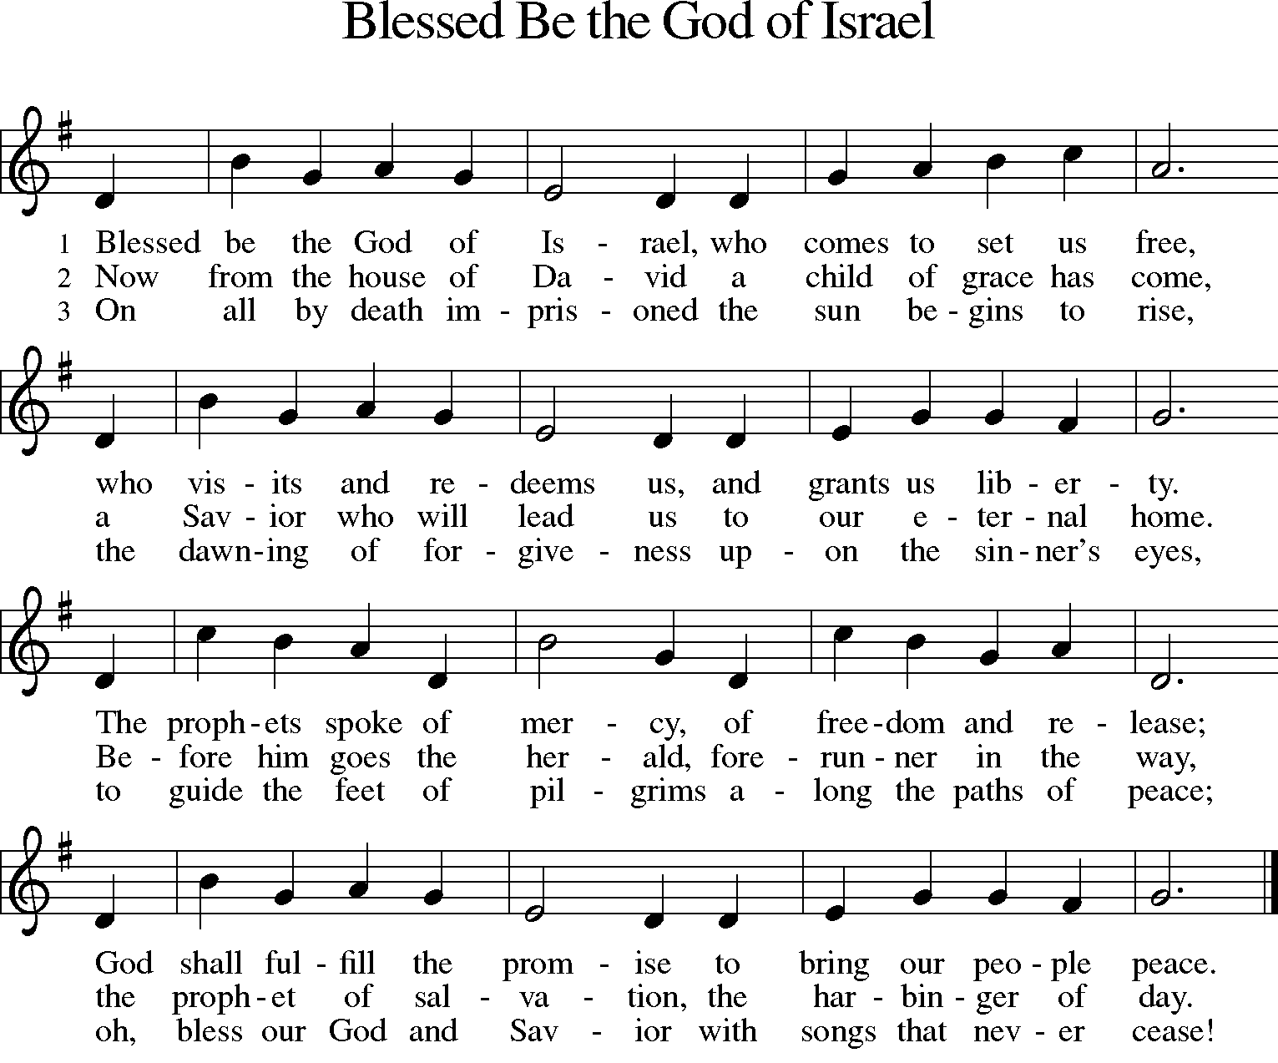
Response Hymn: Blessed Be the God of Israel ELW 552 v.1& 4
(Silent reflection)

P: O God, whose wonderful deeds of old shine forth even to our own day: By the power of your mighty arm you once delivered your chosen people from slavery under Pharaoh, a sign for us of the salvation offered to everyone by the water of baptism. Grant that all the peoples of earth may partake in the salvation of the Israelites and together dance on the safe side of the sea, through Jesus Christ, our Savior and Lord, Amen.

Reading Isaiah 55:1–11
Salvation freely offered to all
¹Ho, everyone who thirsts,
come to the waters;
and you that have no money,
come, buy and eat!
Come, buy wine and milk
without money and without price.
²Why do you spend your money for that which is not bread,
and your labor for that which does not satisfy?
Listen carefully to me, and eat what is good,
and delight yourselves in rich food.
³Incline your ear, and come to me;
listen, so that you may live.
I will make with you an everlasting covenant,
my steadfast, sure love for David.
⁴See, I made him a witness to the peoples,
a leader and commander for the peoples.
⁵See, you shall call nations that you do not know,
and nations that do not know you shall run to you,
because of the Lord your God, the Holy One of Israel,
for he has glorified you.
⁶Seek the Lord while he may be found,
call upon him while he is near;
⁷let the wicked forsake their way,
and the unrighteous their thoughts;
let them return to the Lord, that he may have mercy on them,
and to our God, for he will abundantly pardon.
⁸For my thoughts are not your thoughts,
nor are your ways my ways, says the Lord.
⁹For as the heavens are higher than the earth,
so are my ways higher than your ways
and my thoughts than your thoughts.
¹⁰For as the rain and the snow come down from heaven,
and do not return there until they have watered the earth,
making it bring forth and sprout,
giving seed to the sower and bread to the eater,
¹¹so shall my word be that goes out from my mouth;
it shall not return to me empty,
but it shall accomplish that which I purpose,
and succeed in the thing for which I sent it.

Response Hymn: Children of the Heavenly Father ELW 781 v.1&4
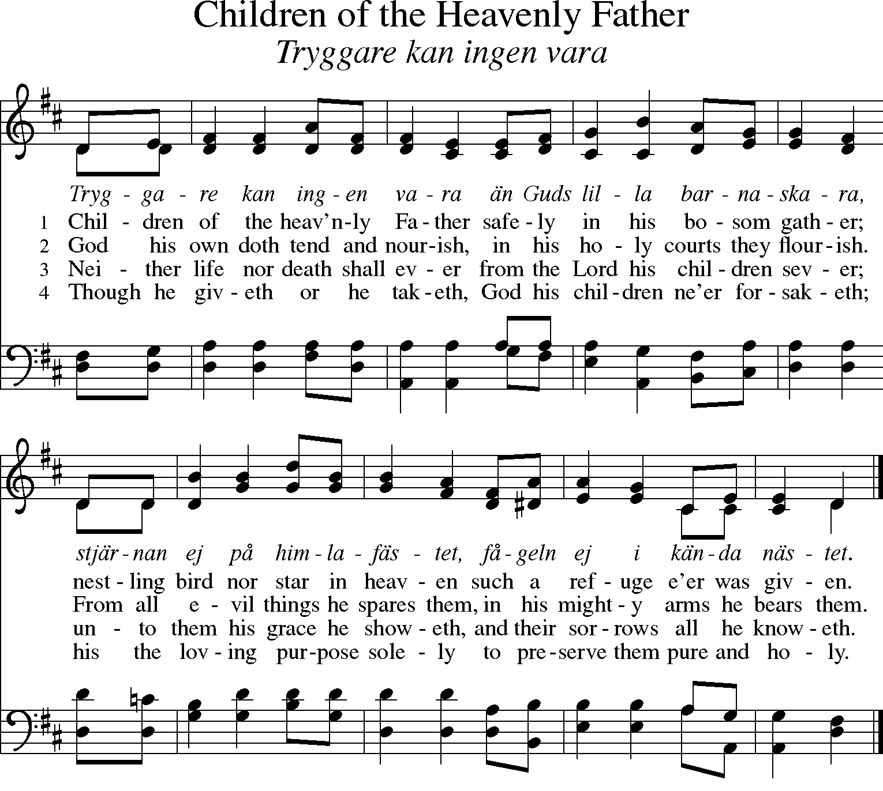
(Silent reflection)
P: Holy God, you created all things by the power of your Word, and you renew the whole earth by your Spirit. Give now the water of life to all who thirst for you, that, rejoicing in your covenant of mercy, we may bring forth abundant fruit, through Jesus Christ, our Savior and Lord, Amen.

*THE RESURRECTION OF OUR LORD
P: The Holy Gospel according to John 20:1-18
C: Glory to you, O Lord.
¹Early on the first day of the week, while it was still dark, Mary Magdalene came to the tomb and saw that the stone had been removed from the tomb. ²So she ran and went to Simon Peter and the other disciple, the one whom Jesus loved, and said to them, “They have taken the Lord out of the tomb, and we do not know where they have laid him.” ³Then Peter and the other disciple set out and went toward the tomb. ⁴The two were running together, but the other disciple outran Peter and reached the tomb first. ⁵He bent down to look in and saw the linen wrappings lying there, but he did not go in. ⁶Then Simon Peter came, following him, and went into the tomb. He saw the linen wrappings lying there, ⁷and the cloth that had been on Jesus’ head, not lying with the linen wrappings but rolled up in a place by itself. ⁸Then the other disciple, who reached the tomb first, also went in, and he saw and believed; ⁹for as yet they did not understand the scripture, that he must rise from the dead. ¹⁰Then the disciples returned to their homes.
¹¹But Mary stood weeping outside the tomb. As she wept, she bent over to look into the tomb; ¹²and she saw two angels in white, sitting where the body of Jesus had been lying, one at the head and the other at the feet. ¹³They said to her, “Woman, why are you weeping?” She said to them, “They have taken away my Lord, and I do not know where they have laid him.” ¹⁴When she had said this, she turned around and saw Jesus standing there, but she did not know that it was Jesus. ¹⁵Jesus said to her, “Woman, why are you weeping? Whom are you looking for?” Supposing him to be the gardener, she said to him, “Sir, if you have carried him away, tell me where you have laid him, and I will take him away.” ¹⁶Jesus said to her, “Mary!” She turned and said to him in Hebrew, “Rabbouni!” (which means Teacher). ¹⁷Jesus said to her, “Do not hold on to me, because I have not yet ascended to the Father. But go to my brothers and say to them, ‘I am ascending to my Father and your Father, to my God and your God.’ ” ¹⁸Mary Magdalene went and announced to the disciples, “I have seen the Lord”; and she told them that he had said these things to her.
P: The Gospel of the Lord.
C: Praise to you, O Christ.

HYMN Peace, to Soothe Our Bitter Woes ELW 381

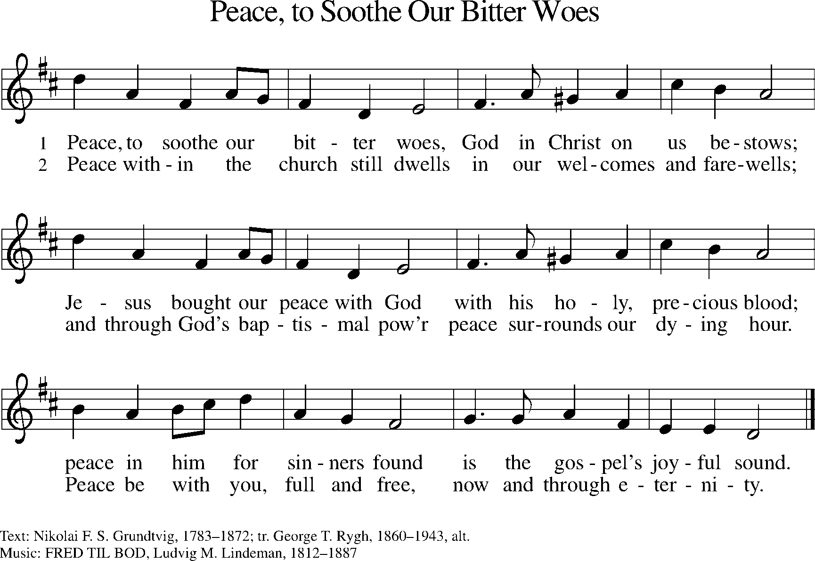

PRAYERS OF INTERCESSION
Turning our hearts to God who is gracious and merciful, we pray for the church, the world, and all who are in need.
(A brief silence is kept for reflection)
God of resurrection, this is the night when your holy church gathers around fire and water, bread and wine, story and celebration. Make us eager to go into all the world with the news that Christ is alive and death is conquered. Hear us, O God. Your mercy is great!

God of resurrection, in the beginning you created all things and declared them good. Where floods and fires threaten to overwhelm and destroy, speak peace against the chaos. Set rainbows in the skies as signs of your faithfulness. Shine your glory through each twinkling star. Hear us, O God. Your mercy is great!

God of resurrection, you are deliverance for people enslaved by conflict, corruption, and inequality. Grant wisdom to governments and world leaders. Lead them in the way of righteousness and along paths of justice. Hear us, O God. C: Your mercy is great!

God of resurrection, hold vigil with all who watch and wait this night: those sitting beside dying loved ones, those working the night shift at hospitals and care centers, emergency first responders, those awaiting test results or diagnoses, those who are in labor, and those who long for healing. Hear us, O God. C: Your mercy is great!

God of resurrection, stir up the waters of salvation and bring renewed life to all who receive or affirm the gift of baptism this night. (Those receiving or affirming baptism may be named.) Claim us as your beloved children, clothe us in the garments of salvation, and raise us from death to life. Hear us, O God. C: Your mercy is great!

God of resurrection, bless the memory of all the faithful witnesses who boldly proclaimed, “We have seen the Lord!” Give us confidence that because Christ has been raised, we too will be raised to new life. Hear us, O God. C: Your mercy is great!

According to your steadfast love, O God, hear these and all our prayers as we commend them to you; through Christ our Lord. C: Amen!

LORD’S PRAYER
Gathered into one by the Holy Spirit, we pray as Jesus taught us…

*THE LORD’S PRAYER
Our Father, who art in heaven,
hallowed be thy name,
thy kingdom come,
thy will be done,
on earth as it is in heaven.
Give us this day our daily bread;
and forgive us our trespasses,
as we forgive those
who trespass against us;
and lead us not into temptation,
but deliver us from evil.
For thine is the kingdom,
and the power, and the glory,
forever and ever. Amen.

BLESSING
May God who has brought us from death to life
fill you with great joy.
Almighty God, Father, ☩ Son, and Holy Spirit,
bless you now and forever.
C:Amen.

DISMISSAL
A:Alleluia! Christ is risen.
C:Christ is risen indeed. Alleluia!
A:Go in peace. Share the good news. Alleluia!
C:Thanks be to God. Alleuia!

Candles may be extinguished.

