

Holy Trinity Lutheran Church
150 River Road Red Bank, NJ 07701
Church Office: (732) 741-9241 Fax: (732) 741-9577
email: holytrinitychurch4@verizon.net
Website: htlcredbank.org
Pastor: Rev. John Mack, Jr.
Cell: (336)-392-5839
Minister of Music: Peter Isherwood
Parish Administrator: Deanna Vergari
Council President: Cynthia Kazmac

April 05, 2026

Resurrection of Our Lord: Easter Day

Introduction
This is the day the Lord has made! Christ is risen, and through him all creation is made new! Indeed, “God shows no partiality” (Acts 10:34): Christ’s resurrection truly brings life to everyone. We sing hymns of praise, gather around sacred words, and proclaim God’s faithfulness, power, and love in the feast of holy communion. With the women at the tomb, we are astonished, elated, and grateful. We depart with joy to proclaim the good news of God’s endless love.

Welcome & Announcements (Please remember to silence your cell phone!)

Prelude (We prayerfully prepare our hearts and minds to worship!)

+ GATHERING +

Thanksgiving for Baptism
All may make the sign of the cross, the sign that is marked at baptism, as the presiding minister begins.
P:Alleluia! Christ is risen.
C:Christ is risen indeed. Alleluia!
P:Salvation belongs to our God who is seated on the throne
and to the Lamb!
C:Amen.
P:Let us give thanks for the gifts of baptism.
Water may be poured into the font as the presiding minister continues.
P:Merciful God,
you are the one who was, who is, and who is to come.
You lead us beside still waters.
We thank you for the waters of creation:
morning dew, gentle rain, roaring waves.
We thank you for the waters that nourish us (local waters may be named).
Blessed are you.
C:You guide us to springs of the water of life.
P:Jesus Christ, you are the faithful witness
who accompanies us on our journeys.
We give you thanks for your life-giving death and resurrection.
We praise you for joining us in joy and sorrow.
Blessed are you.
C:You guide us to springs of the water of life.
P:Holy Spirit, you anoint our head with oil and our cup overflows.
Break down barriers that divide us.
Fill us with the breath of peace.
Blessed are you.
C:You guide us to springs of the water of life.
P:Holy One, we thank you for the gifts and grace of baptism,
and for making us a new creation.
We join with saints and angels, giving you honor and praise,
now and forever.
C:Amen.

*Gathering Hymn ELW 365 Jesus Christ is Risen Today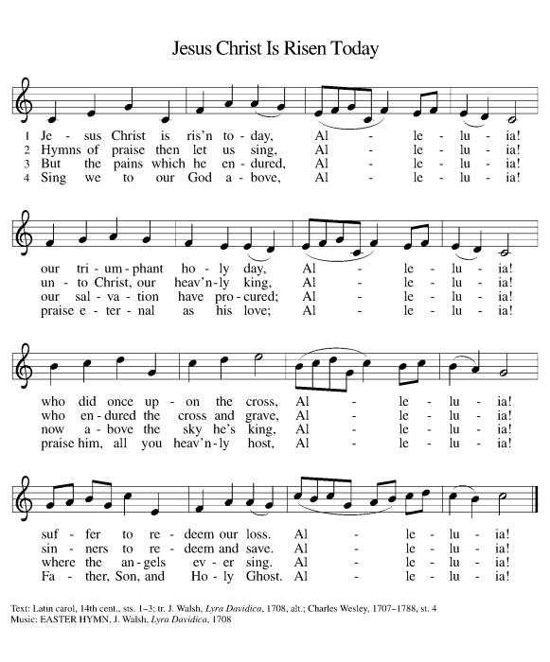

*Pastoral Greeting

P: The Grace of our Lord Jesus Christ, the love of God, and the communion of the Holy Spirit be with you all.

C: And also with you!

Hymn of Praise

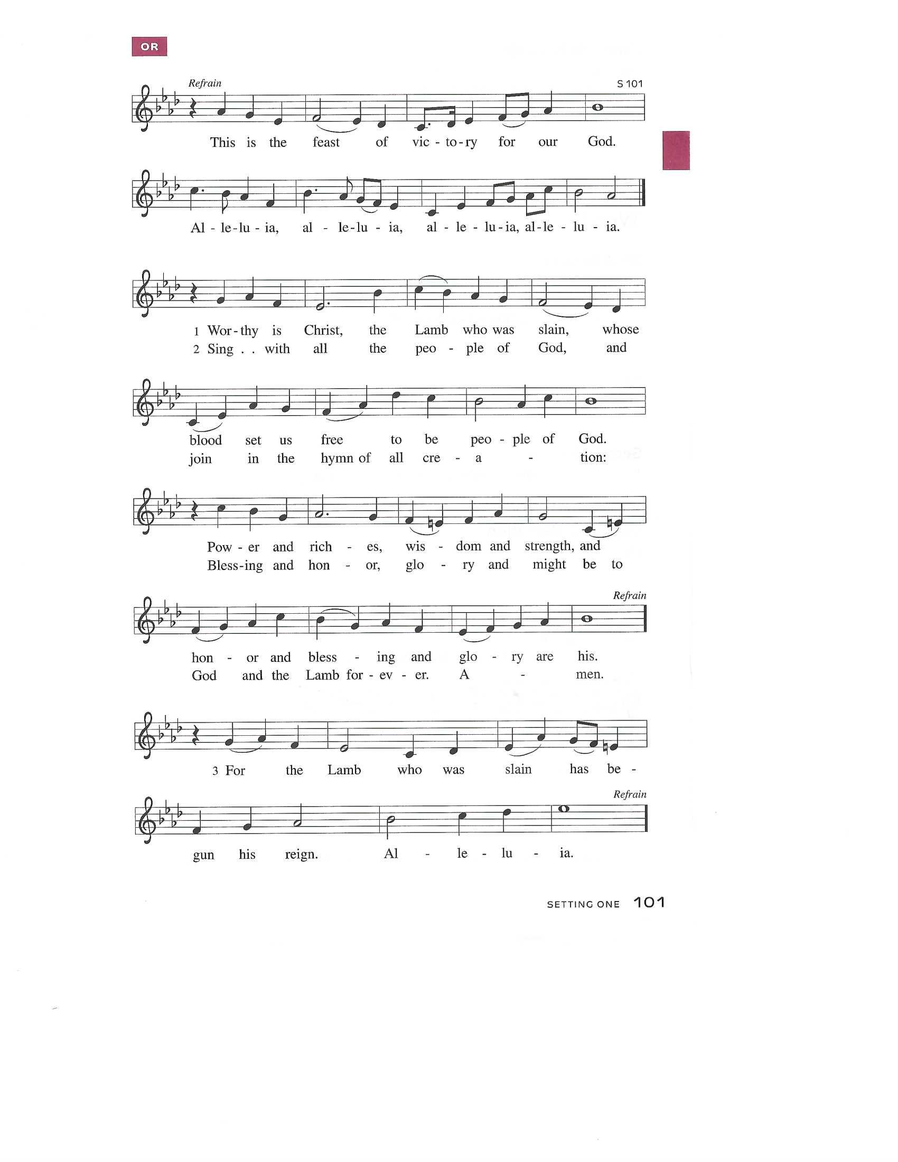

Prayer of the Day
P: O God, you gave your only Son to suffer death on the cross for our redemption, and by his glorious resurrection you delivered us from the power of death. Make us die every day to sin, that we may live with him forever in the joy of the resurrection, through your Son, Jesus Christ our Lord, who lives and reigns with you and the Holy Spirit, one God, now and forever.
C: Amen!

+WORD+

First Reading: Acts 10:34-43
Peter’s sermon, delivered at the home of Cornelius, a Roman army officer, is a summary of the essential message of Christianity: Everyone who believes in Jesus, whose life, death, and resurrection fulfilled the words of the prophets, “receives forgiveness of sins through his name.”

³⁴ Peter began to speak to [Cornelius and his household]: “I truly understand that God shows no partiality, ³⁵ but in every people anyone who fears him and practices righteousness is acceptable to him. ³⁶ You know the message he sent to the people of Israel, preaching peace by Jesus Christ—he is Lord of all. ³⁷ That message spread throughout Judea, beginning in Galilee after the baptism that John announced: ³⁸ how God anointed Jesus of Nazareth with the Holy Spirit and with power; how he went about doing good and healing all who were oppressed by the devil, for God was with him. ³⁹ We are witnesses to all that he did both in Judea and in Jerusalem. They put him to death by hanging him on a tree, ⁴⁰ but God raised him on the third day and allowed him to appear, ⁴¹ not to all the people but to us who were chosen by God as witnesses and who ate and drank with him after he rose from the dead. ⁴² He commanded us to preach to the people and to testify that he is the one ordained by God as judge of the living and the dead. ⁴³ All the prophets testify about him that everyone who believes in him receives forgiveness of sins through his name.

Psalm: 118:1-2, 14-24
This is the day that the Lord has made; let us rejoice and be glad in it. (Ps. 118:24)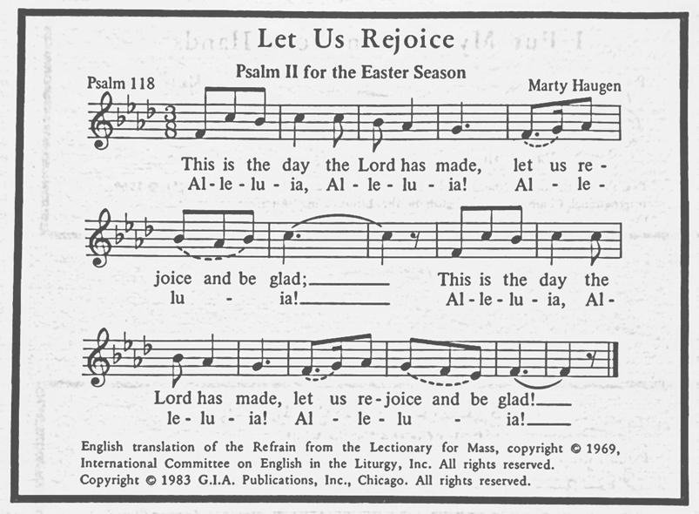

Second Reading: Colossians 3:1-4
Easter means new life for us as it first meant new life for Christ. His resurrection reshapes the entire focus and motivation for our lives since we are now hidden with the risen Christ in God.

¹ If you have been raised with Christ, seek the things that are above, where Christ is, seated at the right hand of God. ² Set your minds on the things that are above, not on the things that are on earth, ³ for you have died, and your life is hidden with Christ in God. ⁴ When Christ who is your life is revealed, then you also will be revealed with him in glory.

*Gospel Acclamation
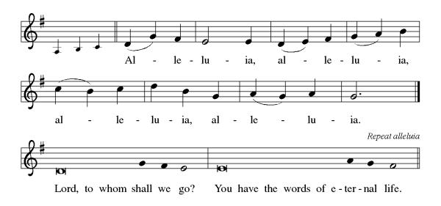

P: The Holy Gospel According to St. Matthew 28th Chapter
C: Glory to You O Lord!

Gospel: Matthew 28:1-10
Sorrow gives way to “fear and great joy” when two women are sent by an angel to proclaim the good news: Jesus is risen!

¹ After the Sabbath, as the first day of the week was dawning, Mary Magdalene and the other Mary went to see the tomb. ² And suddenly there was a great earthquake, for an angel of the Lord, descending from heaven, came and rolled back the stone and sat on it. ³ His appearance was like lightning and his clothing white as snow. ⁴ For fear of him the guards shook and became like dead men. ⁵ But the angel said to the women, “Do not be afraid, for I know that you are looking for Jesus who was crucified. ⁶ He is not here, for he has been raised, as he said. Come, see the place where he lay. ⁷ Then go quickly and tell his disciples, ‘He has been raised from the dead, and indeed he is going ahead of you to Galilee; there you will see him.’ This is my message for you.” ⁸ So they left the tomb quickly with fear and great joy and ran to tell his disciples. ⁹ Suddenly Jesus met them and said, “Greetings!” And they came to him, took hold of his feet, and worshiped him. ¹⁰ Then Jesus said to them, “Do not be afraid; go and tell my brothers and sisters to go to Galilee; there they will see me.”

P: The Gospel of the Lord
C: Praise to you, O Christ!
Sermon
*Hymn of the Day ELW 385 Good Christiam Friends, Rejoice and Sing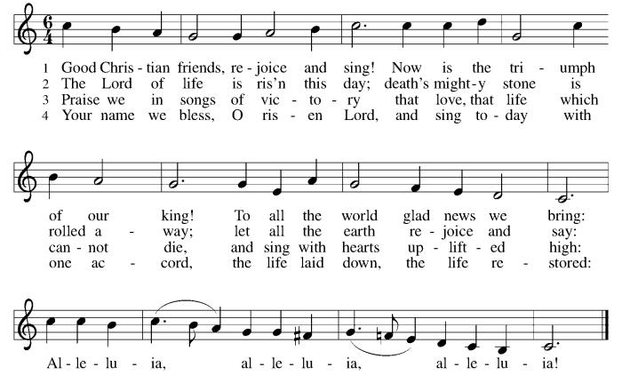

*Nicene Creed
We believe in one God,
the Father, the Almighty,
maker of heaven and earth,
of all that is, seen and unseen.
We believe in one Lord, Jesus Christ,
the only Son of God,
eternally begotten of the Father,
God from God, Light from Light,
true God from true God,
begotten, not made,
of one Being with the Father;
through him all things were made.
For us and for our salvation
he came down from heaven,
was incarnate of the Holy Spirit and the Virgin Mary
and became truly human.
For our sake he was crucified under Pontius Pilate;
he suffered death and was buried.
On the third day he rose again
in accordance with the Scriptures;
he ascended into heaven
and is seated at the right hand of the Father.
He will come again in glory to judge the living and the dead,
and his kingdom will have no end.
We believe in the Holy Spirit, the Lord, the giver of life,
who proceeds from the Father and the Son,
who with the Father and the Son is worshiped and glorified,
who has spoken through the prophets.
We believe in one holy catholic and apostolic church.
We acknowledge one baptism for the forgiveness of sins.
We look for the resurrection of the dead,
and the life of the world to come. Amen.

*Prayers of Intercession
Trusting in the power of Christ’s resurrection to heal and redeem our broken world, let us pray for the needs of all creation.
A brief silence.
Risen Savior, you have conquered death and opened the gates of everlasting life. Dispel our doubts and fears and renew our faith and hope in you. Merciful God,
C:receive our prayer.
Life-giving God, the created world rejoices in Christ’s victory over death. May all the earth be renewed by the light of Jesus’ resurrection, and may we be faithful stewards of all you have made. Merciful God,
C:receive our prayer.
Sovereign God, let the nations acknowledge your reign of justice and truth. Where violence, oppression, and corruption hold sway, pour out your holy and life-giving Spirit to transform and redeem. Merciful God,
C:receive our prayer.
Gentle Shepherd, like the women at the empty tomb, many grieve or feel lost and afraid. Draw near to those who are ill or in pain (especially). Reveal yourself to them as the Risen One. Merciful God,
C:receive our prayer.
Faithful God, we thank you for the living hope you give us through Christ’s resurrection. Bless this community, that we may boldly proclaim Christ’s victory over death in word and deed. Merciful God,
C:receive our prayer.
Here other intercessions may be offered.
Eternal One, we give thanks for all who have died and now share in the joy of your resurrection. Bring us, with them, to the unending feast of your victory. Merciful God,
C:receive our prayer.
God of resurrection power, use us and these prayers to proclaim the good news of new life to all the world, through Jesus Christ, our risen Savior.
C: Amen.

Greeting of Peace
P: The peace of Christ be with you always!
C: And also with you!

Offering (Thank you for your support for our ministry!)

*Doxology ELW 384 v.4 (Please stand and join in singing as we share our gifts!)
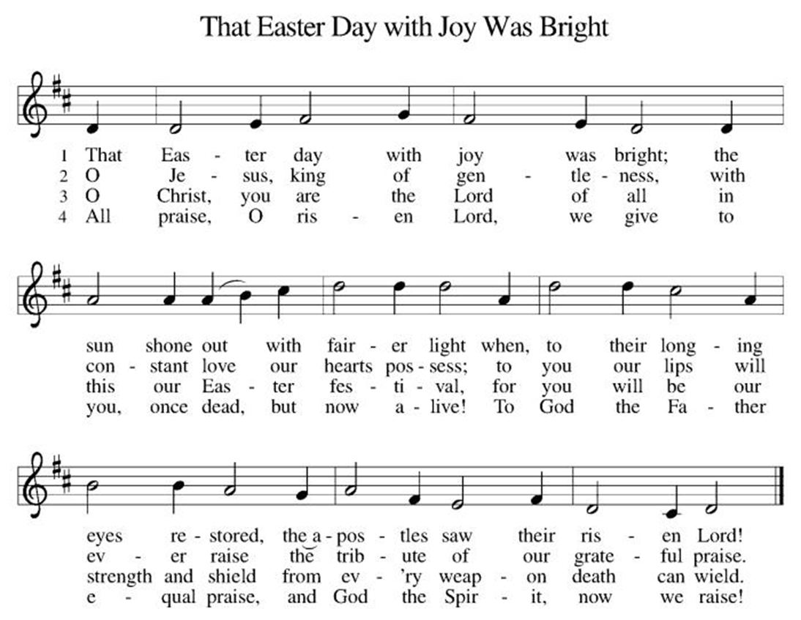

*Offering Prayer
A: Merciful God,
C: accept the fruits of our labor, gathered to give you glory.
You have set a table before us, a glimpse of that great day
when we will hunger and thirst no more.
Nourish us with the body and blood of Jesus,
that goodness and mercy may follow us
and bless the world you love.
In the name of Jesus,
Amen!

+MEAL+
*Great Thanksgiving
P: The Lord be with you.
C: And also with you.

P: Lift up your hearts.
C: We lift them to the Lord.

P: Let us give thanks to the Lord our God.
C: It is right to give our thanks and praise.

P: It is indeed right, our duty and our joy,
that we should at all times and in all places
give thanks and praise to you, almighty and merciful God,
for the glorious resurrection of our Savior Jesus Christ,
the true Paschal Lamb who gave himself to take away our sin;
who in dying has destroyed death,
and in rising has brought us to eternal life.
And so, with Mary Magdalene and Peter and all the witnesses of the resurrection, with earth and sea and all their creatures,
and with angels and archangels, cherubim and seraphim,
we praise your name and join their unending hymn:
*Sanctus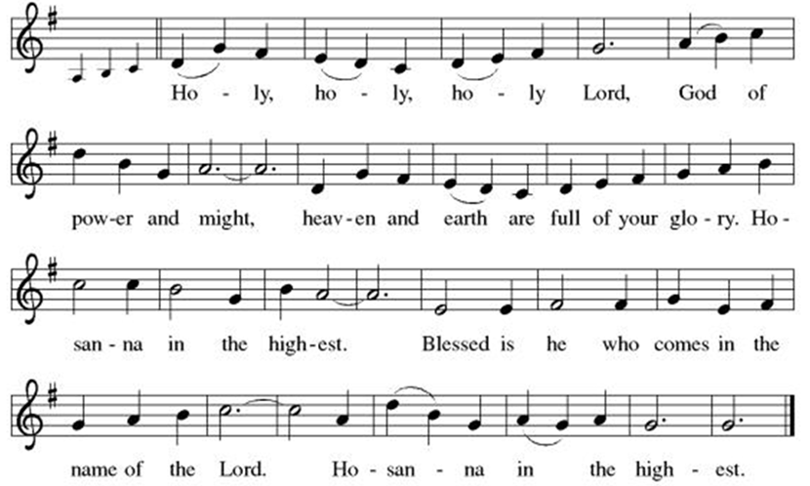
*Eucharistic Prayer
P: Blessed are you, O God of the universe.
Your mercy is everlasting
and your faithfulness endures from age to age.

Praise to you for creating the heavens and the earth.
Praise to you for saving the earth from the waters of the flood.
Praise to you for bringing the Israelites safely through the sea.
Praise to you for leading your people through the wilderness
to the land of milk and honey.
Praise to you for the words and deeds of Jesus, your anointed one.
Praise to you for the death and resurrection of Christ.
Praise to you for your Spirit poured out on all nations.

In the night in which he was betrayed,
our Lord Jesus took bread, and gave thanks;
broke it, and gave it to his disciples, saying:
Take and eat; this is my body, given for you.
Do this for the remembrance of me.

Again, after supper, he took the cup, gave thanks,
and gave it for all to drink, saying:
This cup is the new covenant in my blood,
shed for you and for all people for the forgiveness of sin.
Do this for the remembrance of me.

With this bread and cup
we remember our Lord’s passover from death to life
as we proclaim the mystery of faith:

C: Christ has died.
Christ is risen.
Christ will come again.

P: O God of resurrection and new life:
Pour out your Holy Spirit on us
and on these gifts of bread and wine.
Bless this feast.
Grace our table with your presence.
Come, Holy Spirit.

Reveal yourself to us in the breaking of the bread.
Raise us up as the body of Christ for the world.
Breathe new life into us.
Send us forth,
burning with justice, peace, and love.
Come, Holy Spirit.

With your holy ones of all times and places,
with the earth and all its creatures,
with sun and moon and stars,
we praise you, O God,
blessed and holy Trinity,
now and forever.
C: Amen.

*THE LORD’S PRAYER
Our Father, who art in heaven,
hallowed be thy name,
thy kingdom come,
thy will be done,
on earth as it is in heaven.
Give us this day our daily bread;
and forgive us our trespasses,
as we forgive those
who trespass against us;
and lead us not into temptation,
but deliver us from evil.
For thine is the kingdom,
and the power, and the glory,
forever and ever. Amen.
*Lamb of God
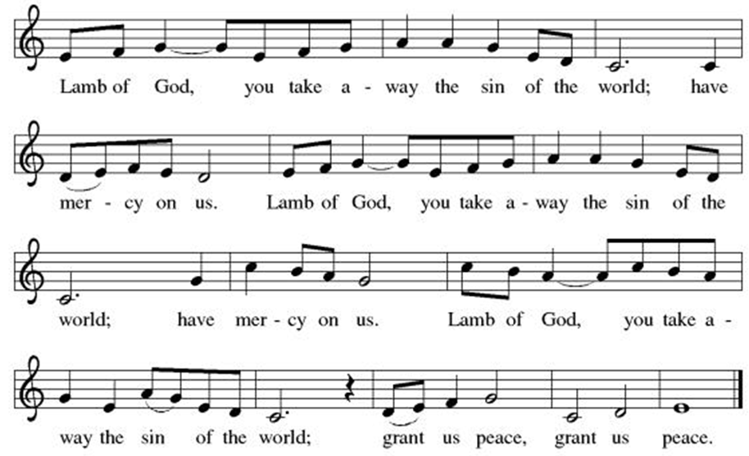
Spiritual Communion Prayer
P: Let us pray for the communion of all present here, those viewing our service virtually, those in our hearts and in our world.
C: Lord Jesus, I believe you are truly present in the Sacrament of Holy Communion. When I cannot receive Communion, I pray that you come into my heart. I know that nothing in Heaven or on earth can separate me from your love. Amen.

Invitation to Communion
P: Come to the table of new life.
Receive the risen Lord.

C: Thanks be to God!

(All are invited to the communion rail following the guidance of the ushers. Communion will be shared through the host and individual cups. If you would like communion but are unable to join us at the rail, please alert the usher!)

Communion Hymns (Please join in singing!)
ELW 485 I Am the Bread of Life
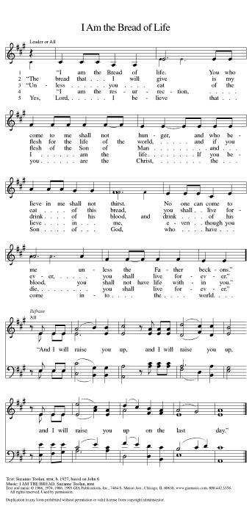

ELW 376 Thine Is the Glory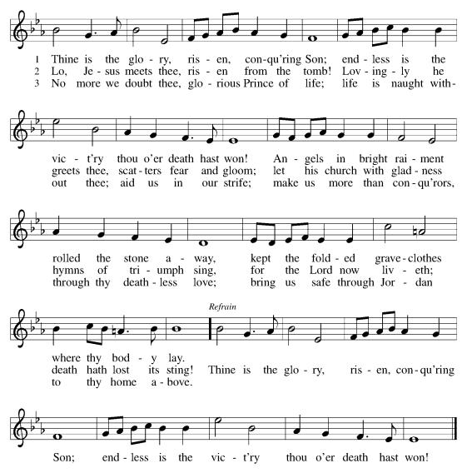

ELW 379 Now the Green Blade Rises
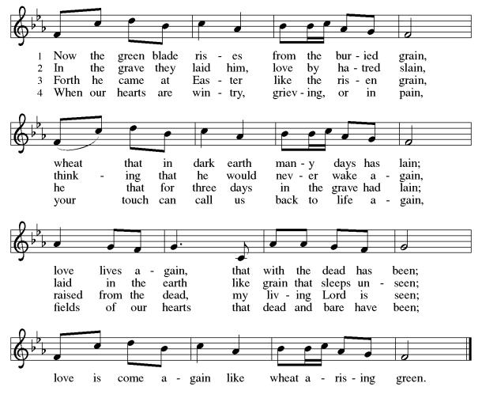

P: The body and blood of our Lord Jesus Christ strengthen you and keep you in his grace.
C: Amen!

*Prayer after Communion
A: Holy One,
through this meal you have made your home among us
and are making all things new.
Send us now to speak peace to anxious hearts,
to love our enemies,
and to bring your healing to the nations.
In the name of Jesus,
C: Amen.

+Sending+

*Blessing
P: God Almighty, who is the beginning and the end,
Jesus Christ, the firstborn of the dead,
and the Spirit, our advocate and peace,
☩ bless you now and forever.
C: Amen!

*Sending Hymn ELW 369 Christ the Lord Is Risen Today; Alleluia!
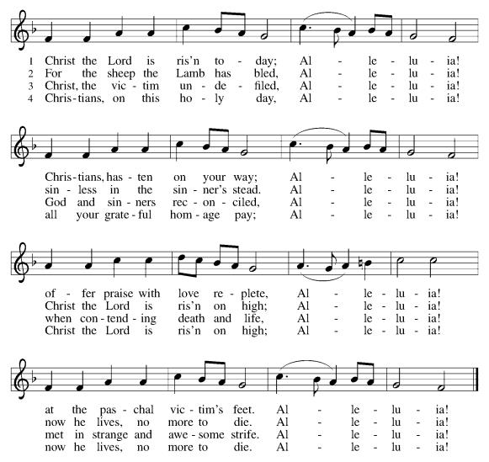

*Dismissal
A: Go in peace. Praise the Lord. Alleluia!
C: Thanks be to God. Alleluia!

Postlude

Copyright © 2020 Augsburg Fortress. All rights reserved. Reprinted by permission under Augsburg Fortress Liturgies Annual License #SB106907. New Revised Standard Version Bible, Copyright © 1989, Division of Christian Education of the National Council of the Churches of Christ in the United States of America. Used by permission. All rights reserved. Revised Common Lectionary, Copyright © 1992 Consultation on Common Texts, admin Augsburg Fortress. Used by permission.

Treasurer’s Report

February giving totaled $53,512, putting us ahead of pace toward our 2026 Challenge goal of $244,000, with 29% raised in just 17% of the year. Continued participation through regular or additional Challenge gifts will help ensure we fully fund HTLC’s ministry and mission in the months ahead.
Worship Volunteer Schedule
Date | Asst. Min | Usher | Sacristan | Lector | Counter
April 5 | Chris Foard | Lauren Gripp | Helga Britton | Jeff Ridberg | Carleo/Spreen
April 12 | Keith Bennett | The Gripps | Sherry Lee | Jeff Ridberg | Foss/Foard
April 19 | Chris Foard | Keith Bennett | Pat Pienkos | Emily Kaster | Volk/Bohner
April 26 | Charlie Rugg | Jill Socha | Sherry Lee | Rosemary Lane | Kazmac/Giordano
May 3 | Linda Coleman | Kathy Caputo | Joanne Giordano | Bill Spreen | Socha/Cheek

Coffee Hour- 03/29/2026 Andy Wehr and Erin O’Neill
04/05/2026 Easter Breakfast

ANNOUNCEMENTS Thank you! To all who consistently support our church and ministries through your time, talent, and treasure. Please help us grow by inviting your friends and family to worship and events. You are what makes Holy Trinity a wonderful church family!

Thank you! With heartfelt gratitude, we thank our wonderful choir and all of our dedicated volunteers. Your time, talent, and commitment each week—and especially during holidays—bring beauty, warmth, and meaning to our services. Your contributions help create a welcoming and uplifting experience for our entire community. We are truly grateful for all that you do.

Dorcas Circle- Will meet April 9th at noon due to Holy Week.

Stay in touch! Please visit our church website, www.htlcredbank.org for updates and information. You can also find us on Facebook and view services online. The office is open from 9am to 2pm, Monday to Thursday.

100 Anniversary Committee- If you are interested in being a part of the committee to help plan the 100th anniversary celebration of HTLC in 2028, please sign up in the red book. All are welcome! Also, the committee will be looking for photos and documents of HTLC throughout the years. If you have anything to share, please bring them to the church and marked envelopes or email electronic copies to the church office.

Name Tag Sundays: On the first Sunday of each month, names tags and markers will be at each entrance of the sanctuary. Please fill out a tag and wear one for worship and for coffee hour to welcome visitors and help newcomers put names to faces.

WELCA UPDATE -
Several WELCA members got together on 3/15 to discuss upcoming donations and events. Trivia Night brought in $709.75 and a donation will be made to Doctors Without Borders. We also discussed the need to continue to pay the $140.00 semi-annual dues to the NJ Chapter of WELCA. The Cross Roads Tee sign (a donation of $300) will be made along with social ministry and evangelism.

The Women of WELCA will be hosting coffee hour on April 12th. Please let Debbie Yetka know if you are able to bring something in and what it is.

Easter Dinner Donations:
Thank you for all the donations toward the collection for the Easter dinner bags. We were able to collect enough food for 28 bags. We were also able to donate some extra food items on the list and a gift card. Beth Gebhart, from Lutheran Social Ministries, picked up the food on March 23rd.

Sunday School in the New Year, we will continue to study stories and lessons from the Old Testament beginning with Jacob. Kids will love the crafts, songs and games that accompany each lesson.
The following dates there will be Sunday School:
Jan- 11 and 25, Feb- 8 and 22, March- 1, 15 and 29*Easter Egg Hunt!
April- 12 and 26, May- 3, 17 and 31, June- 7 and 14
As was done in the fall, there will be opportunities to volunteer as SS lead teacher. A signup will be emailed out shortly and will also be posted in the red binder. Consider signing up! All lesson materials will be supplied and laid out and a leader guide will be emailed to volunteers approximately 1 week in advance. Blessings for a wonderful 2026!~Lauren

Choir The Holy Trinity Choir welcomes our singers back for a preparation rehearsal on Sunday, September 7th at 9am in the church hall. All are welcome to join us in song as often as you are able. Choir meets each Sunday at 9am to practice and prepare our music. Join us and help us grow by spreading the word about the HTLC Choir!

Quilting- The Quilters need gently used any bed sheets of any size! Please leave any donations in the quilters closet in Fellowship Hall. Thank you!

Quilters Need Help
If anyone is traveling through Mechanicsville, PA, and can add a few extra minutes to your trip, the warehouse for shipping quilts, school kits, etc is located directly off one of the exits.
We accumulate many quilts throughout the year and we would appreciate sending some quilts with you to deliver. Any questions, please call Sherry Lee or Elaine Theophall.

Weekly Quilting on Wednesdays at 9:30. Bring your lunch and enjoy some fellowship at noon. All are welcome.

Social Ministry
*Year-round collections will continue for food items for Lunch Break. There is a sign-up sheet in the red book for those who can help drop these items to Lunch Break.
*We will also collect adult men's socks to periodically drop at the Red Bank Warminq Center.
*For those interested in the Heartwarminq Center — the new women's shelter is adjacent to the First Baptist Church of Red Bank at 90 Maple Ave. You can follow up on this mission through their website - https://www.thefeastnj.org- On this site, they also include wish list items that can be purchased through amazon. We will be exploring purchasing some of these through a Thrivent card. If you want to purchase on your own, you can leave items at church, and the Social Ministry will deliver them.

Pastoral Care and Prayer... We are here to care for and pray! Please contact the office to add or adjust prayer requests. If you or someone you know needs pastoral care, please contact the office and Pastor Mack!

THANK YOU for supporting and sustaining our church and ministries! All are welcome here! Please invite your family and friends to worship with us! Find us online at www.htlcredbank.org
Easter Flowers
Linda and Mark Csernica | In celebration of our grandchildren. Summer, Callum, Avery and Conor
Linda Coleman | In memory of John Vitols
Molly and Chris Foard | In gratitude to God for family and friends
The Grillon Family | In celebration of our grandchildren
Bruce and Rosemary Lane | In memory of our parents
Patricia and Jeff Pienkos | Flowers given in memory of Bobby Kronberger
Nancy and Bob Poole | The blessings of our family
Carol Rosen | Glory to God
Beth and Ron Ruberg | In memory of loved ones
Sue and David Steiger | Memory of our parents, Dorothy and Emil, Monica and John
Pete and Elaine Theophall | In memory of family and friends
Debbie Yetka | In memory of George Yetka

