Holy Trinity Lutheran Church
150 River Road Red Bank, NJ 07701
Church Office: (732) 741-9241
email: Office@htlcredbank.org
Website: htlcredbank.org
Pastor: Rev. John Mack, Jr.
Cell: (336)-392-5839
Minister of Music: Peter Isherwood
Parish Administrator: Deanna Vergari
Council President: Cynthia Kazmac

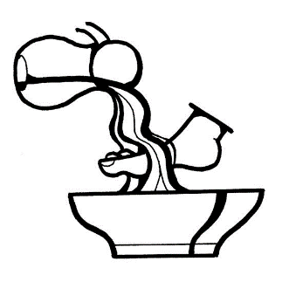

April 2, 2026 Maundy Thursday

Introduction

This evening our Lenten observance comes to an end, and we gather with Christians around the world to celebrate the Three Days of Jesus’ death and resurrection. Tonight, we remember Christ’s last meal with his disciples, but the central focus is his commandment that we live out the promise embodied in this meal. As Jesus washed his disciples’ feet, so we are called to give and receive love in humble service to one another. Formed into a new body in Christ through this holy meal, we are transformed by the mercy we have received and carry it into the world. Departing worship in solemn silence, we anticipate the coming days.

The Confession and Forgiveness
P: Friends in Christ, in this Lenten season we have heard our Lord’s call to struggle against sin, death, and the devil—all that keeps us from loving God and each other. This is the struggle to which we were called at baptism.
Within the community of the church, God never wearies of forgiving sin and giving the peace of reconciliation. On this night let us confess our sin against God and our neighbor, and enter the celebration of the great Three Days reconciled with God and with one another.
Silence is kept for reflection and self-examination.
P: Most merciful God,
C: We confess that we are captive to sin and cannot free ourselves. We have sinned against you in thought, word, and deed, by what we have done and by what we have left undone. We have not loved you with our whole heart; we have not loved our neighbors as ourselves. For the sake of your Son, Jesus Christ, have mercy on us. Forgive us, renew us, and lead us, so that we may delight in your will and walk in your ways, to the glory of your holy name. Amen.
P: God, who is rich in mercy, loved us even when we were dead in sin,
and made us alive together with Christ. By grace you have been saved.
In the name of ☩ Jesus Christ, your sins are forgiven.
Almighty God strengthen you with power through the Holy Spirit, that Christ may live in your hearts through faith.
C: Amen

Gathering Hymn ELW 606 [1 and 3]
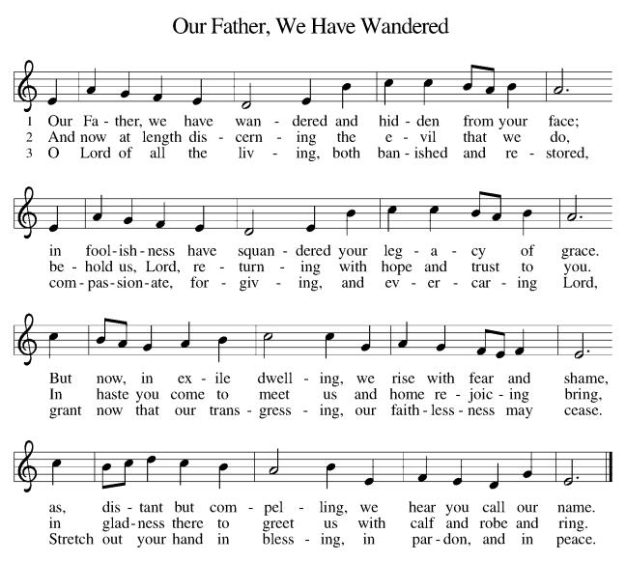

Prayer of the Day
P: Holy God, source of all love, on the night of his betrayal, Jesus gave us a new commandment, to love one another as he loves us. Write this commandment in our hearts, and give us the will to serve others as he was the servant of all, your Son, Jesus Christ, our Savior and Lord, who lives and reigns with you and the Holy Spirit, one God, now and forever.
C: Amen

First Reading: Exodus 12:1-4 [5-10] 11-14

Israel remembered its deliverance from slavery in Egypt by celebrating the festival of Passover. This festival featured the Passover lamb, whose blood was used as a sign to protect God’s people from the threat of death. The early church described the Lord’s supper using imagery from the Passover, especially in portraying Jesus as the lamb who delivers God’s people from sin and death.

¹The Lord said to Moses and Aaron in the land of Egypt: ²This month shall mark for you the beginning of months; it shall be the first month of the year for you. ³Tell the whole congregation of Israel that on the tenth of this month they are to take a lamb for each family, a lamb for each household. ⁴If a household is too small for a whole lamb, it shall join its closest neighbor in obtaining one; the lamb shall be divided in proportion to the number of people who eat of it. [⁵Your lamb shall be without blemish, a year-old male; you may take it from the sheep or from the goats. ⁶You shall keep it until the fourteenth day of this month; then the whole assembled congregation of Israel shall slaughter it at twilight. ⁷They shall take some of the blood and put it on the two doorposts and the lintel of the houses in which they eat it. ⁸They shall eat the lamb that same night; they shall eat it roasted over the fire with unleavened bread and bitter herbs. ⁹Do not eat any of it raw or boiled in water, but roasted over the fire, with its head, legs, and inner organs. ¹⁰You shall let none of it remain until the morning; anything that remains until the morning you shall burn. ] ¹¹This is how you shall eat it: your loins girded, your sandals on your feet, and your staff in your hand; and you shall eat it hurriedly. It is the passover of the Lord. ¹²For I will pass through the land of Egypt that night, and I will strike down every firstborn in the land of Egypt, both human beings and animals; on all the gods of Egypt I will execute judgments: I am the Lord. ¹³The blood shall be a sign for you on the houses where you live: when I see the blood, I will pass over you, and no plague shall destroy you when I strike the land of Egypt.
¹⁴This day shall be a day of remembrance for you. You shall celebrate it as a festival to the Lord; throughout your generations you shall observe it as a perpetual ordinance.

Psalm: Psalm 116:1-2, 12-19

I will lift the cup of salvation and call on the name of the Lord. (Ps. 116:13)

¹I love the Lord, who has | heard my voice,
and listened to my | supplication,
²for the Lord has given | ear to me
whenev- | er I called.
¹²How shall I re- | pay the Lord
for all the good things God has | done for me?
¹³I will lift the cup | of salvation
and call on the name | of the Lord.
¹⁴I will fulfill my vows | to the Lord
in the presence of | all God’s people.
¹⁵Precious in your | sight, O Lord,
is the death | of your servants.
¹⁶O Lord, truly I | am your servant;
I am your servant, the child of your handmaid; you have freed me | from my bonds.
¹⁷I will offer you the sacrifice | of thanksgiving
and call upon the name | of the Lord.
¹⁸I will fulfill my vows | to the Lord
in the presence of | all God’s people,
¹⁹in the courts of | the Lord‘s house,
in the midst of you, | O Jerusalem.

Second Reading: 1st Corinthians 11:23-26

In the bread and cup of the Lord’s supper, we experience intimate fellowship with Christ and with one another because it involves his body given for us and the new covenant in his blood. Faithful participation in this meal is a living proclamation of Christ’s death until he comes in the future.

²³For I received from the Lord what I also handed on to you, that the Lord Jesus on the night when he was betrayed took a loaf of bread, ²⁴and when he had given thanks, he broke it and said, “This is my body that is for you. Do this in remembrance of me.” ²⁵In the same way he took the cup also, after supper, saying, “This cup is the new covenant in my blood. Do this, as often as you drink it, in remembrance of me.” ²⁶For as often as you eat this bread and drink the cup, you proclaim the Lord’s death until he comes.

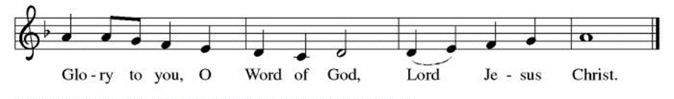
P. The Holy Gospel According to John 13th Chapter
C. Glory to You O Lord

Gospel: John 13:1-17, 31b-35

The story of the last supper in John’s gospel recalls a remarkable event not mentioned elsewhere: Jesus performs the duty of a slave, washing the feet of his disciples and urging them to do the same for one another.

¹Now before the festival of the Passover, Jesus knew that his hour had come to depart from this world and go to the Father. Having loved his own who were in the world, he loved them to the end. ²The devil had already put it into the heart of Judas son of Simon Iscariot to betray him. And during supper ³Jesus, knowing that the Father had given all things into his hands, and that he had come from God and was going to God, ⁴got up from the table, took off his outer robe, and tied a towel around himself. ⁵Then he poured water into a basin and began to wash the disciples’ feet and to wipe them with the towel that was tied around him. ⁶He came to Simon Peter, who said to him, “Lord, are you going to wash my feet?” ⁷Jesus answered, “You do not know now what I am doing, but later you will understand.” ⁸Peter said to him, “You will never wash my feet.” Jesus answered, “Unless I wash you, you have no share with me.” ⁹Simon Peter said to him, “Lord, not my feet only but also my hands and my head!” ¹⁰Jesus said to him, “One who has bathed does not need to wash, except for the feet, but is entirely clean. And you are clean, though not all of you.” ¹¹For he knew who was to betray him; for this reason he said, “Not all of you are clean.”
¹²After he had washed their feet, had put on his robe, and had returned to the table, he said to them, “Do you know what I have done to you? ¹³You call me Teacher and Lord—and you are right, for that is what I am. ¹⁴So if I, your Lord and Teacher, have washed your feet, you also ought to wash one another’s feet. ¹⁵For I have set you an example, that you also should do as I have done to you. ¹⁶Very truly, I tell you, servants are not greater than their master, nor are messengers greater than the one who sent them. ¹⁷If you know these things, you are blessed if you do them.”
^{31b}“Now the Son of Man has been glorified, and God has been glorified in him. ³²If God has been glorified in him, God will also glorify him in himself and will glorify him at once. ³³Little children, I am with you only a little longer. You will look for me; and as I said to the Jews so now I say to you, ‘Where I am going, you cannot come.’ ³⁴I give you a new commandment, that you love one another. Just as I have loved you, you also should love one another. ³⁵By this everyone will know that you are my disciples, if you have love for one another.”

Sermon

Hymn of the Day ELW 359 [v. 2 & 4]

Nicene Creed
We believe in one God,
the Father, the Almighty,
maker of heaven and earth,
of all that is, seen and unseen.
We believe in one Lord, Jesus Christ,
the only Son of God,
eternally begotten of the Father,
God from God, Light from Light,
true God from true God,
begotten, not made,
of one Being with the Father;
through him all things were made.
For us and for our salvation
he came down from heaven,
was incarnate of the Holy Spirit and the Virgin Mary
and became truly human.
For our sake he was crucified under Pontius Pilate;
he suffered death and was buried.
On the third day he rose again
in accordance with the Scriptures;
he ascended into heaven
and is seated at the right hand of the Father.
He will come again in glory to judge the living and the dead,
and his kingdom will have no end.
We believe in the Holy Spirit, the Lord, the giver of life,
who proceeds from the Father and the Son,
who with the Father and the Son is worshiped and glorified,
who has spoken through the prophets.
We believe in one holy catholic and apostolic church.
We acknowledge one baptism for the forgiveness of sins.
We look for the resurrection of the dead,
and the life of the world to come. Amen.

Foot Washing

On this night we have heard our Lord's commandment to love one another as he has loved us. We who receive God's love in Jesus Christ are called to love one another, to be servants to each other as Jesus became our servant. Our commitment to this loving service is signified in the washing of feet, following the example our Lord gave us on the night before his death.

Prayers of Intercession
Sustained by God’s abundant mercy, let us pray for the church, the world, and all of creation.
(A brief silence is kept for reflection)
A: You make a new covenant with your people. Gather your church around word and table in love and promise as these three holy days enfold us. Open us to behold the mystery of our salvation. Merciful God,
C: receive our prayer.
A: You give us our daily bread, fruit of the earth and work of human hands. Bless those who labor and tend to their crops and those who prepare our meals. Strengthen us to advocate for food justice and a fair distribution of resources. Merciful God,
C: receive our prayer.
A: You, our Savior and Teacher, stoop down to us in servant love. Inspire national and local leaders (especially) with a renewed sense of public service. Increase in them a humility to serve with equity and fairness. Teach us to pray for our enemies. Merciful God,
C: receive our prayer.
A: You incline your ear to us in every need. Befriend all who are lonely. Comfort those who grieve. Soothe any who are anxious. Console all who are distressed. Graciously tend to the hurts of your children who suffer in body, mind, and spirit (especially). Merciful God,
C: receive our prayer.
A: You inspire your people to praise in word, song, and art. We give thanks for artists (especially Albrecht Dürer, Matthias Grünewald, and Lucas Cranach) whose gifts enrich the church’s worship. Kindle in us appreciation for all who beautify our worship space throughout the changing seasons. Merciful God,
C: receive our prayer.
(Here other intercessions may be offered for our world and community)
A: Precious in your sight is the death of your faithful ones. We remember and give thanks for the those who have died (especially). With them, we trust your promise to love your own until the end. Merciful God,
C: receive our prayer.
A: We lift our prayers to you, O God, trusting in your steadfast love and your promise to renew your whole creation; through Jesus Christ our Savior.
C: Amen

Greeting of Peace
P: The peace of Christ be with you always.
C: And also with you.

Offertory (Thank you for your support for our church!)

*Offering Hymn ELW 186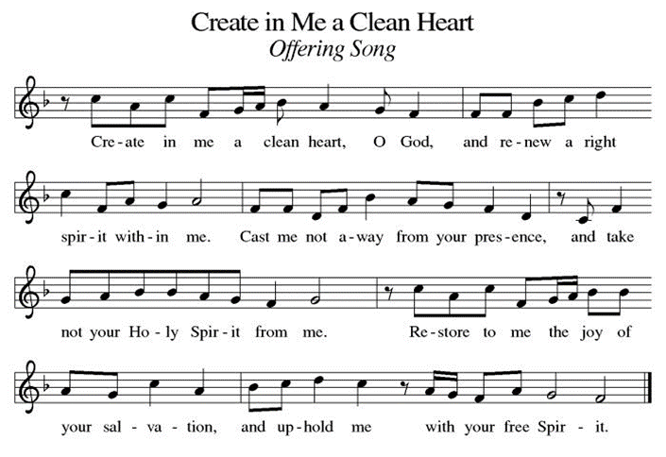

Offering Prayer
A: Gracious and generous God,
C: You have blessed us with the fullness of creation. Now we gather at your feast where you offer us the food that satisfies. Take and use what we offer here, come among us, and feed us with the body and blood of Christ, in whose name we pray. Amen.

*Great Thanksgiving
P: The Lord be with you.
C: And also with you.

P: Lift up your hearts.
C: We lift them to the Lord.

P: Let us give thanks to the Lord our God.
C: It is right to give our thanks and praise.

P: It is indeed right, our duty and our joy,
that we should at all times and in all places give thanks and praise to you, almighty and merciful God, through our Savior Jesus Christ, whose suffering and death gave salvation to all.
You gather your people around the tree of the cross, transforming death into life. And so, with all the choirs of angels, with the church on earth and the hosts of heaven, we praise your name and join their unending hymn:
*Sanctus
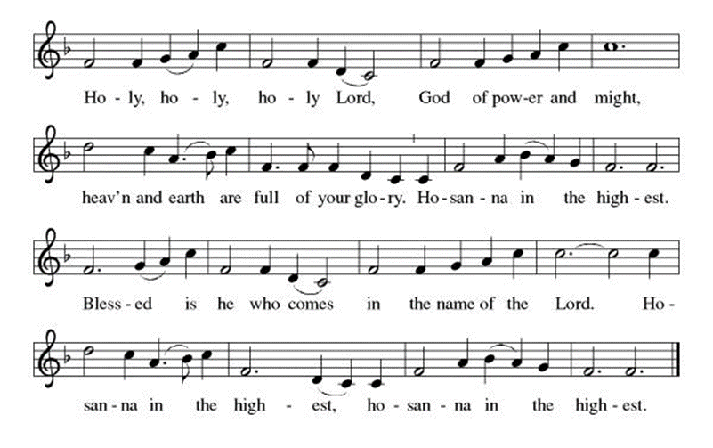
P: In the night in which he was betrayed,
our Lord Jesus took bread, and gave thanks;
broke it, and gave it to his disciples, saying:
Take and eat; this is my body, given for you.
Do this for the remembrance of me.

Again, after supper, he took the cup, gave thanks,
and gave it for all to drink, saying:
This cup is the new covenant in my blood,
shed for you and for all people for the forgiveness of sin.
Do this for the remembrance of me.

Through him, with him, in him, in the unity of the Holy Spirit,
all glory and honor is yours, almighty Father, now and forever.
C: Amen

*THE LORD’S PRAYER
Our Father, who art in heaven,
hallowed be thy name,
thy kingdom come,
thy will be done,
on earth as it is in heaven.
Give us this day our daily bread;
and forgive us our trespasses,
as we forgive those
who trespass against us;
and lead us not into temptation,
but deliver us from evil.
For thine is the kingdom,
and the power, and the glory,
forever and ever. Amen.
Lamb of God
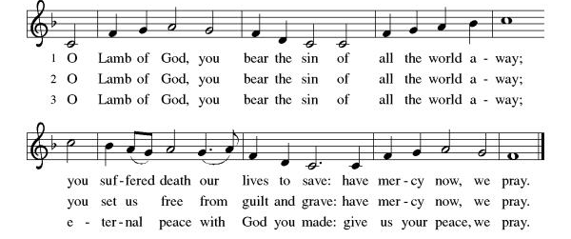

Spiritual Communion Prayer
P: Let us pray for the communion of all present here, those viewing our service virtually, those in our hearts and in our world.
C: Lord Jesus, I believe you are truly present in the Sacrament of Holy Communion. When I cannot receive Communion, I pray that you come into my heart. I know that nothing in Heaven or on earth can separate me from your love. Amen.

Invitation to Communion
P: Here is food and drink for the journey of life. Take and be filled!
C: Thanks be to God!

Communion
(All are invited to the communion rail following the guidance of the ushers. Communion will be shared through the host and individual cups. If you would like communion but are unable to join us at the rail, please alert the usher!)

Communion Hymn
ELW #474 Bread of Life from Heaven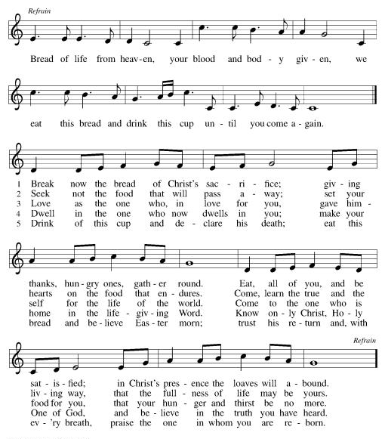

P: The body and blood of our Lord Jesus Christ strengthen you and keep you in his grace. C: Amen!

*Prayer after Communion
A: Lord Jesus, in this wonderful sacrament
you strengthen us with the saving power
of your suffering, death, and resurrection.
May this sacrament of your body and blood
so work in us that the fruits of your redemption
will show forth in the way we live,
for you live and reign with the Father and the Holy Spirit,
one God, now and forever.
C: Amen
+SENDING+
Sending Hymn ELW 353 (v. 1 /3 / 5)
Stripping of the Altar
All depart in silence.
(Please join us for our liturgies on Good Friday and Easter!)

