
How to Download the CBF APP

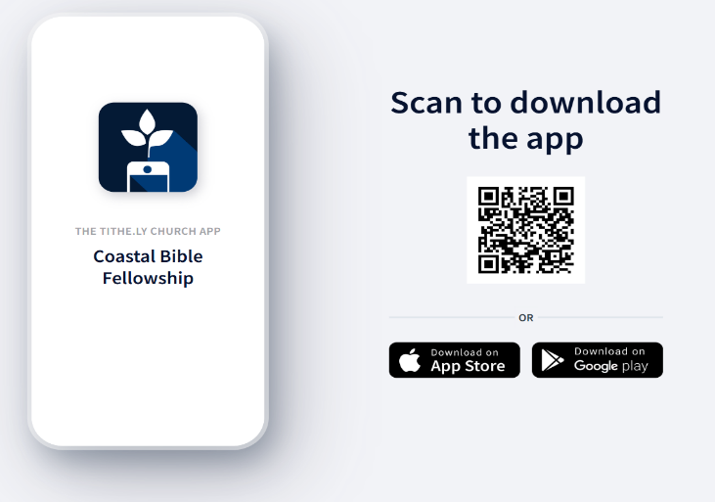
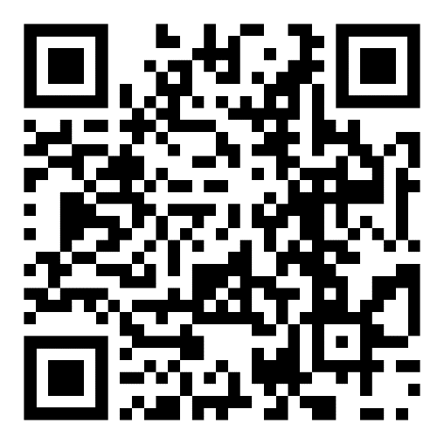
Click Ctrl + this link to download the CBF APP
You can download by either going to the APP Store, Google play, or scan QR code.
This is what the APP will look like (blue not green).
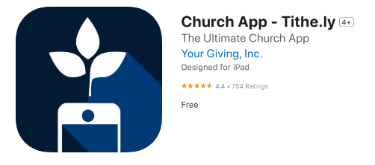
After you download the APP:
To connect with CBF prayer, groups, and information, you will need to do all the following.
- Please allow location while using app
- Allow notifications
- Type in Coastal Bible Fellowship on line 1 & Flagler Beach on line 2, then search.
- Click Coastal Bible Fellowship
- Click Personalize Notifications to green
- You will be asked to switch the Tithe.ly logo to the CBF logo (CBF pic coming soon)
- You will be asked to create a username & password
- Contact Pastor Chris or Tom Lajoie if you have any questions
1 2 3 4 5 6
