


A CELEBRATION OF WORSHIP
SUNRISE SERVICE
APRIL 5TH, 2026

GOD’S PEOPLE GATHER TOGETHER IN FELLOWSHIP

+OPENING HYMN Dawning Grace Amazing Grace
Jacob Baker on Bagpipes
WELCOME
HYMN In the Garden Words on Back!
MESSAGE
COMMUNION
HYMN Christ the Lord is Risen Today Words on Back!

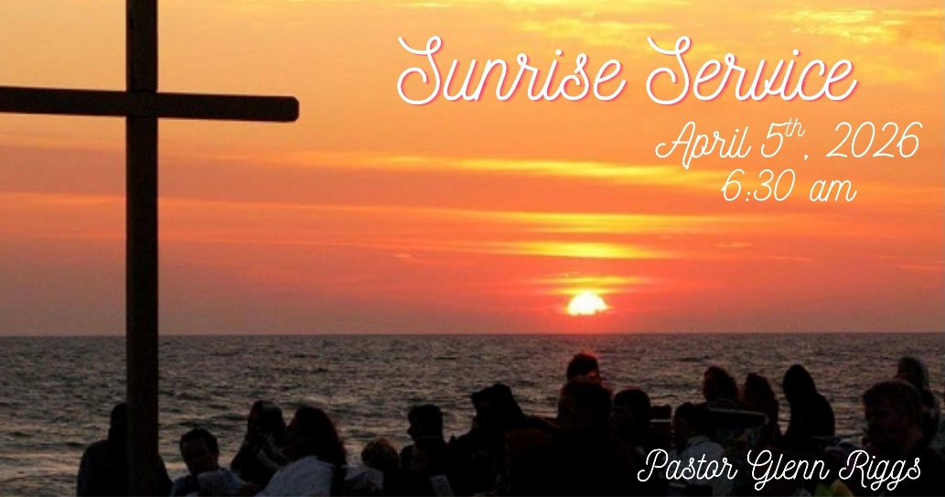

A CELEBRATION OF WORSHIP
SUNRISE SERVICE
APRIL 5TH, 2026

GOD’S PEOPLE GATHER TOGETHER IN FELLOWSHIP

+OPENING HYMN Dawning Grace Amazing Grace
Jacob Baker on Bagpipes
WELCOME
HYMN In the Garden Words on Back!
MESSAGE
COMMUNION
HYMN Christ the Lord is Risen Today Words on Back!

In the Garden
- I come to the garden while the dew is still on the roses,
and the voice I hear falling on my ear, the Son of God discloses
Refrain
And he walks with me, and he talks with me, and he tells me
I am his own; and the joy we share as we tarry there, none other
has ever known.
- He speaks, and the sound of his voice is so sweet the
Birds hush their singing, and the melody that he gave to me
Within my heart is ringing.
Refrain
And he walks with me, and he talks with me, and he tells me
I am his own; and the joy we share as we tarry there, none other
has ever known.

Christ the Lord Is Risen Today
- Christ the Lord is risen today, Alleluia!
Earth and heaven in chorus say, Alleluia!
Raise your joys and triumphs high, Alleluia!
Sing, ye heavens, and earth reply, Alleluia!

- Love’s redeeming work is done, Alleluia!
Fought the fight, the battle won Alleluia!
Death in vain forbids him rise, Alleluia!
Christ has opened paradise, Alleluia!

In the Garden
- I come to the garden while the dew is still on the roses,
and the voice I hear falling on my ear, the Son of God discloses
Refrain
And he walks with me, and he talks with me, and he tells me
I am his own; and the joy we share as we tarry there, none other
has ever known.
- He speaks, and the sound of his voice is so sweet the
Birds hush their singing, and the melody that he gave to me
Within my heart is ringing.
Refrain
And he walks with me, and he talks with me, and he tells me
I am his own; and the joy we share as we tarry there, none other
has ever known.

Christ the Lord Is Risen Today
- Christ the Lord is risen today, Alleluia!
Earth and heaven in chorus say, Alleluia!
Raise your joys and triumphs high, Alleluia!
Sing, ye heavens, and earth reply, Alleluia!

- Love’s redeeming work is done, Alleluia!
Fought the fight, the battle won Alleluia!
Death in vain forbids him rise, Alleluia!
Christ has opened paradise, Alleluia!

