St. Paul
UNITED CHURCH OF CHRIST

April 3, 2026 12:00pm
Welcome! Whether you are a guest, friend or member, we are delighted that you are here. Large print bulletins are available at either door. Ask a greeter for any directions you may need.

“Please note that this service will be live-streamed on Facebook. If you do not wish to be visible on camera, please let an usher know so we can take appropriate measures to ensure your privacy."

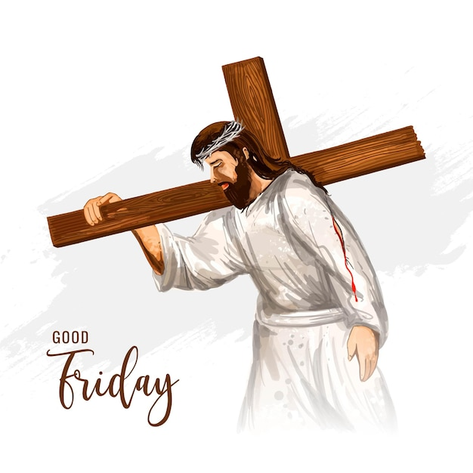

Rev. Jim Oleson, Pastor
Eugene Rahmier, Guest Pastor
Christopher Dickmeyer, Musician
Good Friday
*Please rise in body or spirit
Ringing of the Bell
Welcome & Announcements
The body is a unit, though it is made up of many parts; and though all its parts are many, they form one body. So it is with Christ. For we were all baptized by one Spirit into one body – whether Jews or Greeks, slaves or free – and given one Spirit to drink.
Prelude and Lighting of the Candles
*Opening Prayer Pastor Jim
We gather to worship, O God, under the shadow of the cross, sign of human shame and divine wisdom. Like Jesus, we would follow faithfully in your way; Like Jesus, we would live to you and die to you. We are your people; we belong to you. We offer you our worship and our lives. May your name be glorified in your church as we are open to your presence today; Through Christ Jesus our Savior. Amen.
Hymn #226 New Century O Sacred Head, Now Wounded
The Seven Last Words of Christ
Written Word Luke 23:32-34, 39-43 Pastor Eugene
Hymn #195 New Century On a Hill Far Away
Written Word John 19:25-27 Pastor Jim
Hymn #229 New Century Were You There?
(Verses 1 & 2)
Written Word Matthew 27:45-46 Pastor Eugene
Message My God, My God, why have you forsaken me? Pastor Eugene Rahmier
Hymn #229 New Century Were You There?
(Verse 3)
Written Word John 19:28-30 Pastor Jim
Message It Is Finished Rev. Jim Oleson

Written Word Luke 23:44-46 Pastor Jim
Church in Prayer Pastor Eugene
Pastoral Prayer
Lord’s Prayer (Debts, Debtors)
* Hymn #224 New Century When I Survey the Wondrous Cross
*Commission and Benediction Pastor Jim
*Christ’s Light Leads Us into the World
*Ringing of the Bell and Postlude

903 Meier Road, Old Monroe, Missouri 63369
stpauluccom@gmail.com
Website: stpauluccom.com
636-665-5329
OFFICE HOURS
Wednesday: 9:00am – 3:00pm
Friday: 9:00am - 12:00pm

